

The Single Electricity Market (SEM)

Part A Agreed Procedure 3: Communication Channel Qualification

Version 28.0

18 August 2023

SEM Part A Agreed Procedure

|  |  |
| --- | --- |
| Title | Part A Agreed Procedure 3: Communication Channel Qualification |
| Version | 28.0 |
| Date | 18 August 2023 |

Table of Contents

1. Introduction 6

1.1 Background and Purpose 6

1.2 Scope of Agreed Procedure 6

1.3 Definitions and Interpretation 6

1.4 Compliance with Agreed Procedure 6

2. Descriptive Overview 7

2.1 Registration for Communication Channel 7

2.2 Communication Channel Testing 8

2.3 Accessing the Market Operator Isolated Market System 9

2.4 Maintaining A Communication Channel 9

2.5 Communication Channel Suspension 10

3. SwimLanes 11

3.1 Obtaining a Digital Certificate 11

3.2 Communication Channel Qualification 12

3.3 Digital Certificate Cancellation 13

3.4 Communication Channel Suspension 14

4. Procedural Steps 15

4.1 Obtaining A Digital Certificate 15

4.2 Communication Channel Qualification 16

4.3 Digital Certificate Cancellation 17

4.4 Communication Channel Suspension 18

APPENDIX 1: Definitions and Abbreviations 20

Definitions 20

Abbreviations 21

**DOCUMENT HISTORY**

|  |  |  |  |
| --- | --- | --- | --- |
| Version | Date | Author | Comment |
| 1.0 | 21/07/2006 | Kim McClenaghan | Initial draft |
| 2.0 | 03/11/2006 | Kim McClenaghan | Issued to Regulatory Authorities |
| 3.0 | 11/05/2007 | Regulatory Authorities | Consultation Version |
| 3.2 | 22/06/2007 | Regulatory Authorities | Approved for Go-Active by Regulatory Authorities and TSO/SEM Programme |
| 5.0 | 07/04/2009 | SEMO | SEM Design Baseline Documentation at V5.0 |
| 6.0 | 30/10/2009 | SEMO | SEM Design Baseline Documentation at V6.0 |
| 7.0 | 28 /05/2010 | SEMO | SEM Design Baseline Documentation at V7.0 |
| 8.0 | 19/11/2010 | SEMO | SEM Design Baseline Documentation at V8.0 |
| 9.0 | 06/05/2011 | SEMO | SEM Design Baseline Documentation at V9.0 |
| 10.0 | 21/10/2011 | SEMO | SEM Design Baseline Documentation at V10.0 |
| 11.0 | 21/07/2012 | SEMO | SEM Design Baseline Documentation at V11.0 |
| 12.0 | 16/11/2012 | SEMO | SEM Design Baseline Documentation at V12.0 |
| 13.0 | 10/05/2013 | SEMO | SEM Design Baseline Documentation at V13.0 |
| 14.0 | 15/11/2013 | SEMO | SEM Design Baseline Documentation at V14.0 |
| 15.0 | 16/05/2014 | SEMO | SEM Design Baseline Documentation at V15.0 |
| 16.0 | 14/11/2014 | SEMO | SEM Design Baseline Documentation at V16.0 |
| 17.0 | 15/05/2015 | SEMO | SEM Design Baseline Documentation at V17.0 |
| 18.0 | 02/10/2015 | SEMO | SEM Design Baseline Documentation at V18.0 |
| 19.0 | 17/05/2017 | SEMO | SEM Design Baseline Documentation at V19.0 |
| 20.0 | 23/05/2017 | SEMO | SEM Design Baseline Documentation at V20.0 |
| 20.0 | 23/05/2017 | SEMO | Mod_01_17 Change to enable I-SEM (Part A) |
| 21.0 | 12/04/2019 | SEMO | SEMO Baseline Documentation at V 21.0 |
| 22.0 | 29/04/2020 | SEMO | SEMO Baseline Documentation at V 22.0 |
| 23.0 | 03/11/2020 | SEMO | SEMO Baseline Documentation at V 23.0 |
| 24.0 | 01/07/2021 | SEMO | SEMO Baseline Documentation at V 24.0 |
| 25.0 | 09/11/2021 | SEMO | SEMO Baseline Documentation at V 25.0 |
| 26.0 | 17/05/2022 | SEMO | SEMO Baseline Documentation at V 26.0 |
| 27.0 | 07/12/2022 | SEMO | SEMO Baseline Documentation at V 27.0 |
| 28.0 | 18/08/2023 | SEMO | SEMO Baseline Documentation at V28.0 |

**RELATED DOCUMENTS**

|  |  |  |  |
| --- | --- | --- | --- |
| Document Title | Version | Date | By |
| Trading and Settlement Code | V28.0 | 18/08/2023 | SEMO |
| Agreed Procedure 1 “Participant and Unit Registration and Deregistration” |  |  |  |
| Agreed Procedure 4 “Transaction Submission and Validation” |  |  |  |
| Agreed Procedure 5 "Data Storage and IT Security" |  |  |  |
| Agreed Procedure 7 “Emergency Communications” |  |  |  |
| Agreed Procedure 11 "Market System Operation, Testing, Upgrading and Support" |  |  |  |
| Agreed Procedure 14 “Disputes” |  |  |  |

1. Introduction
   1. Background and Purpose

This Agreed Procedure describes the specific procedures for the qualification, setup and maintenance of Type 2 Channels and Type 3 Channels, and with which Parties to the Trading and Settlement Code (the Code) must comply.

* 1. Scope of Agreed Procedure

This Agreed Procedure is a definition of procedural steps to be followed by the Market Operator and Participants. It forms an annexe to, and is governed by, the Trading and Settlement Code. This document is a statement of process and procedure. Parties’ rights and obligations are set out in the Code.

* 1. Definitions and Interpretation

Save as expressly defined, words and expressions defined in the Code shall have the same meanings when used in this Agreed Procedure.

References to particular sections relate internally to this Agreed Procedure unless specifically noted.

* 1. Compliance with Agreed Procedure

Compliance with this Agreed Procedure is required under the terms of the Code.

1. Descriptive Overview

This section 2 provides an overview of the procedure provided for in the main Sections of the Code, for explanatory purposes and to set the context for this Agreed Procedure only. The overview contained in this section is not legally binding and is not intended to create rights or impose obligations on any Party.

These processes detail how a Participant gains access to the Market Operator Isolated Market System through either the Type 2 Channel or the Type 3 Channel. The steps required to maintain this access are also detailed. To qualify for a particular Communication Channel the following sequence of events need to occur:

1. Obtain a Digital Certificate for the test environment.
2. Perform a series of data transfer tests using the desired Communication Channel(s).
3. Obtain a Digital Certificate for the production environment.
4. Gain full access to the production Market Operator Isolated Market System.

Type 1 Channel communication is a manual communication option for Data Transactions generally consisting of paper based and fax communications. Type 1 Channel communications are used

1. during the initial registration as described in Agreed Procedure 1 “Participant and Unit Registration and Deregistration”;
2. where there is problem with the use of Type 2 Channel and Type 3 Channel Communication as described in Agreed Procedure 7 “Emergency Communications”; and
3. for all Data Transactions not supported via Type 2 Channel or Type 3 Channel.
   1. Registration for Communication Channel

This process applies to Participants wishing to access the Market Operator Isolated Market System through Type 2 Channels and Type 3 Channels only.

1. The Participant submits their registration details in hard copy (refer to Agreed Procedure 1 "Participant and Unit Registration and Deregistration" for more detail).
2. The application will include a reference to the required Communication Channels (Type 2 Channel, Type 3 Channel or both). Test and production users are to be associated with each Communication Channel.
3. The Market Operator validates the application. If the Participant User does not already have appropriate Digital Certificates then the following steps must take place.
4. The Market Operator informs the Certificate Authority that the Participant User has been authorised to receive a Digital Certificate.
5. The Market Operator issues an email to the Participant User indicating authorisation to collect a Digital Certificate and provides the Participant User with a link to the Certificate Authority’s enrolment webpage (hosted on the Corporate Website).
6. The Participant User navigates to the link and enters the required information.
7. The Certificate Authority checks that the Participant User is authorised and once validated issues a PIN and URL via email to the Participant User.
8. Using the URL and PIN the Participant User connects to the Certificate Authority website, and downloads and installs the Digital Certificate.

The following process relates to obtaining Digital Certificates for additional Participant Users post Communication Channel Qualification of the first Participant User.

1. The Participant User is created with the appropriate attributes using the Market Operator’s Isolated Market System.
2. The Participant notifies the Market Operator that a Digital Certificate is required for a new Participant User.
3. The steps 3 to 7 in the above process are followed.
   * 1. Guidelines Governing Digital Certificate Use
4. One Digital Certificate is required for each Participant User and is associated with that User’s profile. For Type 3 Channel interactions, note that a Participant User may represent a machine rather than an individual person.
5. A single Digital Certificate can allow the Participant User to access any or all of the Functional Areas as specified when the User was set-up in the Market Operator’s Isolated Market System.
6. A Participant User can be associated with any or all of the Units for a single Party, so long as the entity hierarchy (defined in Agreed Procedure 1 "Participant and Unit Registration and Deregistration") is adhered to.
7. Digital Certificates are environment specific – i.e. a separate Digital Certificate is required when accessing test and production environments.
8. When qualifying for a new Communication Channel Type, it is required that a different Participant User identifier be used to those previously used for other Communication Channel Types for that Participant.
   1. Communication Channel Testing

The following steps apply for both Type 2 Channel and Type 3 Channel testing. Communication Channel testing can only begin when the Participant is in possession of a valid Digital Certificate and has been granted read/write access to the relevant Functional Areas.

1. The Participant connects to the Participant Certification Environment. In the case of a Type 2 Channel this involves accessing a website whereas a Type 3 Channel involves Web Services interaction. Note that this Participant Certification Environment is a test environment distinct from the Market Operator’s Isolated Market System.
2. A number of tests must be successfully performed. Where appropriate this may include:

* Upload/submit bid/offer data
* Download/request bid/offer data
* Download a report
* Update registration details
* Download a settlement file
* The Market Operator evaluates all the transaction results.

1. The Participant is notified by fax that testing is complete and is informed either that additional tests are required or that Communication Channel Qualification has been granted for specified Communication Channels.
   * 1. Guidelines Governing Communication Channel Testing

* It is envisaged that this process will only be conducted once per Participant per Communication Channel. If a Participant User is added at a later date Communication Channel testing will not be repeated.
* Testing is Communication Channel specific. Separate tests are required for each Communication Channel.
* Communication Channel Qualification can be suspended by the Market Operator (details in 2.5)
  1. Accessing the Market Operator Isolated Market System

In order to obtain full access to the Market Operator Isolated Market System the following steps must be followed:

* The Market Operator verifies that Communication Channel testing has been completed successfully.
* The Market Operator verifies that the Participant has demonstrated compliance through self certification with the IT security guidelines outlined in Agreed Procedure 5 "Data Storage and IT Security" sections 2.2 and 2.3.
* The Market Operator sets the Communication Channel Qualification flag allowing access to the Market Operator Isolated Market System. Once the Market Operator is satisfied with the above the Participant is notified by fax that they will be granted access to the Market Operator‘s Isolated Market System via the relevant Communication Channel for which testing has been successfully completed.
  1. Maintaining A Communication Channel
     1. IT Security Requirements

Parties shall ensure that interfaces to their Type 2 Channels and Type 3 Channels comply with the IT security requirements set out in Agreed Procedure 5 “Data Storage and IT Security” as required under the Code. Any significant deviation from these requirements could effect a Communication Channel suspension in accordance with section 2.5 of this Agreed Procedure.

* + 1. Maintaining a Type 2 Channel

In order for a Participant to maintain a Type 2 Channel, the Participant shall fulfil the following requirements:

* There must be a valid Participant User per Functional Area, with required access to administer the required functionality, except where this access to this Functional Area is covered under a qualified Type 3 Channel.
* A valid Digital Certificate is required per Participant User.
* Adequate internet access is required per Participant User.
* Each Participant User is to access the production Market Operator’s Isolated Market System using their assigned Digital Certificate.
* Participants are required to notify the Market Operator, via the Help Desk in accordance with Agreed Procedure 11 "Market System Operation, Testing, Upgrading and Support", of transaction malfunction issues due to Communication Channel failure.

A Participant that has qualified for Type 2 Channel communications is obliged to remain qualified for the duration of its participation in the Pool unless the Participant has also qualified for Type 3 Channel communications.

* + 1. Maintaining a Type 3 Channel

In order for a Participant to maintain a Type 3 Channel, the Participant shall fulfil the following requirements:

* There must be a valid Participant User per Functional Area, with required access to administer the required functionality, except where this access to this Functional Area is covered under a qualified Type 2 Channel.
* A valid Digital Certificate is required per Participant user.
* Adequate internet access is required.
* Participants are to notify the Market Operator, via the Help Desk in accordance with Agreed Procedure 11 "Market System Operation, Testing, Upgrading and Support", of transaction malfunction issues due to Communication Channel failure.
* Participants are to monitor their operations to ensure that required submissions are made, and error messages are acted upon in an appropriate and timely manner.

A Participant that has qualified for Type 3 Channel communications is obliged to remain qualified for the duration of its participation in the Pool unless the Participant has also qualified for Type 2 Channel communications.

* 1. Communication Channel Suspension

A Participant may be suspended from using either a Type 2 Channel or Type 3 Channel. This will be a temporary measure reversed when the Market Operator is satisfied that appropriate action has been taken towards re-qualification. The following may lead to Communication Channel suspension:

* The Participant may request for a particular Communication Channel to be temporarily suspended. This could arise when the Participant becomes aware of a security breach.
* The Participant does not have valid users with the appropriate access rights to operate in the Single Electricity Market.
* The Participant is deemed by the Market Operator to be non compliant with the required IT standards as specified in Agreed Procedure 5 "Data Storage and IT Security" and this could affect the security/performance of the Market Operator’s Isolated Market Systems.
* The Market Operator has reasonable evidence of an IT security breach in the Participant’s Isolated Market Systems and this could affect the security/performance of the Market Operator’s Isolated Market Systems.

Where the Market Operator has suspended a Communication Channel for a particular Participant the Participant will be immediately notified by fax and provided with the reason(s) for the suspension. Steps shall be taken with the Participant to resolve the issue. Due to the time restrictions involved it is not possible to make the suspension dependent on an appeals process. Any disagreement with a temporary suspension must be dealt with through the Dispute process under Agreed Procedure 14 “Disputes”.

1. SwimLanes

These swimlanes are provided as an illustration of the Procedural Steps. The Procedural Steps take precedence, in the event of conflict between the swimlanes and the Procedural Steps.

* 1. Obtaining a Digital Certificate

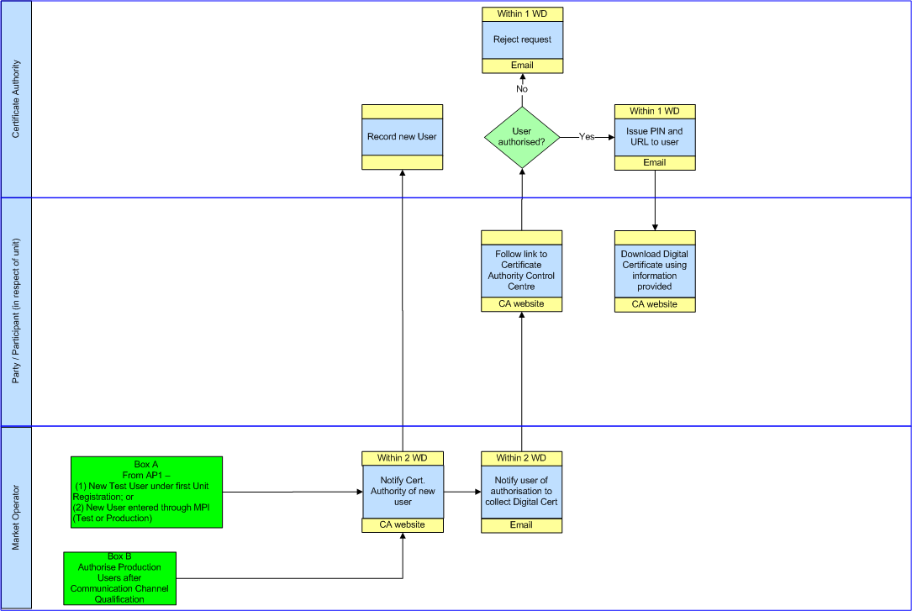

* 1. Communication Channel Qualification

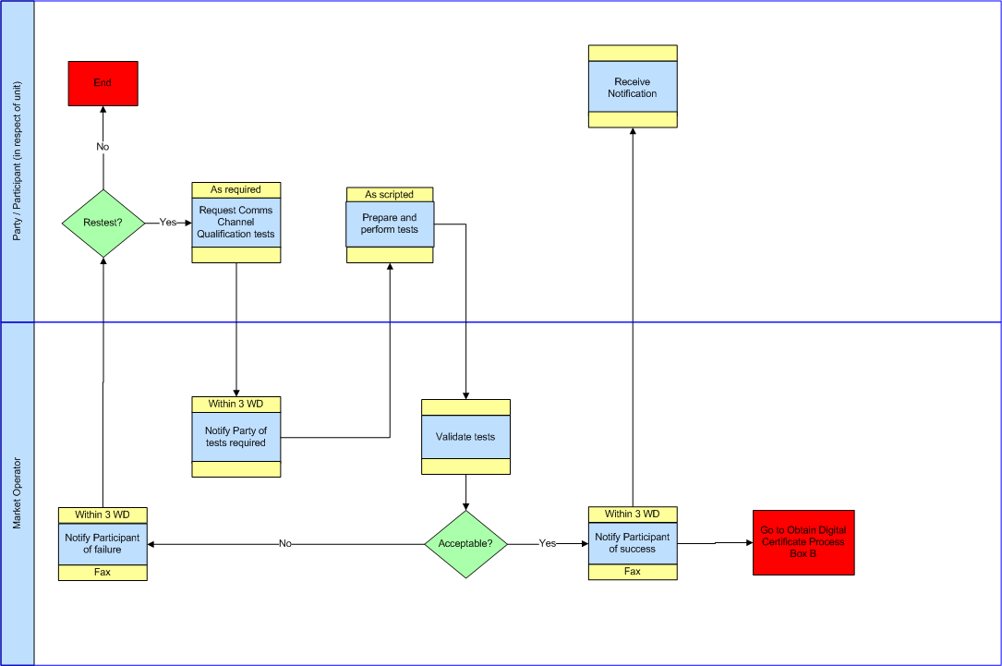

* 1. Digital Certificate Cancellation

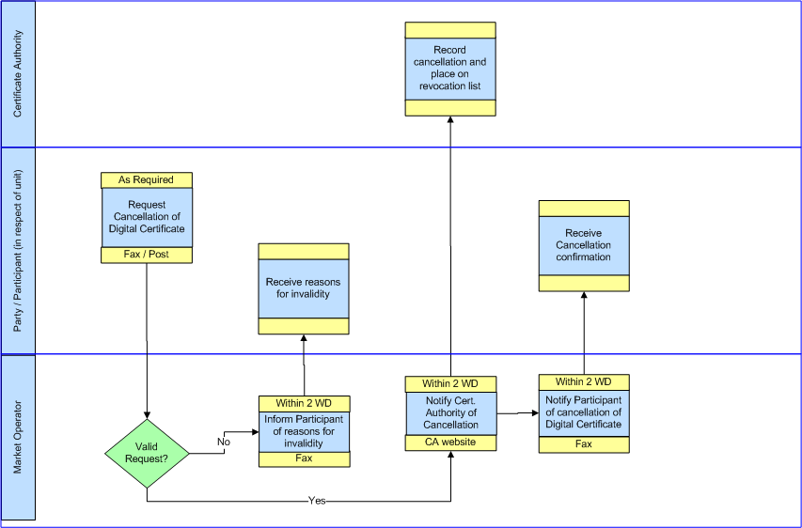

* 1. Communication Channel Suspension

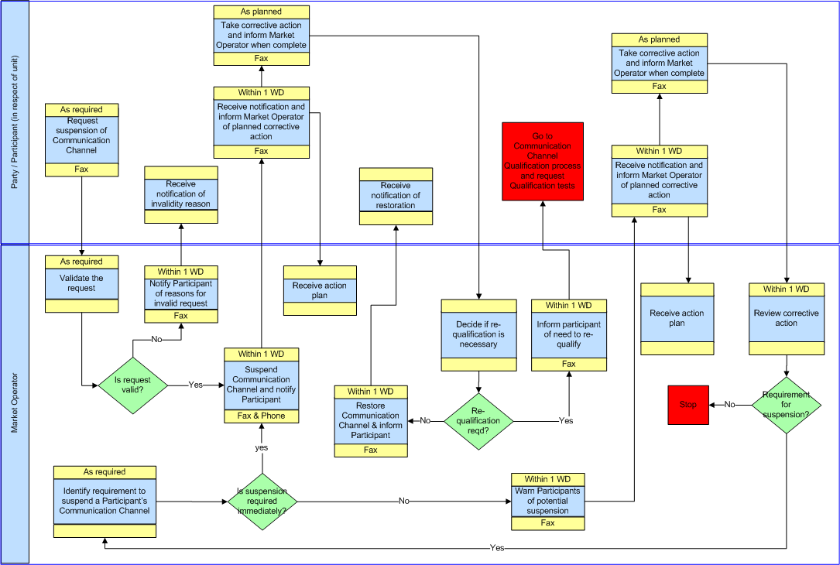

1. Procedural Steps
   1. Obtaining A Digital Certificate

| # | Procedural Step | Timing | Method | By / From | To | Linkage |
| --- | --- | --- | --- | --- | --- | --- |
| 1 | Start:  From either  Digital Certificate request from Unit Registration application from Agreed Procedure 1 "Participant and Unit Registration and Deregistration “; or  Enter new User via MPI and request Digital Certificate for the new User in Agreed Procedure 1 "Participant and Unit Registration and Deregistration”; or  Successful completion of Communication Channel Qualification and setting up of authorising Digital Certificates for Users requested during Registration in Agreed Procedure 1 "Participant and Unit Registration and Deregistration” | As required |  | Market Operator |  |  |
| 2 | Inform the Certificate Authority that the Participant User has been authorised to receive a Digital Certificate | Within 2 Working Days | Certificate Authority’s website | Market Operator | Certificate Authority |  |
| 3 | Inform the Participant User indicating authorisation to collect a Digital Certificate and provide link to the Certificate Authority’s enrolment webpage | Within 2 Working Days | Fax | Market Operator | Participant |  |
| 4 | Access Certificate Authority’s enrolment webpage and enter required information | As required | Certificate Authority’s website | Participant |  |  |
| 5 | Check that the Participant User is authorised and issue PIN and URL | Within 1 Working Day | Email | Certificate Authority | Participant |  |
| 6 | Download and install Digital Certificate using URL and PIN | As required | Certificate Authority’s website | Participant |  |  |

* 1. Communication Channel Qualification

| # | Procedural Step | Timing | Method | By / From | To | Linkage |
| --- | --- | --- | --- | --- | --- | --- |
| 1 | Request Communication Channel Testing.  (Note Participant will need to obtain a Digital Certificate for the Participant Certification Environment using Obtaining a Digital Certificate process (section 4.1 in this Agreed Procedure) to perform testing) | As required | Fax / Post | Participant | Market Operator |  |
| 2 | Notify Participant of tests required and fixed scripted schedule of test | Within 3 Working Days | Fax | Market Operator | Participant |  |
| 3 | Prepare tests, connect to Participant Certification Environment and execute tests | Under fixed script in Step 2 | Participant Certification Environment Website | Participant |  |  |
| 4 | Validate tests.  If acceptable go to step 7, otherwise go to step 5 | Under fixed script in Step 2 | - | Market Operator |  |  |
| 5 | Inform Participant of failed tests. | Within 3 Working Days | Fax | Market Operator | Participant |  |
| 6 | If Participant requires retest (after correction of Participant’s systems complete) go to step 1  Otherwise Stop | As required | - | Participant |  |  |
| 7 | Inform of successful tests and set Communication Channel Qualification flag | Within 3 Working Days | Fax | Market Operator | Participant |  |
| 8 | Go to process in section 4.1 in this AP to authorise obtain a Digital Certificate in the Production Environment | Within 3 Working Days | Fax | Market Operator | Participant |  |

* 1. Digital Certificate Cancellation

| # | Procedural Step | Timing | Method | By / From | To | Linkage |
| --- | --- | --- | --- | --- | --- | --- |
| 1 | Request Cancellation of Digital Certificate. | As required | Fax / Post | Participant | Market Operator |  |
| 2 | Validate the request has all the required information and is from an appropriately Authorised Person (see Agreed Procedure 11 "Market System Operation, Testing, Upgrading and Support")  If valid go to step 4  If invalid go to step 3 | Within 2 Working Days | - | Market Operator |  |  |
| 3 | Inform Participant of reasons for invalidity then process stops. | Within 2 Working Days | Fax | Market Operator |  |  |
| 4 | Notify Certificate Authority of Digital Certificate cancellation | Within 2 Working Days | CA Website | Market Operator |  |  |
| 5 | Place Digital Certificate on revocation list | - | CA Website | Certificate Authority |  |  |
| 6 | Notify Participant of cancellation of Digital certificate | Within 2 Working Days | Fax | Participant |  |  |

* 1. Communication Channel Suspension

| # | Procedural Step | Timing | Method | By / From | To | Linkage |
| --- | --- | --- | --- | --- | --- | --- |
| 1 | Start:  Either  Participant request suspension of Communication Channel , go to step 2  Market Operator identifies requirement to suspend a Participants Communication Channel, go to step 4 | As required  As required | Fax / Post | Participant  Market Operator | Market Operator |  |
| 2 | Validate the suspension request has all the required information and is from an appropriately Authorised Person (see Agreed Procedure 11 "Market System Operation, Testing, Upgrading and Support")  If valid go to step 5  If invalid go to step 3 | - | - | Market Operator |  |  |
| 3 | Inform Participant of reasons for invalidity then process stops. | Within 1 WD | Fax | Market Operator | Participant |  |
| 4 | If suspension is required immediately got to step 5  Otherwise go to step 12 | - |  | Market Operator |  |  |
| 5 | Suspend Communication Channel and inform Participant | Within 1 WD | Fax & Phone | Market Operator | Participant |  |
| 6 | Notify Market Operator of planned corrective action | Within 1 WD | Fax | Participant | Market Operator |  |
| 7 | Notify Market Operator when planned corrective action completed | As planned in step 6 | Fax | Participant | Market Operator |  |
| 8 | Decide if Participant is required to undergo Communication Channel Qualification  If no re-qualification is necessary go to step 9  If qualification is required go to step 10 | - |  | Market Operator |  |  |
| 9 | Restore Communication Channel and inform Participant.  Process stops | Within 1 WD | Fax | Market Operator | Participant |  |
| 10 | Inform Participant of the need to re-qualify | Within 1 WD | Fax | Market Operator | Participant |  |
| 11 | Go to start of Communication Channel Qualification process in this AP. | - |  | Participant |  |  |
| 12 | Inform Participants of potential channel suspension and request Participant to take corrective action | Within 1 WD | Fax | Market Operator | Participant |  |
| 13 | Notify Market Operator of planned corrective action | Within 1 WD | Fax | Participant | Market Operator |  |
| 14 | Notify Market Operator when planned corrective action completed | As planned in step 13 | Fax | Participant | Market Operator |  |
| 15 | Decide if Participant corrective action is sufficient to prevent suspension  If corrective action sufficient then process stops  If corrective action is insufficient then go to step 4 | - |  | Market Operator |  |  |

1. Definitions and Abbreviations

Definitions

|  |  |
| --- | --- |
| **Certificate Authority** | As defined in Agreed Procedure 5 "Data Storage and IT Security" |
| **Code** | As defined in the Code |
| **Communication Channel** | As defined in the Code |
| **Communication Channel Qualification** | As defined in the Code |
| **Digital Certificate** | As defined in Agreed Procedure 5 "Data Storage and IT Security" |
| **Dispute** | As defined in the Code |
| **Functional Area** | As defined in Agreed Procedure 1 "Participant and Unit Registration and Deregistration" |
| **Help Desk** | As defined in Agreed Procedure 11 "Market System Operation, Testing, Upgrading and Support" |
| **Isolated Market System** | As defined in the Code |
| **Market Operator** | As defined in the Code |
| **Participant** | As defined in the Code |
| **Participant Certification Environment** | This is a test environment which allows the Participant to test their ability to interact with Market Operator Isolated Market System functionality. |
| **Party** | As defined in the Code |
| **Production Environment** | The live version of the Market Operator’s Isolated Market System |
| **Regulatory Authorities** | As defined in the Code |
| **Settlement** | As defined in the Code |
| **Single Electricity Market** | As defined in the Code |
| **Test Environment** | As defined in Agreed Procedure 11 “Market System Operation, Testing, Upgrading and Support” |
| **Type 1 Channel** | As defined in the Code |
| **Type 2 Channel** | As defined in the Code |
| **Type 3 Channel** | As defined in the Code |
| **Unit** | As defined in the Code |
| **User** | As defined in Agreed Procedure 4 “Transaction Submission and Validation” |
| **Web Services** | As defined in Agreed Procedure 4 “Transaction Submission and Validation” |

Abbreviations

|  |  |
| --- | --- |
| **CA** | Certificate Authority |
| **SEM** | Single Electricity Market |
| **WD** | Working Day |