

The Single Electricity Market (SEM)

Part A Agreed Procedure 15  
Invoicing

Version 28.0

18 August 2023SEM Part A Agreed Procedure

|  |  |
| --- | --- |
| Title | Part A Agreed Procedure 15: Invoicing |
| Version | 28.0 |
| Date | 18 August 2023 |

Table of Contents

1. Introduction 6

1.1 Background & Purpose 6

1.2 Scope of Agreed Procedure 6

1.3 Definitions 6

1.4 Compliance with Agreed Procedure 6

2. Descriptive Overview 7

2.1 General Description 7

2.2 Settlement Statement Components 11

2.3 Participant Invoice Components 12

2.4 Data Query / Settlement Query 14

2.5 Settlement Disputes 14

3. Procedure Definition 15

3.1 Invoicing for Initial Settlement Statements 15

3.2 Invoicing for Settlement Rerun Statements 15

3.3 Payment Default 15

3.4 Procedural Steps 18

3.5 Swimlanes 27

APPENDIX 1: Definitions and Abbreviations 32

APPENDIX 2: Currency Cost 35

Document History

|  |  |  |  |
| --- | --- | --- | --- |
| Version | Date | Author | Comment |
| 2.0 | 03/10/2006 | SEM Implementation Team | Release to Regulatory Authorities |
| 3.0 | 21/05/2007 | Regulatory Authorities | Consultation Version |
| 3.2 | 25/06/2007 | Regulatory Authorities | Approved for Go-Active by Regulatory Authorities and TSO/SEM Programme |
| 4.0 | 20/11/2007 | Modification Committee Secretariat | Included RA Approved Mod_71_07 including swimlane change |
| 4.1 | 24/09/2008 | Modification Committee Secretariat | Mod_36_08 Incorrect Title  Mod_30_08 SEMO Branding |
| 5.0 | 19/03/2009 | Modification Committee Secretariat | Mod_66_07_V2 VAT |
| 5.0 | 07/04/2009 | SEMO | SEMO Design Baseline Documentation at V5.0 |
| 5.1 | 14/05/2009 | SEMO | Mod_11_09 Removal of ambiguity in various clauses of Agreed Procedures 10, 13 and 15 |
| 6.0 | 30/10/2009 | SEMO | SEMO Design Baseline Documentation at V6.0 |
| 6.0 | 18/08/2009 | SEMO | Mod_28_09 Clarification on Settlement Statement – Full Settlement Period Republished |
| 7.0 | 28/05/2010 | SEMO | SEMO Design Baseline Documentation at V7.0 |
| 8.0 | 19/11/2010 | SEMO | SEMO Design Baseline Documentation at V8.0 |
| 8.0 | 18/06/2010 | SEMO | Mod_20_10 Setting a De Minimus Level on Letter of Credit Drawdown |
| 8.0 | 17/08/2010 | SEMO | Mod_25_10 Payment Period Currency Costs |
| 9.0 | 06/05/2011 | SEMO | SEMO Design Baseline Documentation at V9.0 |
| 10.0 | 21/10/2011 | SEMO | SEMO Design Baseline Documentation at V10.0 |
| 11.0 | 21/07/2012 | SEMO | SEMO Design Baseline Documentation at V11.0 |
| 12.0 | 16/11/2012 | SEMO | SEMO Design Baseline Documentation at V12.0 |
| 13.0 | 10/05/2013 | SEMO | SEMO Design Baseline Documentation at V13.0 |
| 14.0 | 15/11/2013 | SEMO | SEMO Design Baseline Documentation at V14.0 |
| 15.0 | 16/05/2014 | SEMO | SEMO Design Baseline Documentation at V15.0 |
| 16.0 | 14/11/2014 | SEMO | Baseline of SEMO documentation V16.0 |
| 17.0 | 15/05/2015 | SEMO | Baseline of SEMO documentation V17.0 |
| 18.0 | 02/10/2015 | SEMO | Baseline of SEMO documentation V18.0 |
| 19.0 | 17/05/2017 | SEMO | Baseline of SEMO documentation V19.0 |
| 20.0 | 23/05/2017 | SEMO | SEMO Design Baseline Documentation at V20.0 |
| 20.0 | 23/05/2017 | SEMO | Mod_01_17 Changes to enable I-SEM (Part A) |
| 21.0 | 12/04/2019 | SEMO | SEMO Design Baseline Documentation at V21.0 |
| 21.0 | 12/04/2019 | SEMO | Mod_02_17 Unsecured Bad Energy Debt and Unsecured Bad Capacity Debt Timelines |
| 22.0 | 29/04/2020 | SEMO | SEMO Design Baseline Documentation at V22.0 |
| 23.0 | 03/11/2020 | SEMO | SEMO Design Baseline Documentation at V23.0 |
| 24.0 | 01/07/2021 | SEMO | SEMO Design Baseline Documentation at V24.0 |
| 25.0 | 09/11/2021 | SEMO | SEMO Design Baseline Documentation at V25.0 |
| 26.0 | 17/05/2022 | SEMO | SEMO Design Baseline Documentation at V26.0 |
| 27.0 | 07/12/2022 | SEMO | SEMO Design Baseline Documentation at V27.0 |
| 28.0 | 18/08/2023 | SEMO | SEMO Design Baseline Documentation at V28.0 |

**RELATED DOCUMENTS**

|  |  |  |  |
| --- | --- | --- | --- |
| Document Title | Version | Date | By |
| Trading and Settlement Code | V28.0 | 18/08/2023 | SEMO |
| **Agreed Procedure 1 "Participant and Unit Registration and Deregistration"** |  |  |  |
| **Agreed Procedure 9 “Management of Credit Cover and Credit Default”** |  |  |  |
| Agreed Procedure 10 “Settlement Reallocation” |  |  |  |
| Agreed Procedure 13, “Query Generation” |  |  |  |
| Agreed Procedure 14 “Dispute Process” |  |  |  |

1. Introduction
   1. Background & Purpose

This Agreed Procedure describes the specific procedures for the invoicing of the payments and charges in the Single Electricity Market administered by the Market Operator (MO), and with which Parties to the Trading and Settlement Code (the “Code”) must comply.

* 1. Scope of Agreed Procedure

This Agreed Procedure is a definition of procedural steps to be followed by the MO and Participants. It forms an annexe to, and is governed by, the Code. This document is a statement of process and procedure. Parties’ rights and obligations are set out in the Code.

* 1. Definitions

Save as expressly defined, words and expressions defined in the Code shall have the same meanings when used in this Agreed Procedure.

References to particular sections relate internally to this Agreed Procedure unless specifically noted.

* 1. Compliance with Agreed Procedure

Compliance with this Agreed Procedure is required under the terms as set out in the Code.

1. Descriptive Overview
   1. General Description
      1. Introduction

This Agreed Procedure describes the process for calculating and issuing Settlement Statements, Self Billing Invoices, Debit Notes and Invoices for the payments and charges of the SEM. The general rules for Settlement and Invoicing calculations are defined in the Code.

The invoicing process starts with the calculation of Settlement amounts in respect of given timetables and given calculation rules and ends with the financial settlement of the market. The regular and automatic invoicing tasks of the SEM are detailed in section 3.1. The invoicing tasks for Resettlements are detailed in section 3.2. Section 3.3 details the invoicing procedure associated with payment default.

Invoices and Self Billing Invoices will be created for each active Participant that operates in the Single Electricity Market in respect of its Generator Units and/or Supplier Units. The Invoice and Self Billing Invoice presents a line by line summary of amounts by charge or payment type. The Invoice and Self Billing Invoice is issued in the Participant’s currency and includes the applicable VAT and Settlement Reallocation amounts.

Each Invoice and Self Billing Invoice will span different periods dependent on the type of charge / payment.

* For Trading Payments and Trading Charges, the Billing Period will be one week – starting on a Sunday at 00:00 and ending on the next Saturday at 24:00.
* For Capacity Payments and Capacity Charges, the Capacity Period will be a calendar month, starting at 00:00 on the first day of the month, and ending at 24:00 on the last day of the month.
* For Fixed Market Operator Charges, the period will be a calendar month, starting at 00:00 on the first day of the month, and ending at 24:00 on the last day of the month.
* For Variable Market Operator Charges, the period will be a Billing Period

The invoicing process is initiated on the completion of an Initial Settlement Statement for the last Settlement Day of the Settlement Period.

* + 1. Categories of Settlement

In this Agreed Procedure where reference is made to Settlement Statements this includes the financial settlement statements and Participation Information Reports as detailed in Appendix F of the Code. Each Settlement Statement contains details per Trading Period by Generator Unit or Supplier Unit and amounts to be paid by or to Participants.

There are three categories of Settlement Statements:

**Ex-Post Indicative Settlement Statement** – The Ex-Post Indicative Settlement Statement is not used for payment purposes. For Trading Payments / Trading Charges the Ex-Post Indicative Settlement Statement is issued by 17:00 one Working Day after the end of each Settlement Day. For Capacity Payments / Capacity Charges the Ex-Post Indicative Settlement Statement for each Settlement Day in the Capacity Period is issued by 17:00 three Working Days after the end of the Capacity Period.

**Initial Settlement Statement** – The calculated Settlement amounts in the Initial Statements will be used in the Invoice / Self Billing Invoice in respect of the Initial Settlement Statements for the Settlement Period. For Trading Payments / Trading Charges the Initial Settlement Statement is issued by 12:00 five Working Days after the end of each Settlement Day. For Capacity Payments / Capacity Charges the Initial Settlement Statement for each Settlement Day in the Capacity Period is issued by 12:00 seven Working Days after the end of the Capacity Period.

**Settlement Rerun Statement**– Timetabled Settlement Reruns are completed within the fourth and thirteenth month after the invoice in respect of the Initial Settlement Statements of a Billing Period or Capacity Period. The Capacity Period or Billing Period is defined with reference to the last day of that Settlement Period. Invoices and Self Billing Invoices from Settlement Rerun Statements are issued to all Participants for all applicable charges and payments. The Timetabled Settlement Rerun shall be based on the data then available to the Market Operator at the time of its production. This will include any change based on a resolved Data Query, Settlement Query or Settlement Dispute to be judged to be of Low Materiality.

An ad-hoc Settlement Rerun will be run if;

* a Data Query, Settlement Query or Settlement Dispute is upheld and the value of change to Settlement items is judged to be of High Materiality, or
* if the matter is resolved after the final Timetabled Settlement Rerun.

**2.1.2.1 Republishing of Settlement Statements**

When republishing of Initial Settlement Statements, timetabled Settlement Reruns, or ad-hoc Settlement Reruns is required, all days in the relevant Settlement Period will be published to the same version number for the same Settlement Run. This alignment of version numbers will occur even if only a subset of the days in the Settlement Period have changed.

Participant Information Reports do not contain versioning and will be overwritten for the entire Settlement Period where the republishing of Initial Settlement, timetabled Settlement Reruns of ad-hoc Settlement Reruns is required.

Note: Currency Cost Statements may not be the same version number as the associated Settlement Statements due to the possibility of republishing Settlement Statements before Invoicing occurs for a given Settlement Period.

* + 1. Invoices

Five Working Days after the completion of the Billing Period or seven Working Days after the completion of the Capacity Period, the Initial Settlement Statement amounts are aggregated to calculate the Invoices and Self Billing Invoices from the Initial Settlement Statement for that Settlement Period. These Invoices and Self Billing Invoices are issued to Participants by post and are available for viewing and download via the Market Participant Interface.

A Participant is entitled to lodge a Data Query with the MO in relation to the Ex-Post Indicative Settlement Statement. If the Data Query is unresolved in the Initial Settlement Statement, this does not alter the obligation to make full payment on the Invoice or Self Billing Invoice.

The timeline for the Market Operator Charge Invoice is set out in the Settlement Calendar and these Invoices will be due 7 days after it is issued.

* + - 1. Types of Invoices

Although it is more usual for the supplier of goods or services to issue an invoice to the purchaser of the goods or services, it is also possible, for the purchaser to self bill the supplier. Instead of an invoice this document is referred to as a “Self Billing Invoice”.

The MO will generate and issue Invoices to Participants in respect of their Supplier Units for the purchases by these Units from the SEM. The MO will generate and issue a Self Billing Invoice to Participants in respect of their Generator Units for the amounts of electricity generated by these Units.

The MO will issue Invoices, Self Billing Invoices or Debit Notes to Participants in respect of the following types of charges and payments:

* Trading – This includes Energy Payments, Constraint Payments, Uninstructed Imbalance Payments and Make Whole Payments as well as Energy Charges, Imperfection Charges and Testing Charges. This invoice will be issued to relevant Participants for each Billing Period. A Participant will receive separate invoices for its Supplier Units and Generator Units.
* Capacity – This includes Capacity Payments and recovery of Capacity Charges. This invoice will be issued to relevant Participants for each Capacity Period. A Participant will receive separate invoices for its Supplier Units and Generator Units.
* Market Operator Charges – This includes charges to recover MO operating costs. There will be a weekly Invoice for the Variable Market Operator Charge for each Billing Period. The Charges on this Invoice will be calculated at a rate per MWh and will be invoiced to Participants in respect of their Supplier Units. The Fixed Market Operator Charge will be a monthly Charge to all Participants based on the annual Charge set out for each Generator Unit and Supplier Unit. The Fixed Market Operator Charge will be included in the first weekly Invoice for the Variable Market Operator issued for the first Billing Period of each calendar month.
* Debit Note – This includes the Charges for Unsecured Bad Energy Debt and the Charge for Unsecured Bad Capacity Debt. Debit Notes will be issued on an ad hoc basis, only in the event of an Unsecured Bad Energy Debt or Unsecured Bad Capacity Debt. These charges are levied on each Participant in respect of their Generator Units based on their respective proportionate entitlement as stated in the Code.
* Self Billing Invoice for Unsecured Bad Debt – This includes payments as a consequence of recovering any Unsecured Bad Energy Debt or Unsecured Bad Capacity Debt. This Invoice will be issued on an ad hoc basis, only in the event recovery of Unsecured Bad Debt. These payments are credited to each Participant in respect of their Generator Units.

All Invoices and Self Billing Invoices will include an amount in respect of the Currency Cost incurred by the MO in settling the dual currency market with the exception of Debit Notes, Self Billing Invoices for Unsecured Bad Debt and Market Operator Charges.

* + 1. Timings

The MO will publish a Settlement Calendar each year, four months before the beginning of the year. This is an annual calendar which contains the actual dates for Ex-Post Indicative Settlement Statements and Initial Settlement Statements for all types of Settlement Statements; Self Billing Invoices and Invoices including Invoice Due Dates and Self Billing Invoice Due Dates as well as the dates for the Timetabled Settlement Reruns.

For a Billing Period, the timing of the Ex-Post Indicative Settlement Statement, Initial Settlement Statement and the Invoices and Self Billing Invoices in respect of the Initial Settlement Statements are shown below in for example purposes.

Diagram 1



* + 1. Interest

Interest is applicable in the following circumstances:

* + - 1. Settlement Rerun

#### Interest is applicable whenever the Settlement Rerun increases or decreases the total amount payable for a Billing Period or Capacity Period. Interest in this case shall be charged at LIBOR plus 1%.

* + - 1. Shortfall and Unsecured Bad Debt

Interest is applicable on any Shortfall or Unsecured Bad Debt amount from the time the payment is due at the Default Interest rate (as defined in the Code).

* + - 1. Other Overdue Payments under the Code including Market Operator Charges

Interest is applicable as per the Code at the Default Interest rate

* + - 1. Over and Under Payments

Interest shall be paid in accordance with the Code.

Intentionally Blank.

* + 1. Currency Cost

The MO manages the Currency Cost for the Participants.

Currency Costs as incurred will include the following.

* Invoice Period Currency Cost which represents the costs or benefits incurred managing the change in exchange rates between each Trading Day and the exchange rate in force on the date of issue of the Invoices;
* Payment Period Currency Cost which represents the costs or benefits incurred managing the change in exchange rates between the date of issue of the Invoices and the dates on which the invoices are finally settled;

The Currency Cost for a given Settlement Period is the sum of the Invoice Period Currency Cost and the Payment Period Currency Cost. The distinction between the two components of the invoicing cycle is outlined in Appendix 2 – Currency Cost.

This Agreed Procedure sets out the calculation of the Billing Period Currency Cost and Capacity Period Currency Cost as well as the method for distributing this cost amongst the Participants.

The MO will prepare a statement of the Currency Cost for each Billing Period and Capacity Period. The statement will be published on the MO Website.

* 1. Settlement Statement Components

Settlement Statements and Participant Information Reports contain both the input data and the calculated Settlement data by Trading Period and by Generator Unit or Supplier Unit.

Trading Payments Settlement Statement contains;

* Metered Generation, Actual Availability, Market Schedule Quantities, Dispatch Quantity, System Marginal Prices.
* Energy Payments, Constraint Payments, Uninstructed Imbalance Payments, Make Whole Payments, Testing Charges.

Trading Charges Settlement Statement contains;

* Metered Demand, Net Demand, System Marginal Prices.
* Energy Charges, Imperfections Charges.

Capacity Payments Settlement Statement contains;

* Eligible Availability
* Capacity Payments

Capacity Charges Settlement Statement contains;

* Net Demand
* Capacity Charges

Market Operator Charge Settlement Statement contains;

* Fixed Market Operator Charges (as applicable)
* Variable Market Operator Charges

Both Ex-Post Indicative Settlement Statements and Initial Settlement Statements in respect of Trading Payments and Trading Charges are prepared and published daily on a Working Day basis. Each daily Settlement Statement in respect of Trading Payments and Trading Charges will contain the components detailed above with the exception of Make Whole Payments which are calculated on a Billing Period basis. As such, Make Whole Payments are only calculated and published with the Settlement Statements for the last Settlement Day of the Billing Period. For the avoidance of doubt, the Make Whole Payments will appear on both the Ex-Post Indicative Settlement Statement and Initial Settlement Statements for the last Settlement Day of the Billing Period.

Settlement Statements for Capacity Charges and Capacity Payments will be prepared at the end of the Capacity Period for each Settlement Day within that period. For the avoidance of doubt there will be a Settlement Statement for each Settlement Day within the Capacity Period.

* 1. Participant Invoice Components

With respect to the Energy Invoice, Capacity Invoice and Market Operator Charge Invoice, each Invoice is composed of an Invoice Header and Invoice Body sections

A sample Invoice for Trading Payments showing the components of the Invoice is shown in .

Diagram 2

|  |  |  |  |  |
| --- | --- | --- | --- | --- |
| Invoice Header | | | | |
| Semo Logo SMALL | |  | From : |  |
|  | Company Name  Company Address | |
|  |  |  |
|  |  |  |
|  | Invoice Desc - Self Billing Invoice |  |  |  |
|  |  |  | Account Number |  |
|  | To: SMO |  |  |  |
|  | SMO Address Details |  |  |  |
|  |  |  |  |  |
|  |  | Date of Issue | |  |
|  | Invoice # | Due Date |  |  |
|  | Settlement Type - Initial | Billing Period | |  |
|  | Invoice Type - Energy | | |  |
|  |  |  |  |  |
|  |  |  |  |  |
| Invoice Body | | | | |
| **Charge_ID** | **Charge_Type** | **Net Amt** | **VAT** | **Gross Amt** |
|  | Energy Payments |  |  |  |
|  | Constraint Payments |  |  |  |
|  | Uninstructed Imbalance Payments |  |  |  |
|  | Make Whole Payments |  |  |  |
|  | Testing Charges |  |  |  |
|  | Currency Cost |  |  |  |
|  | Total Invoice |  |  |  |
|  | Currency Cost Adjustment (Reallocations) |  |  |  |
|  | Grand Total Amount |  |  |  |
|  | Settlement Reallocation(s) |  |  |  |
|  | Amount Due |  |  |  |

* + 1. Invoice Header

The Invoice Header will contain the following components –

* Invoice description – indicating if it is an Invoice or a Self Billing Invoice;
* Address of the issuing company – this will be the MO in the case of an Invoice and the Participant in the case of a Self Billing Invoice;
* Address of the receiving company – this will be the Participant in the case of an Invoice and the MO in the case of a Self Billing Invoice;
* Invoice number;
* Date of Issue of the invoice;
* Payment Due Date;
* Settlement Type – indicating if this invoice relates to Initial Settlement Statements or a Settlement Rerun Statements;
* Billing Period or Capacity Period – indicating the duration to which the invoice relates;
* Invoice Type - indicating if it is an invoice for Energy Invoice, Capacity Invoice, Market Operator Charges Invoice etc.
* VAT registration numbers. This is the VAT number of the issuer of the Invoice. This will only appear on the Market Operator Charge Invoice. A VAT number will not appear on Invoices or Self Billing Invoices.
  + 1. Invoice Body Components

The Invoice Body will contain the following components.

* + - 1. Charges and Payments

The Invoice and Self Billing Invoice will contain an aggregation across the Billing Period or Capacity Period of calculated Settlement Statement amounts. The charges and payments included in the invoice will vary depending on the type of invoice;

* Trading
  + Energy Payment / Energy Charge
  + Constraint Payment
  + Uninstructed Imbalance Payment
  + Make Whole Payment
  + Imperfections Charge
  + Testing Charges
* Capacity
  + Capacity Payment / Capacity Charge
* Market Operator Charges
  + Variable Market Operator Charge
  + Fixed Market Operator Charge
    - 1. Currency Cost

The Participant’s share of Currency Cost is incorporated in the Invoice and Self Billing Invoice as a separate line item. The Currency Cost is a gain or a loss to the market and the invoiced amount will be displayed accordingly as a positive or negative amount.

* + - 1. Interest

Interest is applicable to Invoices and Self Billing Invoices in respect of all types of Settlement Rerun invoices. Interest is calculated on the difference between the amount in the Invoice or Self Billing Invoice in respect of the Initial Settlement Statements and the amount in the Invoice or Self Billing Invoice in respect of the Settlement Rerun Statements for a Settlement Period.

Interest will also be included in Self Billing Invoices for Unsecured Bad Debt where interest has been recovered from the Defaulting Participant.

* + - 1. Currency Cost Adjustment (Reallocations)

There may be a currency cost caused by any Settlement Reallocation Agreements where the Debited Participant and the Credited Participant are in different Currency Zones. The currency cost of any such Settlement Reallocation is charged among all Participants in the same manner as the apportioning of the Billing Period Currency Cost or Capacity Period Currency Cost as set out in the Code.

* + - 1. VAT

VAT is applied to Participants through the invoicing system according to the VAT Agreement and the charge type. VAT will apply to Trading Payments, Trading Charges, Capacity Payments, Capacity Charges and Market Operator Charges. VAT will not be applied to Interest or Settlement Reallocations amounts.

* + - 1. Settlement Reallocation

When two Participants have entered into a Settlement Reallocation Agreement, one Participant (called the Debited Participant) will effectively transfer an amount in respect of payments due from the MO to another Participant (called Credited Participant).

Settlement Reallocation amounts will be applied to the Invoices and Self Billing Invoices in respect of Initial Settlement Statement and will reduce the amount of payment due to the Debited Participant and amount payable by a Credited Participant.

The process for Settlement Reallocation is described in Agreed Procedure 10 “Settlement Reallocations”.

* + - 1. Amount Due

The sum of all of the Invoice components is the amount due for payment.

## 

* 1. Data Query / Settlement Query

A Participant is entitled to raise a Data Query or a Settlement Query with the MO regarding the items on its Settlement Statements associated with their Generator Units or Supplier Units. If a Data Query is resolved after the calculation of the Initial Settlement Statements, it will then be incorporated in a Settlement Rerun. The timing of the Settlement Rerun will depend on the materiality of the queried item.

Further details of the Data Query and Settlement Query process are provided in Agreed Procedure 13, “Query Generation”.

* 1. Settlement Disputes

A Settlement Dispute can be raised by a Participant that has previously raised a Settlement Query (or Data Query) in relation to the disputed Settlement data. If a Settlement Dispute is upheld, then the amended Settlement data will be included in either the next Timetabled Settlement Rerun or a dedicated Settlement Rerun, depending on the materiality of the Settlement Dispute.

Further details of the Settlement Dispute process are provided in Agreed Procedure 14 “Dispute Process”.

1. Procedure Definition
   1. Invoicing for Initial Settlement Statements

Ex-Post Indicative Settlement Statements will be prepared and issued to the Participant via the Market Participant Interface by 17:00 one Working Day after the end of each Settlement Day or Capacity Period as appropriate.

Initial Settlement Statements will be prepared and issued to the Participant via the Market Participant Interface by 12:00 five Working Days after the end of each Settlement Day or by 12:00 seven Working days after the end of each Capacity Period as appropriate.

Five Working Days after the completion of the Billing Period or Capacity Period, the Initial Settlement Statement amounts are aggregated to calculate the Invoices and Self Billing Invoices from the Initial Settlement Statement for that Settlement Period. These Invoices and Self Billing Invoices are issued to Participants by post and are available for viewing and download via the Market Participant Interface by 12:00 five working days after the end of the Billing Period or by 12:00 seven Working days after the end of each Capacity Period.

Payment is due;

* three Working Days after the Invoice date.
* four Working Days after the Self Billing Invoice date.

Where there is a payment default the process as described in 3.3 shall be followed.

* 1. Invoicing for Settlement Rerun Statements

Timetabled Settlement Rerun Statements and associated Invoices and Self Billing Invoices are calculated and issued by the Market Operator to Participants within the fourth and thirteenth month after the invoice in respect of the Initial Settlement Statement for the Settlement Period. Invoices and Self Billing Invoices from Settlement Rerun Statements are issued to all Participants for all charges and payments.

Settlement Reruns based on resolutions of Settlement Queries or Disputes can be completed at any time.

Settlement Rerun amounts are calculated for each charge and payment type. Presented on the Settlement Rerun Invoice and Self Billing Invoice, for each charge or payment (except for currency costs and interest) are,

* the Settlement Rerun amount,
* the previous Settlement Statement Invoice amount, and
* the change in the Settlement amounts.

Where there is a payment default the process as described in 3.3 shall be followed.

* 1. Payment Default

**Financial Default**

In the event that a Participant fails to fully pay an Invoice by the due date, the MO will draw down on the Posted Credit Cover of the Participant to cover the Shortfall. See Agreed Procedure 9 “Management of Credit Cover and Credit Default” for further details. The Shortfall is the amount that a Participant has failed to pay by the Invoice Due Date. The proceeds of the drawn down Credit Cover will be used to complete the outstanding payments.

The MO will apply interest to any amounts overdue from the time the payment is due.

**De Minimis Level for Letter of Credit Draw Down**

Where

(a) a Participant has not paid an Invoice or Invoices on time in accordance with the Code and

(b) that Participant's Required Credit Cover is satisfied only in the form of a Letter of Credit and not cash collateral, or there is insufficient cash collateral and the amount remaining is then left covered by a Letter of Credit, and

(c) the amount outstanding (or amount not covered by the cash collateral) is less than or equal to €1,000 (one thousand euros) or sterling equivalent, and

(d) there are funds due to the Market Operator in respect of the Balancing Cost sufficient to cover such amount

then,

* the amount will be temporarily funded by the sums due to the Market Operator in respect of the Balancing Cost, and
* the Letter of Credit will not be drawn down.

Provided That:

* The amount will remain outstanding as a Default against the Participant until paid by the Participant.
* The Participant will receive a Default Notice in respect of this Default despite the fact that the Letter of Credit may not have been drawn down.
* In the event the unpaid amount is not paid in full within 2 Working Days of the original due date of the Invoice (or first due Invoice in the case of multiple Invoices), then the Letter of Credit will be drawn down for the outstanding amount;
* If insufficient funds are due to the Market Operator in the Balancing Cost this provision shall not apply and the Letter of Credit will be drawn down as otherwise provided for in the Code.

**Unsecured Bad Debt Charge**

Where an Invoice in respect to Trading Charges or Capacity Charges is not fully paid and the drawn down Credit Cover does not cover the Shortfall by the Self Billing Invoice Due Date, the unpaid amount is referred to as Unsecured Bad Debt. In the event of Unsecured Bad Debt, the MO will be required to reduce the amount that is paid out to the Participant payments so as to balance Settlement for that Settlement Period. The amount of the reduction will be the Unsecured Bad Debt Charge. This charge will be offset against the Self Billing Invoice issued by the MO in respect of that Settlement Period for each Participant in respect of their Generator Units. These Participants are known as the Reduced Participants and the Participant who has incurred the Shortfall and subsequently the Unsecured Bad Debt is known as the Defaulting Participant. The MO will issue a Debit Note to each Reduced Participant by post and fax which will include details of the reduced payment. There will be no electronic version of the Debit Note. The amount included on this Debit Note will represent the amount by which the original Self Billing Invoice will be reduced.

Where the Unsecured Bad Debt is an Unsecured Bad Energy Debt or an Unsecured Bad Capacity Debt, the payments to Participants will be reduced in accordance with the methodology set out in the Code.

**Recovery of Unsecured Bad Debt Charge**

Where Unsecured Bad Debt is later partially or fully recovered from the Defaulting Participant, the Reduced Participants will be paid their share of the recovered Unsecured Bad Debt. The Market Operator shall calculate and produce a Self Billing Invoice to the Reduced Participants in accordance with the methodology set out in the Code. The MO will issue a Self Billing Invoice to each of the Reduced Participants by post and fax. There will be no electronic version of this Self Billing Invoice. The Self Billing Invoice will be paid in line with the Invoices and Self Billing Invoices for the next Billing Period or Capacity Period as appropriate.

**Unpaid Market Operator Charge**

The MO will bear the cost of any unpaid Market Operator Charges and these will be included in the calculation of the Market Operator Charge for subsequent years. For the avoidance of doubt, unpaid Market Operator Charges are not included within Unsecured Bad Debt. The unpaid Market Operator Charges are a debt of the relevant Participant that ranks pari passu with other Shortfall and Unsecured Bad Debt. Variable Market Operator charges will be recovered by the Market Operator from available Credit Cover or, if none is available, as part of the Market Operator Charge in subsequent years

* 1. Procedural Steps
     1. Procedural Steps for Invoices and Self Billing Invoices in respect of Billing Period Initial Settlement Statements

| **#** | **Procedural Step** | **Timing** | **Method** | **From / By** | **To** |
| --- | --- | --- | --- | --- | --- |
| I1.1 | Produce & Issue Ex-Post Indicative Settlement Statements for each Settlement Day. For the last day of the Billing Period, this will include Make Whole Payments. | By 17:00, one Working Day after Settlement Day. | Type 2 Channel / Type 3 Channel | Market Operator | Participant |
| I1.2 | Validate and if required raise Data Queries in accordance with Agreed Procedure 13 “Query Generation”. | By 17:00, four Working Day after Settlement Day. | In accordance with AP13 | Participant |  |
| I1.3 | Produce & Issue Initial Settlement Statements for each Settlement Day. For the last day of the Billing Period, this will include Make Whole Payments. | By 12:00, five Working Days after Settlement Day. | Type 2 Channel / Type 3 Channel | Market Operator | Participant |
| I1.4 | Validate and if required raise Settlement Queries in accordance with Agreed Procedure 13 “Query Generation” | In accordance with Agreed Procedure 13 “Query Generation” | In accordance with AP13 | Participant |  |
| I1.5 | Produce & Issue Invoices and Self-Billing Invoices from:   * the Initial Settlement Statements, * the Invoice Period Currency Cost for this Billing Period * The Payment Period Currency Costs for the previous Billing Period * Validated Settlement Reallocation Agreements. | By 12:00, five Working Days after the end of the Billing Period. | Type 1 Channel / Type 2 Channel / Type 3 Channel | Market Operator | Participant |
| I1.6 | Payment of Participant Invoices. | By 12:00 3 WD after the issue of the Invoices | In accordance with AP17 | Participants | Market Operator |
| I1.7 | Market Operator establishes whether there is any Shortfall. If there is no Shortfall go to step I1.14.  Otherwise go to step I1.8. | By 17:00, 4 WD after the issue of the Self Billing Invoice | - | Market Operator |  |
| I1.8 | Draw down Credit Cover of any Participant with a Shortfall and follow Agreed Procedure 9 “Credit Risk Management” to re-establish Credit Cover if required.  If Credit Cover draw down covers the whole of the Shortfall prior to payment of the Self Billing Invoice go to step I1.14.  Otherwise go to step I1.9. | In sufficient time to meet 17:00 4 WD payment deadline after the issue of the Self Billing Invoice | - | Market Operator |  |
| I1.9 | Calculate and Issue Debit Note for Participants in respect of their Generator Units. | By 00:00 4 WD after the issue of the Self Billing Invoice in the event of Unsecured Bad Debt. | Type 1 Channel | Market Operator | Reduced Participant |
| I1.10 | Instruct payment of the net of the Self Billing Invoice and the Debit Note to each Participant with a Self Billing Invoice. | By 00:00 4 WD after the issue of the Self Billing Invoice in the event of Unsecured Bad Debt. | In accordance with AP17 | Market Operator | Participant |
| I1.11 | Issue a Default Notice to the Participant and if appropriate, initiate steps under Suspension in Agreed Procedure 1 "Participant and Unit Registration and Deregistration". | By 17:00 4 WD after the issue of the Self Billing Invoice | Type 1 Channel | Market Operator | Defaulting Participant |
| I1.12 | Market Operator attempts to recover Unsecured Bad Debt. Whenever Unsecured Bad Debt is recovered Market Operator issues a Self Billing Invoice for Unsecured Bad Debt. | In timescales for the next Self Billing Invoices for a Billing Period after recovery of monies. | Type 1 Channel | Market Operator | Reduced Participant |
| I1.13 | Market Operator pays Self Billing Invoice for Unsecured Bad Debt.  If there is still Unsecured Bad Debt go to step I1.12.  Otherwise end of process. | In timescales for the next Self Billing Invoices for a Billing Period after recovery of monies. | In accordance with AP17 | Market Operator | Reduced Participant |
| I1.14 | Payment of Self Billing Invoices. | By 17:00 4 WD after the issue of the Self Billing Invoice | In accordance with AP17 | Market Operator | Participant |

* + 1. Procedural Steps for Invoices and Self Billing Invoices in respect of Capacity Period Initial Settlement Statements

| **#** | **Procedural Step** | **Timing** | **Method** | **From / By** | **To** |
| --- | --- | --- | --- | --- | --- |
| I2.1 | Produce & Issue Ex-Post Indicative Settlement Statements for the Capacity Period. | By 17:00, three Working Days after Capacity Period | Type 2 Channel / Type 3 Channel | Market Operator | Participant |
| I2.2 | Validate and if required raise Data Queries in accordance with Agreed Procedure 13 “Query Generation”. | By 17:00, four Working Day after Capacity Period | In accordance with AP13 | Participant |  |
| I2.3 | Produce & Issue Initial Settlement Statements for the Capacity Period. | By 12:00, seven Working Days after Capacity Period | Type 2 Channel / Type 3 Channel | Market Operator | Participant |
| I2.4 | Validate and if required raise Settlement Queries in accordance with Agreed Procedure 13 “Query Generation”. | In accordance with Agreed Procedure 13 “Query Generation” | In accordance with AP13 | Participant |  |
| I2.5 | Produce & Issue Invoices and Self-Billing Invoices from:   * the Initial Settlement Statements, * the Invoice Period Currency Cost for this Billing Period * The Payment Period Currency Costs for the previous Billing Period * Validated Settlement Reallocation Agreements. | By 12:00, seven Working Days after the end of the Capacity Period. | Type 1 Channel / Type 2 Channel / Type 3 Channel | Market Operator | Participant |
| I2.6 | Payment of Participant Invoices. | By 12:00 3 WD after the issue of the Invoices | In accordance with AP17 | Participants | Market Operator |
| I2.7 | Market Operator establishes whether there is any Shortfall. If there is no Shortfall go to step I2.14.  Otherwise go to step I2.8. | By 17:00 4 WD after the issue of the Self Billing Invoice | - | Market Operator |  |
| I2.8 | Draw down Credit Cover of any Participant with a Shortfall and follow Agreed Procedure 9 “Credit Risk Management” to re-establish Credit Cover if required.  If Credit Cover draw down covers the whole of the Shortfall prior to payment of the Self Billing Invoice go to step I2.14.  Otherwise go to step I2.9. | In sufficient time to meet 17:00 4 WD payment deadline after the issue of the Self Billing Invoice | - | Market Operator |  |
| I2.9 | Calculate and Issue Debit Note for Participants in respect of Generator Units. | By 00:00 4 WD after the issue of the Self Billing Invoice in the event of Unsecured Bad Debt. | Type 1 Channel | Market Operator | Participant |
| I2.10 | Instruct payment of the net of the Debit Note and Self Billing Invoice to each Participant with a Self Billing Invoice. | By 00:00 4 WD after the issue of the Self Billing Invoice in the event of Unsecured Bad Debt. | In accordance with AP17 | Market Operator | Participant |
| I2.11 | Issue a Default Notice to the Participant and initiate steps under Suspension in Agreed Procedure 1 "Participant and Unit Registration and Deregistration". | By 17:00 4 WD after the issue of the Self Billing Invoice | Type 1 Channel | Market Operator | Defaulting Participant |
| I2.12 | Market Operator attempts to recover Unsecured Bad Debt. Whenever Unsecured Bad Debt is recovered Market Operator issues a Self Billing Invoice for Unsecured Bad Debt. | In timescales for the next Self Billing Invoices for a Capacity Period after recovery of monies. | Type 1 Channel | Market Operator | Reduced Participant |
| I2.13 | Market Operator pays Self Billing Invoice for Unsecured Bad Debt.  If there is still Unsecured Bad Debt go to step I2.12.  Otherwise end of process. | In timescales for the next Self Billing Invoices for a Capacity Period after recovery of monies. | In accordance with AP17 | Market Operator | Reduced Participant |
| I2.14 | Payment of Self Billing Invoices. | By 17:00 4 WD after the issue of the Self Billing Invoice | In accordance with AP17 | Market Operator |  |

* + 1. Procedural Steps for Invoices and Self Billing Invoices in respect of Settlement Rerun Statements

| **#** | **Procedural Step** | **Timing** | **Method** | **From / By** | **To** |
| --- | --- | --- | --- | --- | --- |
| I3.1 | Produce & Issue Settlement Rerun Statements for the whole of the Settlement Period. | In accordance with the published Settlement Calendar | Type 2 Channel / Type 3 Channel | Market Operator | Participant |
| I3.2 | Produce & Issue Invoices and Self-Billing Invoices from:   * the Settlement Rerun Statements, * the latest previous Settlement Statements for the Settlement Period * the Invoice Period Currency Cost for this Settlement Period * The Payment Period Currency Costs for the previous Settlement Period. | In accordance with the published Settlement Calendar | Type 1 Channel / Type 2 Channel / Type 3 Channel | Market Operator | Participant |
| I3.3 | Validate and if required raise Settlement Queries in accordance with Agreed Procedure 13 “Query Generation”. | In accordance with Agreed Procedure 13 “Query Generation” | In accordance with AP13 | Participant |  |
| I3.4 | Payment of Participant Invoices. | By 12:00 3 WD after the issue of the Invoices | In accordance with AP17 | Participants | Market Operator |
| I3.5 | Market Operator establishes whether there is any Shortfall. If there is no Shortfall go to step I3.12.  Otherwise go to step I3.6. | By 17:00 4 WD after the issue of the Self Billing Invoice | In accordance with AP13 | Market Operator |  |
| I3.6 | Draw down Credit Cover of any Participant with a Shortfall and follow Agreed Procedure 9 “Credit Risk Management” to re-establish Credit Cover if required.  If Credit Cover draw down covers the whole of the Shortfall prior to payment of the Self Billing Invoice go to step I3.12.  Otherwise go to step I3.7. | By 17:00 4 WD after the issue of the Self Billing Invoice | - | Market Operator |  |
| I3.7 | Calculate and Issue Debit Note for Participants in respect of Generator Units. | By 00:00 4 WD after the issue of the Self Billing Invoice in the event of Unsecured Bad Debt. | Type 1 Channel | Market Operator | Reduced Participant |
| I3.8 | Instruct payment of the net of the Debit Note and Self Billing Invoice to each Participant with a Self Billing Invoice. | By 00:00 4 WD after the issue of the Self Billing Invoice in the event of Unsecured Bad Debt. | In accordance with AP17 | Market Operator | Participant |
| I3.9 | Issue a Default Notice to the Participant and if appropriate, initiate steps under Suspension in Agreed Procedure 1 "Participant and Unit Registration and Deregistration". | By 17:00 4 WD after the issue of the Self Billing Invoice | Type 1 Channel | Market Operator | Defaulting Participant |
| I3.10 | Market Operator attempts to recover Unsecured Bad Debt. Whenever Unsecured Bad Debt is recovered Market Operator issues a Self Billing Invoice for Unsecured Bad Debt. | In timescales for the next Self Billing Invoices for the next Billing Period/ Capacity Period after recovery of monies. | Type 1 Channel | Market Operator | Reduced Participant |
| I3.11 | Market Operator pays Self Billing Invoice for Unsecured Bad Debt.  If there is still Unsecured Bad Debt go to step I3.10.  Otherwise end of process. | In timescales for the next Self Billing Invoices for the next Billing Period/ Capacity Period after recovery of monies. | In accordance with AP17 | Market Operator | Reduced Participant |
| I3.12 | Payment of Self Billing Invoices. | By 17:00 4 WD after the issue of the Self Billing Invoice | In accordance with AP17 | Market Operator |  |

* + 1. Procedural Steps Invoices for Market Operator Charges (in respect of both initial and Settlement Reruns)

| **#** | **Procedural Step** | **Timing** | **Method** | **From / By** | **To** |
| --- | --- | --- | --- | --- | --- |
| I4.1 | Produce & Issue Settlement Statements for Market Operator Charges | In accordance with the published Settlement Calendar for Billing Period Initial Settlement Statements and Billing Period Settlement Reruns | Type 2 Channel / Type 3 Channel | Market Operator | Participant |
| I4.2 | Produce & Issue Invoices for Market Operator Charges. | In accordance with the published Settlement Calendar for Invoices for Trading Payments | Type 1 Channel /Type 2 Channel / Type 3 Channel | Market Operator | Participant |
| I4.3 | Payment of Participant Invoices. | Within 7 days after the issue of the Invoices | In accordance with AP17 | Participants | Market Operator |
| I4.4 | Market Operator establishes whether there is any Shortfall due to Variable Market Operator Charges. If there is no Shortfall due to Variable Market Operator Charges end of process.  Otherwise go to step I4.5. | Within 7 days after the issue of the Invoice | - | Market Operator |  |
| I4.5 | Draw down Credit Cover of any Participant with a Shortfall due to Variable Market Operator Charges and follow Agreed Procedure 9 “Credit Risk Management” to re-establish Credit Cover if required.  If Credit Cover draw down covers the whole of the Shortfall due to Variable Market Operator Charges end of process.  Otherwise go to step I4.6. | After 7 days after the issue of the Invoice | - | Market Operator |  |
| I4.6 | Market Operator attempts to recover Unsecured Bad Debt. | As occurs | - | Market Operator |  |

* 1. Swimlanes

These swimlanes are provided as an illustration of the Procedural Steps. The Procedural Steps take precedence, in the event of conflict between the swimlanes and the Procedural Steps.

* + 1. Swimlane for Invoices and Self Billing Invoices in respect of Billing Period Initial Settlement Statements

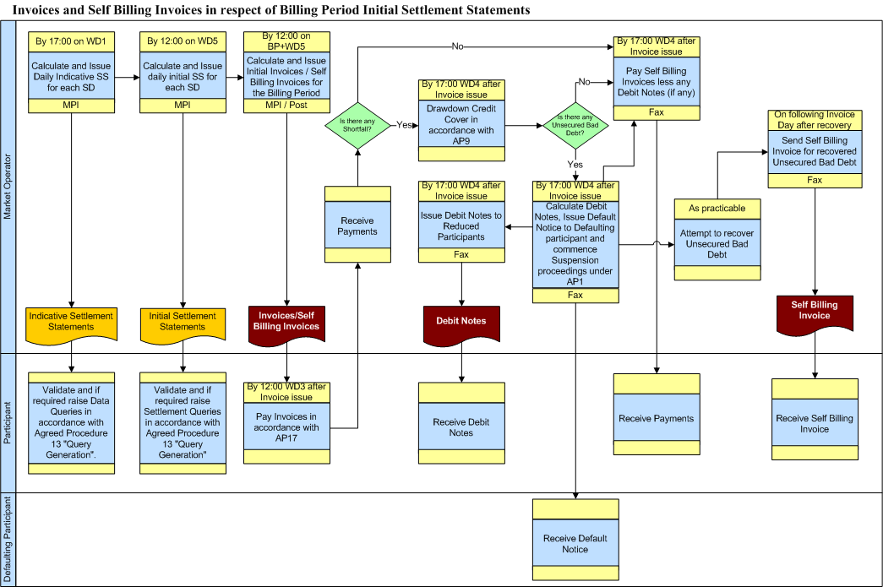

* + 1. Swimlane for Invoices and Self Billing Invoices in respect of Capacity Period Initial Settlement Statements

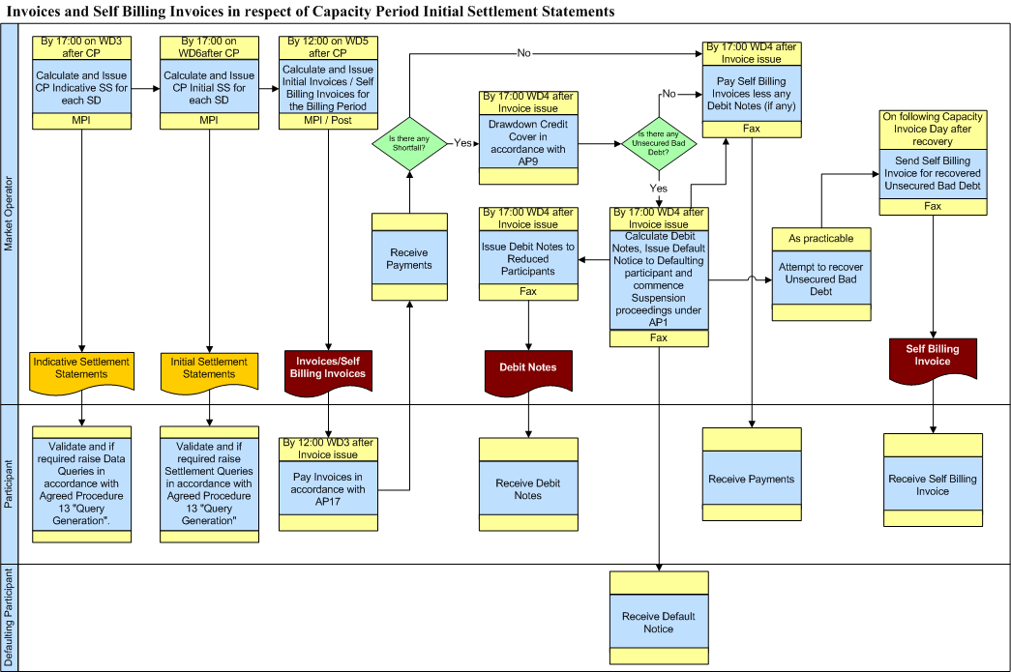

* + 1. Swimlane for Invoices and Self Billing Invoices in respect of Settlement Rerun Statements

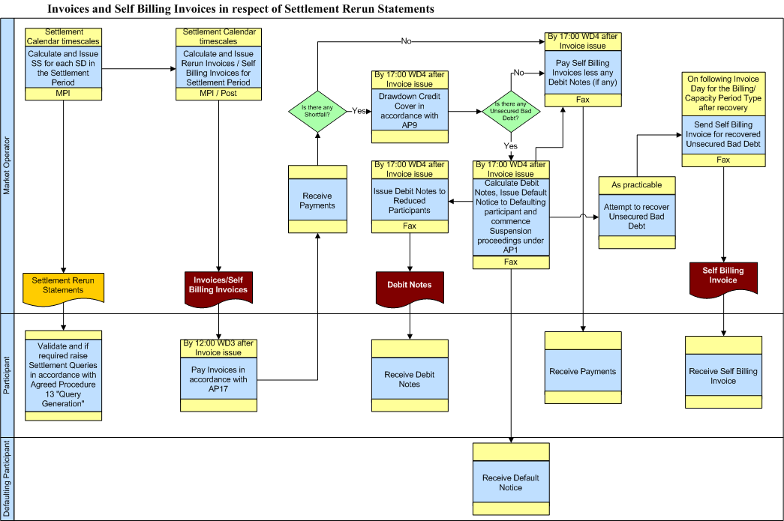

* + 1. Swimlane for Market Operator Charge Invoices

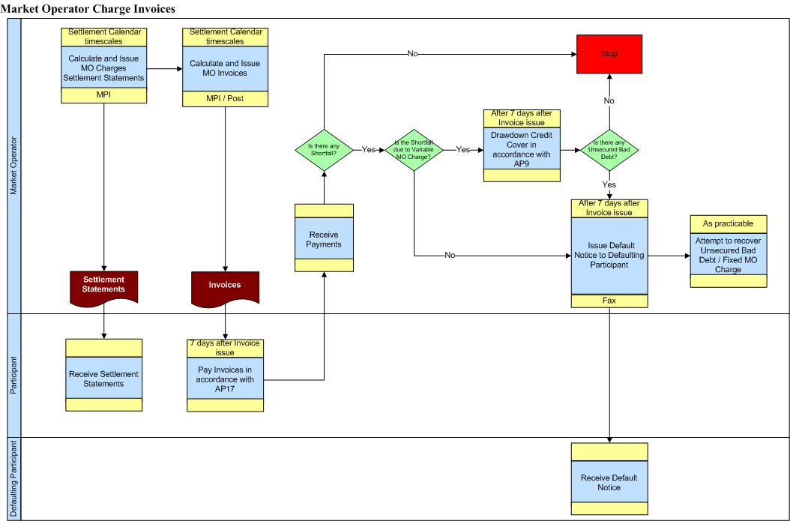

APPENDIX 1: Definitions and Abbreviations

## Definitions

| **Actual Availability** | As defined in the Code |
| --- | --- |
| **Actual Exposure** | As defined in the Code |
| **Agreed Procedure** | As defined in the Code |
| **Balancing Cost** | As defined in the Code |
| **Billing Period** | As defined in the Code |
| **Billing Period Currency Cost** | As defined in the Code |
|  |  |
| **Capacity Charge** | As defined in the Code |
| **Capacity Payment** | As defined in the Code |
| **Capacity Period** | As defined in the Code |
| **Capacity Period Currency Cost** | As defined in the Code |
| **Code** | As defined in the Code |
| **Constraint Payments** | As defined in the Code |
| **Credit Cover** | As defined in the Code |
| **Credit Cover Increase Notice** | As defined in the Code |
| **Credited Participant** | As defined in the Code |
| **Currency** | As defined in the Code |
| **Currency Cost** | As defined in the Code |
| **Data Query** | As defined in the Code |
| **Debit Note** | As defined in the Code |
| **Debited Participant** | As defined in the Code |
| **Defaulting Participant** | As defined in the Code |
| **Default Interest** | As defined in the Code |
| **Default Notice** | As defined in the COde |
| **Dispatch Quantity** | As defined in the Code |
| **Eligible Availability** | As defined in the Code |
| **Energy Charges** | As defined in the Code |
| **Energy Payment** | As defined in the Code |
| **Euro** | As defined in the Code |
| **Fixed Market Operator Charge** | As defined in the Code |
| **Generator** | As defined in the Code |
| **Generator Unit** | As defined in the Code |
| **Imperfections Charge** | As defined in the Code |
| **Initial Settlement Statement** | As defined in the Code |
| **Interest** | As defined in the Code |
| **Invoice** | As defined in the Code |
| **Invoice Day Exchange Rate** | means the Trading Day Exchange Rate as defined in Part A of the Code for the day on which the Invoice and Self Billing Invoice is produced or means the Trading Day Exchange Rate as defined in Part B of the Code for the day on which the Invoice and Self Billing Invoice is produced where this day is after the Cutover Time as set out in Part C of the Code. |
| **Invoice Period** | The period from the start of the Billing Period / Capacity Period to the date of the calculation and issue of the Invoice (BP+ 5 –WD/CP+7WD). |
| **Invoice Period Currency Cost** | The Currency Cost that accrues in the period from when the energy or capacity is dispatched and consumed to the date of Invoicing. |
| **Isolated Market System** | As defined in the Code |
| **Letter of Credit** | As defined in the Code |
| **Make Whole Payment** | As defined in the Code |
| **Market Operator** | As defined in the Code |
| **Market Operator Charge** | As defined in the Code |
| **Market Operator Charge Invoice** | Invoice which include charges to recover MO operating costs. There will be an monthly invoice to recover the Fixed Market Operator Charge and the Variable market Operator Charge. |
| **Market Schedule Quantity** | As defined in the Code |
| **Market Start Date** | As defined in the Code |
| **Net Demand** | As defined in the Code |
| **Participant** | As defined in the Code |
| **Participant Information Report** | A report that provides a Participant with information of the energy delivered or consumed within each defined interval. |
| **Party** | As defined in the Code |
| **Payment Period** | The period between the date of the calculation and issue of the Invoice (BP+5WD/CP+7WD) and the date of the payment of Self Billing Invoices (BP+9WD/CP+11WD) |
| **Payment Period Currency Cost** | The Currency Cost that accrues from the date of Invoicing to the date of payment of Self Billing Invoices. |
| **Payment Due Date** | As defined in the Code |
| **Reduced Participant** | As defined in the Code |
| **Regulatory Authorities** | As defined in the Code |
| **Resettlement** | As defined in the Code |
| **Revenue Authorities** | As defined in this Agreed Procedure in Appendix 2 – Currency Cost |
| **Self Billing Invoice** | As defined in the Code |
| **Settlement** | As defined in the Code |
| **Settlement Calendar** | As defined in the Code |
| **Settlement Day** | As defined in the Code |
| **Settlement Dispute** | As defined in the Code |
| **Settlement Query** | As defined in the Code |
| **Settlement Period** | As defined in the Code |
| **Settlement Reallocation** | As defined in the Code |
| **Settlement Reallocation Agreement** | As defined in the Code |
| **Settlement Reallocation Agreement Currency Cost Adjustment** | means the adjustment required in the event that a Settlement Reallocation Agreement is lodged between the different Currency Zones and is associated with the Billing Period Currency Cost or Capacity Period Currency Cost or both as the context requires. |
| **Settlement Rerun** | As defined in the Code |
| **Settlement Statement** | As defined in the Code |
| **Shortfall** | As defined in the Code |
| **Single Electricity Market** | As defined in the Code |
| **Supplier** | As defined in the Code |
| **Supplier Unit** | As defined in the Code |
| **Suspension Order** | As defined in the Code |
| **System Marginal Price** | As defined in the Code |
| **Timetabled Settlement Rerun** | As defined in the Code |
| **Trading Day** | As defined in the Code |
| **Trading Day Exchange Rate** | As defined in Part A the Code or as defined in Part B of the Code for any day which is after the Cutover Time as set out in Part C of the Code. |
| **Trading Period** | As defined in the Code |
| **Uninstructed Imbalance Payment** | As defined in the Code |
| **Unsecured Bad Capacity Debt** | As defined in the Code |
| **Unsecured Bad Debt** | As defined in the Code |
| **Unsecured Bad Energy Debt** | As defined in the Code |
| **Variable Market Operator Charge** | As defined in the Code |
| **VAT** | As defined in the Code |
| **Working Day** | As defined in the Code |

## Abbreviations

|  |  |
| --- | --- |
| **AP** | Agreed Procedure |
| **CCA** | Currency Cost Adjustment |
| **MO** | Market Operator |
| **MSQ** | Market Schedule Quantity |
| **SEM** | Single Electricity Market |
| **SMP** | System Marginal Price |
| **SRA** | Settlement Reallocation Agreement |
| **TDXR** | Trading Day Exchange Rate |
| **WD** | Working Day |

APPENDIX 2: Currency Cost

For the purpose of invoicing for Currency Cost, the Billing Period / Capacity Period is split between the Invoice Period and the Payment Period. The purpose of splitting the period is to allow the MO to recover a current estimate at the time at which the Invoice is issued of the Currency Cost for the Billing Period / Capacity Period. The MO will be required to fund any further Settlement imbalance due to Currency Cost until those costs can be recovered from the market. By recovering the Currency Cost up to the date of the Invoice, the MO shall minimise the likely funding of Currency Cost.

The Invoice Period defines the period from the start of the Billing Period / Capacity Period to the date of the calculation and issue of the Invoice (BP+ 5 WD for each Billing Period, CP+7 WD for each Capacity Period). The Payment Period defines the period between the date of the calculation and issue of the Invoice (BP+ 5 WD for each Billing Period, CP+7 WD for each Capacity Period) and the date of the payment of Self Billing Invoices (BP+ 9 WD for each Billing Period, CP+11WD for each Capacity Period).

An illustration of the divide in the Billing Period for Initial Settlement is shown in Diagram Four. The Invoice Period Currency Cost takes account of changes in Settlement amounts due to the fluctuations in the exchange rate from each of the Settlement Days to the date of the Invoice. The impact on Settlement amounts from the change in the exchange rate between the Invoice date and the payment of Self Billing Invoices is captured in the Payment Period Currency Cost.

### Diagram Four



At the time when the Invoice is prepared, the MO does not know the Payment Period Currency Cost for that period. The MO will therefore recover the Invoice Period Currency Cost as well the Payment Period Currency Cost for the previous period for a given Billing Period / Capacity Period.

The Currency Cost is then adjusted for Settlement Reallocation Agreements between Participants in different jurisdictions.

The Billing period Currency Cost (BPCb) and the Capacity Period Currency Cost (CAPCc) are calculated as the sum of the Invoice Period Currency Cost, Payment Period Currency Cost and the Settlement Reallocation Agreement Currency Cost Adjustment.

The Currency Cost for the Resettlement Invoice represents the gain of loss on Currency associated with the Resettlement Invoices. The Currency Cost for the Resettlement Invoice is distributed between Participants as per Sections 6.136, 6.136A, 6.139 and 6.139A based on the latest Settlement Rerun Statement values.

**Billing Period Currency Cost**

The Billing Period Currency Cost (BPCb) is calculated as follows:



Where

1.  is the Invoice Period Currency Cost for Billing Period b;
2.  is the Payment Period Currency Cost for the previous Billing Period b-1;
3.  is the Settlement Reallocation Agreement Currency Cost Adjustment for Billing Period b.

**Capacity Period Currency Cost**

The Capacity Period Currency Cost (CPCc) is calculated as follows:



Where

1.  is the Invoice Period Currency Cost for Capacity Period c;
2.  is the Payment Period Currency Cost for the previous Capacity Period c-1;
3.  is the Settlement Reallocation Agreement Currency Cost Adjustment for Capacity Period c.

The Currency Cost is calculated for the SEM in Pounds sterling. For Participants registered in the Republic of Ireland, the inverse of the Invoice Day Exchange Rate is used to convert the Billing Period Currency Charges (BPCCSpb, BPCCGpb) and the Capacity Period Currency Charges (CPCCSpc, CPCCGpc) into euros.

**Calculation of the Invoice Period Currency Cost**

The Invoice Period Currency Costs are calculated on the Invoice date.

For each settlement day in the relevant Billing/Capacity Period calculate the Invoice Period Currency Costs for each Trading Period:

1. Retrieve the Settlement Statement amounts for Pounds Sterling Participants as calculated for the current Invoice job.
2. Retrieve the Settlement Statement amounts for Pounds Sterling Participants as calculated for the previous Invoice job. (Note – if the current Invoice job is the Initial invoice, then this value will be zero).
3. Determine the net Settlement Statement amount, for each Trading Period, by deducting the Settlement Statements for Pounds Sterling Participants for the previous Invoice job from the Settlement Statement amounts for Pounds Sterling Participants for the current Invoice job.
4. Calculate the Invoice Period Currency Cost for each Trading Period by multiplying the net Settlement Statement amount by the current Invoice Day Exchange Rate minus the Trading Day Exchange Rate for that Trading Period.
5. Sum the Invoice Period Currency Cost for each Trading Period in the Billing/Capacity Period to determine the Invoice Period Currency Cost.

**Calculation of the Payment Period Currency Cost**

The Payment Period Currency Cost can only be calculated after payment of Invoices and Self Billing Invoices.

1. Retrieve the Invoice or Self Billing Invoice for the previous Settlement Period in respect of the Invoices for Pounds Sterling Participants as if they were prepared using the Invoice Day Exchange Rate and sum the amounts.
2. Retrieve the Invoice or Self Billing Invoice for the previous Settlement Period in respect of the Invoices for Pound Sterling Participants as if they were prepared using the Trading Day Exchange Rate that prevailed on the date of payment and sum the amounts.
3. Calculate the Payment Period Currency Cost for the previous Settlement Period by subtracting the value retrieved in step 1 from the value retrieved in step 2.

**Calculation of the Currency Cost Adjustment in Respect of Settlement Reallocation Agreements**

In the event that a Settlement Reallocation Agreement is lodged between the different Currency Zones, there will be an adjustment required to the Currency Costs as calculated in the Billing Period or Capacity Period.

To calculate the Settlement Reallocation Currency Cost Adjustment, multiply the euro value of each Settlement Reallocation Agreement (based on the appropriate Trading Day Exchange Rate) that is between different Currency Zones by the difference between the Invoice Day Exchange Rate and the Trading Day Exchange Rate or Annual Capacity Exchange Rate that applies to the Settlement Reallocation Agreement. The Currency Cost Adjustment is the sum of all these values.