|  |  |
| --- | --- |
| Agreed Procedure 12: Modifications Committee Operation | July 30  2024 |

Trading and Settlement Code

Version 29.0

Contents

1. Introduction 1

1.1. Background and Purpose 1

1.2. Scope of Agreed Procedure 1

1.3. Definitions 1

1.4. Compliance with Agreed Procedure 1

2. Overview 2

2.1. Quorum 2

2.2. Voting 2

2.3. Responsibilities of the Secretariat and meetings 2

2.3.1. Maintenance of lists 2

2.3.2. Website 3

2.3.3. Meetings 3

2.3.4. Consultation 3

2.3.5. Emergency Meetings and Extraordinary Meetings 4

2.3.6. Minutes of Meetings 4

2.3.7. Other responsibilities of the Secretariat 4

2.4. Working Groups 5

2.4.1. Establishing a Working Group 5

2.4.2. Terms of Reference 5

2.4.3. Assessment of Modification Proposal 5

2.4.4. Reporting to the Modifications Committee 6

3. Procedural Steps 7

3.1. Submission and acceptance of a New or Revised Standard Modification Proposal 7

3.2. Submission of a New or Revised Urgent Modification Proposal 10

3.3. Ordinary Meetings of the Modifications Committee 13

3.4. Emergency Meetings of the Modification Committee 15

3.5. Progressing and Reaching a decision on Standard Modification Proposals and Agreed Procedure Modification Proposals 17

3.6. Progressing And Reaching a Decision on an Urgent Modification Proposal 22

3.7. Annual Nominating Participant Election 24

3.8. Ad-Hoc Nominating Participant Election Procedure 28

Appendix 1: Definitions and Abbreviations 30

Appendix 2: Modification Proposal Form 32

Document History

|  |  |  |  |
| --- | --- | --- | --- |
| Version | Date | Author | Comment |
| 20.0 | 07/04/2017 | I-SEM Project Team | Baseline Documentation at V20.0 |
| 21.0 | 12/04/2019 | SEMO | Baseline Documentation at V21.0 |
| 22.0 | 29/04/2020 | SEMO | Baseline Documentation at V22.0 |
| 23.0 | 03/11/2020 | SEMO | Baseline Documentation at V23.0 |
| 23.0 | 03/11/2020 | SEMO | Mod_02_20 Housekeeping Feb 2020 |
| 23.0 | 03/11/2020 | SEMO | Mod_04_20 Voting clarification and additional transparency |
| 24.0 | 01/07/2021 | SEMO | Baseline Documentation at V24.0 |
| 25.0 | 09/11/2021 | SEMO | Baseline Documentation at V25.0 |
| 26.0 | 17/05/2022 | SEMO | Baseline Documentation at V26.0 |
| 27.0 | 07/12/2022 | SEMO | Baseline Documentation at V27.0 |
| 28.0 | 18/08/2023 | SEMO | Baseline Documentation at V28.0 |
| 29.0 | 30/07/2024 | SEMO | Baseline Documentation at V29.0 |

Related Documents

|  |  |  |  |
| --- | --- | --- | --- |
| Document Title | Version | Date | By |
| Trading and Settlement Code | 29.0 | 30/07/2024 | SEMO |
| Agreed Procedure 11 “Market System Operation, Testing, Upgrading and Support” |  |  |  |

Introduction

* 1. Background and Purpose

This Agreed Procedure supplements the Modifications Process set out in the Trading and Settlement Code (hereinafter referred to as the “**Code**”). It sets out procedures with which Parties to the Code must comply.

* 1. Scope of Agreed Procedure

This Agreed Procedure defines the procedural steps to be followed by the Secretariat, Chairperson, and Members with respect to:

1. the arrangement, location and form of Meetings;
2. the Quorum and voting procedures;
3. the communication of the Modifications Process;
4. the procedural steps of how to develop Modification Proposals; and
5. the procedural steps on the election of Members to the Modifications Committee.

This Agreed Procedure does not cover the constitution of the Modifications Committee.

It also describes the required actions from the Regulatory Authorities to facilitate this Agreed Procedure consistent with the requirements for approval under Condition 1(c) of the Market Operator Licence.

This Agreed Procedure forms an annex to, and is governed by, the Code. It sets out procedures to be followed subject to the rights and obligations of Parties under the Code. In the event of any conflict between a Party’s obligations set out in the Code and this Agreed Procedure, the Code shall take precedence.

It is not intended that there be any inconsistency or conflict between section 2 “Overview” and section 3 “Procedural Steps”. However, in the event of any inconsistency or conflict, section 3 “Procedural Steps” shall take precedence.

In section 3 “Procedural Steps” a corresponding process flow diagram is included for each procedural steps table.  Process flow diagrams are for illustrative purposes.  It is not intended that there be any inconsistency or conflict between any procedural steps table and process flow diagram however, in the event of any inconsistency or conflict, a procedural steps table shall take precedence.

* 1. Definitions

Words and expressions defined in the Code shall, unless the context otherwise requires or unless otherwise defined herein at Appendix 1 “Definitions and Abbreviations”, have the same meanings when used in this Agreed Procedure.

References to particular sections relate internally to this Agreed Procedure unless specifically noted.

* 1. Compliance with Agreed Procedure

Compliance with this Agreed Procedure is required under the terms of the Code.

Overview

* 1. Quorum

The Modifications Committee Quorum is nine Members and a representative of the Secretariat. To form a Quorum the Chairperson or Vice-chairperson must be present, together with the following Members:

1. at least four voting Members, of which at least two are Supplier Unit registrant representatives and at least two are Generator Unit registrant representatives;
2. at least one Regulatory Authorities appointee;
3. at least one System Operator appointee;
4. the Market Operator appointee; and
5. at least two Meter Data Provider appointees, one of which is not a System Operator.

Unless otherwise specified, the Quorum is the same for all types of meeting. A Quorum requires that Members be present at the Meeting, either in person or alternatively via video or phone conferencing or equivalent.

Any meeting at which a Quorum is not present shall be adjourned until such time as a Quorum may be achieved.

Any resolution of adjournment of a Meeting shall state when and where the next Meeting will be reconvened, and this shall be communicated by the Secretariat via the Website and the mailing list within two Working Days of the adjourned Meeting.

* 1. Voting

All decisions of the Modifications Committee shall be by simple majority vote provided that a Quorum is present, with the exception of certain decisions in respect of Agreed Procedure Modification Proposals, as outlined below. Each voting Member of the Modifications Committee is entitled to one vote.

Voting may be conducted by open ballot (each voting Member openly approving or disapproving the resolution to be made) or by a show of hands (each voting Member openly approving or disapproving the resolution to be made). In the event of a tied vote, the Chairperson (or Vice-chairperson, as appropriate) will cast the deciding vote.

In accordance with the Code, a unanimous decision may be made to accept or reject an Agreed Procedure Modification Proposal if it is supported by all Members referred to in paragraph B.17.3.1 (b) of the Code or appointed by the Regulatory Authorities in accordance with paragraph B.17.3.4.

If there is no unanimous decision, voting on the Agreed Procedure Modification Proposal shall be in accordance with the usual voting procedures.

* 1. Responsibilities of the Secretariat and meetings

Maintenance of lists

The Secretariat shall maintain a list of Modifications Committee Members to include name, address, organisation, telephone number (including a mobile number to facilitate Urgent Modification Proposals) and email address for all Members of the Modifications Committee.

In addition the Secretariat shall maintain a list of Interested Parties.

Website

The Secretariat shall maintain the Website, updating it within five Working Days of new material becoming available. The following information shall be contained on the Website:

1. All Modification Proposals, uniquely numbered, version controlled, with their status identified;
2. All information relating to the Modification Proposals including impact assessments, consultation notes, consultation responses, final recommendation reports, decisions from the Regulatory Authorities, (subject to the confidentiality provisions set out in the Code);
3. A Modification Proposal Form including a licence of Intellectual Property Rights, and waiver of moral rights in respect of the content, format or other aspects of the proposal;
4. All Meeting agendas and minutes which are approved by the Committee prior to publication on the Website;
5. A schedule of Meetings published at the beginning of the year, and the time and location of new Meetings as they arise;
6. All the latest versions of approved Market Documentation. This includes the latest approved Code, Agreed Procedures, and approved Modifications which have not yet been incorporated into the current baseline versions of the Code and Agreed Procedures. The Code and Agreed Procedures will be version controlled and each new version will identify in the version history what Modification Proposals have been included since the previous version;
7. The quarterly report summarising the progress of the Modification Proposals.

Meetings

The Secretariat shall prepare an agenda for each Committee Meeting to include:

1. approval and amendments of the minutes from the previous Meeting;
2. recommendations, opinions and voting on Modification Proposals;
3. update on implementation;
4. any other business; and
5. any agenda item that can be generated by a person other than the Secretariat may be provided to the Secretariat up to and including the same Working Day of the issue of the agenda for that Meeting.

Meetings shall be held at least once every two months, as per the fixed yearly schedule. If there are no proposed agenda items, any scheduled Meeting may be cancelled with the agreement of the Members. If there are no Modification Proposals under discussion, a meeting can be cancelled.

Consultation

The Modifications Committee may determine that a Consultation is required for a Modification Proposal. The Modifications Committee in conjunction with the Secretariat:

* 1. determine who is required to input to the preparation of the Consultation and notify accordingly;
  2. request information from the relevant parties;
  3. prepare the Consultation paper;
  4. set the duration of Consultation with a minimum consultation period of (10) WDs; and,
  5. produce a post Consultation report to inform the decision making of the Modifications Committee.

Emergency Meetings and Extraordinary Meetings

Emergency Meetings or Extraordinary Meetings can be called in accordance with the procedure outlined in section 3.4 below. Emergency Meetings will be limited to discussion of the relevant Urgent Modification Proposal.

Emergency Meetings are called after an Urgent Modification Proposal has been raised and is deemed to be Urgent by the Regulatory Authorities;

Extraordinary Meetings may be called:

1. by the Chairperson; or
2. by a notice emailed by at least four Members of the Modifications Committee; or
3. by a notice emailed by at least five Parties to the Code, provided to the Secretariat; or
4. by agreement at an ordinary Meeting.

Minutes of Meetings

The Secretariat shall take minutes at all Meetings and circulate draft minutes to Members for comment within five Working Days of an ordinary Meeting or Extraordinary Meeting, or within two Working Days of an Emergency Meeting. Members shall be allowed five Working Days to provide comments on the minutes to the Secretariat. The Secretariat shall include these comments as tracked changes to the minutes or as an addition to the end of the minutes, detailing who made the comments. These updated minutes shall be published on the Website within two Working Days for final approval at the next Meeting.

The Secretariat shall note in the minutes of an ordinary Meeting, any objections to the minutes from the previous Meeting.

Other responsibilities of the Secretariat

The Secretariat shall also be responsible for:

1. The production of a quarterly report summarising the progress of the Modification Proposals and submitting this to the Regulatory Authorities;
2. Updating the Code and Agreed Procedures with approved Modification Proposals as soon as practicable, but no less frequently than twice yearly, in line with the Scheduled Release;
3. The management of the progression of Modification Proposals through the process, with responsibility on the Modifications Committee for the full development of Modification Proposals. The onus is on the Modifications Committee to review and further the progress of the Modification Proposal;
4. The management of the arrangement of Modification Working Groups, and will follow up on actions of the Working Groups;
5. The production of Final Recommendation Reports for each Modification where appropriate, with input from the Committee Members. An initial draft may be circulated by the Secretariat, but the onus is on the Members to ensure all detail is captured in the report;
6. Where a Modification has been deemed by a Regulatory Authority decision as 'requiring further work', the Secretariat shall, based on the direction in the decision paper and with the Committee's input, allocate responsibilities and track the progress of this work; and
7. The management of responses to all queries on Modifications Committee business and delegating responses to Members where appropriate. 
   1. Working Groups

Establishing a Working Group

In accordance with the Code, the Modifications Committee may direct a Working Group to develop a Modification Proposal. A Working Group shall consist of Members and other Interested Parties as appropriate. The Secretariat shall nominate a chairperson for the Working Group from the list of attendees.

A Working Group may convene where the Modifications Committee believes it necessary for further work to take place in advance of making a decision on a Modification Proposal. The Modifications Committee may at any time decide to end a Working Group or direct further work to take place following a Working Group recommendation.

Terms of Reference

The terms of reference for a Working Group established under paragraph 2.4.1 of this Agreed Procedure, shall be drafted and approved by the Modifications Committee in advance of a Working Group meeting. The Secretariat shall publish the terms of reference on the Website in advance of the Working Group meeting and communicate these to the Working Group participants in advance of the meeting. The Secretariat shall note any additional comments on the terms of reference and a decision made by the Modifications Committee with regard to any necessary amendment following receipt of comments.

Assessment of Modification Proposal

The Working Group shall consider options for a given proposal and may request appropriate impact assessments where necessary, including those procured from the vendor. The Working Group will make a recommendation to the Modifications Committee with regard to how the group believes it best to proceed and the Modifications Committee may direct further work to be carried out following a Working Group recommendation.

Reporting to the Modifications Committee

The Secretariat shall prepare a timeline for progression of each Working Group topic and update the Modifications Committee at Meetings regarding the outcome of each Working Group meeting. The Secretariat shall prepare a report following each Working Group meeting for the Modifications Committee, with input from the Working Group participants. The report will detail any actions and recommendations of the Working Group.

Procedural Steps

* 1. Submission and acceptance of a New or Revised Standard Modification Proposal

| Step | Step Description | Timing | Method | From / By | To |
| --- | --- | --- | --- | --- | --- |
|  | Complete Modification Proposal Form, indicating that it is a Standard Modification Proposal. Indicate if it is a revision of an existing Modification Proposal. | As required | Modification Proposal Form at Appendix 2 | Any person | n/a |
|  | Send Modification Proposal Form to the email addresses specified on the Modification Proposal Form. | At least 10 WD prior to Meeting at which the proposer wishes it to be considered | Email | Any person | Secretariat |
|  | Acknowledge receipt of Modification Proposal Form. Determine if form is complete. If form is complete, go to step 5. If form is incomplete, continue to step 4. | Within 2 WD of receipt of Modification Proposal | In accordance with the check-list appended to the Modification Proposal Form at Appendix 2 and Secretariat process checks | Secretariat | MPO |
|  | Send a reply identifying where the Modification Proposal Form is not correct or omits detail. The process restarts if Proposer resubmits email with newly submitted Modification Form. Otherwise, **end process**. | Within 2 WD of receipt of email | Email | Secretariat | Proposer and person who submitted Modification Proposal (if different) |
|  | Determine if the Modification Proposal merits consideration as “Urgent”.  If it does continue to step 6 of section 3.2 below, otherwise continue to step 6 of this section. | Within 2 WD of receipt of email | n/a | Secretariat or MC |  |
|  | Designate the accepted Modification Proposal with a unique tracking number and version number (if required) and publish it on the Website with a status of 'new'. | Within 2 WD of receipt of email | n/a | Secretariat | n/a |
|  | Notify of update to Website. | Within 2 WD of receipt of email | Email | Secretariat | MC mailing list and Interested Parties |
|  | Include Modification Proposal on the next Meeting agenda. | At least 5 WD prior to the next Meeting | n/a | Secretariat | n/a |
|  | Present Modification Proposal at the next Meeting which is at least 10 WD after the date of submission of the Modification Proposal. | At First Meeting | n/a | MPO | n/a |

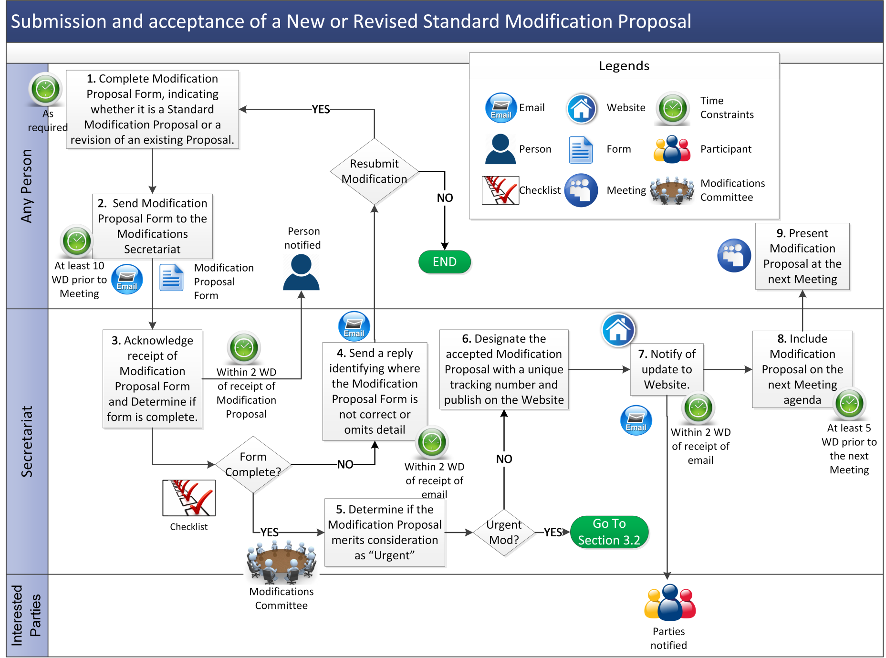

* 1. Submission of a New or Revised Urgent Modification Proposal

| Step | Step Description | Timing | Method | From / By | To |
| --- | --- | --- | --- | --- | --- |
|  | Notification of imminent Urgent Modification Proposal. | As required | Email / telephone | Any person | Secretariat / RAs |
|  | Complete Modification Proposal Form, indicating that it is an Urgent Modification Proposal. Indicate if it is a revision of an existing Modification Proposal. | As required | Modification Proposal Form at Appendix 2 | Any person | n/a |
|  | Send Modification Proposal Form to the email address indicated on the Modification Proposal Form, highlighting the urgency of the proposed Modification Proposal to Secretariat in the email. | As required | Email | Proposer or person submitting form on their behalf | Secretariat |
|  | Determine if form is complete.  If the form is incomplete, notify Proposer and seek clarification or new version of Modification Proposal. Process restarts if the Proposer submits an email with a new Modification Proposal Form. If no clarification received, **end process**.  If form is complete, designate the Urgent Modification Proposal with a unique tracking number and version number, and publish it on the Website with a status of 'new'. | Within 1WD of receipt of email with original Urgent Modification Proposal | n/a | Secretariat | n/a |
|  | Send a copy of Modification Proposal to the RAs. | As soon as possible following receipt or decision by Secretariat or MC that Modification Proposal appears Urgent | Email | Secretariat | RAs |
|  | RAs determine whether or not Modification Proposal is Urgent, in accordance with the Code, and notify Secretariat of decision. | As soon as possible following receipt | Email | RAs | Secretariat |
|  | If Modification Proposal is Urgent, an Emergency Meeting to be called. Otherwise, process as Standard Modification Proposal. | n/a | n/a | RAs | n/a |

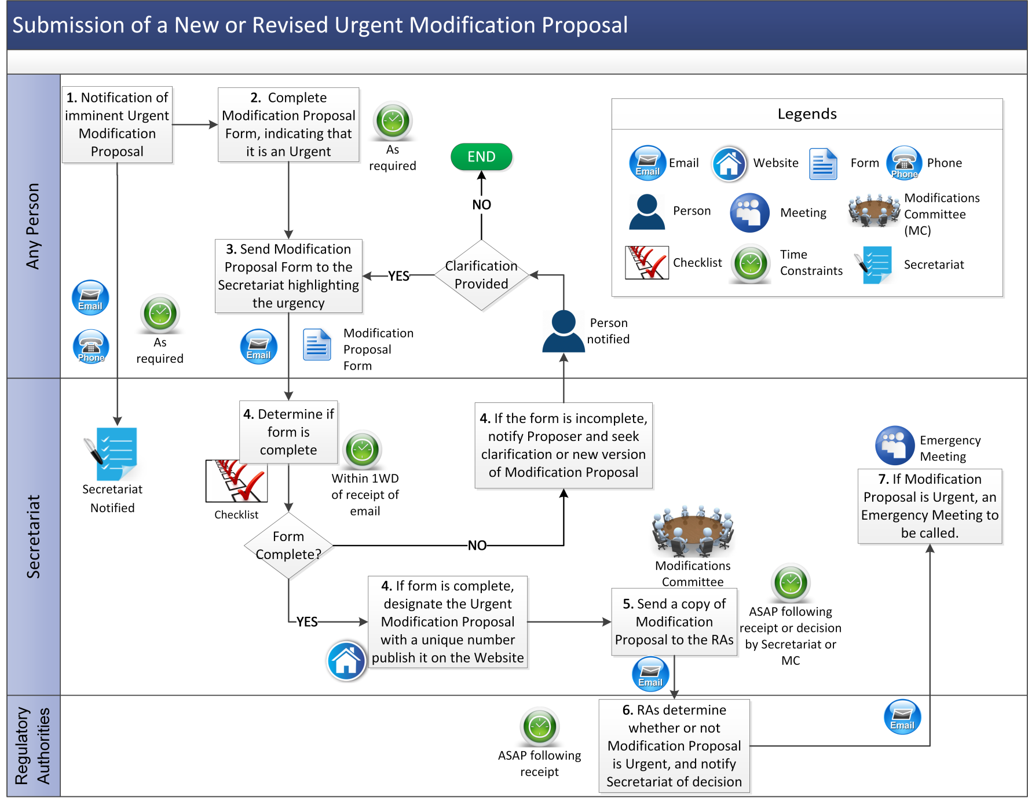

* 1. Ordinary Meetings of the Modifications Committee

| Step | Step Description | Timing | Method | From / By | To |
| --- | --- | --- | --- | --- | --- |
|  | Circulate the agenda for the Meeting and publish on Market Operator website, specifying details of the location of the Meeting and requesting MC and observer notification of attendance. | At least 5 WD before Meeting | Email | Secretariat | MC, Website |
|  | Request notification of attendance at Meeting | At least 5 WD before Meeting | Email | Secretariat | MC mailing list |
|  | Committee advise Secretariat of attendance at Meeting.  All Non-Committee or observers request permission to attend Meeting. | No later than 5 WD before Meeting | Email | MC or Non-Committee Members and Alternates | Secretariat |
|  | If a Quorum is present at the Meeting, proceed with business, **end process**. Otherwise continue to step 5. | At Meeting | n/a | All Members and Secretariat | n/a |
|  | Refer to the RAs for guidance or disband the Meeting upon direction by the Chairperson, recording the reason why and the agreed time for the next Meeting in the Meeting minutes. | At Meeting | n/a | MC, Secretariat | n/a |

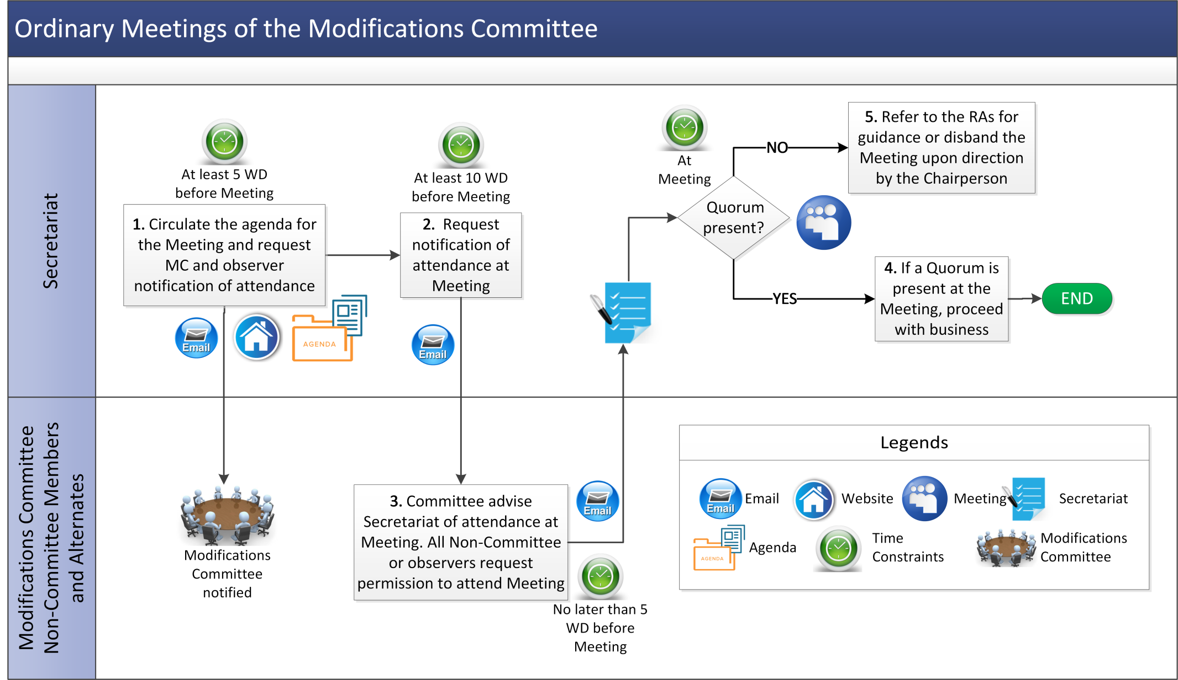

* 1. Emergency Meetings of the Modification Committee

| Step | Step Description | Timing | Method | From / By | To |
| --- | --- | --- | --- | --- | --- |
|  | Circulate proposed date and time for the Meeting and request notification of availability from MC. | As early as possible before Meeting | Email | Secretariat | Members and Alternates of MC |
|  | Advise Secretariat of availability. | As early as possible before Meeting | Email | MC | Secretariat |
|  | Circulate the agenda for the Meeting including the time, location and conference call numbers (if relevant). | As early as possible before Meeting | Email | Secretariat | MC |
|  | If a Meeting cannot be convened or if a Quorum is not present, refer to RAs for guidance. | Within 2 WD of RAs deeming that Modification Proposal is Urgent or at Meeting if a Quorum is not present | Email | Secretariat | RAs |

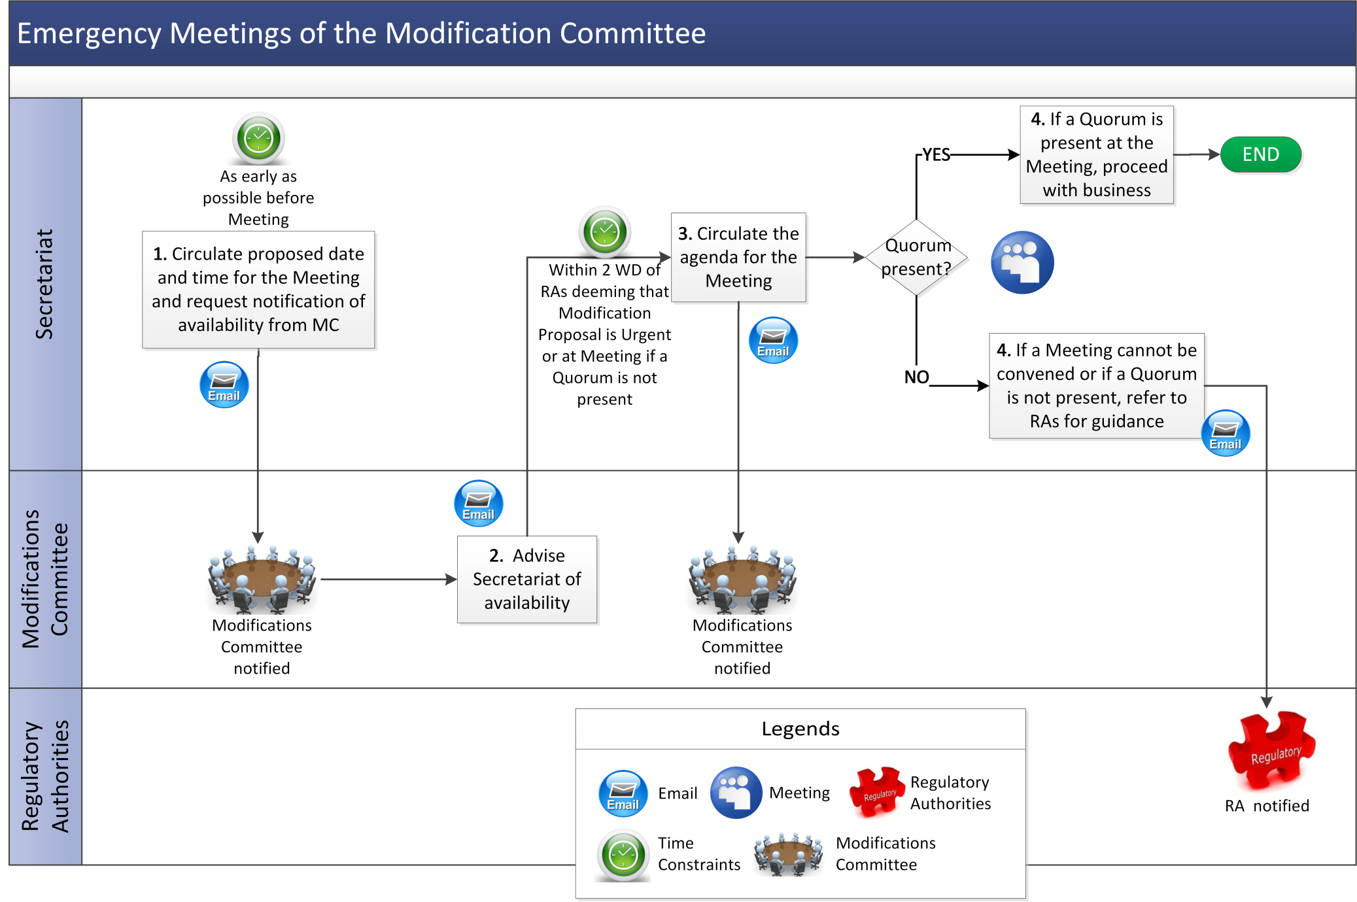

* 1. Progressing and Reaching a decision on Standard Modification Proposals and Agreed Procedure Modification Proposals

| Step | Step Description | Timing | Method | From / By | To |
| --- | --- | --- | --- | --- | --- |
|  | If the Modification Proposal is new continue to step 2.  If the Modification Proposal was deferred at a previous meeting or if the Modification Proposal is deemed to require further work by the RAs, continue to step 3. | At Meeting | n/a | MC | n/a |
|  | If the MC or RAs determines the Modification Proposal is spurious, **end process**. | At Meeting | n/a | MC / RAs / Secretariat | n/a |
|  | If the Modification Proposal can be voted on at this Meeting without further development, go to step 11.  Otherwise, determine the method and timetable for progression of the Modification Proposal as follows:   * + - 1. If further work on the proposal is required, notify the relevant parties regarding input to develop the proposal.       2. If a Working Group required, determine who may be involved in drafting terms of reference, input to the meeting and select chairperson, and go to step 4. Otherwise see (c) below.       3. If a Public Consultation is required draft the Consultation paper and issue Consultation, return to step 3. Otherwise, go to step 6 and update the Modification Proposal status to 'deferred' | At Meeting | n/a | MC / Secretariat | n/a |
|  | Invite Working Group members to meeting and circulate agenda items. | As appropriate with regard to timetable | Email | Secretariat | n/a |
|  | Procure impact assessment by MC or third party if necessary. If analysis of systems impact is required, go to Agreed Procedure 11 “Market System Operation, Testing, Upgrading and Support”. | As appropriate with regard to timetable | n/a | Secretariat / MC | n/a |
|  | Update Modification Proposal status as appropriate. Circulate updates on development of proposal to MC for next MC Meeting. If consultation is being performed return to step 3, otherwise continue to step 7. | Within 2 WD of completion of impact assessment report | n/a | Secretariat | Website |
|  | If third party consultant’s report required to inform decision, determine business case and fixed costs and continue to step 8. Otherwise, go to step 11. | At Meeting | n/a | MC / Secretariat | n/a |
|  | Send fixed costs and business case to RAs for approval. If the RAs approve the procurement, proceed with procurement activities. Otherwise, continue to step 11. | Within 2 WD of Meeting | Business Case Form in email | Secretariat | RAs |
|  | If an alternative proposal is received in sufficient time to consider it during the process continue to step 10. |  | n/a | n/a | n/a |
|  | Determine whether to develop both proposals, reject the alternative proposal or replace the original proposal with the alternative proposal. Repeat step 5 to step 9 as necessary / appropriate for the alternative proposal, if applicable. | At Meeting | n/a | MC | n/a |
|  | Vote on whether or not Modification Proposal should be adopted. Make note of the reasons for the decision and dissenting opinions and continue to step 13.  If the Modification Committee cannot reach a decision, notify the RAs, **end process**. | At Meeting | n/a | MC | n/a |
|  | If RAs veto decision of MC on an Agreed Procedure Modification Proposal, advise Modification Committee, **end process**. | As soon as possible after the Meeting | n/a | Secretariat | MC |
|  | Ensure that all exhibits to the Final Recommendation Report / AP Notification are prepared and have been submitted to the Secretariat. If any exhibits are missing, allocate a Member or Alternate Member to provide the necessary information to the Secretariat within a specified time. | At Meeting | n/a | Secretariat / MC | n/a |
|  | Finalise and sign off on the Final Recommendation Report / AP Notification and submit to RAs. | In accordance with Secretariat timetable | Email | MC/Secretariat | Secretariat |
|  | RAs make determination and send decision to Secretariat either:   1. approving or rejecting the change at a fixed date for all Code Modification Proposals, go to step 16;   or   1. directing the MC to further develop the Modification Proposal in accordance with a specified timeframe, return to step 3. | Within 5 WD of receipt of Modification Recommendation Report / 3 WD of receipt of AP Notification | Email | RAs | Secretariat |
|  | Allocate actions for further work arising out of RA decision. Monitor work and include Modification in next Meeting agenda. | Set new timetable for work | n/a | Secretariat | n/a |

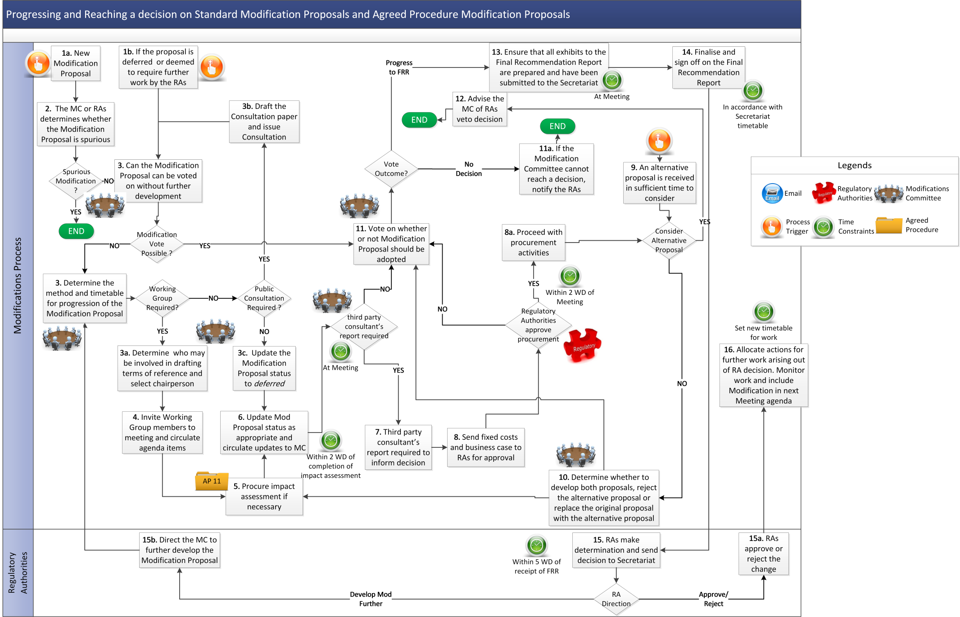

* 1. Progressing And Reaching a Decision on an Urgent Modification Proposal

| Step | Step Description | Timing | Method | From / By | To |
| --- | --- | --- | --- | --- | --- |
|  | If the Modification Proposal be voted on at this Meeting without further development, Working Group or Consultation, continue to step 2.  Otherwise, decide on the timetable for processing Urgent Modification Proposal. | At Meeting | n/a | MC | n/a |
|  | Vote on Modification Proposal and notify RAs of decision. | At Meeting in accordance with agreed timetable | n/a | MC | n/a |
|  | Distribute Meeting minutes and timetable. | Within 1 WD of Meeting | At Meeting in accordance with agreed timetable. | n/a | n/a |
|  | If RAs amend or veto timetable, if necessary arrange for telephone conference with RAs to agree timetable and proceed in accordance with revised timetable suggested or approved by Regulatory Authorities. Otherwise, proceed in accordance with the timetable agreed at the Meeting. | Within 2 WDs of submission of proposed timetable to Regulatory Authorities | Email / Telephone | RAs | MC |
|  | Complete Final Recommendation Report and continue from step 13 of section 3.5 above. | See Standard Modification Proposal procedure. | n/a | Secretariat | n/a |

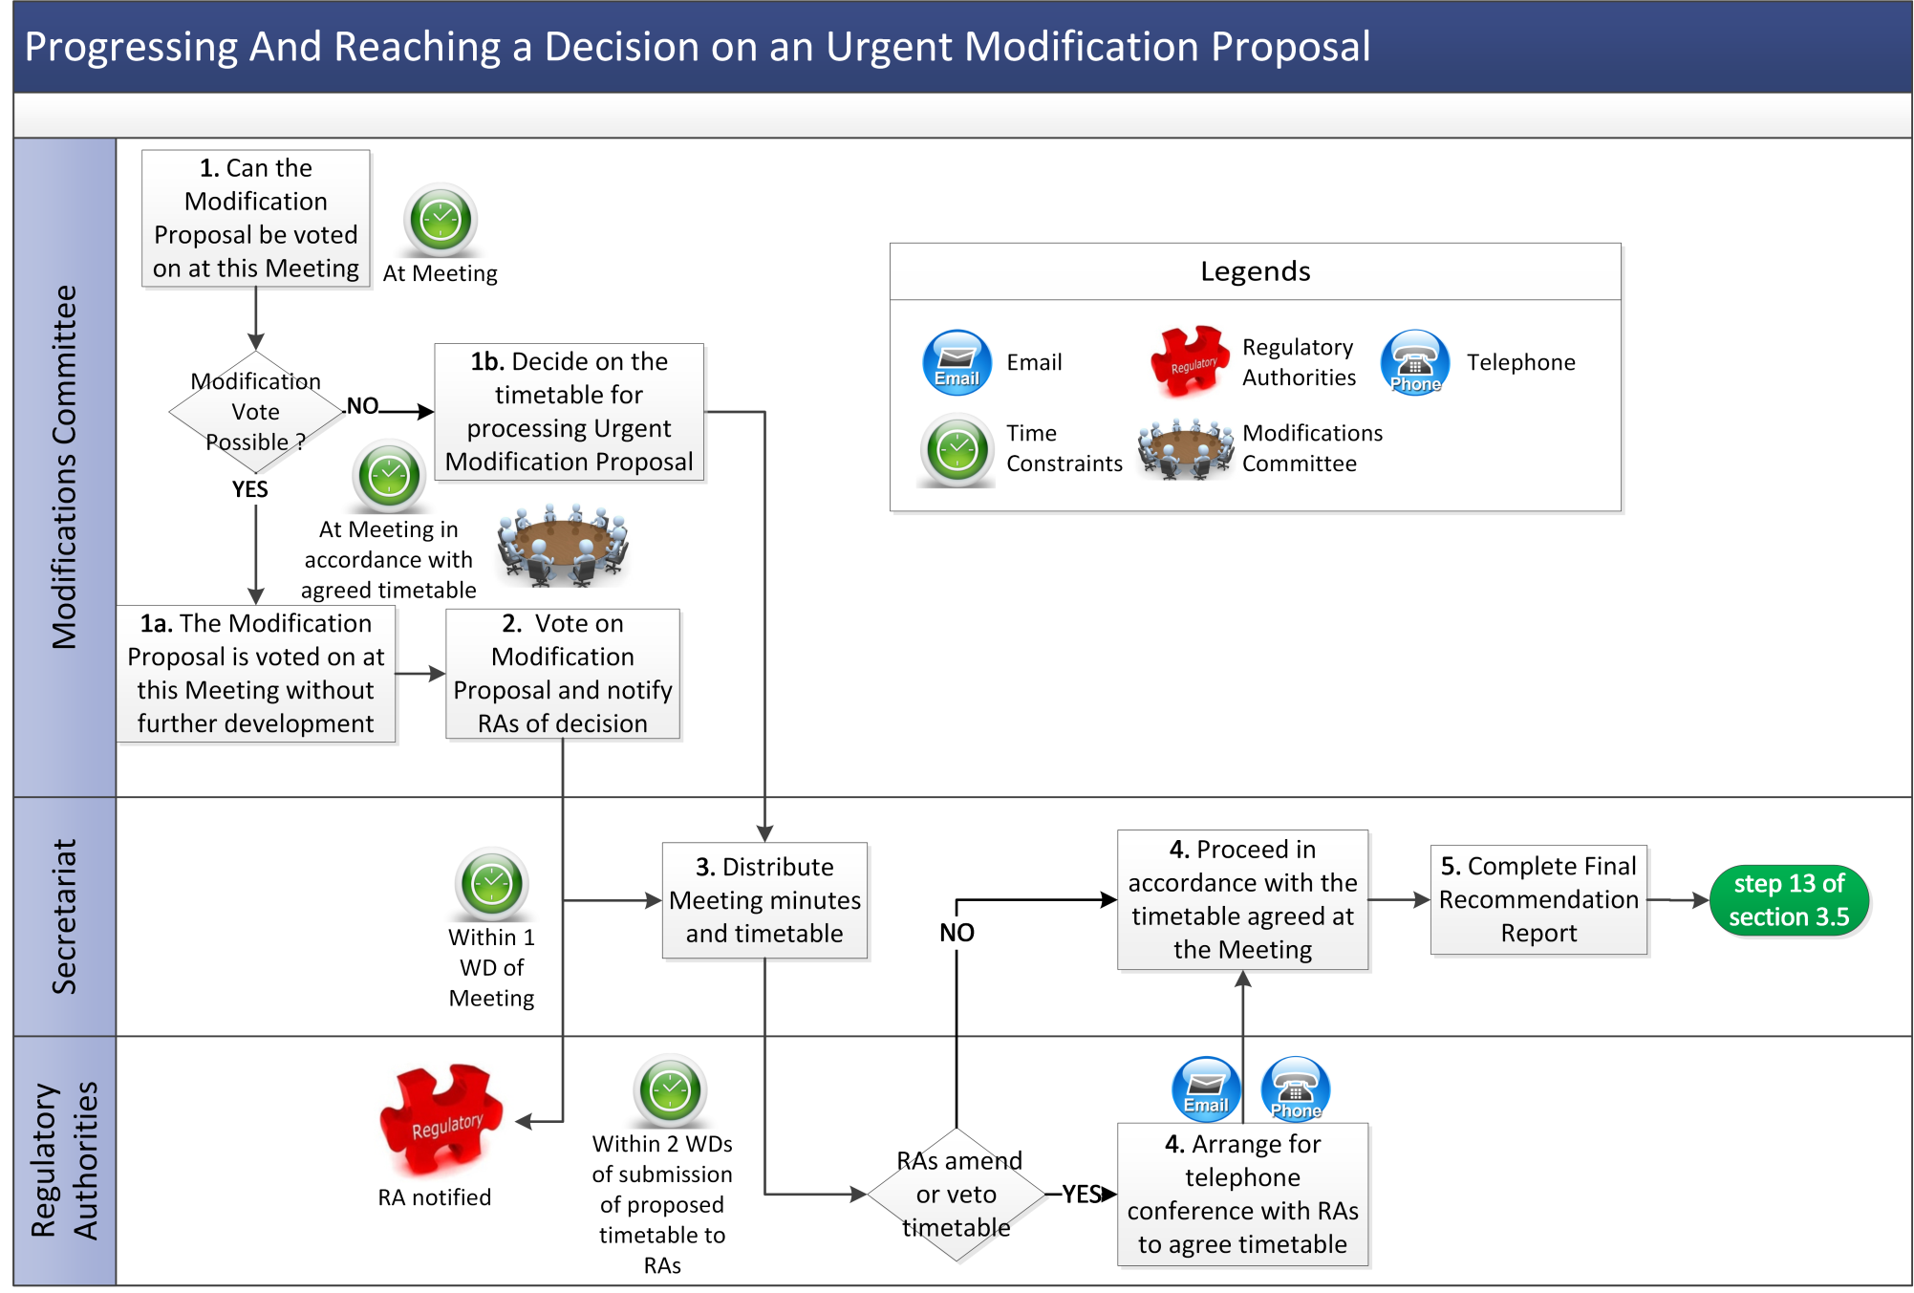

* 1. Annual Nominating Participant Election

| Step | Step Description | Timing | Method | From / By | To |
| --- | --- | --- | --- | --- | --- |
|  | Send notice inviting candidate membership nominations for Annual Nominating Participant Election. The notice should:   1. Identify the expiring memberships (Member Name, Participant type); 2. Identify membership duties; 3. Identify nominations due date; and 4. Request candidate job-title, company and descriptions. | 6 weeks prior to expiry of all Members terms | Email | Secretariat | Participants |
|  | Send in membership nominations. A Party with multiple Participant categories can only nominate for a single category per term. | By nominations due date | Email | Participants | Secretariat |
|  | Acknowledge membership nominations. | As received | Email | Participants | Secretariat |
|  | Send ballot paper and candidate descriptions to all Participants. The notice should give election instructions and specify:   1. ballot paper due date; 2. who is eligible to Vote; 3. date result will be announced; and 4. voting instructions e.g. ballot secrecy. | 4 weeks prior to expiry of all members terms (ballot paper due date) | Email | Secretariat | Participants |
|  | Notwithstanding Step 2, a Participant with multiple categories can cast a vote for each category in any given election. Votes are cast as follows:   1. Nominating Generation Participants cast one vote per Participant in relation to Generation Participant Members vacancy; 2. Nominating Supply Participants cast one vote per Participant in relation to Supply Participant Members vacancy; 3. Nominating Demand Side Participants cast one vote per Participant in relation to Demand Side Participant Members vacancy; and 4. Nominating Assetless Participants cast one vote per Participant in relation to Assetless Participant Members vacancy.   Voting rules are as follows:   1. In the event of only 1 candidate nomination for the relevant Participant Member position, this candidate will be automatically deemed the successful candidate in an uncontested election; 2. In the event of 2 or more candidate nominations for 1 relevant Participant Member position, voters have one vote only, The successful candidate is the candidate with the highest number of votes. In the event of a tie, one additional round of voting shall occur for the affected position | Within 4 weeks of expiry of all members terms (ballot paper due date) | Email | Participants | Secretariat |
|  | Send notification of close of ballot. | Ballot paper due date as above | Email | Secretariat | Participants |
|  | Count and file votes then:   1. In the event of tie or inconclusive election results go to Step 8, 2. If a majority of votes is assigned to a candidate go to Step 9; | 2 WD after ballot paper due date or as soon as possible thereafter | Email | Secretariat | Participants |
|  | In the event of equal numbers of votes being cast for candidates, consult RAs for final determination of election result. | As soon as practicable | Email | Secretariat | RAs |
|  | Notify candidates of election result. | 2 WD after ballot paper due date or as soon as possible thereafter | Email | Secretariat | Candidates |
|  | Notify Participants of election results including general turnout by Participant’s category, calculated by the sum of all votes cast over the total eligible voters. Further details on individual Participant’s results can be requested privately from the Secretariat as long as confidentiality is not breached.. | 2 WD after ballot paper due date or as soon as possible thereafter | Email | Secretariat | Participants |

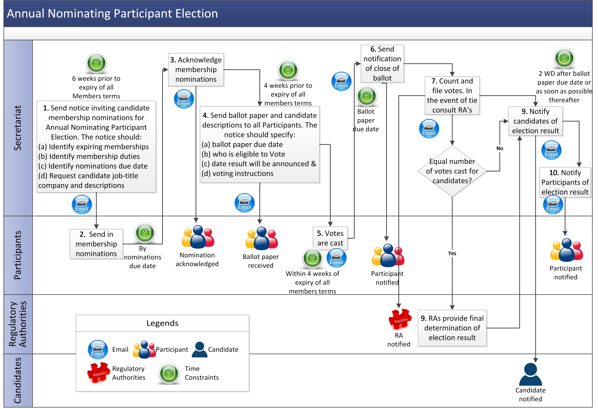

* 1. Ad-Hoc Nominating Participant Election Procedure

| Step | Step Description | Timing | Method | From / By | To |
| --- | --- | --- | --- | --- | --- |
|  | If Member is resigning or retiring, send notice to the Secretariat. If Member is being removed, Secretariat sends notice to the Member. | At least 2 weeks prior to next scheduled Modification Panel Meeting | Email | Secretariat / Members | Secretariat / Members |
|  | Include Member vacancy as an item on the next Committee Meeting agenda. | If applicable | n/a | Secretariat | Members |
|  | Modification Committee decides that Ad-Hoc Nominating Participant Election will take place or that the Alternate Member may fill this vacancy in accordance with paragraph 2.180 of the Code.  If the Alternate Member shall fill the vacancy, **end process**. If Member is to be elected, continue to step 2 of section 3.7 (Annual Nominating Participant Election). | At next scheduled Meeting or as soon as practicable | Email / Meeting | Members | n/a |

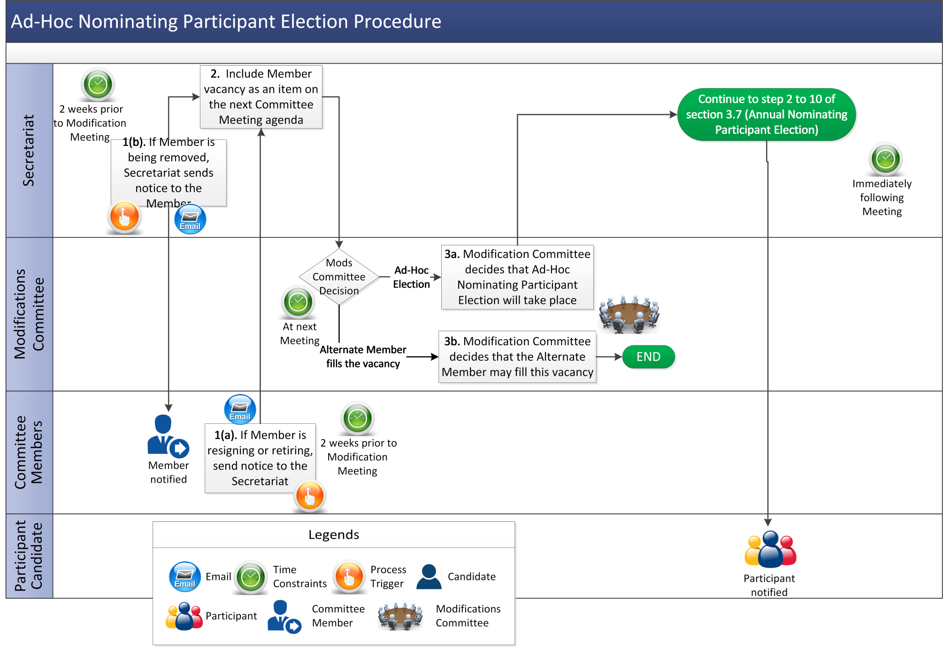

Appendix 1: Definitions and Abbreviations

**Definitions**

|  |  |
| --- | --- |
| **Ad-hoc Nominating Participant Election** | means an ad-hoc election for the replacement of members appointed in respect of Generation Participants, Supply Participants, Demand Side Participants or Assetless Participants who have resigned, retired or been removed outside of the annual election timeframe. |
| **Annual Nominating Participant Election** | means an election for the replacement of members appointed in respect of Generation Participants, Supply Participants, Demand Side Participants or Assetless Participants whose terms are due to expire on the annual membership expiry date. |
| **Alternate Member** | means a nominated representative who may exercise the vote of a Member of the Modifications Committee where that Member is unable to attend a Meeting. |
| **AP Notification** | means a notification to the Regulatory Authorities in respect of a decision by the Modifications Committee to modify an Agreed Procedure in accordance with paragraph 2.223 of the Code. |
| **Business Case Form** | means the form used by the Market Operator from time to time to be sent to the Regulatory Authorities setting out the business case for a procured consultancy where the Modifications Committee is required as part of a Modification Proposal. |
| **Chairperson** | means the chairperson of the Modifications Committee appointed in accordance with the Code. |
| **First Meeting** | means the first meeting at which a Modification Proposal is considered, or where the Regulatory Authorities have exercised a right of veto regarding a determination by the Modifications Committee at such meeting that (i) a Modification Proposal is spurious or (ii) accepting or rejecting an AP Modification Proposal, the next meeting following receipt by the Secretariat of the Regulatory Authorities’ decision. |
| **Interested Parties** | persons who have made a request to receive communications from the Market Operator in relation to Modifications. |
| **Market Documentation** | means documents which together comprise the full contractual information of the Code and Agreed Procedures, including any approved Modification Proposals which have not been fully incorporated into those documents. |
| **Member** | means a member of the Modifications Committee. |
| **Modification Proposal Form** | means the Form for submitting a Modification Proposal as shown in Appendix 2. |
| **Modification Proposal Originator** | means the person named on the Modification Proposal as the author of the Modification Proposal. |
| **Public Consultation** | means a consultation run via the Website and the Secretariat, seeking the public’s views on a particular Modification Proposal. |
| **Standard Modification Proposal** | means a Modification Proposal that is non-Urgent. A Modification Proposal is a Standard Modification Proposal under this Agreed Procedure unless expressly identified as Urgent. |
| **Urgent Modification Proposal Form** | means a form for submitting an Urgent Modification Proposal under this Agreed Procedure or Agreed Procedure 11. |
| **Vice-chairperson** | means the vice-chairperson of the Modifications Committee appointed in accordance with the Code. |
| **Website** | means the website or part of a website designated for information about the Modifications Process. |

**Abbreviations**

|  |  |
| --- | --- |
| **MC** | Modifications Committee |
| **MO** | Market Operator |
| **MPO** | Modification Proposal Originator |
| **RA** | Regulatory Authorities |

Appendix 2: Modification Proposal Form

|  |  |  |  |  |  |
| --- | --- | --- | --- | --- | --- |
| **MODIFICATION PROPOSAL FORM** | | | | | |
| **Proposer**  *(Company)* | **Date of receipt**  *(assigned by Secretariat)* | | **Type of Proposal**  *(delete as appropriate)* | | **Modification Proposal ID**  *(assigned by Secretariat)* |
|  |  | | **Standard / Urgent/Provisional** | |  |
| **Contact Details for Modification Proposal Originator** | | | | | |
| **Name** | | **Telephone number** | | **Email address** | |
|  | |  | |  | |
| **Modification Proposal Title** | | | | | |
|  | | | | | |
| **Documents affected**  *(delete as appropriate)* | | **Section(s) Affected** | | **Version number of T&SC or AP used in Drafting** | |
| **T&SC**  **Appendices**  **Glossary**  **Agreed Procedures** | |  | |  | |
| **Explanation of Proposed Change**  *(mandatory by originator)* | | | | | |
|  | | | | | |
| **Legal Drafting Change**  *(Clearly show proposed code change using* ***tracked*** *changes, if proposer fails to identify changes, please indicate best estimate of potential changes)* | | | | | |
|  | | | | | |
| **Modification Proposal Justification**  *(Clearly state the reason for the Modification)* | | | | | |
|  | | | | | |
| **Code Objectives Furthered**  *(State the Code Objectives the Proposal furthers, see Section A.2.1.4 of the T&SC for Code Objectives)* | | | | | |
|  | | | | | |
| **Implication of not implementing the Modification Proposal**  *(State the possible outcomes should the Modification Proposal not be implemented)* | | | | | |
|  | | | | | |
| **Working Group**  *(State if Working Group considered necessary to develop proposal)* | | | **Impacts**  *(Indicate the impacts on systems, resources, processes and/or procedures; also indicate impacts on any other Market Code such as Capacity Market Code, Grid Code, Exchange Rules etc.)* | | |
|  | | |  | | |
| ***Please return this form to Secretariat by email to*** [balancingmodifications@sem-o.com](mailto:balancingmodifications@sem-o.com) | | | | | |

**Notes on completing Modification Proposal Form:**

1. **If a person submits a Modification Proposal on behalf of another person, that person who proposes the material of the change should be identified on the Modification Proposal Form as the Modification Proposal Originator.**
2. **Any person raising a Modification Proposal shall ensure that their proposal is clear and substantiated with the appropriate detail including the way in which it furthers the Code Objectives to enable it to be fully considered by the Modifications Committee.**
3. **Each Modification Proposal will include a draft text of the proposed Modification to the Code unless, if raising a Provisional Modification Proposal whereby legal drafting text is not imperative.**
4. **For the purposes of this Modification Proposal Form, the following terms shall have the following meanings:**

**Agreed Procedure(s): means the detailed procedures to be followed by Parties in performing their obligations and functions under the Code as listed in Appendix D “List of Agreed Procedures”.**

**T&SC / Code: means the Trading and Settlement Code for the Single Electricity Market. The Proposer will also need to specify which sections are affected by the proposed Modification;**

**Modification Proposal: means the proposal to modify the Code as set out in the attached form**

**Derivative Work: means any text or work which incorporates or contains all or part of the Modification Proposal or any adaptation, abridgement, expansion or other modification of the Modification Proposal**

**The terms “Market Operator”, “Modifications Committee” and “Regulatory Authorities” shall have the meanings assigned to those terms in the Code.**

**In consideration for the right to submit, and have the Modification Proposal assessed in accordance with the terms of Chapter B of the Code (and Agreed Procedure 12) , which I have read and understand, I agree as follows:**

**1. I hereby grant a worldwide, perpetual, royalty-free, non-exclusive licence:**

* 1. **to the Market Operator and the Regulatory Authorities to publish and/or distribute the Modification Proposal for free and unrestricted access;**
  2. **to the Regulatory Authorities, the Modifications Committee and each member of the Modifications Committee to amend, adapt, combine, abridge, expand or otherwise modify the Modification Proposal at their sole discretion for the purpose of developing the Modification Proposal in accordance with the Code;**
  3. **to the Market Operator and the Regulatory Authorities to incorporate the Modification Proposal into the Code;**

**1.4 to all Parties to the Code and the Regulatory Authorities to use, reproduce and distribute the Modification Proposal, whether as part of the Code or otherwise, for any purpose arising out of or in connection with the Code.**

**2. The licences set out in clause 1 shall equally apply to any Derivative Works.**

**3. I hereby waive in favour of the Parties to the Code and the Regulatory Authorities any and all moral rights I may have arising out of or in connection with the Modification Proposal or any Derivative Works.**

**4. I hereby warrant that, except where expressly indicated otherwise, I am the owner of the copyright and any other intellectual property and proprietary rights in the Modification Proposal and, where not the owner, I have the requisite permissions to grant the rights set out in this form.**

**5. I hereby acknowledge that the Modification Proposal may be rejected by the Modifications Committee and/or the Regulatory Authorities and that there is no guarantee that my Modification Proposal will be incorporated into the Code.**