|  |  |  |
| --- | --- | --- |
| CMC Agreed Procedure 3 - Qualification and Auction Process | November 1  2024 | |
|  | | Version 12.0 |

Capacity Market Code

**Contents**

1. Introduction 4

1.1 Background and Purpose 4

1.2 Scope of Agreed Procedure 4

1.3 Definitions 4

1.4 Compliance with Agreed Procedure 5

Part A Qualification Process 6

2. Overview 7

2.1 Qualification Process 7

2.2 Key Qualification Dates 8

3. Procedural Steps 9

3.1 Pre-Qualification Activities 9

3.1.1 Initial Auction Information Pack 9

3.1.2 Exception Application - Unit Specific Price Cap 11

3.1.3 Exception Application - Cost Recovery beyond the New Capacity Investment Rate Threshold 13

3.1.4 Opt-out Notification 15

3.2 Application for Qualification and Qualification Assessment 17

3.3 Notification of Qualification Decisions 19

3.3.1 Provisional SO Qualification Decisions 19

3.3.2 Reconsideration of Provisional SO Qualification Decisions 22

3.3.3 Final Qualification Decisions 25

3.3.4 Publication of Qualification Results 28

3.4 Other Qualification Related Process 30

3.4.1 Extended Qualification for Secondary Trade - Early Start 30

3.4.2 Extended Qualification for Secondary Trade - Extended Duration 32

Part B Auction Process 34

4. Overview 35

4.1 Capacity Auction Process 35

4.2 Key Capacity Auction Dates 36

5. Procedural Steps 38

5.1 Pre-Auction 38

5.2 Post Auction 43

**Document History**

|  |  |  |  |
| --- | --- | --- | --- |
| Version | Date | Author | Comment |
| 1.0 | 31/05/2017 | I-SEM Project Team | Issued to the Regulatory Authorities |
| 2.0 | 21/05/2019 | EirGrid & SONI | Capacity Market Code V2.0 update |
| 3.0 | 10/10/2019 | EirGrid & SONI | Capacity Market Code V3.0 update |
| 4.0 | 31/07/2020 | EirGrid & SONI | Capacity Market Code V4.0 update |
| 5.0 | 16/04/2021 | EirGrid & SONI | Capacity Market Code V5.0 update |
| 6.0 | 18/02/2022 | EirGrid & SONI | Capacity Market Code V6.0 update |
| 7.0 | 12/08/2022 | EirGrid & SONI | Capacity Market Code V7.0 update |
| 8.0 | 09/12/2022 | EirGrid & SONI | Capacity Market Code V8.0 update |
| 9.0 | 01/09/2023 | EirGrid & SONI | Capacity Market Code V9.0 update |
| 10.0 | 08/11/2023 | EirGrid & SONI | Capacity Market Code V10.0 update |
| 11.0 | 08/03/2024 | EirGrid & SONI | Capacity Market Code V11.0 update |
| 12.0 | 01/11/2024 | EirGrid & SONI | Capacity Market Code V12.0 update |

**Related Documents**

|  |  |  |  |
| --- | --- | --- | --- |
| Document Title | Version | Date | By |
| Capacity Market Code | 12.0 | 01/11/2024 | EirGrid & SONI |
| Agreed Procedure 1 “Registration” |  |  |  |

1. Introduction
   1. Background and Purpose

This Agreed Procedure supplements the rules set out in the Capacity Market Code (hereinafter referred as the “**Code**”) in relation to the Qualification Processes administered by the System Operators. It sets out procedures with which Parties to the Code must comply.

* 1. Scope of Agreed Procedure

Part A of this Agreed Procedure sets out the procedures in relation to the Qualification Process in particular:

1. Pre-qualification activities;
2. Application for Qualification;
3. Processing of Applications for Qualification;
4. Qualification results; and
5. Qualification related procedures.

Part B of this Agreed Procedure sets out the procedures in relation to the Capacity Auction process including pre-Capacity Auction and post-Capacity Auction activities.

This Agreed Procedure forms an annex to, and is governed by the Code. It sets out procedures to be followed, subject to the rights and obligations of Parties under the Code. In the event of any conflict between a Party’s obligations set out in the Code and this Agreed Procedure, the Code shall take precedence.

In relation to Part A it is not intended that there be any inconsistency or conflict between section 2 “Overview” and section 3 “Procedural Steps”. However, in the event of any inconsistency or conflict, section 3 “Procedural Steps” shall take precedence.

In relation to Part B, it is not intended that there be any inconsistency or conflict between section 4 “Overview” and section 5 “Procedural Steps”. However, in the event of any inconsistency or conflict, section 5 “Procedural Steps” shall take precedence.

In section 3 “Procedural Steps” and section 5 “Procedural Steps” a corresponding process flow diagram is included for each procedural steps table.  Process flow diagrams are for illustrative purposes.  It is not intended that there be any inconsistency or conflict between any procedural steps table and process flow diagram however, in the event of any inconsistency or conflict, a procedural steps table shall take precedence.

* 1. Definitions

Words and expressions defined in the Code shall, unless the context otherwise requires or unless otherwise defined herein, have the same meanings when used in this Agreed Procedure.

References to sections refer to sections of this Agreed Procedure unless otherwise specified.

* 1. Compliance with Agreed Procedure

Compliance with this Agreed Procedure is required under the terms as set out in the Code.

Part A Qualification Process

1. Overview
   1. Qualification Process

The Qualification Process under the Code consists of a number of stages as set out below. The procedural steps to be followed as part of the Qualification Process are set out in section 3 below.

**Figure 1**- Qualification Stages.

* 1. Key Qualification Dates

Qualification Process milestone dates are summarised below. Any timelines given are indicative and these dates may vary for each Capacity Auction. Key dates in the Qualification Process include:

**Initial Auction Information Pack Date:** the last publication date for the Initial Auction Information Pack.

**Opt-out Notification Date:** the last date a Participant can submit an Opt-out Notification.

**Exception Application Date:** the last time a Participant can make an Exception Application to the Regulatory Authorities.

**Qualification Application Date:** the last date a Participant can submit an Application for Qualification in respect of the Capacity Auction.

**Provisional Qualification Results Date:** the date by which the System Operators are expected to inform persons who submit Applications for Qualification of Provisional SO Qualification Results in respect of the Capacity Auction.

**Final Qualification Submission Date:** the date by which the System Operators are expected to provide Final Qualification Results in respect of the Capacity Year to the Regulatory Authorities for approval.

**Final Qualification Results Date:** the date by which the System Operators are expected to inform persons who submit Applications for Qualification of Final Qualification Results in respect of the Capacity Auction.

**Qualification Results Publication Date:** the date by which the System Operators are expected to publish the total qualified capacity in respect of the Capacity Auction.

1. Procedural Steps
   1. Pre-Qualification Activities
      1. *Initial Auction Information Pack*

*Note:*Where applicable, timelines set out in this procedural steps table refer to numbering of events in the Capacity Auction Timetable indicative timeframes set out in Appendix C “Capacity Auction Timetable” of the Code. For applicable timelines please refer to the Capacity Auction Timetable for the relevant Capacity Auction.

|  |  |  |  |  |  |
| --- | --- | --- | --- | --- | --- |
| Step | Step Description | Timing | Method | By / From | To |
| 1. 1 | The Regulatory Authorities provide certain parameters to the System Operators for the Capacity Auction as set out in paragraph D.3.1.3 of the Code for inclusion in the Initial Auction Information Pack. | - | Post and email | Regulatory Authorities | System Operators |
| 1. 2 | The System Operators publish the Initial Auction Information Pack containing qualification related information in accordance with the Capacity Auction Timetable and section D.3 of the Code. | Before Initial Auction Information Pack Date (Event 1) | System Operators’ website | System Operators | Participants |

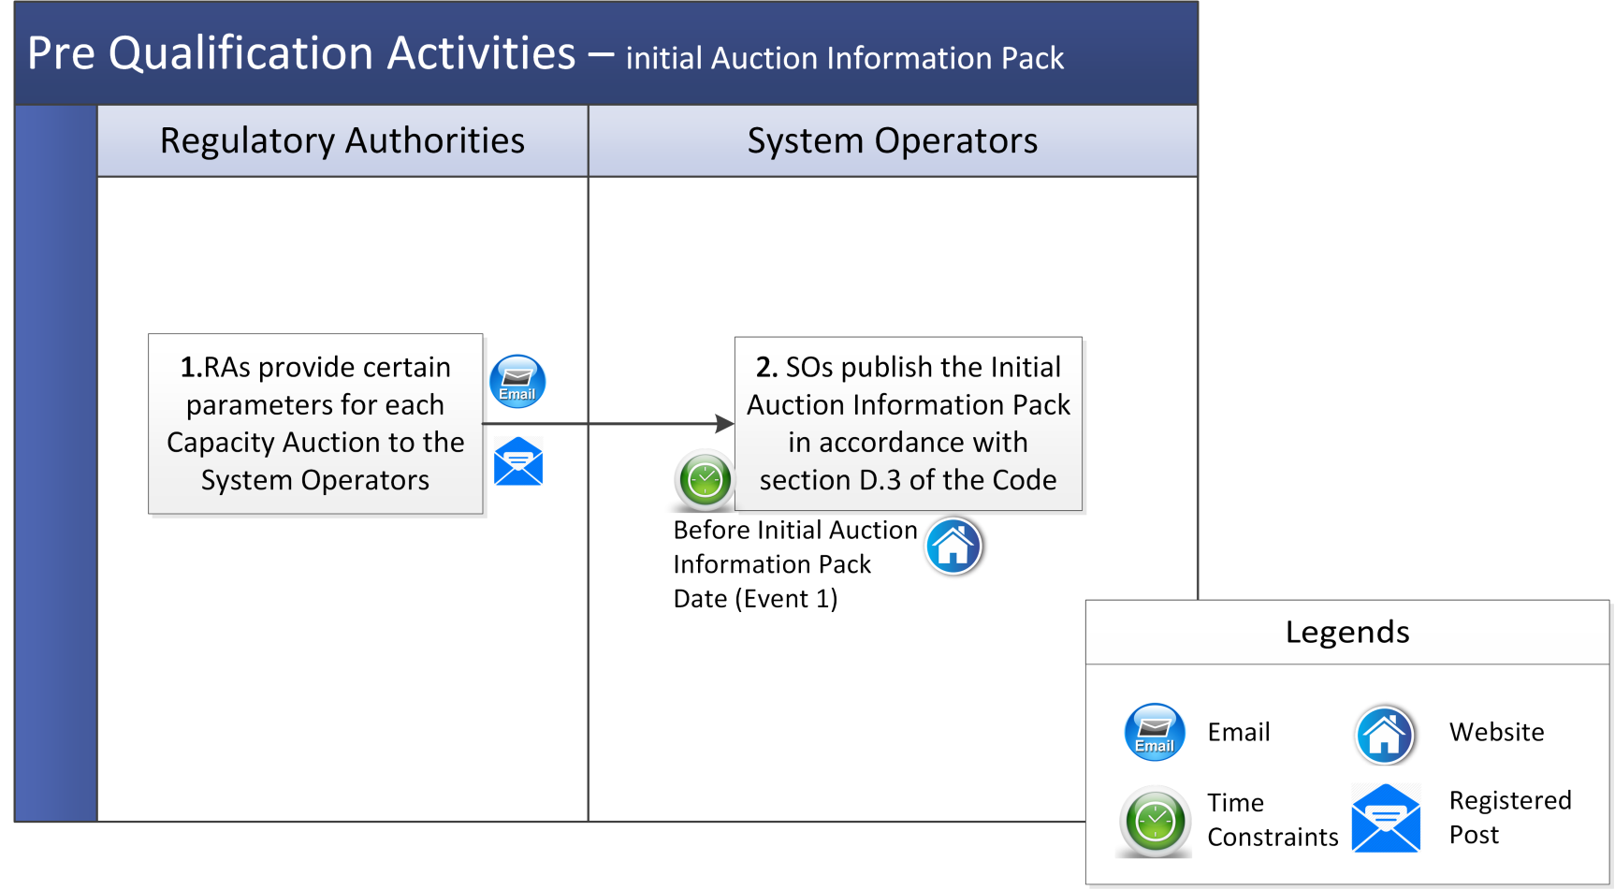

* + 1. *Exception Application - Unit Specific Price Cap*

A Participant may seek the approval of the Regulatory Authorities for all or a specified part of Existing Capacity to have a Unit Specific Price Cap. Details in relation to Unit Specific Price Cap are set out in section E.5 of the Code.

*Note:* Where applicable, timelines set out in this procedural steps table refer to numbering of events in the Capacity Auction Timetable indicative timeframes set out in Appendix C “Capacity Auction Timetable” of the Code. For applicable timelines please refer to the Capacity Auction Timetable for the relevant Capacity Auction.

| Step | Step Description | Timing | Method | By / From | To |
| --- | --- | --- | --- | --- | --- |
|  | Submit an Exception Application to the Regulatory Authorities in accordance with paragraph E.5.1.3 of the Code. | Before the Exception Application Date (Event 3) | As specified by the Regulatory Authorities | Participant | Regulatory Authorities |
|  | The Regulatory Authorities shall notify the System Operators, giving details as to the nature of the Exception Application. | - | - | Regulatory Authorities | Participant |
|  | The Regulatory Authorities may request further information or clarification by written notice to the Participant identifying the further information or clarification required and specifying a timeframe for providing it. | - | Email / Post | Regulatory Authorities | Participant |
|  | The Participant shall provide further information or clarification requested by the Regulatory Authorities within the timeline set out in the request. Otherwise the Participant shall be deemed to have withdrawn the application. | In accordance with the request | Email / Post | Participant | Regulatory Authorities |
|  | The Regulatory Authorities assess the Participant Exception Application for a Unit Specific Price Cap. | Before the Final Qualification Results Date (Event 7) | - | Regulatory Authorities | - |
|  | In accordance with paragraph E.5.1.8 of the Code, the Regulatory Authorities notify the Participant and System Operators whether or not they approve the Exception Application and if the Unit Specific Price Cap is approved, the capacity to which it relates and the Unit Specific Offer Price Cap (if applicable).  *Note:* In accordance with paragraph E.5.1.9 of the Code,  If:   * + - * 1. the Regulatory Authorities notify the System Operators that a Participant has made an Exception Application; but         2. the Regulatory Authorities have not notified the System Operators whether or not they approve the Exception Application 2 Working Days before the Provisional Qualification Results Date,   then, for the purposes of making the Provisional SO Qualification Decisions, the System Operators shall assume that the Exception Application has been approved. The relevant SO Qualification Decisions shall be subject to the condition that the Regulatory Authorities approve the Exception Application.  In accordance with paragraph E.5.1.10 of the Code, if the Regulatory Authorities do not notify the System Operators that they approve an Exception Application in respect of a Capacity Auction before the Final Qualification Results Date, the Regulatory Authorities shall be deemed not to have approved it. | Before the Final Qualification Results Date (Event 7) | Email and Post | Regulatory Authorities | Participant and System Operators |

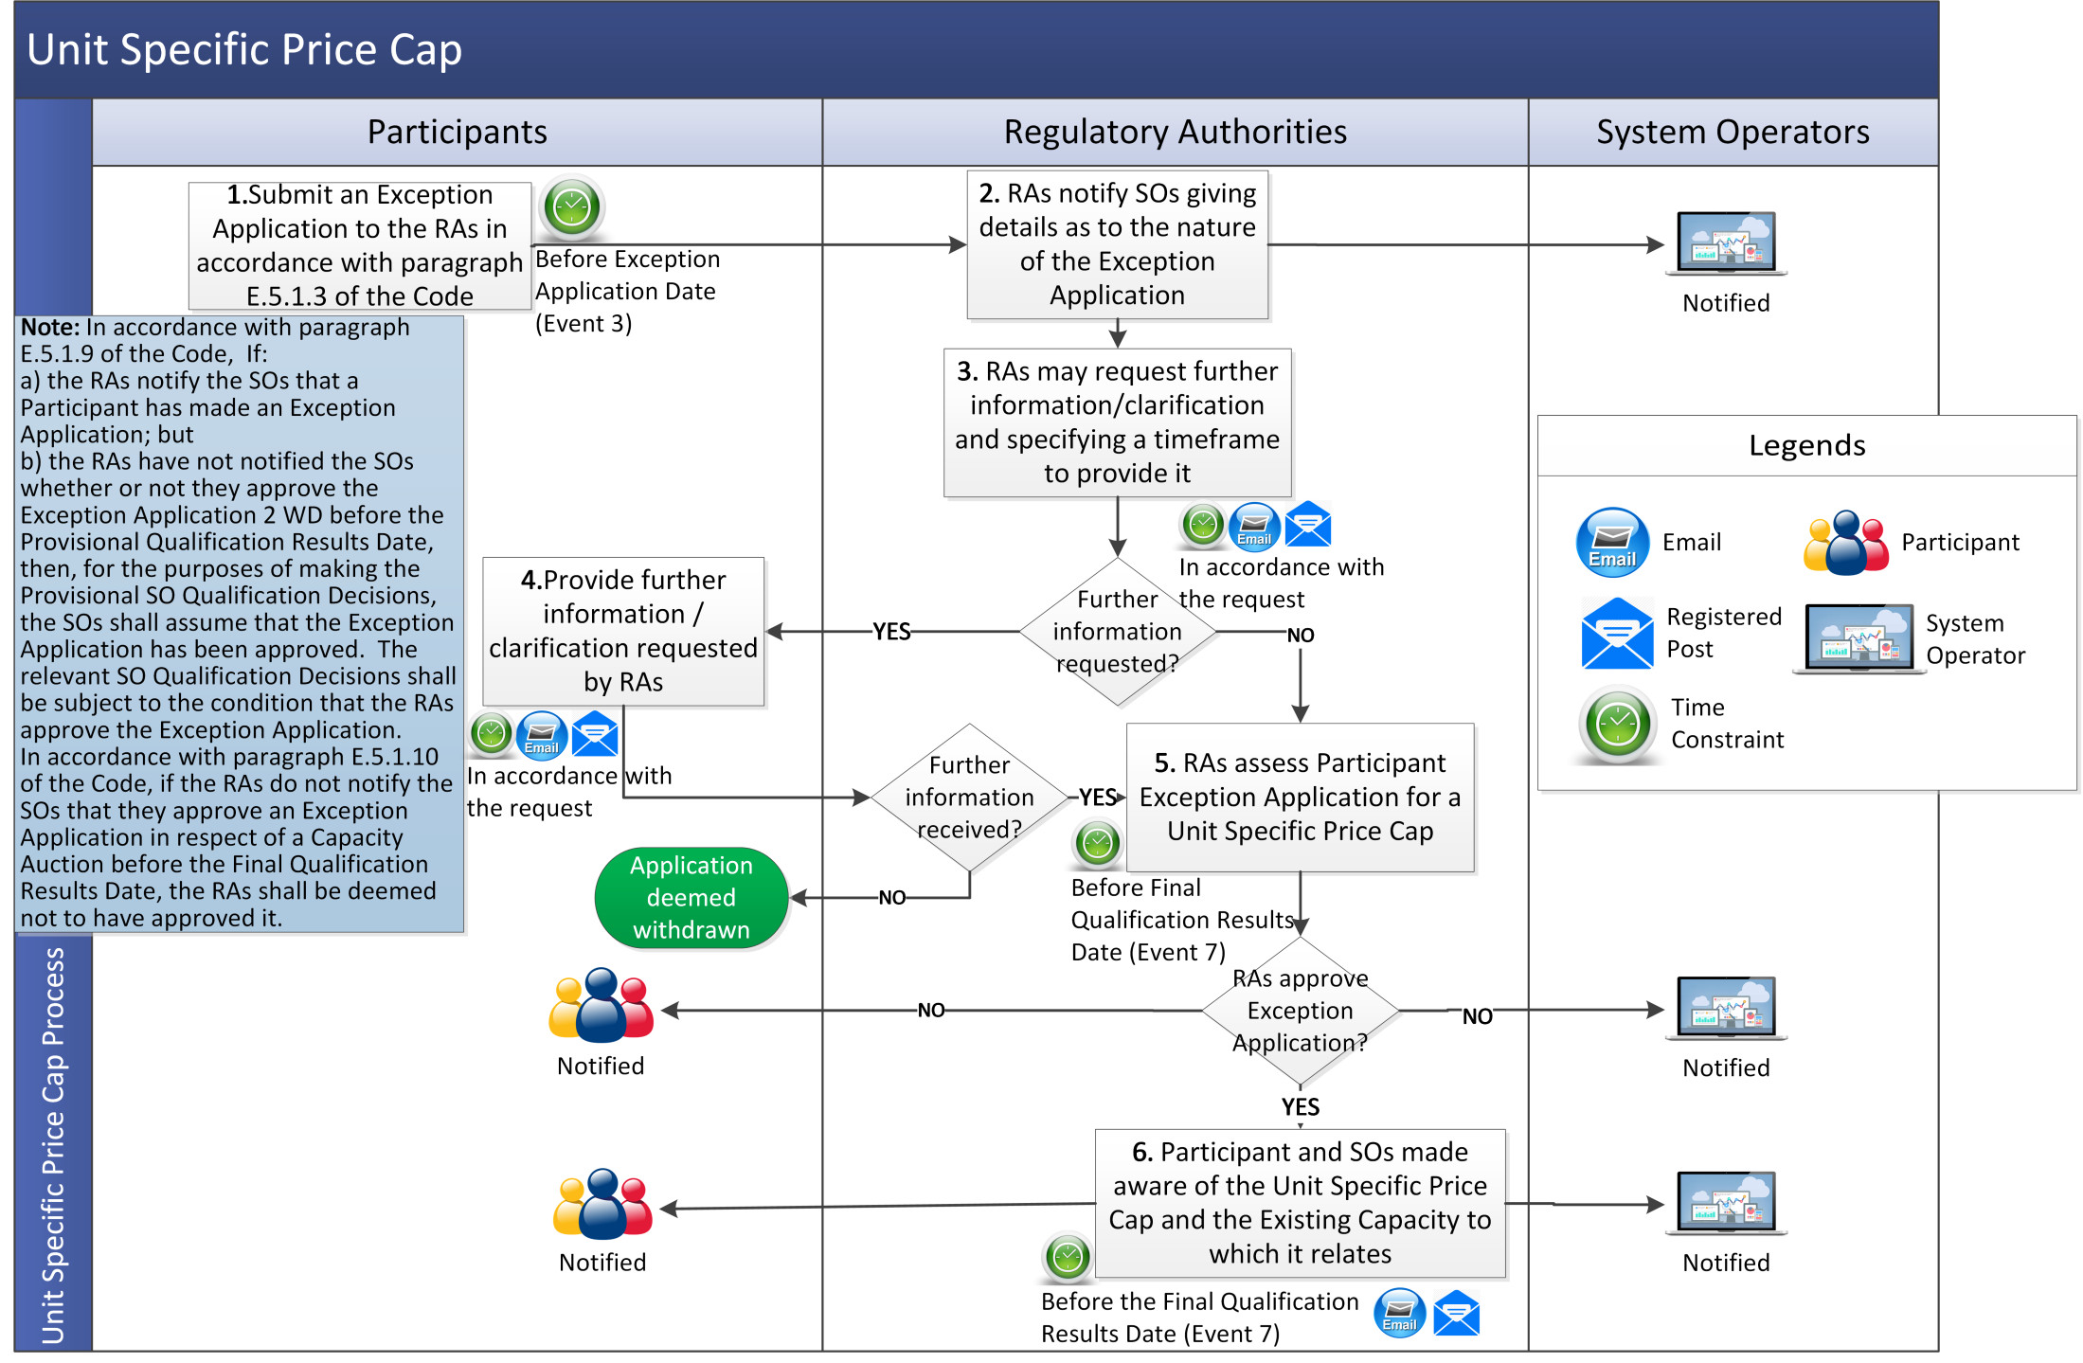

* + 1. *Exception Application - Cost Recovery beyond the New Capacity Investment Rate Threshold*

A Participant seeking cost recovery beyond the New Capacity Investment Rate Threshold should follow the process steps outlined below. Information on cost recovery beyond the New Capacity Investment Rate Threshold can be found in section E.5 and section E.7.5 of the Code.

*Note:* Where applicable, timelines set out in this procedural steps table refer to numbering of events in the Capacity Auction Timetable indicative timeframes set out in Appendix C “Capacity Auction Timetable” of the Code. For applicable timelines please refer to the Capacity Auction Timetable for the relevant Capacity Auction.

| Step | Step Description | Timing | Method | By / From | To |
| --- | --- | --- | --- | --- | --- |
|  | Submit an Exception Application to the Regulatory Authorities with information in Paragraph E.5.1.3 of the Code. | Prior to the Exception Application Date (Event 3) | As specified by the Regulatory Authorities | Participant | Regulatory Authorities |
|  | The Regulatory Authorities shall notify the System Operators, giving details as to the nature of the Exception Application. | - | - | Regulatory Authorities | Participant |
|  | The Regulatory Authorities may request further information or clarification by written notice to the Participant identifying the further information or clarification required and specifying a timeframe for providing it. | - | Email / Post | Regulatory Authorities | Participant |
|  | The Participant shall provide further information or clarification requested by the Regulatory Authorities within the timeline set out in the request. Otherwise the Participant shall be deemed to have withdrawn the application. | In accordance with the request | Email / Post | Participant | Regulatory Authorities |
|  | The Regulatory Authorities assess the Participant Application for cost recovery beyond the New Capacity Investment Rate Threshold. | Prior to the Final Qualification Results Date (Event 7) | - | Regulatory Authorities | - |
|  | The Regulatory Authorities notify the Participant and System Operators whether or not they approve the Exception Application and if they approve the application, the Maximum Capacity Duration approved for the New Capacity.  *Note:* In accordance with paragraph E.5.1.9 of the Code, If:   * + - * 1. the Regulatory Authorities notify the System Operators that a Participant has made an Exception Application E.5.1.2; but         2. the Regulatory Authorities have not notified the System Operators whether or not they approve the Exception Application 2 Working Days before the Provisional Qualification Results Date,   then, for the purposes of making the Provisional SO Qualification Decisions, the System Operators shall assume that the Exception Application has been approved. The relevant SO Qualification Decisions shall be subject to the condition that the Regulatory Authorities approve the Exception Application.  In accordance with paragraph E.5.1.10 of the Code, if the Regulatory Authorities do not notify the System Operators that they approve an Exception Application in respect of a Capacity Auction before the Final Qualification Results Date, the Regulatory Authorities shall be deemed not to have approved it. | Prior to the Final Qualification Results Date (Event 7) | Email and Post | Regulatory Authorities | Participant and System Operators |

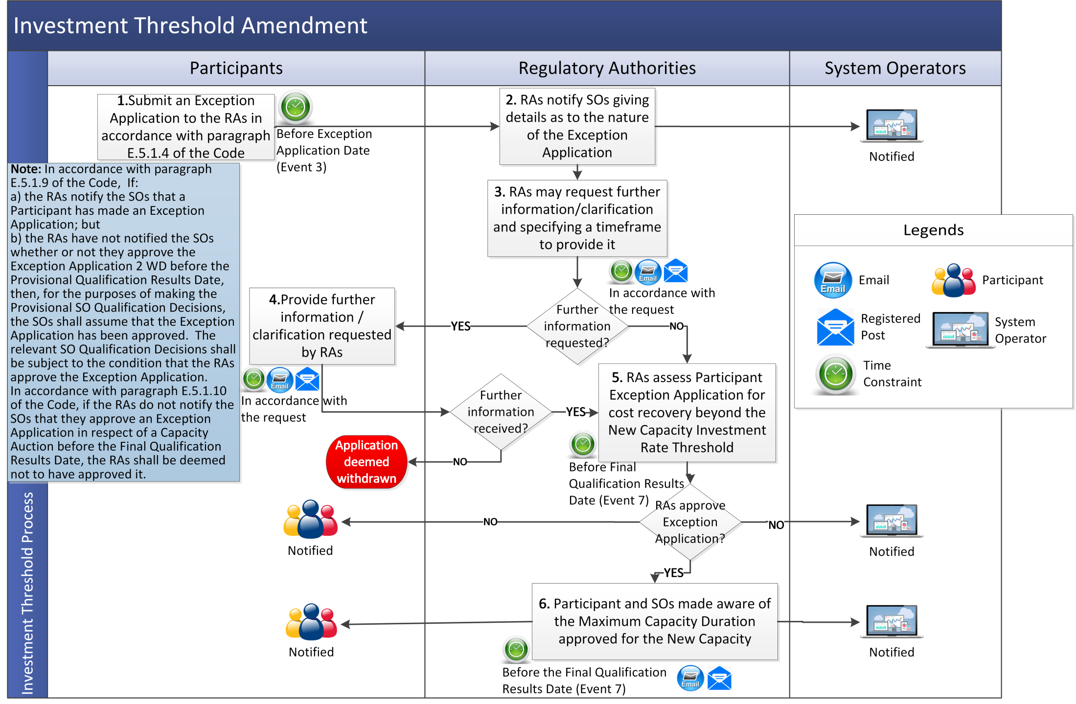

* + 1. *Opt-out Notification*

An Opt-out Notification is a notification provided by a Participant to the System Operators that a Generator Unit or Interconnector of that Participant shall not be included in an Application for Qualification in respect of a Capacity Auction. The rules in relation to Opt-out Notifications are set out in section E.3 of the Code.

*Note:*Where applicable, timelines set out in this procedural steps table refer to numbering of events in the Capacity Auction Timetable indicative timeframes set out in Appendix C “Capacity Auction Timetable” of the Code. For applicable timelines please refer to the Capacity Auction Timetable for the relevant Capacity Auction.

|  |  |  |  |  |  |
| --- | --- | --- | --- | --- | --- |
| Step | Step Description | Timing | Method | By / From | To |
|  | Participant submits an Opt-out Notification. An Opt-out Notification must include all the required information and supporting documentation set out in paragraph E.3.1.3 of the Code.  *Note:* In the event that an Opt-out Notification is rejected, it may be resubmitted before the Opt-out Notification Date (see step 4). Therefore, in order to allow for an opportunity for resubmission, an Opt-out Notification should be submitted as early as possible. | Before the Opt-out Notification Date (Event 2) | Email on template provided by System Operators | Participant | System Operators |
|  | The System Operators assess the Candidate Unit Opt-out Notification application. The System Operators shall either confirm receipt of a valid notification or request additional information or documentation. | As soon as reasonably practicable following the submission | Assessment of the Opt-out Notification data | System Operators | - |
|  | The System Operators shall reject an Opt-out Notification in the circumstances outlined in paragraph E.3.1.4 of the Code and inform the Participant of the rejection. | As soon as reasonably practicable following the submission | Email | System Operators | Participant |
|  | The Participant may resubmit the Opt-out Notification if there is sufficient time. If they choose not to resubmit the Opt-out Notification the Participant should commence the Qualification Process as normal. | Before the Opt-out Notification Date (Event 2) | Email on template provided by System Operators | Participant | System Operators |
|  | The System Operators update the Qualification Capacity Register with the opt-out information provided by the Participant. | On acceptance of the Opt-out Notification | System update | System Operators | - |

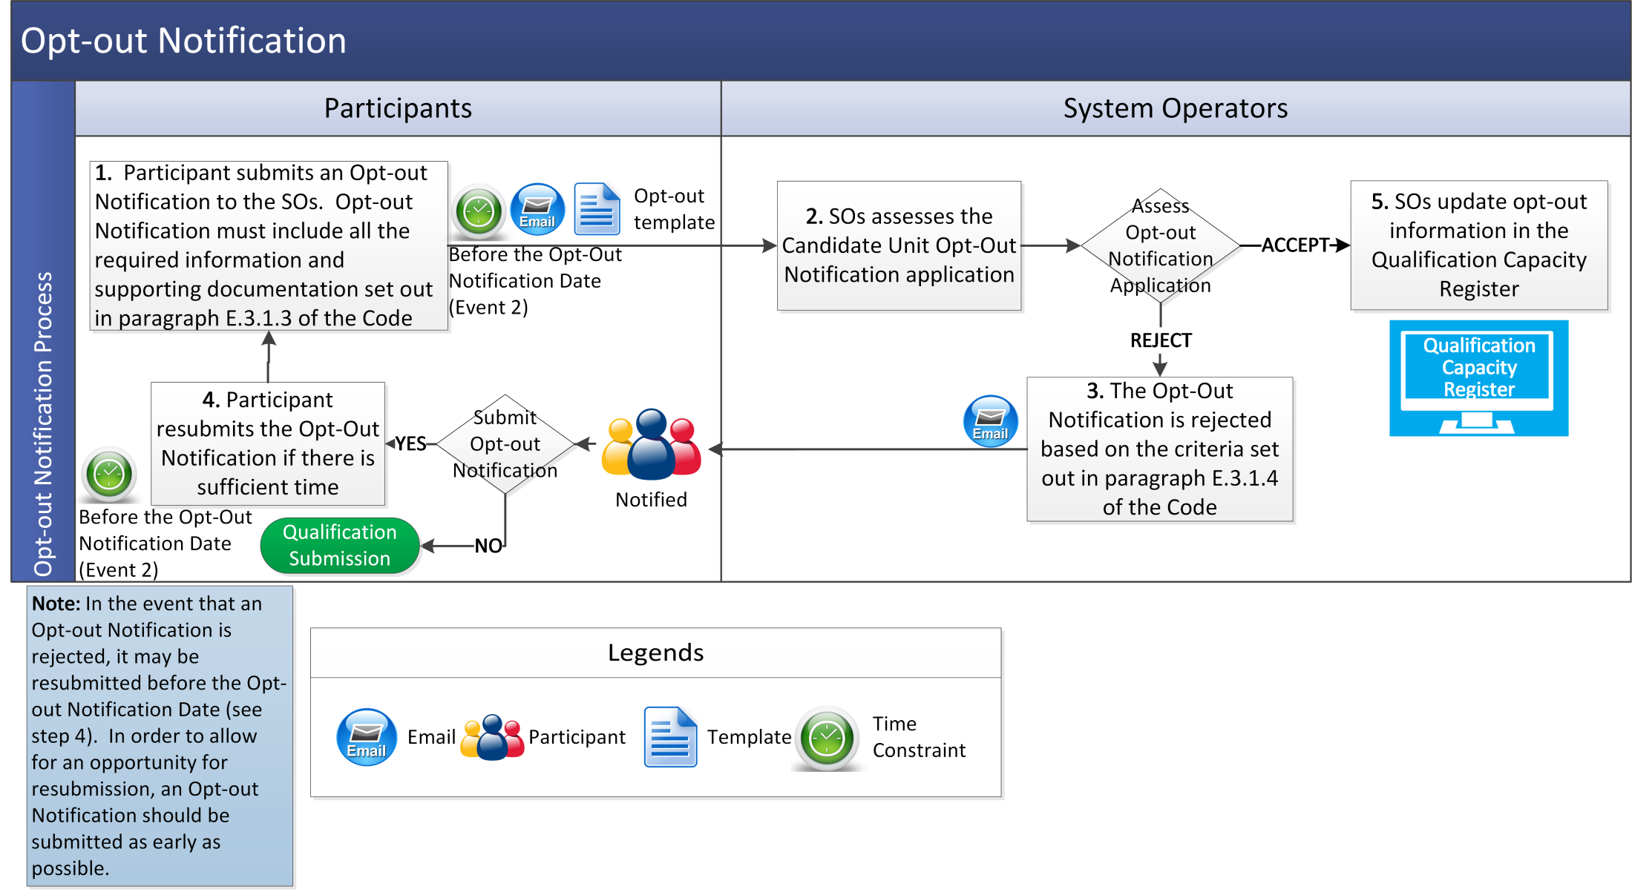

* 1. Application for Qualification and Qualification Assessment

*Note:* Where applicable, timelines set out in this procedural steps table refer to numbering of events in the Capacity Auction Timetable indicative timeframes set out in Appendix C “Capacity Auction Timetable” of the Code. For applicable timelines please refer to the Capacity Auction Timetable for the relevant Capacity Auction.

|  |  |  |  |  |  |  |
| --- | --- | --- | --- | --- | --- | --- |
| Step | Step Description | Timing | Method | By / From | To | |
|  | The System Operators shall provide the relevant forms to be completed by applicants as part of the Qualification Process. | - | System Operators’ website / Email if requested | System Operators | Applicants |
|  | The Participant submits an Application for Qualification for a Candidate Unit or a combination of Candidate Units, in the format specified by the System Operators.  The information required in an Application for Qualification is outlined in Appendix D “Qualification Data” of the Code. | Before the Qualification Application Date (Event 4) | Email | Applicants | System Operators | |
|  | The System Operators shall use reasonable endeavours to conduct an initial assessment to determine whether the Application for Qualification contains all the information required under Appendix D “Qualification Data” of the Code. | - | - | System Operators | - | |
|  | The System Operators may inform the Applicant if the initial assessment in step 3 indicates that the Application for Qualification is incomplete. | - | Email | System Operators | Applicants | |
|  | The Applicant may update its Qualification Data and submit a new Application for Qualification prior to the Qualification Application Date. | Before Qualification Application Date (Event 4) | Email | Applicants | System Operators | |
|  | The System Operators assess the Applications for Qualification in accordance with sections E.6, E.7 and E.8 of the Code. | - | - | System Operators | - | |
|  | The System Operators accept an Application for Qualification and determine that the relevant Candidate Unit is Qualified to be a Capacity Market Unit, or part of a Capacity Market Unit, under section E.6 of the Code, except in the circumstances set out in section E.7 of the Code. | - | - | System Operators | - | |

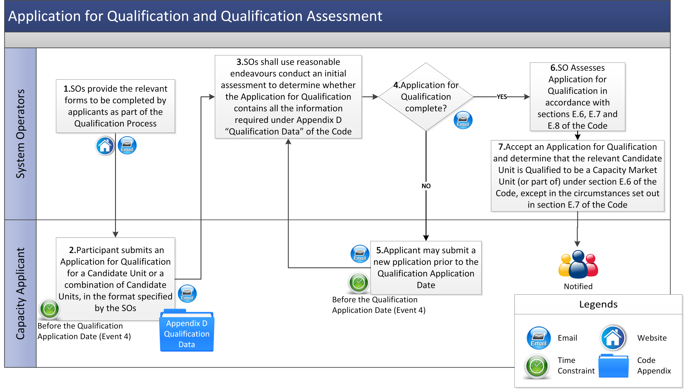

* 1. Notification of Qualification Decisions

Qualification Decisions shall contain the information outlined in section E.9.1 of the Code.

* + 1. *Provisional SO Qualification Decisions*

The procedural steps table below sets out the procedure in relation to the provisional set of decisions in respect of a Qualification Process.

*Note:*Where applicable, timelines set out in this procedural steps table refer to numbering of events in the Capacity Auction Timetable indicative timeframes set out in Appendix C “Capacity Auction Timetable” of the Code. For applicable timelines please refer to the Capacity Auction Timetable for the relevant Capacity Auction.

|  |  |  |  |  |  |
| --- | --- | --- | --- | --- | --- |
| Step | Step Description | Timing | Method | By / From | To |
|  | If the System Operators propose to Qualify a Capacity Market Unit, they shall notify the relevant Participant of their Provisional SO Qualification Decisions in respect of the Capacity Market Unit. | Use reasonable endeavours to give notification before the Provisional Qualification Results Date (Event 5) | Email | System Operators | Participant |
|  | If the System Operators propose to reject an Application for Qualification submitted by a Participant they shall notify the Participant of the requirements under section E.7 of the Code that the Application for Qualification failed to satisfy. | Use reasonable endeavours to give notification before the Provisional Qualification Results Date (Event 5) | Email | System Operators | Participant |
|  | The System Operators submit to the Regulatory Authorities all the Provisional SO Qualification Decisions in relation to the Qualification Process in respect of the Capacity Auction. | Use reasonable endeavours to submit before the Provisional Qualification Results Date (Event 5) |  | System Operators | Regulatory Authorities |
|  | The Applicant may view the Provisional SO Qualification Decisions online. | After the Provisional Qualification Results Date (Event 5) | Capacity Market Platform | Applicant | Qualification system |
|  | An Applicant may request the System Operators to review a rejection or Provisional SO Qualification Decision in accordance with section E.9.3 of the Code and section 3.4.2 below. | - | - | Applicant | System Operators |

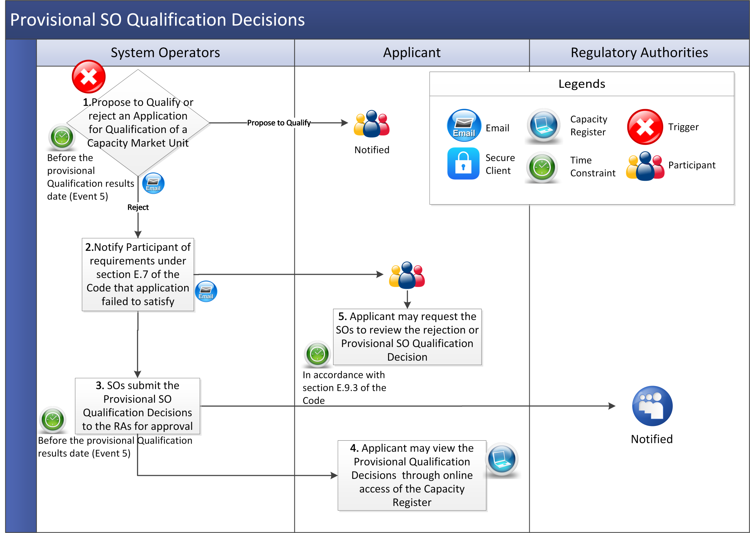

* + 1. *Reconsideration of Provisional SO Qualification Decisions*

In the circumstances set out in paragraph E.9.3.1 of the Code a Participant may request the System Operators to review a rejection of an Application for Qualification or a Provisional SO Qualification Decision in accordance with section E.9.3 of the Code and the procedural steps set out below.

*Note:* Where applicable, timelines set out in this procedural steps table refer to numbering of events in the Capacity Auction Timetable indicative timeframes set out in Appendix C “Capacity Auction Timetable” of the Code. For applicable timelines please refer to the Capacity Auction Timetable for the relevant Capacity Auction.

| Step | Step Description | Timing | Method | By / From | To |
| --- | --- | --- | --- | --- | --- |
|  | In the circumstances set out in paragraph E.9.3.1 of the Code, a Participant may request the System Operators to review a rejection of an Application for Qualification or a Provisional SO Qualification Decision by lodging an Application for Review. An Application for Review must contain the information and documentation outlined in paragraph E.9.3.2 of the Code. | Within the Prescribed Timeframe of being notified of the Reviewable Decision (Event 19) | Email using the template provided by the System Operators | Participant | System Operators |
|  | The System Operators assess the Application for Review for completeness. | - | - | System Operators | - |
|  | If the Application for Review does not comply with paragraph E.9.3.2 of the Code, the System Operators shall give notice to the Participant lodging the application that the application is rejected as it does not comply with that paragraph, and give the reason why. | Within the Prescribed Timeframe after receiving an Application for Review (Event 20) | Email | System Operators | Participant |
|  | If further information is required the System Operators shall request further information in order to reconsider the Reviewable Decision the subject of the Application for Review, then the Participant shall provide that information. | - | Email | System Operators | Participant |
|  | The Participant shall provide any further information requested by the System Operators. | Within the Prescribed Timeframe of the request for further information (Event 21) | Email using the template provided by the System Operators | Participant | System Operators |
|  | The System Operators reconsider the Reviewable Decision that is the subject of the Application for Review and inform the Participant of the outcome of the reconsideration and their reasons for the outcome. | Within the Prescribed Timeframe of receiving an Application for Review (Event 22) | Email | System Operators | - |
| 1. 7 | If the System Operators reject the Application for Review the Participant may give notice of a Qualification Dispute in accordance with paragraph B.14.2.1 of the Code. | In accordance with section B.14 of the Code (Event 24) | - | Participant | - |

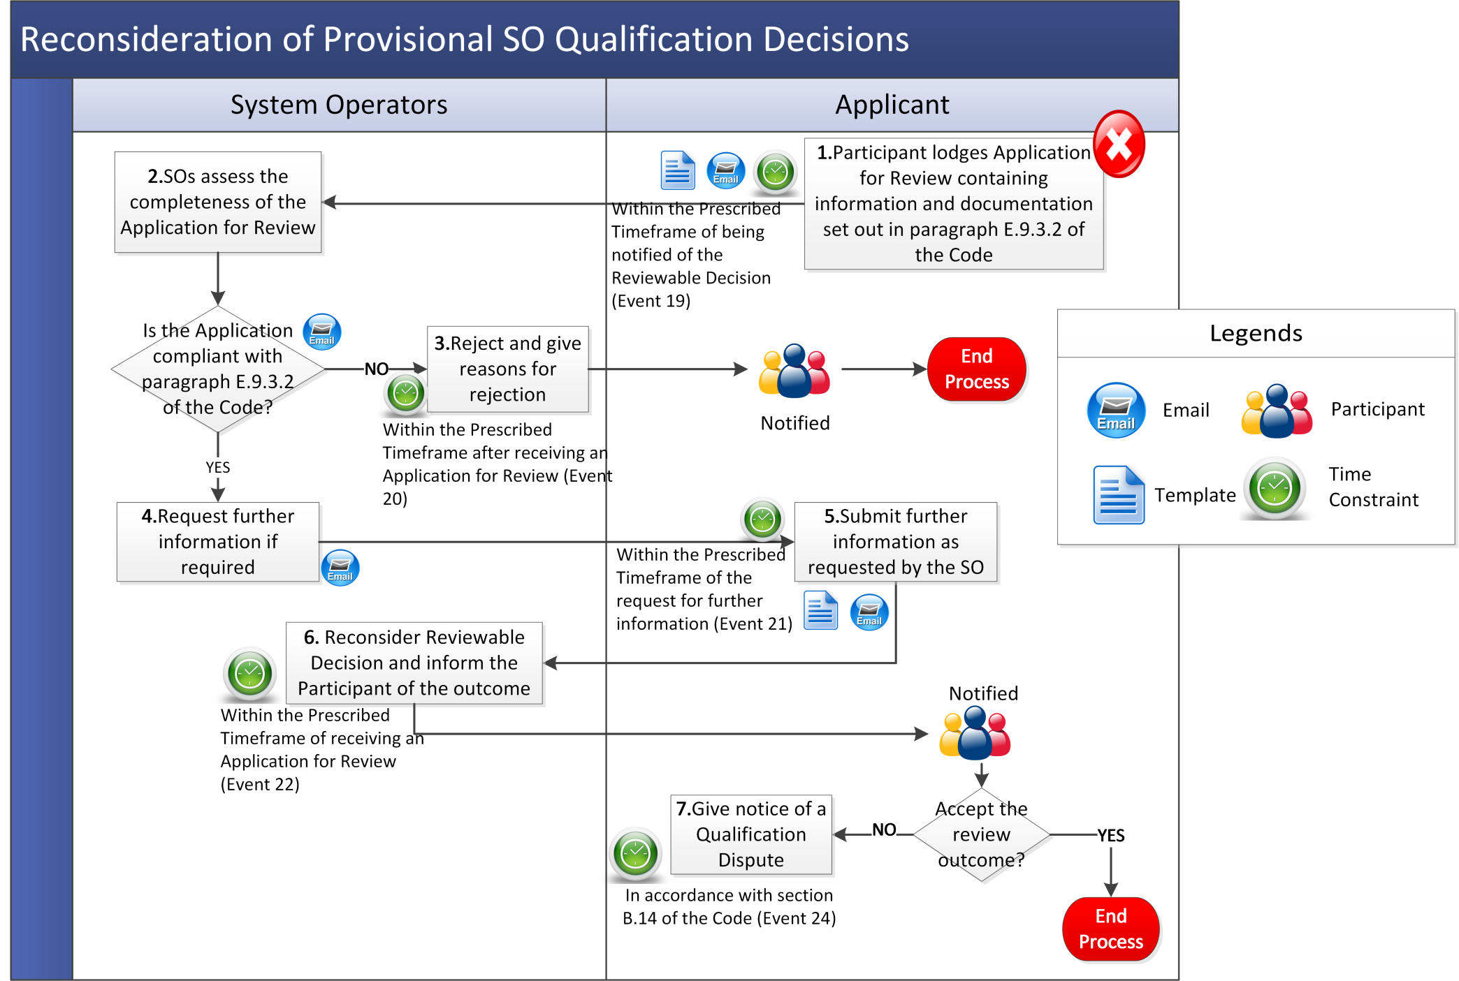

* + 1. *Final Qualification Decisions*

The System Operators shall prepare a set of Final Qualification Decisions specifying the information set out at paragraph E.9.4.1 of the Code.

*Note:*Where applicable, timelines set out in this procedural steps table refer to numbering of events in the Capacity Auction Timetable indicative timeframes set out in Appendix C “Capacity Auction Timetable” of the Code. For up-to-date timelines please refer to the Capacity Auction Timetable for the relevant Capacity Auction.

| **Step** | **Step Description** | **Timing** | **Method** | **By / From** | **To** |
| --- | --- | --- | --- | --- | --- |
|  | The System Operators submit the Final Qualification Decisions to the Regulatory Authorities for approval. | Use reasonable endeavours to submit before the Final Qualification Submission Date (Event 6) | Email | System Operators | Regulatory Authorities |
|  | The Regulatory Authorities review the Final Qualification Decisions. | - | - | Regulatory Authorities | - |
|  | The Regulatory Authorities may approve or reject one or more Final Qualification Decisions submitted by the System under paragraph E.9.4.1 of the Code by written notice to the System Operators (giving reasons in the case of rejection).  *Note:* If the Regulatory Authorities do not notify the System Operators that they reject a Final Qualification Decision on or before the date that is two Working Days before the Final Qualification Results Date then they will be taken to have approved the decision submitted by the System Operators. | - | Written notice | Regulatory Authorities | System Operators |
|  | If the Regulatory Authorities reject a Final Qualification Decision submitted by the System Operators under paragraph E.9.4.1 of the Code, then the Regulatory Authorities may determine an alternative decision in substitution for that of the System Operators. | - | Written notice | Regulatory Authorities | System Operators |
|  | The System Operators shall notify Participants of the approved Final Qualification Decisions in respect of their Capacity Market Units.  Note: The Final Qualification decisions approved, or deemed to have been approved by the Regulatory Authorities (and as substituted by the Regulatory Authorities) under section E.9.4 of the Code are final and binding on the Parties. | By later of Final Qualification Results Date (Event 7) and a date being two Working Days after the Regulatory Authorities have approved (or deemed to have approved) the Final Qualification Decisions in respect of the relevant Capacity Auction | Email | System Operators | Participants |

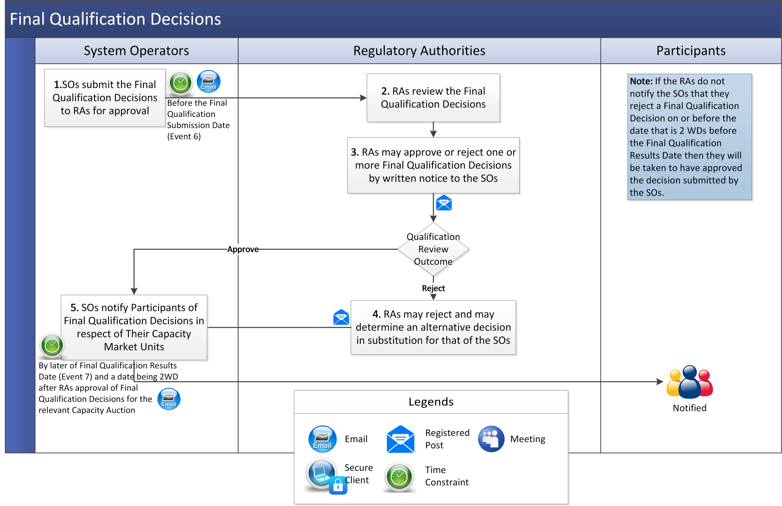

* + 1. *Publication of Qualification Results*

*Note:* Where applicable, timelines set out in this procedural steps table refer to numbering of events in the Capacity Auction Timetable indicative timeframes set out in Appendix C “Capacity Auction Timetable” of the Code. For applicable timelines please refer to the Capacity Auction Timetable for the relevant Capacity Auction.

|  |  |  |  |  |  |
| --- | --- | --- | --- | --- | --- |
| Step | Step Description | Timing | Method | By / From | To |
|  | The Systems Operators shall publish the information as outlined in section E.9.5 of the Code. | Use reasonable endeavours to publish before Qualification Results Publication Date (Event 8) | System Operators’ website | System Operators | - |
|  | Any person may view the qualification results report online. | Post Qualification Results Publication | System Operators’ website | - | - |

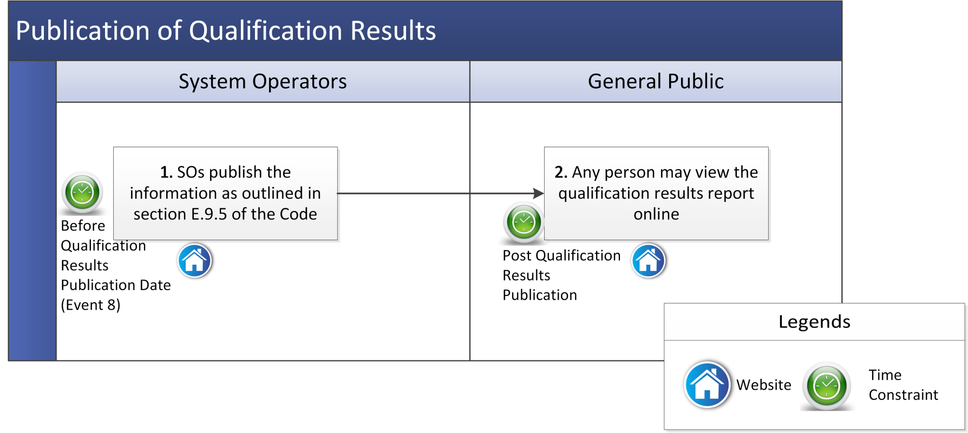

* 1. Other Qualification Related Process
     1. *Extended Qualification for Secondary Trade - Early Start*

Where Existing Capacity has been Qualified in respect of a Capacity Year (in this section called “**Qualified Year**”) and is commissioned prior to the commencement of the Qualified Year, a Participant may apply to the System Operators for permission to participate in Secondary Trade Auctions in respect of the relevant Capacity Market Unit from a specified date (in this section called the “**Start Date**”) in the prior Capacity Year (in this section called the “**Prior Year**”).

|  |  |  |  |  |  |
| --- | --- | --- | --- | --- | --- |
| Step | Step Description | Timing | Method | By / From | To |
|  | Participant submits an application to participate in Secondary Trade Auctions in respect of the relevant Capacity Market Unit (has been Qualified in respect of Existing Capacity for the Qualified Year but has not previously been so Qualified for the Prior Year) using the “Secondary Trade Early Start Template” provided by the System Operators. | - | Email using the relevant template provided by the System Operators | Participant | System Operators |
|  | System Operators shall where applicable, if they consider that further information or clarification is required in order to consider the application, send a notice to the Participant identifying the further information or clarification required. | Within 5 WD of receiving the application | Email | System Operators | Participant |
|  | In the circumstances set out in paragraph E.10.1.2 (a) – (c) of the Code, the System Operators shall:   1. approve the application; and 2. determine that the Qualified values that apply in the Qualified Year shall also apply in the Prior Year from the Start Date. | In accordance with section E.10.3 of the Code | - | System Operators | - |
|  | The System Operators shall:   1. notify the Participant accordingly; and 2. publish a notice identifying the Capacity Market Unit and specifying the new Start Date from which it is Qualified. | In accordance with section E.10.3 of the Code | Email / System Operators’ website | System Operators | Participant / Public |

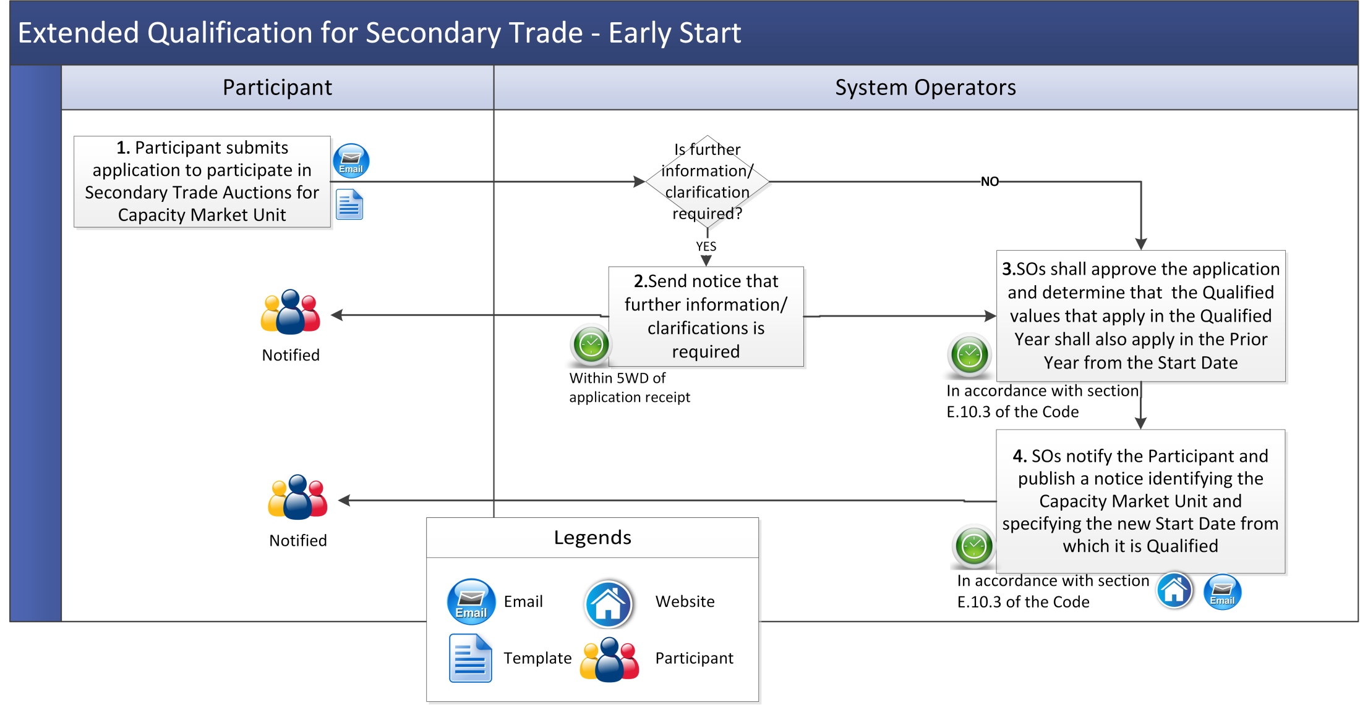

* + 1. *Extended Qualification for Secondary Trade - Extended Duration*

Where Existing Capacity has been Qualified in respect of a Capacity Year (in this section called the “**Qualified Year**”) and the relevant Participant intends to Close the relevant Capacity Market Unit during the following Capacity Year (in this section called the “**Following Year**”), the Participant may apply to the System Operators for permission to participate in Secondary Trade Auctions until a specified date (in this section called the “**Closing Date**”).

|  |  |  |  |  |  |
| --- | --- | --- | --- | --- | --- |
| Step | Step Description | Timing | Method | By / From | To |
|  | Participant submits an application for qualification for permission to participate in Secondary Trade Auctions until the Closing Date in the Following Year in respect of the relevant Capacity Market Unit that has been Qualified in respect of the Existing Capacity for the Qualified Year but has not previously been so Qualified for the Following Year using the relevant template provided by the System Operators. | - | Email using the template provided by the System Operators | Participant | System Operators |
|  | System Operators shall where applicable, if they consider that further information or clarification is required in order to consider the application, send a notice to the Participant identifying the further information or clarification required. | Within 5 WD of receiving the application | Email | System Operators | Participant |
|  | In the circumstances set out in paragraph E.10.2.2 (a) – (b) of the Code the System Operators shall:   1. approve the application; and 2. determine that the qualified values with respect to the Capacity Market Unit that apply in the Qualified Year to apply in the Following Year until the specified Closing Date. | In accordance with section E.10.3 of the Code | - | System Operators | - |
|  | The System Operators:   1. notify the Participant accordingly; and 2. publish a notice identifying the Capacity Market Unit and the Closing Date. | In accordance with section E.10.3 of the Code | Email and System Operators’ website | System Operators | Participant |

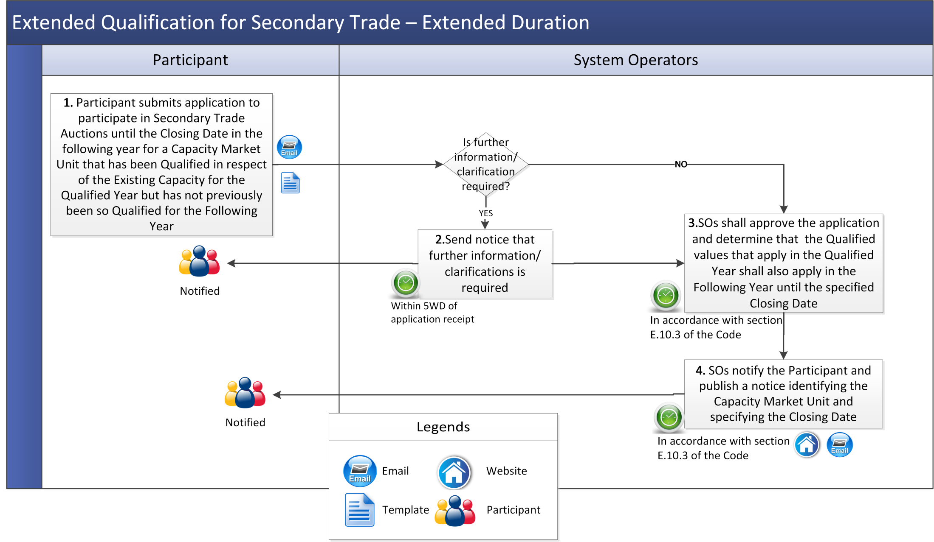

Part B Auction Process

1. Overview
   1. Capacity Auction Process

The procedures outlined in this section consist of a number of pre Capacity Auction and Post Capacity Auction steps as summarised below.

* 1. Key Capacity Auction Dates

This section provides an overview of the sequence of Auction events. Any timelines given are indicative as these dates are approved by the Regulatory Authorities and may vary for each Capacity Auction. Key Capacity Auction dates are set out below.

**Initial Auction Information Pack Date:**  the last publication date for the Initial Auction Information Pack.

**Date for finalising the Locational Capacity Constraint Limits for the Capacity Auction.**

**Final Auction Information Pack Date:** the date by which the System Operators are expected to publish the Final Auction Information Pack for the Capacity Auction.

**Capacity Auction Submission Commencement:**  The earliest date and time that Participants will be able to submit Capacity Auction Offers in respect of Capacity Market Units Qualified to participate in the Capacity Auction.

**Capacity Auction Submission End:**  the last date and time until which Participants will be able to submit Capacity Auction Offers in respect of Capacity Market Units Qualified to participate in the Capacity Auction.

**Capacity Auction Run Start:** the day and time that the System Operators initiate the run of the software program referred to in paragraph F.8.5.1 in respect of the Capacity Auction.

**Capacity Auction Completion Date:** the date by which the System Operators are expected to complete the Capacity Auction (including Capacity Auction Monitor review).

**Capacity Auction Provisional Results Date:** the date by which the System Operators are expected to provide provisional Capacity Auction Results to Participants.

**Capacity Auction Approval Date:** the date by which the Regulatory Authorities are expected to approve the Capacity Auction results.

**Capacity Auction Results Date:** the date the System Operators are expected to publish the Capacity Auction results.

**Performance Security Date:**  the last date for Participants to provide Performance Securities to the System Operators for Awarded New Capacity allocated in the Capacity Auction.

1. Procedural Steps
   1. Pre-Auction
      1. *Final Auction Information Pack Publication*

*Note:* Where applicable, timelines set out in this procedural steps table refer to numbering of events in the Capacity Auction Timetable indicative timeframes set out in Appendix C “Capacity Auction Timetable” of the Code. For applicable timelines please refer to the Capacity Auction Timetable for the relevant Capacity Auction.

|  |  |  |  |  |  |
| --- | --- | --- | --- | --- | --- |
| Step | Step Description | Timing | Method | By From | To |
|  | The Regulatory Authorities shall provide to the System Operators:   1. the final Annual Capacity Payment Exchange Rate to be used by the System Operators in conducting the Capacity Auction applicable to Awarded Capacity in the Capacity Auction to be included in the Final Auction Information Pack; and 2. the Demand Curve to be employed in the Capacity Auction in accordance with section F.3 of the Code. | - | - | Regulatory Authorities | System Operators |
|  | The System Operators shall publish the Final Auction Information Pack for the Capacity Auction which shall include the data outlined in section F.5.1.3 of the Code. | Use reasonable endeavours to publish by the later of: (a) the Final Auction Information Pack Date (Event 10); and (b) two WD after the last of the date the Regulatory Authorities provide the Demand Curve and the final Annual Capacity Payment Exchange Rate for the Capacity Auction to the System Operators. | System Operators’ website | System Operators | Participants |

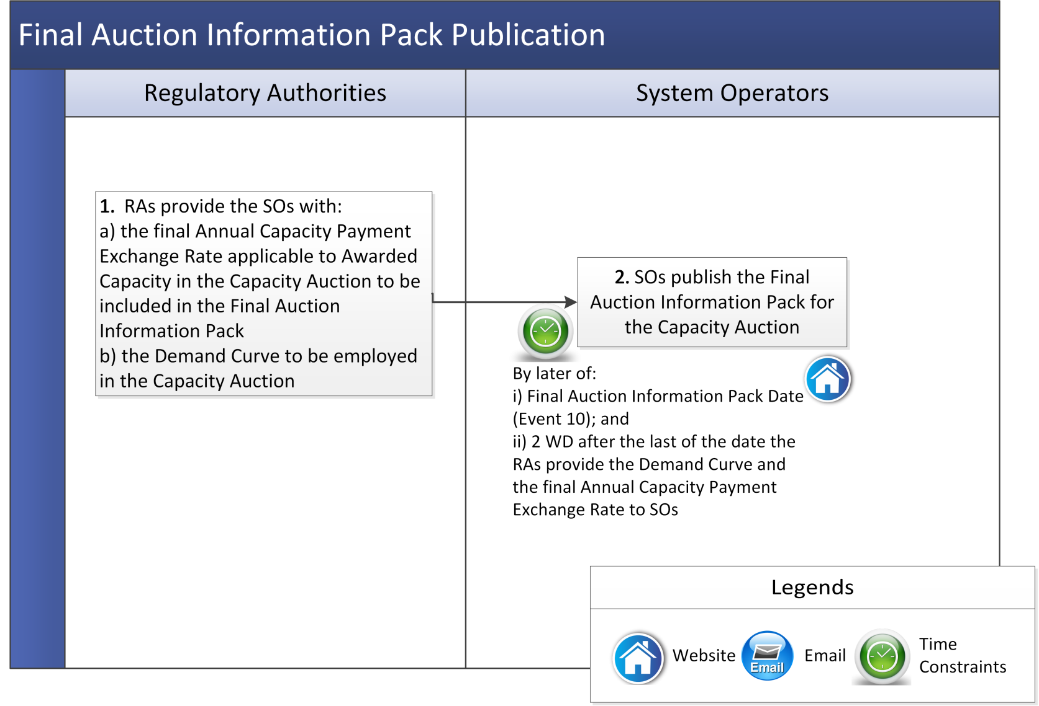

* + 1. *Capacity Auction Platform Access and Capacity Auction Offer Submissions*

A Participant offering quantities into a Capacity Auction shall use the Capacity Market Platform (subject to system and communication failures described in Agreed Procedure 6 “System and Communication Failures) and comply with any procedures issued by the System Operators in relation to using the Capacity Market Platform.

The Auction shall be conducted over the internet. Participants shall access the Capacity Market Platform using an internet browser.

*Note:* Where applicable, timelines set out in this procedural steps table refer to numbering of events in the Capacity Auction Timetable indicative timeframes set out in Appendix C “Capacity Auction Timetable” of the Code. For applicable timelines please refer to the Capacity Auction Timetable for the relevant Capacity Auction.

|  |  |  |  |  |  |
| --- | --- | --- | --- | --- | --- |
| Step | Auction System Access | Timing | Method | By From | To |
|  | The System Operators give Participants with Capacity Market Units Qualified for the Capacity Auction access to the Capacity Market Platform to allow them to submit Capacity Auction Offers. | Before Capacity Auction Submission Commencement date and time (Event 11) | Email | System Operators | Participants |
| Step | **Offer Submissions** | **Timing** | **Method** | **By From** | **To** |
|  | Participants may submit Capacity Auction Offers.  Section F.6.2 of the Code provides information in relation to the submission of Capacity Auction Offers. Additional information in relation to Capacity Auction Offers is set out in section F.7 of the Code. | Between the Capacity Auction Submission Commencement date and time (Event 11), to Capacity Auction Submission End date and time (Event 12) | Capacity Market Platform | Participants | System Operators |
|  | The System Operators assess the Capacity Auction Offers. | Throughout the Capacity Auction window | Automated system check | Capacity Market Platform | - |
|  | The Participants are notified whether are not their offer complies with the requirements of the Code and is therefore a valid Capacity Auction Offer. | Throughout the Capacity Auction window | Capacity Market Platform | System Operators | Participants |
|  | *Note:* If at the close of the Capacity Auction window, the System Operators have not received a valid set of price-quantity pairs in respect of a Capacity Market Unit with a non-zero Firm Offer Requirement, then the System Operators must determine a set of price-quantity pairs for that Capacity Market Unit in accordance with paragraph F.7.1.3 of the Code. | After the Capacity Auction Submission End date and time (Event 11) | In accordance with paragraph F.7.1.3 of the Code | System Operators | - |

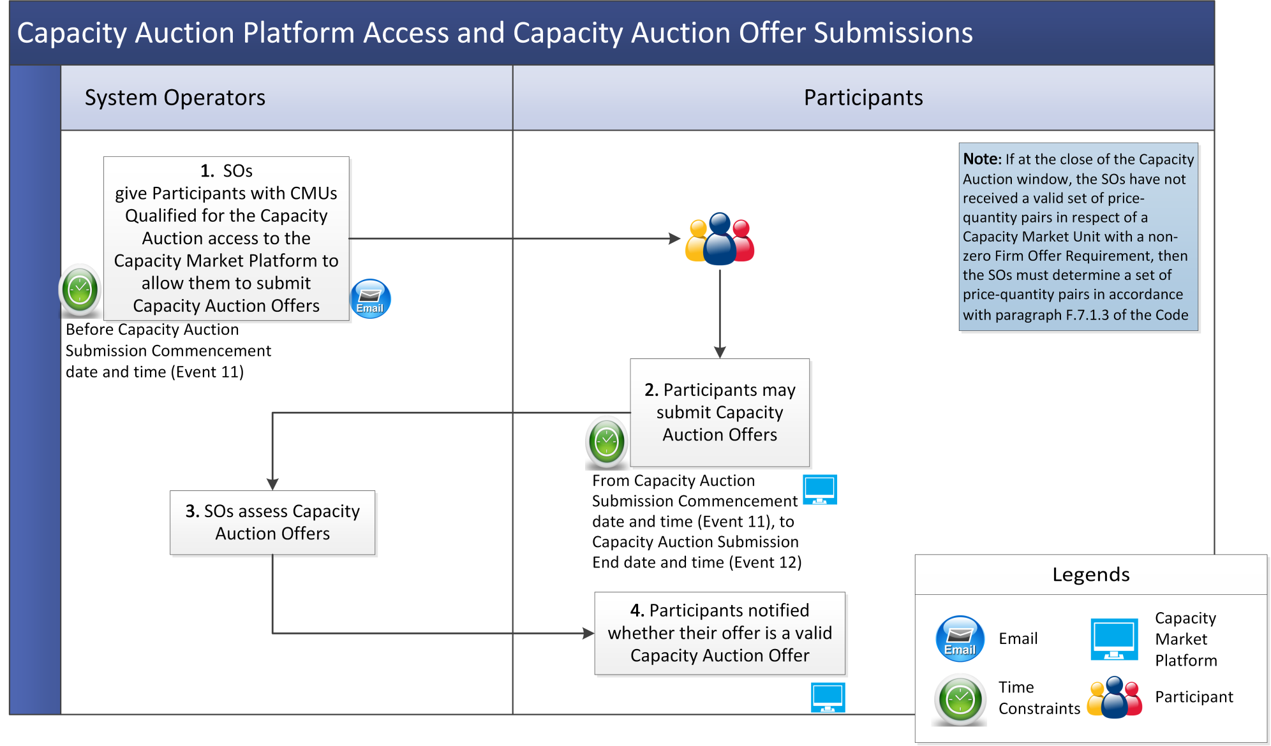

* 1. Post Auction
     1. *Provisional and Final Capacity Auction Results*

*Note:* Where applicable, timelines set out in this procedural steps table refer to numbering of events in the Capacity Auction Timetable indicative timeframes set out in Appendix C “Capacity Auction Timetable” of the Code. For applicable timelines please refer to the Capacity Auction Timetable for the relevant Capacity Auction.

|  |  |  |  |  |  |
| --- | --- | --- | --- | --- | --- |
| Step | Provisional Auction Results | Timing | Method | By / From | To |
|  | The System Operators shall provide provisional Capacity Auction Results to the applicable Participant. Provisional Capacity Auction Results will contain the information as outlined in section F.9.1 of the Code. | Use reasonable endeavours to provide before the Capacity Auction Provisional Results Date (Event 15) | Capacity Auction Platform | System Operators | Participants |
|  | The System Operators submit the provisional Capacity Auction Results for all Capacity Market Units in respect of a Capacity Auction to the Regulatory Authorities for approval. | Before the Capacity Auction Provisional Results Date (Event 15) | - | System Operators | Regulatory Authorities |
|  | The Regulatory Authorities may approve or reject one or more provisional Capacity Auction Results provided by the System Operators under paragraph F.9.3.1 of the Code by written notice to the System Operators (based on the Capacity Auction Monitor’s report in relation to the Capacity Auction provided to the Regulatory Authorities in accordance with section B.11 of the Code).  *Note:* In the circumstances set out in paragraph F.9.3.3 of the Code, the Regulatory Authorities may annul a Capacity Auction by written notice to the System Operators. | Before the Capacity Auction Approval Date (Event 16) | Written notice | Regulatory Authorities | System Operators |
| Step | **Final Auction Results** | **Timing** | **Method** | **By / From** | **To** |
|  | The System Operators release final Capacity Auction Results for a Capacity Market Unit to the Participant for that unit. | By the later of: (a) the Capacity Auction Results Date (Event 17); and (b) a date being 2 WD after the Regulatory Authorities have approved (or are taken to have approved) the Capacity Auction Results (Event 16). | Capacity Auction Platform | System Operators | Participants |
|  | The System Operators shall record the Awarded Capacity and associated information required under sections G.2 and G.3 of the Code in respect of a Capacity Market Unit in the Capacity and Trade Register with separate Contract Register Entries for Awarded Capacity in respect of each price-quantity pair cleared. | Capacity Auction Results Date (Event 17) | Capacity and Trade Register | System Operators | Participants |
| Step | **Information Published Following the Auction** | **Timing** | **Method** | **By / From** | **To** |
|  | The System Operators publish the information set out in section F.9.5 of the Code. | Use reasonable endeavours to publish by the later of: (a) Capacity Auction Results Date (Event 17); and (b) a date being two WD after the Regulatory Authorities have approved (or are deemed to have approved) the provisional Capacity Auction Results | System Operators’ website | System Operators | Participants |

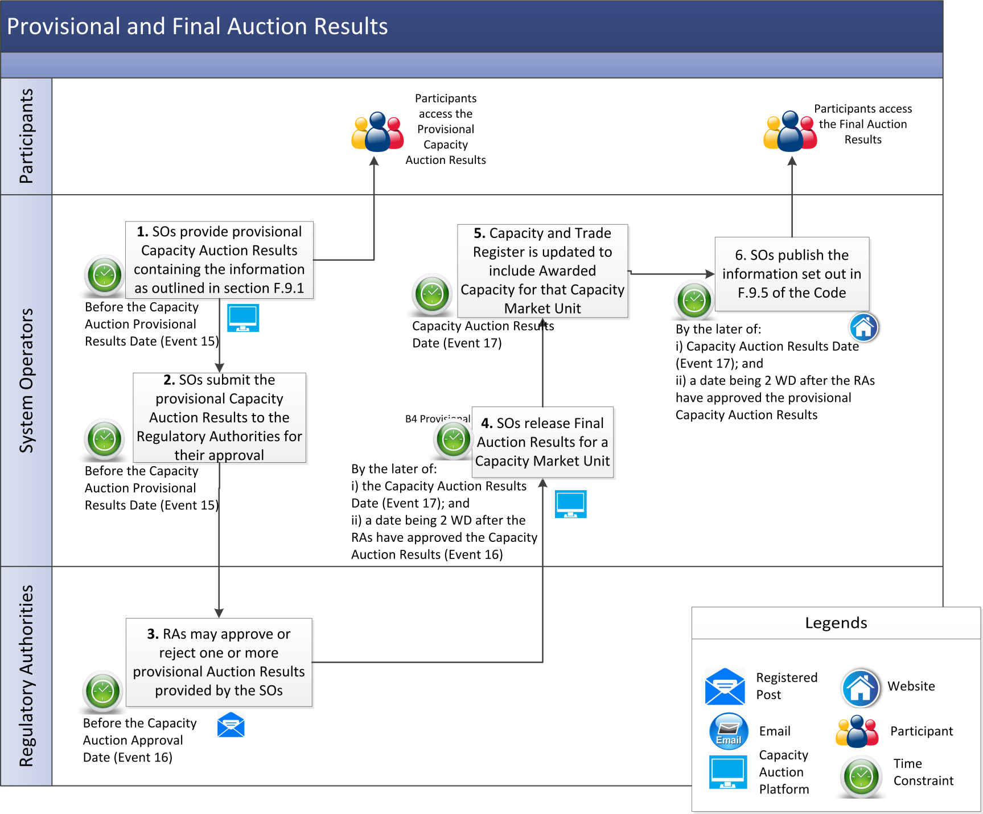

* + 1. *Post Auction Conditions for Awarding Capacity*

|  |  |  |  |  |  |
| --- | --- | --- | --- | --- | --- |
| Step | Step Description | Timing | Method | By / From | To |
|  | Capacity allocated to a Capacity Market Unit as a result of a Capacity Auction becomes Awarded Capacity when it is entered in the Capacity and Trade Register, with the status of “Active” in the case of Existing Capacity and “Pending” in the case of New Capacity, in accordance with paragraph F.9.4.3 of the Code. | - | - | Participants | System Operators |
|  | If a Participant has been allocated New Capacity in a Capacity Auction, in accordance with paragraph F.9.4.5 of the Code it shall:   1. confirm in writing to the System Operators that they agree to the Implementation Plan for the New Capacity provided in the final Capacity Auction Results; and 2. provide to the System Operators a Performance Security for not less that the Required Level in accordance with section J.3 of the Code. | On or before the Performance Security Date (Event 18) | Email / Performance Security | Participants | System Operators |
|  | The Participant is deemed to have agreed to the Implementation Plan set out in the final Capacity Auction Results in respect of any New Capacity allocated to it unless the Participant notifies the System Operators that it does not agree to that plan within 10 Working Days of being notified of the Capacity Auction Results. | Within 10 Working Days of being notified of the Capacity Auction Results | - | Participants | System Operators |
|  | In the circumstances set out in paragraph F.9.4.8 of the Code, the System Operators update the status of the Awarded Capacity in the Capacity and Trade Register to “Active”. | On completion of steps 2 and 3 (as applicable) | Capacity and Trade Register | System Operators | - |

*Note:* Where applicable, timelines set out in this procedural steps table refer to numbering of events in the Capacity Auction Timetable indicative timeframes set out in Appendix C “Capacity Auction Timetable” of the Code. For applicable timelines refer to the Capacity Auction Timetable for the relevant Capacity Auction.

