Capacity Market Code

|  |  |
| --- | --- |
| CMC Agreed Procedure 4 - Communication Channel Qualification | November 1  2024 |

Version 12.0

Contents

1. Introduction 5

1.1 Background and Purpose 5

1.2 Scope of Agreed Procedure 5

1.3 Definitions and Interpretation 5

1.4 Compliance with Agreed Procedure 5

2. Overview 6

2.1 Communication Channels 6

2.2 Communication Channel Qualification Testing 6

2.3 Guidelines Governing Communication Channel Qualification Testing 7

2.4 Obtaining a Digital Certificate 7

2.5 Guidelines Governing Digital Certificate Use 7

2.6 Accessing the Capacity Market Platform 7

2.7 Maintaining Type 2 Channel 8

2.8 Communication Channel Suspension 8

2.9 Authorised Persons 9

2.9.1 Nomination of Authorised Persons 9

2.9.2 Authentication of Information 9

2.10 Security for Type 2 Channel (Digital Certificates) 10

2.10.1 Encryption 10

2.10.2 Authentication and Non-Repudiation 10

2.10.3 Keys 10

2.10.4 Certificate Authority 10

2.10.5 System Operators User Access Management 10

2.10.6 Authorised User Access 10

2.10.7 User Responsibilities 11

2.11 Communication Links 11

2.11.1 Internet Connection 11

2.11.2 Type 2 Channel 11

2.11.3 Denial of Service 11

2.11.4 Change Control of Security Standard for Data Communication 11

3. Procedural Steps 12

3.1 Communication Channel Qualification Testing 12

3.2 Obtaining A Digital Certificate 15

3.3 Digital Certificate Cancellation 18

3.4 Communication Channel Suspension 20

APPENDIX 1: Definitions 24

APPENDIX 2: Authorisation Categories 26

Document History

|  |  |  |  |
| --- | --- | --- | --- |
| Version | Date | Author | Comment |
| 1.0 | 31/05/2017 | I-SEM Project Team | Issued to the Regulatory Authorities |
| 2.0 | 21/05/2019 | EirGrid & SONI | Capacity Market Code V2.0 update |
| 3.0 | 10/10/2019 | EirGrid & SONI | Capacity Market Code V3.0 update |
| 4.0 | 31/07/2020 | EirGrid & SONI | Capacity Market Code V4.0 update |
| 5.0 | 16/04/2021 | EirGrid & SONI | Capacity Market Code V5.0 update |
| 6.0 | 18/02/2022 | EirGrid & SONI | Capacity Market Code V6.0 update |
| 7.0 | 12/08/2022 | EirGrid & SONI | Capacity Market Code V7.0 update |
| 8.0 | 09/12/2022 | EirGrid & SONI | Capacity Market Code V8.0 update |
| 9.0 | 01/09/2023 | EirGrid & SONI | Capacity Market Code V9.0 update |
| 10.0 | 08/11/2023 | EirGrid & SONI | Capacity Market Code V10.0 update |
| 11.0 | 08/03/2024 | EirGrid & SONI | Capacity Market Code V11.0 update |
| 12.0 | 01/11/2024 | EirGrid & SONI | Capacity Market Code V12.0 update |

Related Documents

|  |  |  |  |
| --- | --- | --- | --- |
| Document Title | Version | Date | By |
| Capacity Market Code | 12.0 | 01/11/2024 | EirGrid & SONI |
| Agreed Procedure 1 “Registration” |  |  |  |
| Agreed Procedure 6 “System and Communication Failures” |  |  |  |

1. Introduction
   1. Background and Purpose

This Agreed Procedure supplements the rules set out in the Capacity Market Code (hereinafter referred as the “**Code**”) relating to the qualification, setup and maintenance of Communication Channels. It sets out procedures with which Parties to the Code must comply.

* 1. Scope of Agreed Procedure

This Agreed Procedure sets out procedures in relation to:

1. Obtaining a Digital Certificate;
2. Communication Channel Qualification testing;
3. Digital Certificate cancellation; and
4. Communication Channel suspension.

This Agreed Procedure forms an annex to, and is governed by the Code. It sets out procedures to be followed, subject to the rights and obligations of Parties under the Code. In the event of any conflict between a Party’s obligations set out in the Code and this Agreed Procedure, the Code shall take precedence.

It is not intended that there be any inconsistency or conflict between section 2 “Overview” and section 3 “Procedural Steps”. However, in the event of any inconsistency or conflict, section 3 “Procedural Steps” shall take precedence.

In section 3 “Procedural Steps” a corresponding process flow diagram is included for each procedural steps table.  Process flow diagrams are for illustrative purposes.  It is not intended that there be any inconsistency or conflict between any procedural steps table and process flow diagram however, in the event of any inconsistency or conflict, a procedural steps table shall take precedence.

* 1. Definitions and Interpretation

Words and expressions defined in the Code shall, unless the context otherwise requires or unless otherwise defined herein at Appendix 1 “Definitions”, have the same meanings when used in this Agreed Procedure.

References to sections refer to sections of this Agreed Procedure unless otherwise specified.

* 1. Compliance with Agreed Procedure

Compliance with this Agreed Procedure is required under the terms of the Code.

1. Overview
   1. Communication Channels

The System Operators shall establish and maintain two types of Communication Channel in accordance with paragraph L.2.3.1 of the Code, namely Type 1 Channel and Type 2 Channel.

Type 1 Channel (manual communication) shall be used:

1. during the initial registration procedure as set out in Agreed Procedure 1 “Registration”;
2. when submitting an Application for Qualification;
3. where there is an issue with the use of Type 2 Channel as set out in Agreed Procedure 6 “System and Communication Failures”;
4. in the event that Type 2 Channel has been suspended in accordance with section 3.4 below; and
5. for all Data Transactions not supported by Type 2 Channel.

Type 2 Channel shall be used in the circumstances set out in paragraph L.3.1.1 of the Code. In order to qualify for access to the Capacity Market Platform through Type 2 Channel a Party shall:

1. obtain a Digital Certificate for the Party Certification Environment (Test Environment) and successfully complete a series of data transfer tests in the Test Environment using Type 2 Channel;
2. obtain a Digital Certificate for the production environment; and
3. obtain full access to the production Capacity Market Platform.
   1. Communication Channel Qualification Testing

The procedural steps in relation to Communication Channel Qualification testing are set out at section 3.1 below. The System Operators shall provide the Party with security access credentials (including a Digital Certificate) for the Party Certification Environment to perform testing.

As part of the procedure, the Party connects to the System Operator’s Party Certification Environment. This involves accessing a web-based portal. Note that this Party Certification Environment is a Test Environment distinct from the Capacity Market Platform.

A number of tests must be successfully performed. Where appropriate these may include:

1. uploading / submitting Capacity Auction Offers, Secondary Auction Bids and Secondary Auction Offers;
2. downloading / requesting data in relation to Capacity Auction Offers, Secondary Auction Bids and Secondary Auction Offers; or
3. downloading a report.
   1. Guidelines Governing Communication Channel Qualification Testing

The Communication Channel Qualification testing procedure set out at section 3.2 below shall only be conducted once per Party for Type 2 Channel, unless a re-test is required in accordance with sections 2.7 or 3.4 below. If a User is added at a later date, Communication Channel testing shall not be repeated.

* 1. Obtaining a Digital Certificate

The procedural steps in relation to obtaining a Digital Certificate are set out at section 3.2 below. This procedure applies to Parties, via Users, seeking to access the Capacity Market Platform through Type 2 Channel.

One Digital Certificate is required for access to both the Balancing Market and Capacity Market. A Digital Certificate obtained under the Trading and Settlement Code for access to the Balancing Market shall also provide certification for access to the Capacity Market Interface. A Digital Certificate obtained in accordance with this Agreed Procedure for access to the Capacity Market Platform shall also provide certification for access to the Balancing Market. For the avoidance of doubt, separate Communication Channel testing is required for the Capacity Market and Balancing Market as described in section 2.2 above.

A Digital Certificate may be cancelled in accordance with the procedure set out at section 3.3 below.

Digital Certificates issued by the System Operators for the purposes of Communication Channel Qualification testing (section 3.1 below) relate only to the System Operators’ Party Certification Environment.

* 1. Guidelines Governing Digital Certificate Use

One Digital Certificate is required for each User and is associated with that User’s profile.

A single Digital Certificate can allow the User to access any or all of the Functional Areas specified when the User is set-up for access to the Capacity Market Platform.

A User is given system access at a Participant level. A User can be associated with the Units of one Participant or multiple Participants, depending on their allocated system access.

Digital Certificates are environment specific i.e. a separate Digital Certificate is required when accessing Test Environments and production environments.

* 1. Accessing the Capacity Market Platform

In order to obtain full access to the Capacity Market Platform, the System Operators shall verify:

1. that Communication Channel testing has been completed successfully; and
2. that the Party has demonstrated compliance through self-certification with the IT security guidelines set out in the Code.

The System Operators shall allow access to the Capacity Market Platform once it is satisfied that these steps are complete. The Party shall be notified by email that they are granted access to the Capacity Market Platform via the Communication Channel for which testing has been successfully completed.

* 1. Maintaining Type 2 Channel

Parties shall ensure that interfaces to their Type 2 Channels comply with any IT security requirements specified in the Code and this Agreed Procedure (see sections 2.10 and 2.11). Any deviation from these requirements may result in a Communication Channel suspension in accordance with section 3.4 below.

In order for a Party to maintain a Type 2 Channel, the Party shall comply with the Technical Specification and satisfy the following requirements:

1. there must be a valid User per Functional Area, with access to administer the required functionality;
2. a valid Digital Certificate is required for each User;
3. each User shall obtain a valid Capacity Market Interface password (as enforced by the Capacity Market Platform);
4. adequate and resilient internet access is required;
5. each User shall access the production Capacity Market Platform using their assigned Digital Certificate and Capacity Market Interface username and password; and
6. Parties are required to notify the System Operators, via the Helpdesk in accordance with Agreed Procedure 5 "System Operation, Testing, Upgrading and Support", of transaction malfunction issues due to Communication Channel failure.

A Party is obliged to remain qualified for Type 2 Channel for the duration of its participation in the Capacity Market. The System Operators may instruct a Party to perform a Communication Channel Qualification re-test at any time in accordance with the IT security guidelines set out in the Code and this Agreed Procedure.

* 1. Communication Channel Suspension

The procedural steps in relation to Communication Channel suspension are set out at section 3.4 below.

A Party may be suspended from using Type 2 Channel by the System Operators. This shall be a temporary measure that shall be reversed once the System Operators are satisfied that appropriate action has been taken to resolve the issues that led to suspension. The following circumstances may lead to Communication Channel suspension:

1. The Party requests for a particular Communication Channel to be temporarily suspended. This could arise when the Party becomes aware of a security breach.
2. The Party does not have valid Users with the appropriate access rights to operate in the SEM.
3. The Party Type 2 Channel password has expired.
4. The Party Digital Certificate has expired.
5. The Party is deemed by the System Operators to be non-compliant with the required IT standards as specified in the Code and this could affect the security / performance of the Capacity Market Platform.
6. The System Operators have evidence of an IT security breach in the Party’s systems and this could affect the security / performance of the Capacity Market Platform.
7. The System Operators have evidence that a Party’s interaction with the Capacity Market Platform is having a performance impact.

Where the System Operators have suspended a Communication Channel for a particular Party, the Party shall be immediately notified by email and provided with the reason(s) for the suspension. The System Operators may specify the steps for that Party to take to resolve the issue. Due to the time restrictions involved it is not possible to make the suspension dependent on an appeals process. Any disagreement in relation to a temporary suspension must be dealt with through the Dispute Resolution Process under the Code. A Party shall inform the System Operators of any security breach of its systems as soon as it becomes aware of such breach.

* 1. Authorised Persons
     1. Nomination of Authorised Persons

Where Parties communicate with the System Operators via Type 1 Channel or any other communication required under the Code or Agreed Procedures, that communication must be from an authorised member of staff referred to as an Authorised Person. To be an Authorised Person, Party staff must first be registered as a User via the Capacity Market Interface. A User can then be authorised under one or more of the authorisation categories set out at Appendix 2 “Authorisation Categories”.

A Party Administrative User is permitted to nominate and change the authorisations of other staff from the relevant Party. As this role is administered via the Capacity Market Interface, no other type of User is permitted to perform this function. At least one Party Administrative User must be registered during the process of Party registration (see Agreed Procedure 1 “Registration”). Where a Party does not have any valid Party Administrative User(s) then a new nomination must be submitted on the Party Administrative User form provided by the System Operators and signed by a director or company secretary for the company.

* + 1. Authentication of Information

As part of the authorisation process for performing the tasks set out at Appendix 2 “Authorisation Categories”, authentication information is required by the System Operators to verify the Authorised Person. When a communication is received from the Authorised Person the authentication information provided is dependent on the method of communication and is described in the table below.

**Table 1: Details for Authentication**

|  |  |
| --- | --- |
| **Mode of Communication** | **Authentication information** |
| Post | Full Name,  Signature |
| Facsimile | Full Name,  Signature |
| Email | Full Name,  Originate from registered email address |

To authenticate the communication from an Authorised Person, the System Operators shall request, via telephone, their authentication code or answers to confidential questions specific to the User as provided as part of the User registration process.

* 1. Security for Type 2 Channel (Digital Certificates)

Digital Certificates shall provide the security facilities set out below.

* + 1. Encryption

All data communication shall be encrypted in accordance with the ITU-T X.509 standard. Asymmetric encryption shall be adopted using 2048 bit keys.

* + 1. Authentication and Non-Repudiation

Digital Signatures utilising a “hash” shall be implemented to ensure authentication of message senders and to provide a basis for the non-repudiation of messages. Validation of message “hash” values shall be performed by de-encryption using the sender’s Public Key and comparison with a locally generated “hash”. Validation failure signifies an authentication issue or corruption of message contents and the cause must be investigated by the System Operators and Participant concerned.

* + 1. Keys

The System Operators and each Participant are required to create and exchange a Public Key. Corresponding Private Keys must be protected against theft, use by unauthorised persons, viruses, trojans or malware. The creation and exchanging of Public Keys shall be performed at the time of creation of the Digital Certificate by the Certificate Authority.

* + 1. Certificate Authority

The System Operators shall provide, or procure, Certificate Authority services for the purposes of data communication between the Capacity Market Platform and Participants. These services must include:

1. Digital Certificate creation;
2. Digital Certificate issuance; and
3. Digital Certificate cancellation.
   * 1. System Operators User Access Management

To help prevent unauthorised access to systems, all System Operators’ User access requires a level of authorisation prior to access being given. The System Operators shall implement an authorisation process to ensure only the appropriate level of access is granted to individual System Operators Users and Market Operator Users, to enable them to fulfil their roles.

Market Operator Users, System Operators Users and support staff will have restricted access to specific areas of the system according to their level of authority and access requirements.

* + 1. Authorised User Access

Once Digital Certificates and User passwords are obtained each Party is responsible for authorising access for each of its Users, or removing access for Users to the Functional Areas which are no longer relevant to a Party’s organisation.

It is the responsibility of the Party to ensure that its Digital Certificates and User passwords are valid for any Trading Day, for each relevant User.

* + 1. User Responsibilities

The System Operators shall implement suitable access arrangements to help prevent unauthorised User access to the Capacity Market Platform. Where these access arrangements require the use of passwords by System Operators’ Users, suitable constraints and procedures shall be applied to promote security of the passwords including restricted access to Users’ workstations while the User is connected to the Capacity Market Platform.

* 1. Communication Links
     1. Internet Connection

Data communication to the Capacity Market Platform shall be achieved using the internet. Each Party is responsible for their individual connection(s) to the internet.

All Parties must maintain a redundant and fault-tolerant network configuration of sufficient capacity to meet their peak communication needs.

* + 1. Type 2 Channel

Where a Participant has initiated a Type 2 Channel session, the Capacity Market Platform shall monitor the duration of the session and may terminate the session if there has been no activity for longer than the period specified in the Technical Specification.

* + 1. Denial of Service

Participants shall not engage in activities that may reasonably be construed as denial of service attacks on the Capacity Market Platform or the System Operators’ connection to the internet.  If the System Operators reasonably construe that a Participant is acting in a manner that negatively impacts on the availability or functionality of the Capacity Market Platform then they are entitled to take any action in relation to Communication Channels that is necessary to remedy the situation.

* + 1. Change Control of Security Standard for Data Communication

If the System Operators require the implementation of the security standard for data communications or a change to that standard, they shall follow the procedure set out in Agreed Procedure 5 “Market System Operation, Testing, Upgrading and Support”.

1. Procedural Steps
   1. Communication Channel Qualification Testing

| **Step** | **Step Description** | **Timing** | **Method** | **By / From** | **To** |
| --- | --- | --- | --- | --- | --- |
| **1** | Request Communication Channel testing.  *Note:* The Market Operator shall issue the Party with the security access credentials (including a Digital Certificate) for the Party Certification Environment to perform testing. | As required | Email / Telephone / Facsimile | Party | System Operators |
| **2** | Notify Party of tests required and fixed scripted schedule of test. | Within 3 WD of request | Email | System Operators | Party |
| **3** | Prepare tests, connect to Party Certification Environment and execute tests. | In accordance with fixed script | Party Certification Environment website | Party | - |
| **4** | Validate tests. If acceptable go to step 7, otherwise continue to step 5. | In accordance with fixed script | - | System Operators | - |
| **5** | Inform Party of failed tests. | Within 3 WD of test | Email | System Operators | Party |
| **6** | If Party requires re-test (after correction of Party’s systems is complete) return to step 1, otherwise **end process.** | As required | - | Party | - |
| **7** | Inform of successful tests and set Communication Channel qualification flag. | Within 3 WD of test | Email | System Operators | Party |

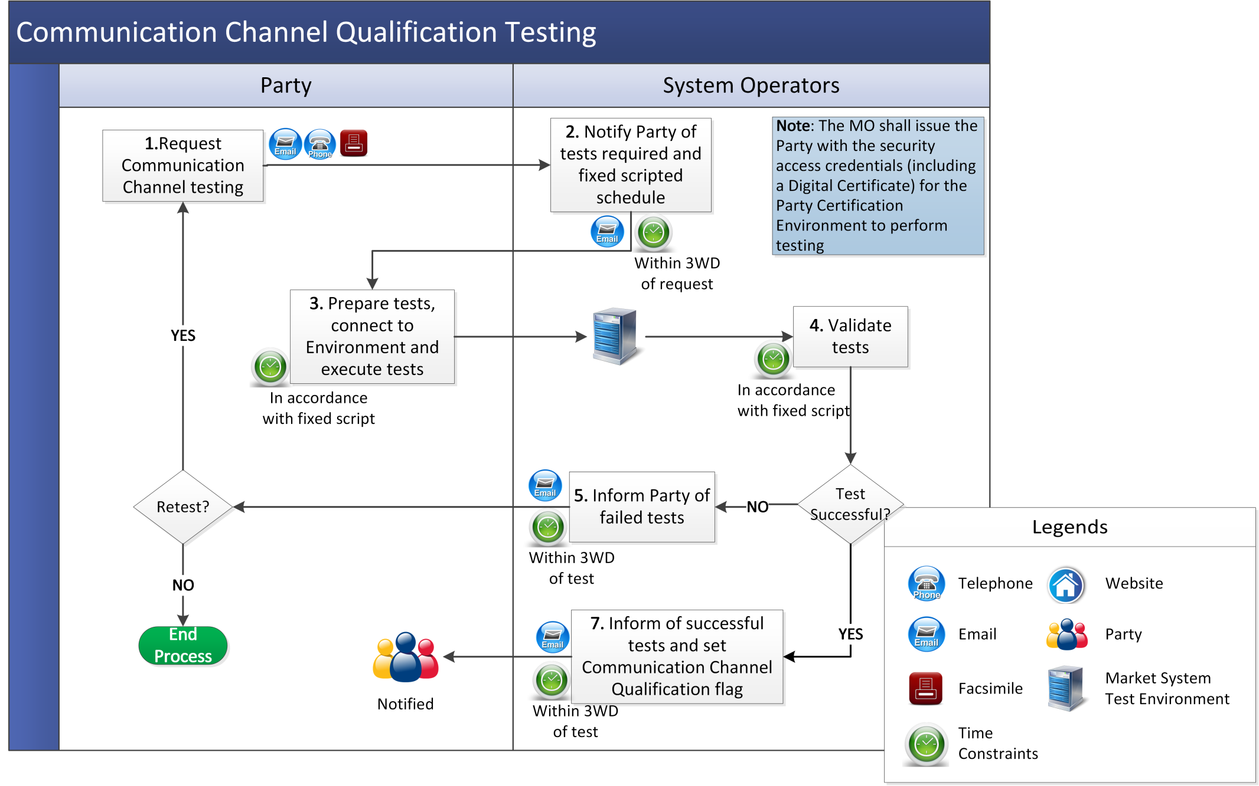

* 1. Obtaining A Digital Certificate

| **Step** | | | **Step Description** | **Timing** | **Method** | | **By / From** | **To** |
| --- | --- | --- | --- | --- | --- | --- | --- | --- |
| **1** | A Digital Certificate request is made during registration for the Capacity Market.  *Note:* If the Participant has obtained a Digital Certificate under the Trading and Settlement Code for access to the Balancing Market that Digital Certificate permits access to the Capacity Market Interface. | | As required | In accordance with Agreed Procedure 1 “Registration” | Party | | System Operators |
| **2** | Inform the Certificate Authority that the Party User has been authorised to receive a Digital Certificate. | | Within 2 WD of request | Certificate Authority website | System Operators | | Certificate Authority |
| **3** | Notify the Party User of authorisation to obtain a Digital Certificate and provide link to the Certificate Authority’s enrolment webpage. | | Within 2 WD of request | Email | System Operators | | Party |
| **4** | Access Certificate Authority’s enrolment webpage and enter required information. | | As required | Certificate Authority website | Party | | - |
| **5** | Check that the Party User is authorised and issue PIN and URL. | | Within 1 WD receipt of required information | Email | Certificate Authority | | Party |
| **6** | Download and install Digital Certificate using URL and PIN. | | As required | Certificate Authority website | Party | | - |
| **7** | Notify System Operators of the Digital Certificate serial number. | | - | Email | Party | | System Operators |
| **8** | System Operators update User access details with the Digital Certificate serial number. | | - | - | System Operators | | - |
| **9** | Log-in to the Capacity Market Interface and change password as prompted. | |  | Certificate Authority website / Capacity Market Interface | Party | | - |

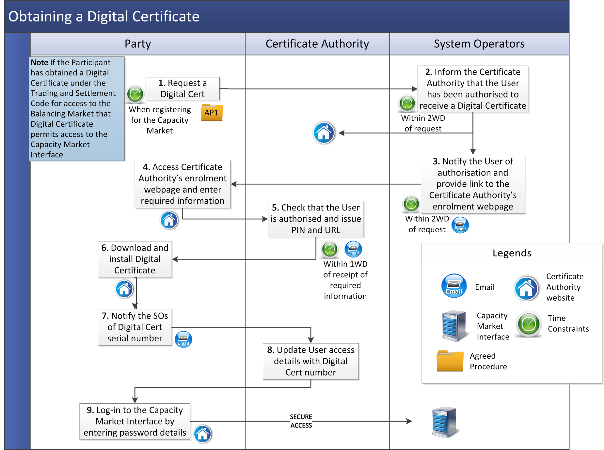

* 1. Digital Certificate Cancellation

|  |  |  |  |  |  |
| --- | --- | --- | --- | --- | --- |
| **Step** | **Step Description** | **Timing** | **Method** | **By / From** | **To** |
| **1** | Request the cancellation of Digital Certificate.  *Note:* Cancellation of a Digital Certificate shall revoke access to both the Balancing Market and Capacity Market (as applicable). | As required | Email / Facsimile | Party | System Operators |
| **2** | Validate the request assessing whether it contains all the required information and is from an appropriate Authorised Person. If valid go to step 4, otherwise continue to step 3. | Within 2 WD of cancellation request | - | System Operators | - |
| **3** | Inform Party User of reasons for invalidity, **end process.** | Within 2 WD of cancellation request | Email | System Operators | Party |
| **4** | Notify Certificate Authority of Digital Certificate cancellation. | Within 2 WD of cancellation request | Certificate Authority website | System Operators | Certificate Authority |
| **5** | Update revocation list to include the Digital Certificate. | - | Certificate Authority website | Certificate Authority | - |
| **6** | Notify Party User of cancellation of Digital Certificate. | Within 2 WD of cancellation request | Email | System Operators | Party |

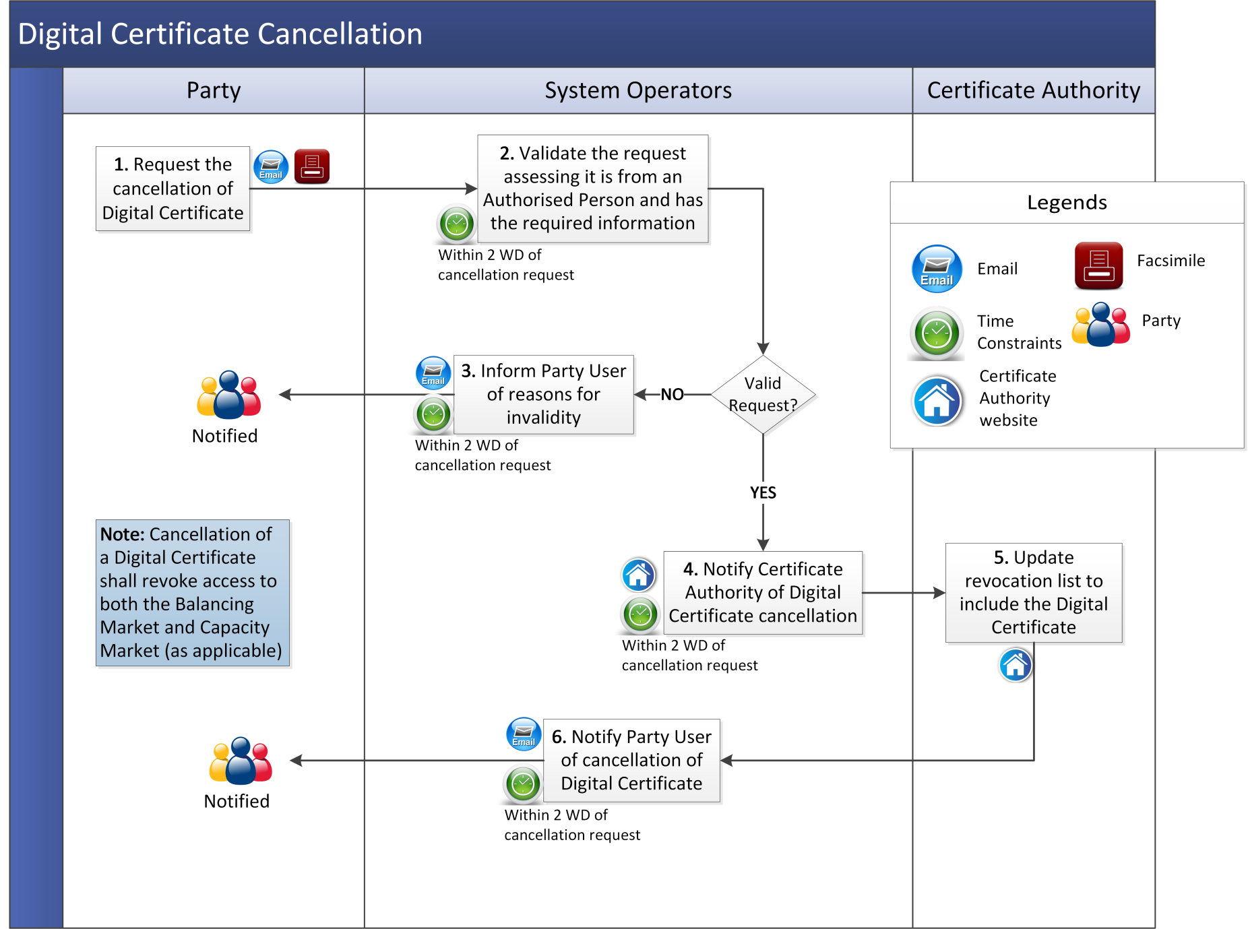

* 1. Communication Channel Suspension

| **Step** | **Step Description** | **Timing** | **Method** | **By / From** | **To** |
| --- | --- | --- | --- | --- | --- |
|  | If:   1. a Party requests suspension of Communication Channel, go to step 2; or 2. the System Operators identify a requirement to suspend a Party’s Communication Channel, go to step 4. | As required | Email and Telephone / Facsimile | Party  System Operators | System Operators |
|  | Validate the suspension request assessing whether it has the required information is from an appropriate Authorised Person. If valid go to step 5, otherwise continue to step 3. | - | - | System Operators | - |
|  | Inform Party of reasons for invalidity, **end process.** | Within 1 WD | Email | System Operators | Party |
|  | If suspension is required immediately, continue to step 5. Otherwise go to step 13. | - | - | System Operators | - |
|  | Suspend Communication Channel and inform Party of suspension. | Within 1 WD | Email and Telephone | System Operators | Party |
|  | Notify System Operators of planned corrective action. | Within 1 WD | Email / Facsimile | Party | System Operators |
|  | Notify System Operators when planned corrective action completed. | Within timelines notified to the System Operators in step 6 | Email / Facsimile | Party | System Operators |
|  | Verify that corrective action is complete. If corrective action is not complete, notify Party and return to step 6. If corrective action is complete continue to step 9. | As soon as practicable following notification at step 7 | Email | System Operators | Party |
|  | Decide if Party is required to undergo Communication Channel Qualification. If re-qualification is not necessary continue to step10. If qualification is required, go to step 11. | - | - | System Operators | - |
|  | Restore Communication Channel and inform Party, **end process** | Within 1 WD | Email | System Operators | Party |
|  | Inform Party of the need to re-qualify for Communication Channel. | Within 1 WD | Email | System Operators | Party |
|  | Commence Communication Channel Qualification testing procedure at section 3.2, **end process**. | - | - | Party | - |
|  | Inform Party of potential Communication Channel suspension and request Party to take corrective action. | Within 1 WD | Email | System Operators | Party |
|  | Notify System Operators of planned corrective action. | Within 1 WD | Email / Facsimile | Party | System Operators |
|  | Notify System Operators when planned corrective action completed. | As specified in step 14 | Email / Facsimile | Party | System Operators |
|  | Decide if Party corrective action is sufficient to prevent Communication Channel suspension. If corrective action sufficient, **end process**. If corrective action is insufficient return to step 4. | - | - | System Operators | - |

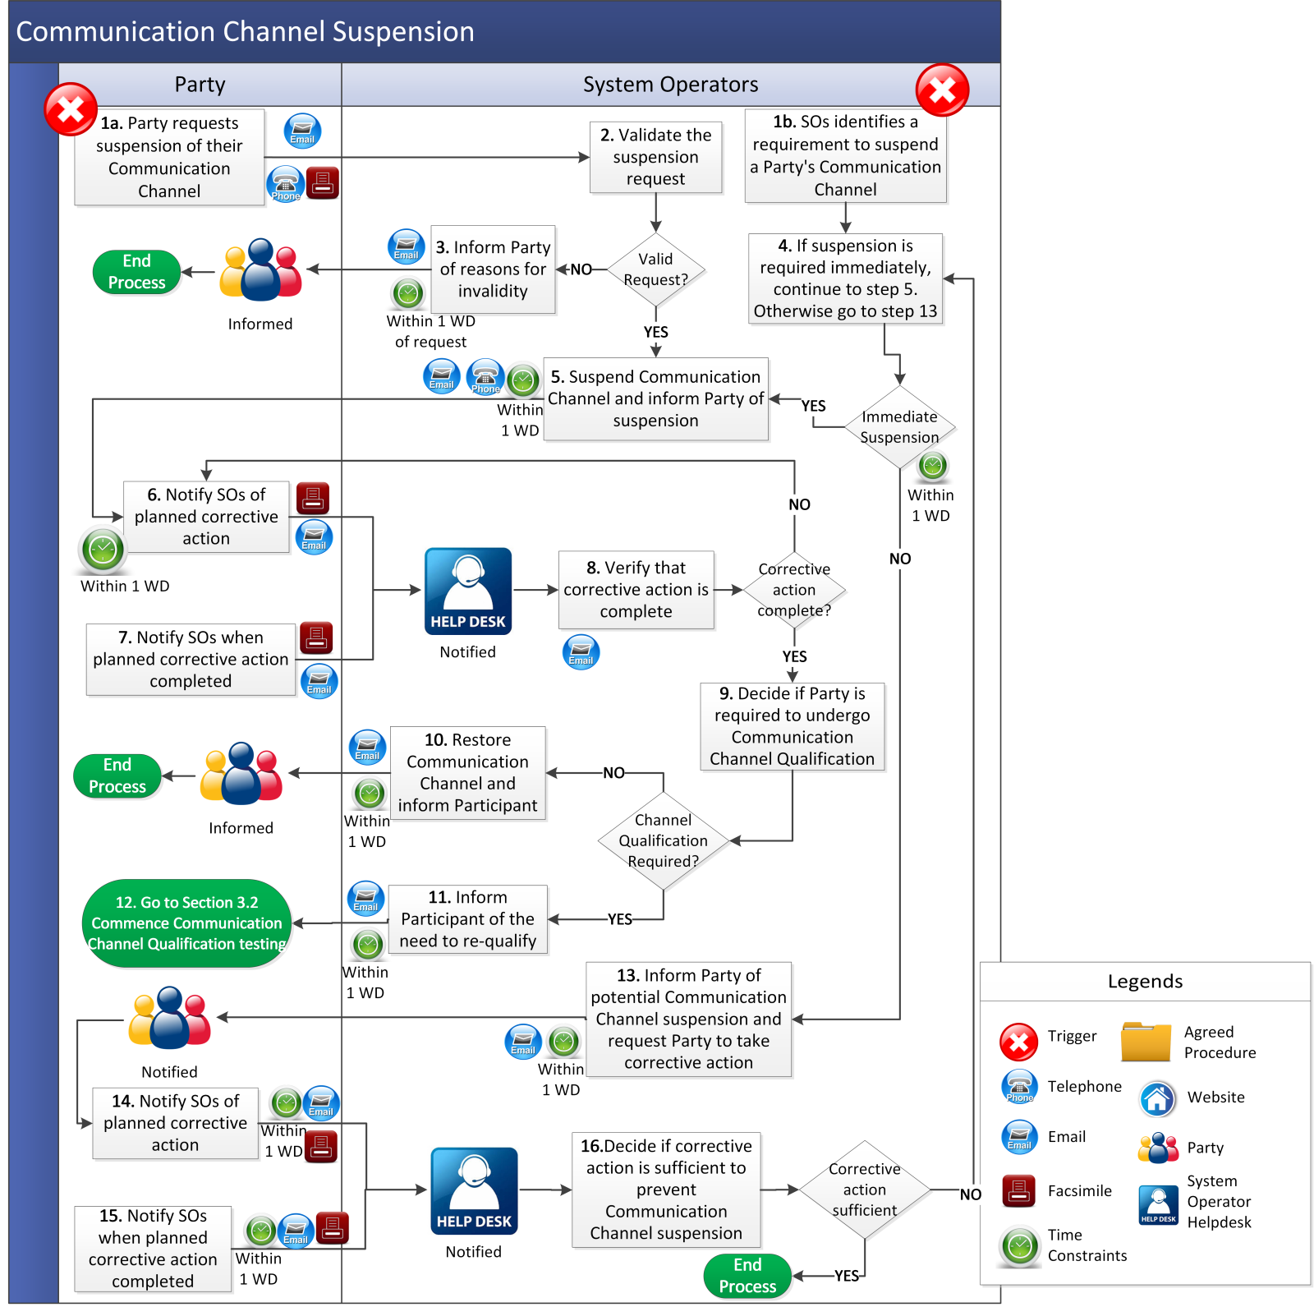

1. Definitions

|  |  |
| --- | --- |
| **Authorised Person** | means the representative of a Party who is authorised by that Party to communicate with the System Operators. |
| **Capacity Market Interface** | means the function within the Capacity Market Platform that interfaces to the Type 2 Channel communications in accordance with the Code. |
| **Certificate Authority** | means an entity which issues Digital Certificates for use by other parties. The Certificate Authority validates the data contained in the Digital Certificate and correctly identifies the party to which it issues the Digital Certificate. |
| **Digital Certificate** | means an electronic credential issued and digitally signed by a Certificate Authority. The international standard upon which most commercial certificates are based is the ITU-T X.509 certificate. The digital certificate represents the certification of an individual, business, or organizational public key. |
| **Functional Area** | means the different parts of the Capacity Market Platform that Users may be provided access to as set out in in Agreed Procedure 1 "Registration". |
| **Party Certification Environment** | means a Test Environment which allows a Party to test their ability to interact with Capacity Market Platform functionality. |
| **Party Administrative User** | means the person who creates and maintains the User information pertaining to a Party. |
| **Test Environment** | means a non-production version of a Capacity Market Platform used for test purposes prior to an update to the Capacity Market Platform. |
| **User** | means:   1. in relation to a Party, a nominated member of a Party staff who is authorised to utilise qualified Communication Channels that interact with the Capacity Market Platform; and 2. in relation to the System Operators, a member of the System Operators’ staff who has been authorised to access specific parts of the Capacity Market Platform.   The procedure in relation to registration of User access rights is set out in Agreed Procedure 1 “Registration”. |
| **Web Services** | means the automated communication consisting of an XML-based programmatic interface. |

1. Authorisation Categories

**Authorised Categories A**

|  |  |  |
| --- | --- | --- |
| **Category** | **Description** | **Agreed Procedure** |
| A | Declare Limited Communication Failure  request | Agreed Procedure 5, Agreed Procedure 6 |

**Authorised Categories B**

The following Authorised Categories list is not covered under the User Authorisations section of the Capacity Market Interface. However, these processes can be activated by Users that have sufficient access privileges to normally perform these tasks via the Capacity Market Interface, but due to a Limited Communications Failure are unable to do so.

|  |  |  |  |
| --- | --- | --- | --- |
| **Category** | **Description** | **Agreed Procedure** | **Authorised Person** |
| 1 | Submit/Modify Unit Registration and/or Interconnector Data | Agreed Procedure 1 | Registration User |
| 2 | Request Capacity Auction Bid/Offer Data | Agreed Procedure 3 | User with trading access |
| 3 | Ad hoc Report request | - | As per requester Capacity Market Interface access |
| 4 | Requesting Digital Certificates | Agreed Procedure 4 | Party Administrative User |
| 5 | Requesting Qualification Data |  | User with Trading Access |