|  |  |
| --- | --- |
| CMC Agreed Procedure 6 - System and Communication Failures | November 1  2024 |

Capacity Market Code

Version 12.0

Contents

1. Introduction 4

1.1 Background and Purpose 4

1.2 Scope of Agreed Procedure 4

1.3 Definitions 4

1.4 Compliance with Agreed Procedure 4

2. Overview 5

2.1 Communication and System Failures 5

2.1.1 Capacity Market Communication Outage 5

2.1.2 Capacity Market System Outage 5

2.1.3 Limited Communication Failure 5

2.2 Alternative Forms of Communication 6

3. Procedural Steps 7

3.1 Capacity Market Communication Outage 7

3.2 Capacity Market System Outage 9

3.3 Limited Communication Failure 12

3.3.1 Capacity Auction Offers 12

3.3.2 Secondary Auction Bids and Secondary Auction Offers 14

Appendix 1: Definitions 18

**Document History**

|  |  |  |  |
| --- | --- | --- | --- |
| Version | Date | Author | Comment |
| 1.0 | 31/05/2017 | I-SEM Project Team | Issued to the Regulatory Authorities |
| 2.0 | 21/05/2019 | EirGrid & SONI | Capacity Market Code V2.0 update |
| 3.0 | 10/10/2019 | EirGrid & SONI | Capacity Market Code V3.0 update |
| 4.0 | 31/07/2020 | EirGrid & SONI | Capacity Market Code V4.0 update |
| 5.0 | 16/04/2021 | EirGrid & SONI | Capacity Market Code V5.0 update |
| 6.0 | 18/02/2022 | EirGrid & SONI | Capacity Market Code V6.0 update |
| 7.0 | 12/08/2022 | EirGrid & SONI | Capacity Market Code V7.0 update |
| 8.0 | 09/12/2022 | EirGrid & SONI | Capacity Market Code V8.0 update |
| 9.0 | 01/09/2023 | EirGrid & SONI | Capacity Market Code V9.0 update |
| 10.0 | 08/11/2023 | EirGrid & SONI | Capacity Market Code V10.0 update |
| 11.0 | 08/03/2024 | EirGrid & SONI | Capacity Market Code V11.0 update |
| 12.0 | 01/11/2024 | EirGrid & SONI | Capacity Market Code V12.0 update |

**Related Documents**

|  |  |  |  |
| --- | --- | --- | --- |
| Document Title | Version | Date | By |
| Capacity Market Code | 12.0 | 01/11/2024 | EirGrid & SONI |
| Agreed Procedure 1 "Registration" |  |  |  |
| Agreed Procedure 5 “System Operation, Testing, Upgrading and Support” |  |  |  |

1. Introduction
   1. Background and Purpose

This Agreed Procedure supplements the rules set out in the Capacity Market Code (hereinafter referred as the “**Code**”) in relation to communication and system failures. It sets out procedures with which Parties to the Code must comply.

* 1. Scope of Agreed Procedure

This Agreed Procedure sets out procedures that shall apply in the event of:

1. a Capacity Market Communication Outage;
2. a Capacity Market System Outage; and
3. a Limited Communication Failure.

For the avoidance of doubt, this Agreed Procedure does not apply to REMIT Data however, the System Operators shall comply with all requirements set out by the European Agency for the Cooperation of Energy Regulators where events which relate to Communication Channels and system performance will impact on REMIT Data Transactions.

This Agreed Procedure forms an annex to, and is governed by the Code. It sets out procedures to be followed, subject to the rights and obligations of Parties under the Code. In the event of any conflict between a Party’s obligations set out in the Code and this Agreed Procedure, the Code shall take precedence.

It is not intended that there be any inconsistency or conflict between section 2 “Overview” and section 3 “Procedural Steps”. However, in the event of any inconsistency or conflict, section 3 “Procedural Steps” shall take precedence.

In section 3 “Procedural Steps” a corresponding process flow diagram is included for each procedural steps table.  Process flow diagrams are for illustrative purposes.  It is not intended that there be any inconsistency or conflict between any procedural steps table and process flow diagram however, in the event of any inconsistency or conflict, a procedural steps table shall take precedence.

* 1. Definitions

Words and expressions defined in the Code shall, unless the context otherwise requires or unless otherwise defined herein at Appendix 1 “Definitions”, have the same meanings when used in this Agreed Procedure.

References to sections refer to sections of this Agreed Procedure unless otherwise specified.

* 1. Compliance with Agreed Procedure

Compliance with this Agreed Procedure is required under the terms of the Code.

1. Overview
   1. Communication and System Failures

There are three types of communication and system failure defined in the Code:

1. Capacity Market Communication Outage;
2. Capacity Market System Outage; and,
3. Limited Communication Failure.
   * 1. Capacity Market Communication Outage

In the event of a Capacity Market Communication Outage the procedure set out at section 3.2 below shall be followed. The rules applicable to a Capacity Market Communication Outage are set out at section L.4.2 of the Code.

During a Capacity Market Communication Outage, the System Operators shall provide regular status updates to all affected Participants. Each status update shall include the original notification and shall provide an estimate, if known, of when normal communication interfaces shall be restored.

During a Capacity Market Communication Outage the response given by the System Operators confirming receipt of a Data Transaction shall be sent by facsimile or email. The System Operators shall act prudently in the event of a Capacity Market Communication Outage and shall prioritise Data Transactions necessary to conduct a Capacity Auction or Secondary Trade Auction. It is recognised that in the event of a Capacity Market Communication Outage some of the System Operators’ obligations under the Code cannot be fulfilled.

* + 1. Capacity Market System Outage

In the event of a Capacity Market System Outage the procedure set out in section 3.1 below shall apply. The rules applicable to a Capacity Market System Outage are set out at section L.4.3 of the Code.

During a Capacity Market System Outage, the System Operators shall provide status updates to all affected Participants. Each status update shall include the original notification of the Capacity Market System Outage and shall provide an estimate of when the Capacity Market Platform shall be restored.

* + 1. Limited Communication Failure

In the event that a Limited Communication Failure impacts submission of Capacity Auction Offers by a Participant in accordance with the Capacity Auction Timetable, the procedure set out in section 3.3.1 below shall be followed. The System Operators shall assist the Participant in submitting Capacity Auction Offers subject to section F.6.2 of the Code.

In the event that a Limited Communication Failure impacts submission of Secondary Auction Bids or Secondary Auction Offers by Participant in accordance with the Secondary Trade Information Pack, the procedure set out in section 3.3.2 below shall be followed.

In the event of a Limited Communication Failure, the System Operators may modify timelines under the Code, a Capacity Auction Timetable or a Secondary Trade Information Pack in accordance with section L.4.4 of the Code.

All Parties are required under section L.2.4 of the Code to maintain a functional interface to the Communication Channels. In the event of a Limited Communication Failure the impacted Party should initially attempt to rectify the problem or utilise other facilities to enable it to use Type 2 Channel.

A Limited Communication Failure shall not affect the obligations of any impacted Participant to submit Data Transactions.

* 1. Alternative Forms of Communication

In the event of a communication failure, alternatives to the normal method of communication shall be employed for the submission of Data Transactions. The Communication Channels to be established and maintained by the System Operators are set out at paragraph L.2.3.1 of the Code, namely Type 1 Channel and Type 2 Channel.

Generally the order of preferred alternative method of communication will run from the most automatic to the most manual, i.e. the preferred method is Type 2 Channel and if Type 2 Channel is affected then, Type 1 Channel.

In the event of issues with Data Transactions, an impacted Party may also contact the System Operators’ Helpdesk as set out in Agreed Procedure 5 “System Operation, Testing, Upgrading and Support”.

1. Procedural Steps
   1. Capacity Market Communication Outage

|  |  |  |  |  |  |
| --- | --- | --- | --- | --- | --- |
| Step | Step Description | Timing | Method | From / By | To |
|  | Notify impacted Parties of the Capacity Market Communication Outage.  *Note:*If required and in accordance with section L.4.4 of the Code, the System Operators may modify any of the timelines under the Code, a Capacity Auction Timetable or a Secondary Trade Information Pack for doing any act or thing during the Capacity Market Communication Outage. | Immediately on becoming aware of a Capacity Market Communication Outage | System Operators’ website / Email | System Operators | All affected Participants |
|  | Where any questions arise, impacted Parties will contact the System Operators. | As required | Telephone / Email / Facsimile | All affected Participants | System Operators |
|  | Notify affected Participants of the alternative communication method to be used. | As required during Capacity Market Communication Outage | System Operators’ website / Email / Facsimile | System Operators | All affected Participants |
|  | Notify affected Participants of best estimate of when the communication interfaces shall be restored. | Immediately once good estimate can be established and following any change to that estimate | System Operators’ website / Email / Facsimile | System Operators | All affected Participants |
|  | Notify affected Participants once Capacity Market Communication Outage ceases. | Immediately once Capacity Market Communication Outage ceases | System Operators’ website / Email / Facsimile | System Operators | All affected Participants |

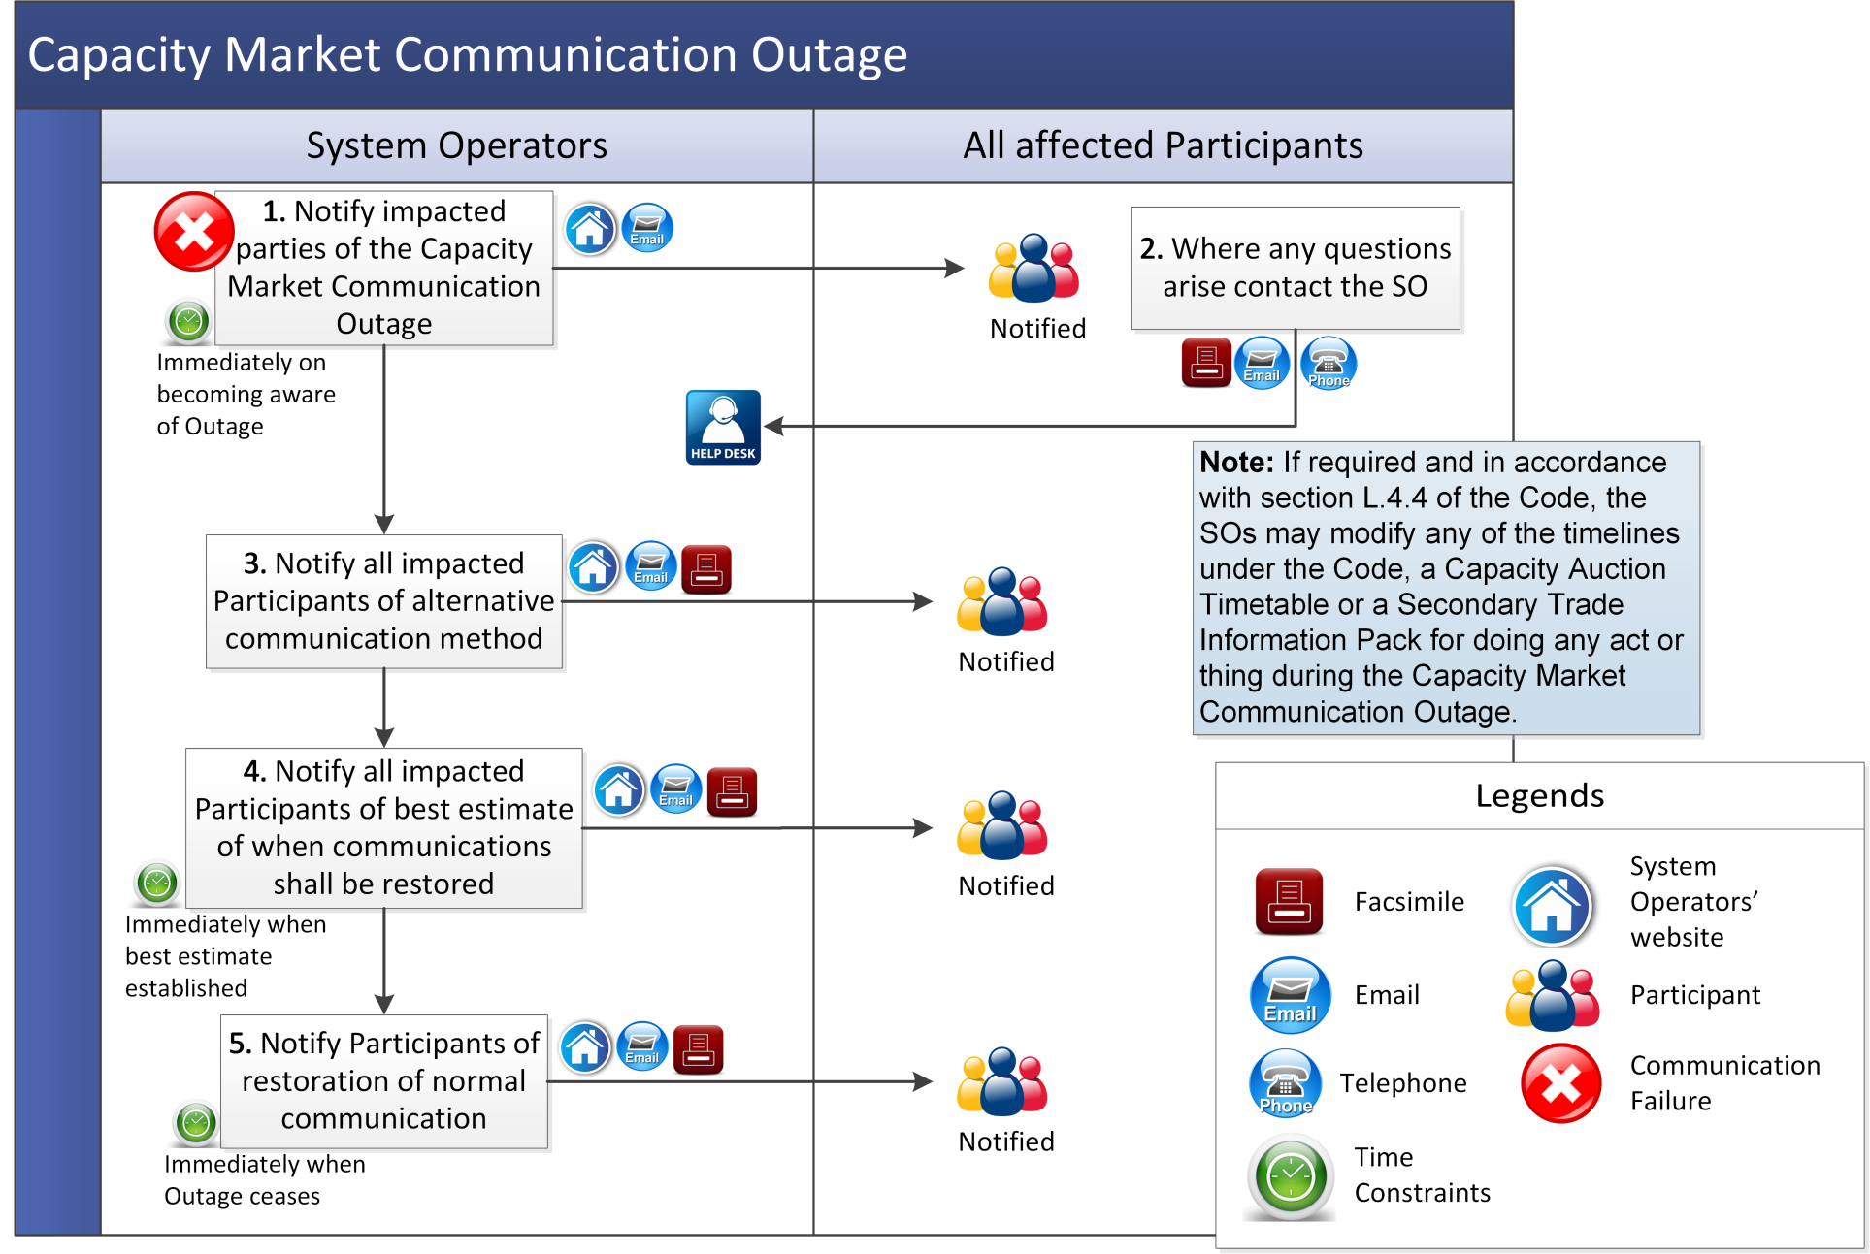

* 1. Capacity Market System Outage

| Step | Step Description | Timing | Method | From / By | To |
| --- | --- | --- | --- | --- | --- |
|  | Notify affected Participants of Capacity Market System Outage. | Immediately on becoming aware that a Capacity Market System Outage has caused or shall cause the System Operators to fail to meet obligations under the Code | System Operators’ website / Email / Facsimile | System Operators | All affected Participants |
|  | Attempt restoration of the Capacity Market Platform (as applicable) in accordance with Agreed Procedure 5 “System Operation, Testing, Upgrading and Support”.  **Note:** If required and in accordance with paragraph L.4.3 of the Code and section L.4.4 of the Code, the System Operators may defer a Capacity Auction or Secondary Trade Auction until after the Capacity Market System Outage ceases and adjust the timelines in the relevant Capacity Auction Timetable or Secondary Trade Information Pack (as applicable) to reflect the deferral. | Immediately on becoming aware of a Capacity Market System Outage | - | System Operators | - |
|  | Notify affected Participants of alternative communication method (if applicable). | As required during Capacity Market System Outage | System Operators’ website / Email / Facsimile | System Operators | All affected Participants |
|  | Invoke internal procedures to switch to alternative communication methods (if applicable). | Immediately following receipt of alternative Communication Channel details at step 4 | - | All affected Participants | - |
|  | Notify affected Participants of best estimate of when the Capacity Market Platform shall be restored. | Immediately once best estimate can be established and following any change to that best estimate | System Operators’ website / Email / Facsimile | System Operators | All affected Participants |
|  | Notify affected Participants once Capacity Market System Outage ceases. | Immediately once Capacity Market System Outage ceases | System Operators’ website / Email / Facsimile | System Operators | All affected Participants |

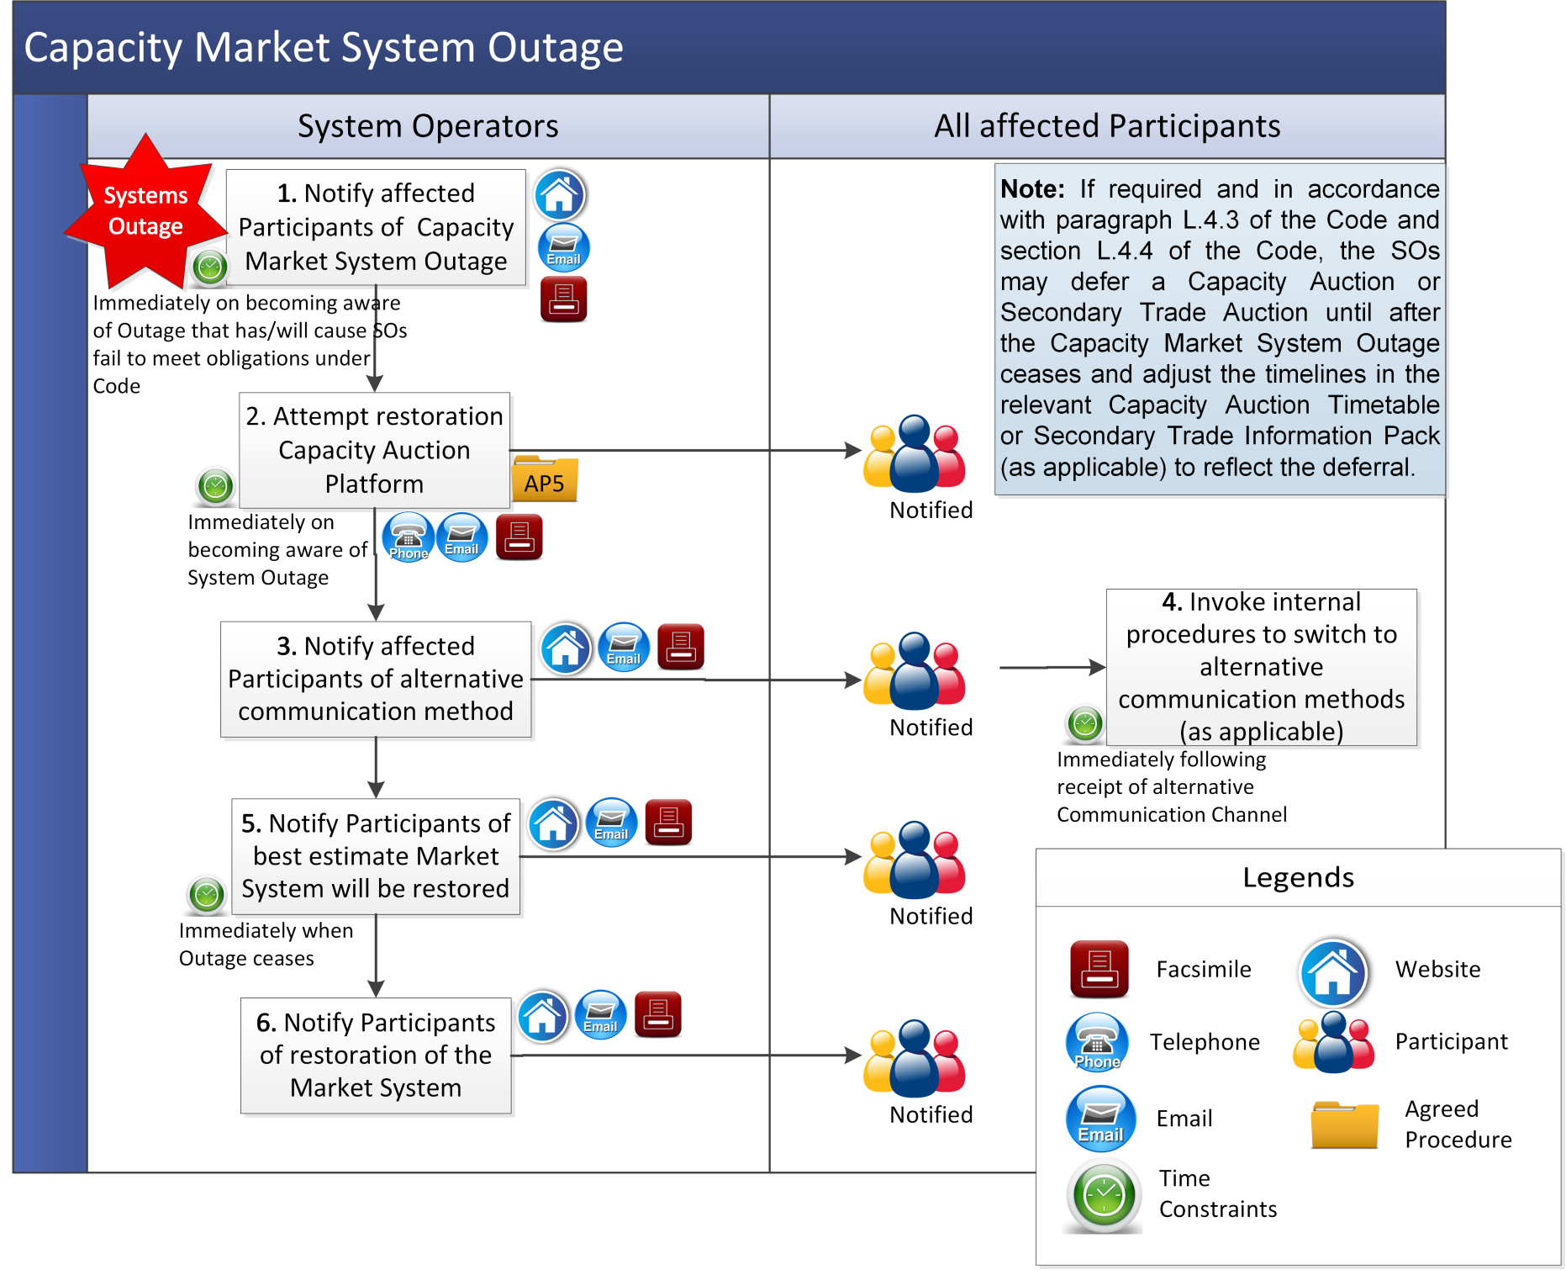

* 1. Limited Communication Failure
     1. Capacity Auction Offers

The following procedure shall apply in the event that a Limited Communication Failure impacts submission of Capacity Auction Offers by a Participant in accordance with the Capacity Auction Timetable.

| Step | Step Description | Timing | Method | From / By | To |
| --- | --- | --- | --- | --- | --- |
|  | Notify the System Operators that there is a Limited Communication Failure which impacts submission of Capacity Auction Offers in accordance with the Capacity Auction Timetable. | Immediately on becoming aware of Limited Communication Failure | Email / Facsimile / Telephone | Participant | System Operators |
|  | Confirm receipt of notification of Limited Communication Failure and provide a reference number for the notification. | As soon as practicable following completion of step 1 | Email | System Operators | Participant |
|  | Assess if Limited Communication Failure is valid and notify Participant of outcome. If Limited Communication Failure is not valid, **end process.** | As soon as practicable following completion of step 1 | Email | System Operators | Participant |
|  | The System Operators shall use reasonable efforts to assist the Participant in submitting the Capacity Auction Offers before the next scheduled Capacity Auction, subject to section F.6.2 of the Code. | As required | Email | System Operators | Participant |

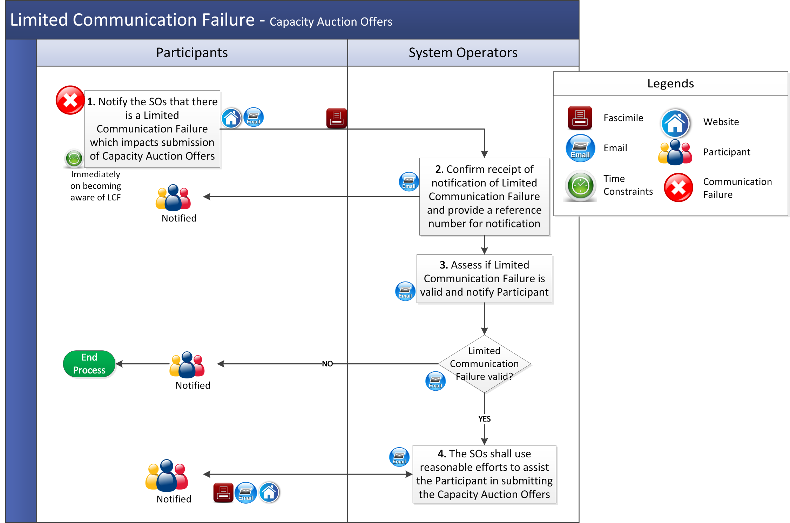

* + 1. Secondary Auction Bids and Secondary Auction Offers

This procedure shall apply in the event that a Limited Communication Failure impacts submission of Secondary Auction Bids and Secondary Auction Offers in accordance with the timelines set out in the Secondary Trade Information Pack.

| Step | Step Description | Timing | Method | From / By | To | |
| --- | --- | --- | --- | --- | --- | --- |
|  | Notify the System Operators that there is a Limited Communication Failure which impacts submission of Secondary Auction Bids or Secondary Auction Offers in accordance with the Secondary Trade Information Pack. | 1. Immediately on becoming aware of Limited Communication Failure; 2. at least 1 hour before the next scheduled Secondary Trade Auction; and 3. before the next bid and offer submission deadline specified in the Secondary Trade Information Pack | Email / Facsimile / Telephone | Participant | System Operators |
|  | Confirm receipt of notification of Limited Communication Failure. | As soon as practicable following completion of step 1 | Email / Facsimile | System Operators | Participant |
|  | Assess if Limited Communication Failure is valid and notify Participant of outcome. If Limited Communication Failure is not valid, **end process.** | As soon as practicable following completion of step 1 | Email / Facsimile | System Operators | Participant |
|  | Notify System Operator of: (a) alternative method of communication to be used for each of the Data Transactions; and (b) the estimated timeline of the Limited Communication Failure. | 1. Immediately on completion of step 1; 2. at least 1 hour before the next scheduled Secondary Trade Auction; and 3. before the next bid and offer submission deadline specified in the Secondary Trade Information Pack | Email / Facsimile | Participant | System Operators |
|  | Acknowledge receipt of notification at step 4 and invoke internal processes to accept Data Transactions from the alternative method of communication notified at step 4. | As soon as practicable following completion of step 4 | Email / Facsimile | System Operators | Participant |
|  | Advise if there is any change to the estimated timelines for the disruption to normal operation. | Immediately following any change to the previous estimate given for expected return to normal operation | Email / Facsimile | Participant | System Operators |
|  | Submit Secondary Auction Bids and Secondary Auction Offers in the format specified by the System Operator for all relevant Capacity Market Units. Submission should include Participant Authorised User, applicable password and the reference number received at step 2. | 1. Following completion of step 4; 2. at least 1 hour before the next scheduled Secondary Trade Auction; and 3. before the next bid and offer submission deadline specified in the Secondary Trade Information Pack | Email / Facsimile | Participant | System Operators |
|  | Confirm receipt of the Secondary Auction Bids and Secondary Auction Offers and,   1. inform the Participant that Secondary Auction Bids and Secondary Auction Offers have been successfully submitted to the Capacity Market Interface before the next scheduled Secondary Trade Auction; or 2. inform the Participant that the Secondary Auction Bids and Secondary Auction Offers were not able to be submitted to the Capacity Market Interface before the next scheduled Secondary Trade Auction. | As soon as practicable following step 7 | Email / Facsimile | System Operators | Participant |
|  | Notify System Operators of restoration of normal method of communication. | Immediately following restoration of normal communication interfaces with System Operators | Facsimile / Email and Telephone | Participant | System Operators |
|  | Acknowledge receipt of notification of restoration to normal method of communication. | As soon as practicable following receipt of notification at step 9 | Email / Facsimile | System Operators | Participant |
|  | Invoke internal processes to revert to normal method of communication for the Participant. | As soon as practicable following receipt of notification at step 9 | - | System Operators |  |

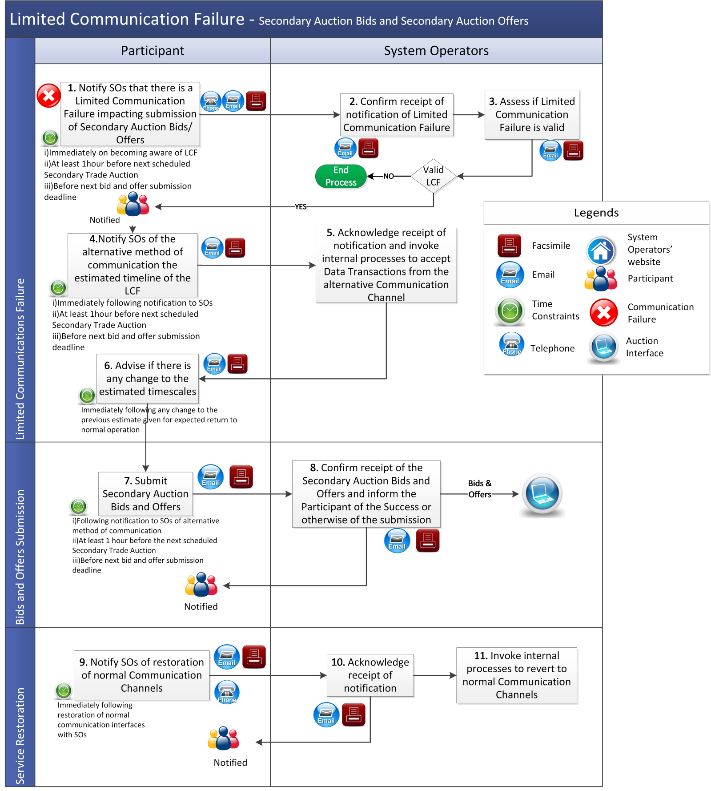

ppendix 1: Definitions

|  |  |
| --- | --- |
| **Capacity Market Interface** | means the function within the Capacity Market Platform that interfaces to the Type 2 Channel in accordance with the Code. |
| **Helpdesk** | means the facility put in place by the System Operators to enable Parties and others to seek assistance and submit requests on any issues arising under the Code. |

**PART 4 – Acknowledgement of Receipt of Meter Data Transaction**