Meetings / Workshops / Working Groups
 | Total | Balancing | Capacity | SEMOpx
2018/2019 | 17 | 12 | 4 | 1
2019/2020 | 19 | 12 | 5 | 2
2020/2021 | 16 | 11 | 3 | 2
2021/2022 | 20 | 11 | 7 | 2
2022/2023 | 15 | 7 | 6 | 2

2018 – 2020
Meeting | Date | Location
87 | 24th October 2018 | Conference Call
88 | 12th December 2018 | Dublin
89 | 20th February 2019 | Belfast
90 | 11th April 2019 | Dublin
91 | 18th April 2019 | Conference Call
92 | 27th June 2019 | Belfast
93 | 22nd August 2019 | Dublin
Mod_03_18 Working Group 1 | 24th January 2019 | Dublin
Mod_03_18 Working Group 2 | 9th May 2019 | Conference Call
Mod_32_18 Working Group 1 | 6th February 2019 | Dublin
Mod_32_18 Working Group 2 | 13th March 2019 | Dublin
Mod_04_19 Working Group 1 | 19th September 2019 | Dublin

2019 – 2020
Meeting | Date | Location
94 | 24th October 2019 | Belfast
95 | 5th December 2019 | Dublin
96 (Extraordinary Meeting) | 18th December 2019 | Conference Call
97 | 20th February 2020 | Belfast
97B (Extraordinary Meeting) | 16th April 2020 | Conference Call
98 | 23rd April 2020 | Conference Call
99 | 18th June 2020 | Conference Call
100 | 20th August 2020 | Conference Call
101B (Extraordinary Meeting) | 17th September 2020 | Conference Call
Mod_15_19 Working Group 1 | 15th November 2019 | Conference Call
Mod_14_19 Working Group 2 | 20th February 2020 | Belfast
Mod_13_19 Industry Call | 21st July 2020 | Conference call

2020 – 2021
Meeting | Date | Location
101 | 22nd October 2020 | Conference Call
102 | 3rd December 2020 | Conference Call
103 | 11th February 2021 | Conference Call
104 | 28th April 2021 | Conference Call
105 | 17th June 2021 | Conference Call
106 | 7th September 2021 | Conference Call
106B (Extraordinary Meeting) | 21st September 2021 | Conference Call
Working Group – Mod_13_19 | 10th December 2020 | Conference Call
Working Group – Mod_01_21, Mod_02_21 & Mod_04_21 | 23rd March 2021 | Conference Call
Industry Call – Mod_15_19 | 23rd February 2021 | Conference Call
Industry Call – Mod_15_19 (follow up) | 26th March 2021 | Conference Call

2021 – 2022
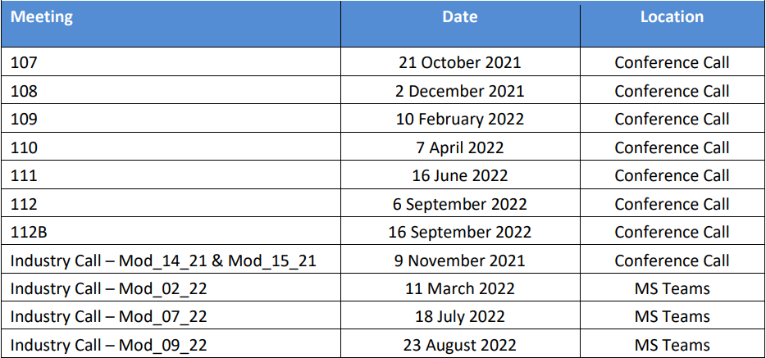

2022 – 2023
Meeting | Date | Location
113 | 20th October 2022 | MS Teams
114 | 1st December 2022 | MS Teams
115 | 22nd February 2023 | MS Teams
116 | 20th April 2023 | MS Teams
117 | 22nd June 2023 | MS Teams
118 | 6th September 2023 (Cancelled) | MS Teams
119 | 19th October 2023 | MS Teams

No of Modifications
 | Total | Balancing | Capacity | SEMOpx
2019 | 37 | 24 | 9 | 4
2020 | 29 | 13 | 12 | 4
2021 | 36 | 21 | 12 | 3
2022 | 41 | 18 | 16 | 7
2023 | 39 | 11 | 23 | 5

