

*Business Process*

**Macro set up for the Guarantees of Origin (GO) Registration Packs**

**How to set up Excel to use the Registration Packs**

The Generator Pack has been used as an example however; the same instructions will work for the Supplier Pack.

To use the Generator Registration pack for the Guarantees of Origin scheme you will need to enable Macros in Excel on your computer.

**Note: these steps should be completed immediately after the spreadsheet is opened.**

If given the security warning prompt shown below, click on “Options…”

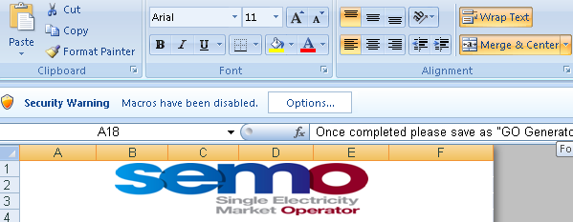

This will open a popup menu, in this menu select “Enable this content” as shown below and then click OK.

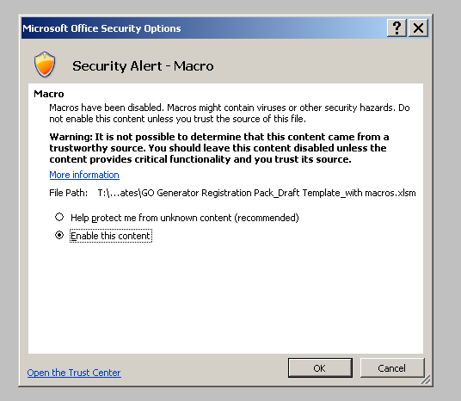

Macros will now be enabled for this Excel sheet. This will allow you to use the registration spreadsheet and **will not alter your settings permanently**.

If the security warning prompt shown above does not appear when the spreadsheet is opened, you will need to alter your Excel options. Click on the office button in the top left hand corner:

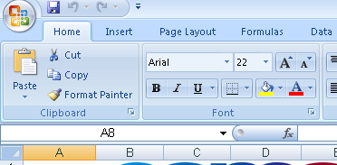

Select “Excel Options” at the bottom.

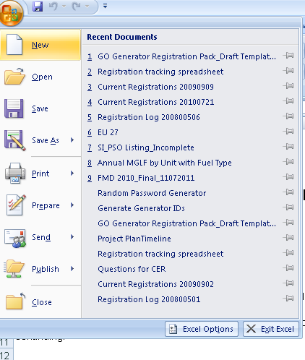

A pop up menu will appear. In the left hand column select “Trust Centre”.

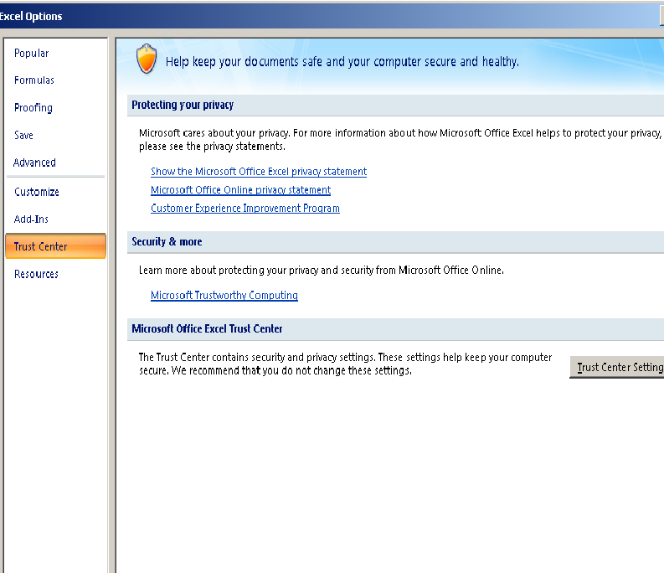

Select “Trust Centre Settings”.



In the pop up menu that appears, select “Macro Settings” in the left hand column.

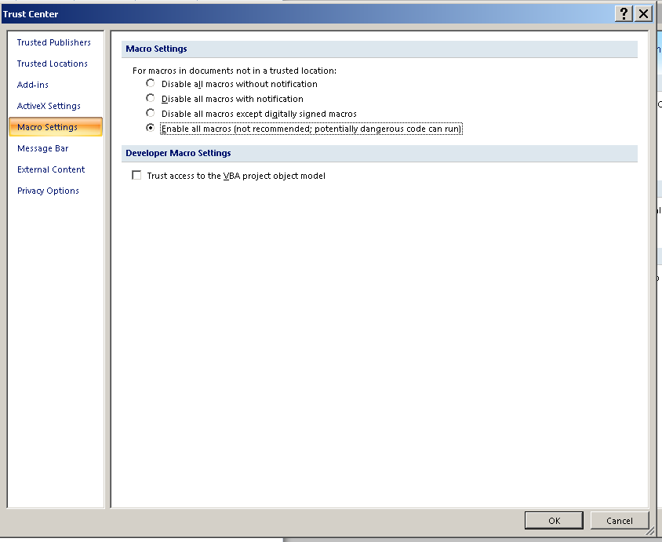

Then select the option “**Enable all Macros**” as shown below:



Click OK:



This will enable macros in Excel and allow you to use the spreadsheet for registration.

However, this option will alter your settings, if you wish for Macros to be disabled as a default you will have to change this setting back after completing the form.

This is done by following the steps above but in the last step selecting “Disable all macros with notification” instead of “Enable all macros”.

