|  |  |
| --- | --- |
| Agreed Procedure 10: Settlement Reallocation | April 7  2017 |

Trading and Settlement Code

Version 1.0

Contents

1. Introduction 1

1.1 Background and Purpose 1

1.2 Scope of Agreed Procedure 1

1.3 Definitions 1

1.4 Compliance with Agreed Procedure 1

2. Overview 2

2.1 Settlement Reallocation Arrangements 2

2.2 Registration of Settlement Reallocation Agreement 3

2.2.1 Submitting a Settlement Reallocation Agreement 3

2.2.2 Eligibility Criteria 3

2.2.3 Acceptance of a Settlement Reallocation Agreement 3

2.3 Settlement and Billing 4

2.4 Credit Assessment Process 4

2.5 Termination of a Settlement Reallocation Agreement 4

2.5.1 Termination by the Market Operator due to Default 4

2.5.2 Termination by the Market Operator due the Eligibility Criteria 4

2.5.3 Termination by a Participant 5

3. Procedural Steps 6

3.1 Registering a Settlement Reallocation Agreement 6

3.2 Termination of a Settlement Reallocation Agreement by a Participant 9

APPENDIX 1: Definitions and Abbreviations 12

APPENDIX 2: Settlement Reallocation Agreement 13

**DOCUMENT HISTORY**

|  |  |  |  |
| --- | --- | --- | --- |
| **Version** | **Date** | **Author** | **Comment** |
| 1.0 | 07/04/2017 | I-SEM Project Team |  |

**RELATED DOCUMENTS**

|  |  |  |  |
| --- | --- | --- | --- |
| **Document Title** | **Version** | **Date** | **By** |
| Trading and Settlement Code |  |  |  |
| Agreed Procedure 1 “Registration” |  |  |  |
| Agreed Procedure 3 “Communication Channel Qualification” |  |  |  |
| Agreed Procedure 4 “Transaction Submission and Validation” |  |  |  |
| Agreed Procedure 9 “Management of Credit Cover and Credit Default” |  |  |  |
| Agreed Procedure 11 “Market System Operation, Testing, Upgrading and Support” |  |  |  |

1. Introduction
   1. Background and Purpose

This Agreed Procedure supplements the rules in relation to the management of Settlement Reallocation set out in the Trading and Settlement Code (hereinafter referred to as the “**Code**”). It sets out the procedures in relation to Settlement Reallocation with which Parties to the Code must comply.

* 1. Scope of Agreed Procedure

This Agreed Procedure sets out the procedures that will apply in relation to:

1. submitting a Settlement Reallocation Agreement to the Market Operator;
2. acceptance of a Settlement Reallocation Agreement by the Market Operator; and
3. termination of a Settlement Reallocation Agreement.

It forms an annex to, and is governed by, the Code. This document sets out procedures to be followed subject to the rights and obligations of Parties under the Code. In the event of any conflict between a Party’s obligations set out in the Code and this Agreed Procedure, the Code shall take precedence.

It is not intended that there be any inconsistency or conflict between section 2 “Overview” and section 3 “Procedural Steps”. However, in the event of any inconsistency or conflict, section 3 “Procedural Steps” shall take precedence.

In section 3 “Procedural Steps” a corresponding process flow diagram is included for each procedural steps table.  Process flow diagrams are for illustrative purposes.  It is not intended that there be any inconsistency or conflict between any procedural steps table and process flow diagram however, in the event of any inconsistency or conflict, a procedural steps table shall take precedence.

* 1. Definitions

Words and expressions defined in the Code shall, unless the context otherwise requires or unless otherwise defined herein at Appendix 1 “Definitions and Abbreviations”, have the same meanings when used in this Agreed Procedure.

References to particular sections relate internally to this Agreed Procedure unless specifically noted.

* 1. Compliance with Agreed Procedure

Compliance with this Agreed Procedure is required under the terms as set out in the Code.

1. Overview
   1. Settlement Reallocation Arrangements

The Settlement Reallocation process allows Participants to reduce Credit Cover requirements in the Single Electricity Market by offsetting debts and credits and reducing circular flows of money.

Settlement Reallocation is a rules supported financial arrangement between the Market Operator and both a Principal Participant and a Secondary Participant (which may be the same or different Parties). Secondary Participants can transfer all payments payable to it by the Market Operator and all charges payable to it by the Market Operator to one Principal Participant.

A Principal Participant can have Settlement Reallocation Agreements with more than one Secondary Participant however a Principal Participant cannot also be a Secondary Participant. A Secondary Participant can have a Settlement Reallocation Agreement with only one Principal Participant.

Settlement Reallocation consists of five key elements:

1. Submission of a Settlement Reallocation Agreement by the Principal Participant and Secondary Participant;
2. Assessment of the eligibility of a Settlement Reallocation Agreement for the billing process;
3. Application of the eligible Settlement Reallocation Agreements in the Settlement Document;
4. Application of the Settlement Reallocation Agreements in the Credit Assessment process; and,
5. Termination of a Settlement Reallocation Agreement (when applicable).

When Participants have a Settlement Reallocation Agreement in place with the Market Operator, the Principal Participant takes over full financial responsibility of all Secondary Participants with which it has posted Settlement Reallocation Agreements. This will result in a transfer of all amounts in respect of Settlement Documents issued to any Secondary Participants to that Principal Participant by the Market Operator. This amount shall also have an effect on the Credit Cover calculation of the affected Participants.

The Settlement Reallocation amount is a monetary value based in the currency of the Principal Participant (either Euro or Pounds Sterling).

Settlement Reallocation Agreements are posted against a Settlement Document relating to all Settlement under the Code.

A Settlement Reallocation Agreement shall have start date (Settlement Day after which the reallocation is to apply) and may have an end date (the Settlement Day after which the reallocation will no longer apply) subject to paragraph G.16.2.2 of the Code.

* 1. Registration of Settlement Reallocation Agreement
     1. *Submitting a Settlement Reallocation Agreement*

In accordance with section G.16.3 of the Code, in order to register a Settlement Reallocation Agreement, a Participant which has executed a draft Settlement Reallocation Agreement may lodge a copy of the draft agreement (executed by both the Principal Participant and the Secondary Participant) with the Market Operator. The form of Settlement Reallocation Agreement is contained in Appendix 2 “Settlement Reallocation Agreement”. A Settlement Reallocation Agreement must satisfy the criteria set out in paragraph G.16.2 of the Code.

Agreed Procedure 4 “Transaction Submission and Validation” sets out the data items required on submission of a Settlement Reallocation Agreement.

* + 1. *Eligibility Criteria*

Participants are qualified to register a Settlement Reallocation Agreement if all of the following eligibility criteria are met:

1. both the Principal Participant and the Secondary Participant are, at the time of the registration, registered as Participants in accordance with the Code and Agreed Procedure 1 “Registration”;
2. both the Principal Participant and Secondary Participant are not, at the time of the registration, subject to a Suspension Order or Termination Order;
3. both the Principal Participant and Secondary Participant, at the time of the registration, have designated and maintained a Communication Channel for the purpose of their participation in accordance with Agreed Procedure 1 “Registration” and Agreed Procedure 3 “Communication Channel Qualification”;
4. the Market Operator has allowed both Principal Participant and Secondary Participant to access the Balancing Market Interface in accordance with the Code, Agreed Procedure 3 “Communication Channel Qualification” and Agreed Procedure 11 “Market System Operation, Testing, Upgrading and Support”; and
5. the Settlement Reallocation Agreement is submitted during the period commencing 60 days prior to the day on which the first Settlement Document to be covered by the relevant Settlement Reallocation Agreement is scheduled to issue and ending 20 Working Days prior to that day.
   * 1. *Acceptance of a Settlement Reallocation Agreement*

Following submission of a Settlement Reallocation Agreement, the Market Operator shall review the agreement and perform validity checks to ensure that the affected Participants are active and qualified to reallocate on the specified Settlement Period. The Settlement Reallocation Agreement is either accepted or rejected by the Market Operator.

Once the Settlement Reallocation Agreement has been accepted by the Market Operator, the Market Operator shall execute the Settlement Reallocation Agreement, register the Settlement Reallocation Agreement and notify the affected Principal and Secondary Participant accordingly. The Settlement Reallocation Agreement can then be applied in the Credit Assessment process and is given effect in accordance with paragraph G.16.4.1 of the Code.

If a Settlement Reallocation Agreement is rejected, the Market Operator shall notify the affected Principal Participant and Secondary Participant. Once submitted, the terms of a Settlement Reallocation Agreement cannot be updated by Participants.

Participants may review the Settlement Reallocation Agreements to which they are a party on the Settlement Reallocation Agreement report made available with the published Settlement Documents for the last day of the Settlement Period.

* 1. Settlement and Billing

A Settlement Reallocation Agreement shall be applied in the billing process administered by the Market Operator unless it has been terminated in accordance with the section G.16.5 of the Code and this Agreed Procedure.

As part of the billing process, the Participant will receive a Settlement Reallocation Agreement report detailing the Settlement Reallocation Agreement that relate to a specific Settlement Document. Settlement Documents shall contain details of the amount transferred as part of that Settlement Reallocation Agreement.

* 1. Credit Assessment Process

When a Settlement Reallocation Agreement is in effect it can be applied in the Credit Assessment process. In calculating Required Credit Cover and assessing a Participant’s Posted Credit Cover against a Participant’s Required Credit Cover, the Credit Assessment process shall take into account any Settlement Reallocation Agreements.

Where the Principal Participant and Secondary Participant are in different Currency Zones, Settlement Reallocation Agreements will be converted using the Trading Day Exchange Rate for the day on which Credit Cover is being calculated.

* 1. Termination of a Settlement Reallocation Agreement

A Settlement Reallocation Agreement can be terminated by the Market Operator or by a Participant that is a party to the agreement.

* + 1. *Termination by the Market Operator due to Default*

If a Principal Participant associated with pending Settlement Reallocation Agreements is a Defaulting Participant, and that Principal Participant has Settlement Reallocation Agreements for which the submission was valid but have not yet been applied to a Settlement Document, the Market Operator may terminate such Settlement Reallocation Agreements at any time.

If a Secondary Participant associated with a pending Settlement Reallocation Agreement is a Defaulting Participant, a report will be issued which will reference the specific Settlement Document to which the Settlement Reallocation Agreement will apply.

* + 1. *Termination by the Market Operator due the Eligibility Criteria*

Prior to Settlement and billing, if the Market Operator determines that a Settlement Reallocation Agreement does not meet the eligibility criteria set out in section 2.2.1 above, the Market Operator may terminate the Settlement Reallocation Agreement.

When the Market Operator terminates a Settlement Reallocation Agreement, both the Principal and Secondary Participant shall be informed via a Settlement Reallocation termination report, which shall be provided together with the next Required Credit Cover Report.

* + 1. *Termination by a Participant*

The procedural steps in relation to termination of a Settlement Reallocation Agreement by a Participant are set out at section 3.2 below.

The Market Operator shall terminate a Settlement Reallocation Agreement if a request to terminate is submitted to the Market Operator on behalf of either the Principal Participant or the Secondary Participant.

A termination request must be made before 17:00, 20 Working Days before the proposed end date of the affected Settlement Reallocation Agreement.

Where the termination of a Settlement Reallocation Agreement will cause the Credit Cover Ratio of the affected Secondary Participant to equal to or exceed the Breach Limit, then that Secondary Participant will be subject to a Credit Cover Increase Notice under the Code and will be obliged to satisfy the requirements of any such notice before the termination of the Settlement Reallocation Agreement can be given effect.

1. Procedural Steps
   1. Registering a Settlement Reallocation Agreement

| Step | Procedural Step | Timing | Method | By/From | To |
| --- | --- | --- | --- | --- | --- |
|  | Deliver an executed draft of the Settlement Reallocation Agreement (executed by the Principal Participant and Secondary Participant). The form of Settlement Reallocation Agreement is contained in Appendix 2 “Settlement Reallocation Agreement”. | During the period commencing 60 days prior to the day on which the first Settlement Document to be covered by the relevant Settlement Reallocation Agreement is scheduled to issue and ending 20 Working Days prior to that day | Registered post | Principal Participant / Secondary Participant | Market Operator |
|  | Review Settlement Reallocation Agreement and perform validity checks to ensure that the affected Participants are active and qualified to reallocate on the specified Settlement Period. | As required | - | Market Operator | - |
|  | Update Credit Cover as instructed by the Market Operator (if required) in accordance with the Credit Assessment process. | As required | - | Principal Participant | - |
|  | Confirm eligibility criteria (set out in the Code and section 2.2.2 above) are met. | As required |  | Market Operator | - |
|  | If eligibility criteria are not met, request required information from Participant. | As required | Email / Facsimile | Market Operator | Principal Participant and Secondary Participant |
|  | If Settlement Reallocation Agreement is accepted, execute the Settlement Reallocation Agreement. | - | - | Market Operator | - |
|  | Update Market Operator Isolated Market Systems to reflect the Settlement Reallocation Agreement. | - | - | Market Operator | - |
|  | Issue notification of the acceptance or rejection of the Settlement Reallocation Agreement, detailing results of validity check. | - | Email / Facsimile | Market Operator | Principal Participant and Secondary Participant |

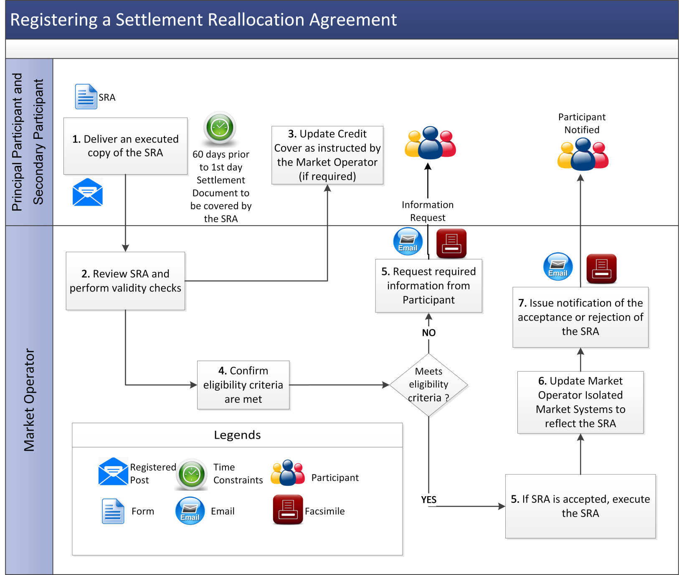

* 1. Termination of a Settlement Reallocation Agreement by a Participant

| Step | Procedural Step | Timing | Method | By/From | To |
| --- | --- | --- | --- | --- | --- |
|  | Request the termination of Settlement Reallocation Agreement by completion of the termination request form available from the Market Operator. | Before 17:00, 20 WD before the proposed termination of the affected Settlement Reallocation Agreement | Registered post | Principal Participant or the Secondary Participant | Market Operator |
|  | Acknowledge receipt of request to terminate. | On receipt of request to terminate at step 1 | Email / Facsimile | Market Operator | Principal Participant, Secondary Participant |
|  | Assess the request to terminate the Settlement Reallocation Agreement. | Within 2 WD of request to terminate at step 1 | - | Market Operator | - |
|  | Give effect to the termination of the Settlement Reallocation Agreement. Update the Market Operator’s Isolated Market System to reflect termination. | From the time when the next Settlement Document is issued after the later of the termination time specified in the termination request at step 1 (if any) and 20 WD following the Market Operator receiving the termination request at step 1 | Email / Facsimile | Market Operator | Principal Participant, Secondary Participant |
|  | Provide notification of the termination of the Settlement Reallocation Agreement. | Within 2 WD of termination of Settlement Reallocation Agreement | - | Market Operator | Principal Participant and Secondary Participant |
|  | Inform the Principal and Secondary Participant of Required Credit Cover as set out in Agreed Procedure 9 “Management of Credit Cover and Credit Default”. | In accordance with Agreed Procedure 9 “Management of Credit Cover and Credit Default” | Email / Facsimile | Market Operator | - |

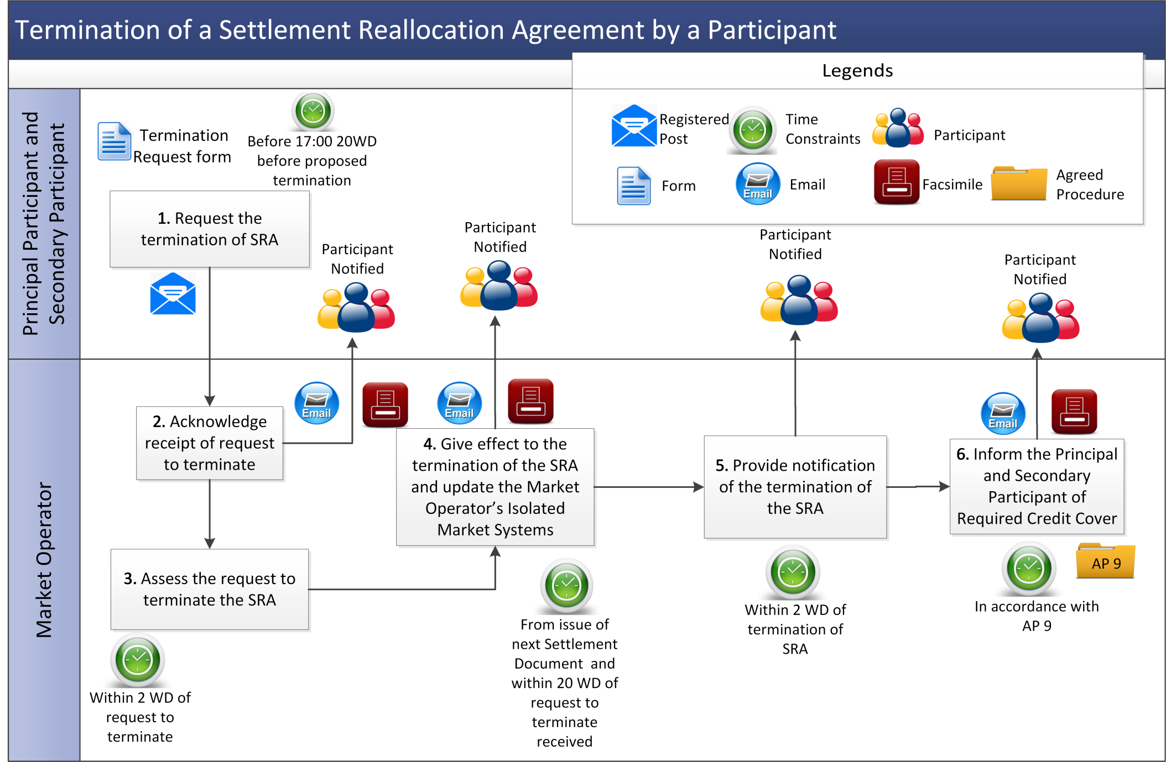

1. Definitions and Abbreviations

**Definitions**

|  |  |
| --- | --- |
| **Balancing Market Interface** | means the function within the Market Operator’s systems that interfaces to the Type 2 Channel and Type 3 Channel communications in accordance with the Code. |

**Abbreviations**

|  |  |
| --- | --- |
| **SRA** | Settlement Reallocation Agreement |

1. Settlement Reallocation Agreement

**Date: [insert date]**

**BETWEEN:**

**[Party XX] [insert name, company registration number and address] on behalf of Principal Participant [insert Principal Participant Name, Principal Participant ID] (referred to herein as the “Principal Participant”)**

**[Party YY] [insert name, company registration number and address] on behalf of Secondary Participant [insert Secondary Participant Name, Secondary Participant ID]:; (referred to herein as the “Secondary Participant”) and**

**Market Operator: EIRGRID plc**, an Irish company formed pursuant to Regulation 34 of the European Communities (Internal Market in Electricity) Regulations 2000 with company registration number 338522 (“**EirGrid**”) and **SONI LIMITED**, a body corporate registered in Northern Ireland with company registration number NI038715 (“**SONI**”), in their joint capacity as Market Operator for the purposes of the Code.

**OTHER DETAILS:**

**Initial Settlement Day: [nominate date after which the Settlement Reallocation is intended to have effect]**

**Final Settlement Day**: [**nominate date after which the Settlement Reallocation will no longer apply, if known]**

**IT IS AGREED** as follows:

1. Unless the context otherwise requires and save as mentioned below, words and expressions defined in, or to be construed in accordance with, the Code shall have the same meanings and construction when used in this Agreement:

“**Code**” means the Trading and Settlement Code, including the Appendices and Agreed Procedures, as amended, varied, modified or replaced from time to time; and

**“Settlement Reallocation Amounts”** means all amounts which, but for this Settlement Reallocation Agreement, would be (as applicable) paid to the Market Operator by the Secondary Participant or by the Market Operator to the Secondary Participant under Settlement Documents issued under the Code during the Effective Period.

2. The Market Operator and the Principal Participant and the Secondary Participant are parties to the Code, and this Agreement is a Settlement Reallocation Agreement under section G.17 of the Code.

3. This Agreement covers all Settlement Documents issued under the Code to the Secondary Participant between:

(a) the later of the Initial Settlement Day and the expiration of 20 Working Days after all parties (including the Market Operator) have executed this Agreement; and

(b) the earlier of the Final Settlement Day (if one is specified above) and the date this Agreement is terminated in accordance with the Code (and such termination takes effect),

(such period being the “**Effective Period**”).

4. Subject to the terms and on the conditions set out in the Code, during the Effective Period:

(a) each of the Market Operator and the Secondary Participant shall be released from further obligations towards one another in respect of each Settlement Reallocation Amount falling due for payment and their respective rights against one another in respect of each Settlement Reallocation Amount shall be cancelled (being the "**Discharged Rights and Obligations**"); and

(b) each of the Market Operator and the Principal Participant shall assume obligations towards one another and acquire rights against one another which differ from the Discharged Rights and Obligations only insofar as the Market Operator and the Principal Participant have assumed and acquired the same in place of the Market Operator and the Secondary Participant.

5. This Agreement reflects a commercial agreement between the Principal Participant and the Secondary Participant, and each of the Principal Participant and the Secondary Participant hereby (a) agree that the Market Operator is not liable for any loss or damage suffered by either the Principal Participant or the Secondary Participant as a result of, or in connection with, this Agreement and any Settlement Reallocations under it (together, the “**SRA Losses**”) and (b) hold the Market Operator harmless and indemnify the Market Operator from any and all SRA Losses which may arise.

6. This Agreement:

(a) may be terminated by the Principal Participant, the Secondary Participant or the Market Operator in accordance with the Code; and

(b) be executed in any number of counterparts, and this has the same effect as if the signatures on the counterparts were on a single copy of this Agreement.

7. This Agreement and any non-contractual obligations arising out of or in connection with it shall be governed by and construed in accordance with the laws of Northern Ireland. The parties hereto hereby agree that the courts of Northern Ireland shall have jurisdiction to hear and determine any suit, action or proceedings that may arise out of or in connection with this Agreement and for such purpose irrevocably submits to the jurisdiction of such courts.

8. It is intended that this Agreement takes effect as a deed notwithstanding the fact that a party hereto may only execute this Agreement under hand.

9. The Principal Participant and the Secondary Participant hereby authorise the Market Operator to date this Agreement at any time following the date that they have each executed this Agreement.

**IN WITNESS** whereof the parties hereto have executed this Agreement as a deed in the manner hereinafter provided on the date shown above.

***[Signature page follows]***

|  |  |
| --- | --- |
| **ON BEHALF OF THE PRINCIPAL PARTICIPANT:** | |
| **\*GIVEN** under the common seal of  **_______________________**  and delivered as a deed  ____________________  (Witness’ Signature)  (Witness’ Address)  (Witness’ Occupation) | *{Common Seal}*  *_________________________*  *(Director)*  *__________________________*  *(Director/Secretary)* |
| **\*SIGNED AND DELIVERED** as a deedfor and on behalf of  _______________________  by  in the presence of:-  (Witness’ Signature)  (Witness’ Address)  (Witness’ Occupation) | *__________________________*  *Role:* |
| **\* Delete / Amend as appropriate \*** | |

|  |  |
| --- | --- |
| **ON BEHALF OF THE SECONDARY PARTICIPANT:** | |
| **\*GIVEN** under the common seal of  **_______________________**  and delivered as a deed  ____________________  (Witness’ Signature)  (Witness’ Address)  (Witness’ Occupation) | *{Common Seal}*  *_________________________*  *(Director)*  *__________________________*  *(Director/Secretary)* |
| **\*SIGNED AND DELIVERED** as a deedfor and on behalf of  _______________________  by  in the presence of:-  (Witness’ Signature)  (Witness’ Address)  (Witness’ Occupation) | *__________________________*  *Role:* |
| **\* Delete / Amend as appropriate \*** | |