Trading and Settlement Code

|  |  |
| --- | --- |
| Agreed Procedure 11: Market System Operation, Testing, Upgrading and Support | April 7  2017 |

Version 1.0

**Contents**

1. Introduction 1

1.1 Background and Purpose 1

1.2 Scope of Agreed Procedure 1

1.3 Definitions 1

1.4 Compliance with Agreed Procedure 2

2. Overview 3

2.1 Helpdesk 3

2.1.1 Categorisation and Prioritisation of Helpdesk Requests 3

2.1.2 Helpdesk Requests - Category 4

2.1.3 Helpdesk Requests - Category 2 4

2.1.4 Helpdesk Requests - Category 3, 4 and 5 4

2.1.5 Logging and Monitoring of Helpdesk Requests 4

2.2 Market Operator’s Isolated Market System Modifications 5

2.2.1 Change Management 5

2.2.2 Release Management (Scheduled Releases) 5

2.2.3 Emergency Releases 6

2.2.4 Testing 6

2.2.5 Implementation Procedure 7

2.2.6 Emergency Implementation 8

2.3 Problem Management 8

2.3.1 Problem Management Function 8

2.3.2 Prioritisation of Actions 8

2.3.3 Procedures applicable in the event of a Failure 9

2.3.4 Post Event Reporting 9

2.4 Authorised Persons 10

2.4.1 Nomination of Authorised Persons 10

2.4.2 Authentication of Information 10

3. Procedural Steps 11

3.1 Helpdesk 11

3.2 Implementation Procedures 14

3.2.1 Change Management for Scheduled Releases 14

3.2.2 Implementation: Maintenance / Application Release and Emergency Release 16

3.3 Problem Management 18

3.4 Post Event Reporting 18

3.5 Authorised Person and Creation of a New Party Administrative User 21

APPENDIX 1: Definitions and Abbreviations 23

APPENDIX 2: Potential Failures and Typical Corrective Actions 26

APPENDIX 3: Authorisation Categories 28

**DOCUMENT HISTORY**

|  |  |  |  |
| --- | --- | --- | --- |
| Version | Date | Author | Comment |
| 1.0 | 07/04/2017 | I-SEM Project Team |  |

**RELATED DOCUMENTS**

|  |  |  |  |
| --- | --- | --- | --- |
| Document Title | Version | Date | By |
| Trading and Settlement Code |  |  |  |
| Agreed Procedure 1 “Registration” |  |  |  |
| Agreed Procedure 3 “Communication Channel Qualification” |  |  |  |
| Agreed Procedure 7 “Emergency Communications” |  |  |  |
| Agreed Procedure 9 “Management of Credit Cover and Credit Default” |  |  |  |
| Agreed Procedure 10 “Settlement Reallocation” |  |  |  |
| Agreed Procedure 12 "Modifications Committee Operation" |  |  |  |
| Agreed Procedure 13 "Settlement Queries" |  |  |  |
| Agreed Procedure 14 "Disputes" |  |  |  |

1. Introduction
   1. Background and Purpose

This Agreed Procedure supplements the rules in the Trading and Settlement Code (hereinafter referred to as the “**Code**”) relating to Market System operation, testing, upgrading and support. It sets out procedures with which Parties to the Code must comply.

* 1. Scope of Agreed Procedure

This Agreed Procedure sets out procedures in relation to how the Market Operator:

1. Provides advice to Parties in relation to the market operation and Communication Channels;
2. Provides a facility for Parties to report incidents;
3. Coordinates and facilitates Implementation of the Market Operator’s Isolated Market Systems and Type 2 Channel / Type 3 Channel;
4. Schedules testing and down-time of the Market Operator’s Isolated Market Systems or Type 2 Channel / Type 3 Channel Balancing Market Interfaces; and
5. Commission an externally audited report as required under the Code in the event of a communication or systems failure.

The Agreed Procedure will also set out the timescales and standards for the Market Operator to restore the Market Operator’s Isolated Market Systems in the event of a General System Failure.

This Agreed Procedure forms an annex to, and is governed by, the Code. It sets out procedures to be followed subject to the rights and obligations of Parties under the Code. In the event of any conflict between a Party’s obligations set out in the Code and this Agreed Procedure, the Code shall take precedence.

It is not intended that there be any inconsistency or conflict between section 2 “Overview” and section 3 “Procedural Steps”. However, in the event of any inconsistency or conflict, section 3 “Procedural Steps” shall take precedence.

In section 3 “Procedural Steps” a corresponding process flow diagram is included for each procedural steps table.  Process flow diagrams are for illustrative purposes.  It is not intended that there be any inconsistency or conflict between any procedural steps table and process flow diagram however, in the event of any inconsistency or conflict, a procedural steps table shall take precedence.

* 1. Definitions

Words and expressions defined in the Code shall, unless the context otherwise requires or unless otherwise defined herein at Appendix 1 “Definitions and Abbreviations”, have the same meanings when used in this Agreed Procedure.

References to particular paragraphs relate internally to this Agreed Procedure unless otherwise specified.

* 1. Compliance with Agreed Procedure

Compliance with this Agreed Procedure is required under the terms as set out in the Code.

1. Overview
   1. Helpdesk

The Market Operator will operate a Helpdesk through which Parties can seek technical and operational advice. The Helpdesk will provide information on the following:

1. Party / Unit registration;
2. Communication Channels;
3. Market operation and obligations of Parties;
4. Incidents affecting the Market Operator’s Isolated Market Systems and Communication Channels; or
5. Initial point of contact for Participants to raise a Settlement Query, log a Dispute, request an ad-hoc data report or any other query.

The Helpdesk can be contacted via email or by telephone except in relation to Disputes and Settlement Queries, which will require the communication methods specified in Agreed Procedure 13 "Settlement Queries" and Agreed Procedure 14 "Disputes" to be used.

### *Categorisation and Prioritisation of Helpdesk Requests*

Helpdesk Requests are separated into 5 categories as outlined in the table below.

**Table 1: Helpdesk Categories**

|  |  |  |
| --- | --- | --- |
| **Category** | **Title** | **Description** |
| 1 | Dispute | Dispute raised under Agreed Procedure 14 "Disputes" |
| 2 | Settlement Query | Query raised under Agreed Procedure 13 "Settlement Queries" |
| 3 | General Urgent Query | A query with very high priority, requiring urgent assistance by the Market Operator and relating to specific issues preventing a Participant from performing its obligations under the Code, such as Credit Cover Increase Notices, invoices, communication failure, and offer data submission problems at Gate Closure. For issues in relation to Offer Data submission, Participants can avail of an emergency telephone line that connects directly to an operator without going through the Helpdesk. |
| 4 | General Important query | A query with medium / high priority relating to items such as training requests, Digital Certificates, configuration of Communication Channels, Authorised Persons, scheduled reports missing from the websites. |
| 5 | General Standard Query | A query with normal priority. It could relate to any item including archive request, query update, access issues, clarification on market rules, general publications. |

### *Helpdesk Requests - Category*

All Helpdesk Requests under Category 1 will be logged and presented to the appropriate Market Operator contact as soon as possible upon receipt. The person processing the Dispute shall follow the procedures and timelines of Agreed Procedure 14 "Disputes".

### *Helpdesk Requests - Category 2*

All Helpdesk Requests under Category 2 will be logged and presented to the appropriate Market Operator contact as soon as possible upon receipt. The person processing the Settlement Query shall follow the procedures and timelines of Agreed Procedure 13 "Settlement Queries".

### *Helpdesk Requests - Category 3, 4 and 5*

A general query is a query submitted by email / voicemail / telephone call without the prescribed form for Settlement Queries or Disputes. As set out in Table 1 “Helpdesk Categories”, these general queries are further categorised as:

* 1. General Urgent Query;
  2. General Important Query; or
  3. General Standard Query.

The classification of general queries set out above helps to prioritise responses and make the process more efficient for those issues that require a fast turnaround. The response will include either the information requested or provide a timeline for processing the request. Depending on the type of issues the response timelines can vary, however the following guidelines are in place:

1. General Urgent Query: respond within maximum one Working Day;
2. General Important Query: respond within maximum three Working Days;
3. General Standard Query: depending on the issue, reasonable endeavour to respond within 15 Working Days. The Helpdesk will inform the Party raising the query if ‘special requests’ (such as large archived data requests or queries with external dependencies) could not be responded to within the above timelines, and will communicate the revised target timelines.

The criteria for classifying a query have been defined in consultation with Participants and are kept in a list maintained by the Helpdesk. Although the list above offers general indications on query classification and will be updated as the need arise, some judgement is required on a case by case basis by the Helpdesk representative where no profile matches the query topic.

### *Logging and Monitoring of Helpdesk Requests*

All Helpdesk Requests will be logged by the Market Operator when initially processed and the details and resolution recorded.

The Helpdesk will inform the Participant of the closure of Helpdesk Requests by telephone, email or via the Market Operators Query Management System portal.

* 1. Market Operator’s Isolated Market System Modifications

### *Change Management*

The Market Operator shall implement a change management process in relation to their Isolated Market System to manage the identification, recording, rectification/development and Implementation of:

1. any change to the production system, applications, environment or infrastructure;
2. defects;
3. approved changes through Agreed Procedure 12 "Modifications Committee Operation";
4. operational improvements not requiring Modifications; and
5. upgrades to system software both core and third party.

The change management process will include procedures to collate Modifications to the Market Operator’s Isolated Market System into Releases.

Parties will be made aware of all changes to the Market Operator’s Isolated Market Systems with the exception of changes that relate to standard IT maintenance activities or internal process improvements which do not impact on system availability or third party interfaces. Parties will be informed of such changes as part of the change management process.

### *Release Management (Scheduled Releases)*

Each year, before the final Working Day in June, the Market Operator shall provide all Parties with a Release timetable for the following year that identifies the dates for Scheduled Releases of the Market Operator’s Isolated Market System. These Releases will be made up of system modifications as a result of Modifications agreed under Agreed Procedure 12 "Modifications Committee Operation", upgrades in system software (core and third party) and corrections of identified defects. The composition of the Releases will not be detailed in the release timetable.

The Market Operator shall maintain the Interface Technical Specification, which shall provide information required for Participants to implement Type 2 Channel and Type 3 Channel interfaces to the Market Operator’s Isolated Market Systems. This documentation shall be maintained under version control by the Market Operator.

Any proposed Implementation shall consider corresponding updates to the Technical Specification and the Market Operator shall detail this update within its Impact Assessment which shall be made available to Participants, Meter Data Providers and System Operators. The Impact Assessment shall assign the Implementation classification (see Table 1 “Levels of Implementation”) and include a proposed Release plan. The Release plan shall include:

1. consultation forum details;
2. proposed delivery date for complete Technical Specification pertaining to proposed Release. Where appropriate a delivery date for provision of sample files will also be specified;
3. proposed Participant interface testing start date and duration; and
4. proposed Release date and Implementation window.

On receipt of the output of the Impact Assessment and Release plan the Participant, Meter Data Providers and System Operators shall be given the opportunity to comment on the content of these documents. All comments must be received by the Market Operator within five Working Days of the date of issue of the Impact Assessment and Release plan. In the case of disagreement in relation to the content, assigned Implementation classification, or Release detail then the rationale for the disagreement must be provided to the Market Operator.

A consultation workshop will be organised by the Market Operator as close as is practicable to five Working Days (and no later than ten Working Days) after the issue of the Impact Assessment and Release plan. Attendance of any Party is voluntary, the purpose of the workshop is to facilitate consultation on the key aspects of the proposed Release.

Once all comments are received (including discussions during the consultation workshop) the Market Operator will issue a document to Participants, Meter Data Providers and System Operators detailing the final Implementation classification, Release content and proposed timeline. The minimum time between issue of this document and implementing a planned Release will be 35 days.

If a Participant, Meter Data Provider or System Operator maintains their disagreement with the assigned Implementation classification or Release detail they shall have recourse to the Modifications Committee through the raising of an Urgent Modification Proposal in accordance with Agreed Procedure 12 “Modifications Committee Operation”. The raising of the Urgent Modification Proposal must be agreed with the Regulatory Authorities and its raising shall prevent the proposed Implementation of the change until a judgement has been concluded by the Emergency Meeting. There will be no specific changes to market documentation associated with the Urgent Modification Proposal.

### *Emergency Releases*

The Market Operator may schedule an Emergency Release: (i) if it considers that there is a risk to the security or operation of the SEM that requires an upgrade in system software (core or third party), security patch(es) or a defect; or (ii) if there is an Implementation of an Urgent Modification.

Where an Emergency Release does not affect the interface with Parties (i.e. there is no requirement for Parties to modify their Isolated Market Systems) then the Market Operator shall publish a summary of the Emergency Release as soon as practicable. It is recognised that this notice may be issued immediately prior to the Emergency Release. Reasonable endeavours shall be made to issue the Emergency Release notification as early as possible.

Where an Emergency Release affects the interface with Parties (i.e. there is a requirement for Parties to modify their Isolated Market Systems) then this shall be agreed through an Urgent Modification. The agreement of the Urgent Modification should also include the Emergency Release timelines and the notices that the Market Operator shall publish to Parties on the Emergency Implementation.

### *Testing*

The Market Operator shall be responsible for testing Releases of its Isolated Market System and for ensuring that any functional and technical changes meet the requirements of the approved Modification Proposals included in the Release.

Where the Release includes changes to the interface with Parties, the Market Operator will provide a separate Test Environment of the relevant Market Operator’s Isolated Market System to enable the affected Parties to test the interface. This Test Environment will be available for a period of not less than five Working Days prior to Implementation of the Release. The date and duration of this test phase will be decided based on feedback received during the initial Release consultation process. If during this phase the Market Operator becomes aware that one or more Participants are experiencing unanticipated issues during testing, the Market Operator may revise the planned Release date.

Where the Release does not include changes to the interface with Parties, the Market Operator will only provide a separate Test Environment of the relevant Market Operator’s Isolated Market System if this has been requested as part of an approved Modification Proposal included in the Release. The Test Environment will be made available within the timelines approved in the approved Modification.

### *Implementation Procedures*

Implementation of Releases containing approved Modification Proposals must be sanctioned by the Regulatory Authorities in accordance with Agreed Procedure 12 “Modifications Committee Operation”.

Implementation of Releases on the production Market Operator’s Isolated Market System or Communication Channels may have an effect on Parties’ interfaces with the Market Operator’s Isolated Market Systems. Four categories of Implementation have been defined based on the operational impact on Parties. These are set out in the table below.

**Table 2: Levels of Implementation**

| **Implementation Classification** | **Description** |
| --- | --- |
| Normal operation | Implementation of parts of the Market Operator’s Isolated Market System which has no impact on Parties and does not require changes to Participants’ Isolated Market Systems. Standard systems maintenance tasks would typically fall into this category. The Central Market Systems will be fully available for the duration of the Implementation. Parties will be notified. |
| Maintenance | Primarily planned maintenance activities which do not require Modification Panel approval. No changes to Participants’ Isolated Market Systems are involved. The Market Operator will provide notice detailing the planned Implementation window at least five Working Days prior to Release date if the Central Market Systems shall not be available during the Implementation. |
| Application Release | Implementation of application software or system change as a result of approved Modification Proposal(s) or a change originating from the Market Operators internal change management process. Section 2.2.2 above sets out further details in relation to Scheduled Releases and the procedure in relation to change management for Scheduled Releases is set out at section 3.2.1 below.. |
| Emergency Release | Implementation of an Emergency Release. Section 2.2.3 above sets out further details in relation to Emergency Releases and the procedure in relation to Emergency Releases is set out at section 3.2.2 below. |

The Market Operator shall remind Participants, Meter Data Providers and System Operators of the Implementation one Working Day prior to the scheduled day for the Implementation.

On the day of the Implementation, if the Implementation is extended such that it falls outside the notified Implementation timelines and the circumstances constitute a Failure, the Market Operator shall initiate the relevant procedures under Agreed Procedure 7 “Emergency Communications”.

When the Implementation is complete, the Market Operator will, as soon as practicable, inform Participants, Meter Data Providers and System Operators by publishing the information on the Market Operator’s website.

For Application Releases a confirmation will be included in the Impact Assessment if the Participants are required to have their Communication Channels re-qualified under Agreed Procedure 3 “Communication Channel Qualification” to allow use of that Communication Channel after the Implementation. As part of the Impact Assessment the Market Operator shall provide an estimate of the Isolated Market System down-time required to deploy the Application Release.

### *Emergency Implementation*

The Market Operator shall be required to inform all affected Parties, as soon as practicable, of the operational impact of an Emergency Implementation. Where the Emergency Implementation is initiated by an approved Urgent Modification Proposal then Market Operator shall consult with Parties as set out in the approved Urgent Modification Proposal.

* 1. Problem Management

### *Problem Management Function*

The Market Operator shall establish a Problem Management Function to consider the interim solutions to be adopted in the event of a Failure. A Failure includes a:

1. General System Failure;
2. General Communication Failure; and
3. Limited Communication Failure where the affected Party is the Interconnector Administrator.

The function may be a single senior officer or a group of officers from the Market Operator.

The Market Operator will communicate the interim solutions to the relevant Parties and shall also communicate the consequences of the Failure taking into account any interim solution adopted.

### *Prioritisation of Actions*

The Problem Management Function will develop the interim solutions and prioritise the restoration of Market Operator’s Isolated Market System to prevent the following consequences of Failures in this priority order:

1. Adoption of Administered Settlement;
2. Failure to meet Billing Timescales;
3. Failure to provide pre-Gate Closure information;
4. Failure to provide Imbalance Price outputs; and
5. Failure to provide D+1 and D+4 WD Settlement outputs.

Typical Failures for each consequence and potential interim solutions are provided in Appendix 2 “Potential Failures and Typical Corrective Actions”.

### *Procedures applicable in the event of a Failure*

The procedures under Agreed Procedure 7 “Emergency Communications” shall apply when a Failure occurs.

### *Post Event Reporting*

The procedural steps in relation to Post Event Reports in the event of a Failure are set out at section 3.4 below.

A Post Event Report will be a detailed study of the cause of the relevant Failure or Material Incident and the behaviour of all Parties during the Failure or Material Incident with particular emphasis on compliance with Agreed Procedure 7 “Emergency Communications”. All Parties will be obliged to cooperate with the authors during the compilation of a Post Event Report.

Where a Post Event Report is initiated by the rectification of a Failure, the Market Operator shall commission the report within two Working Days of restoring the affected system and / or Communication Channels back to their normal operational state.

Where a Failure extends beyond five Working Days, the Market Operator may apply to the Regulatory Authorities to determine the need for a Post Event Report in respect of the Failure in advance of resolving the problem. The Market Operator shall commission such a report within two Working Days of the direction given by the Regulatory Authorities.

The Market Operator shall commission a Post Event Report after a Material Incident. The Regulatory Authorities and the Market Operator shall agree the timelines for the initiation and production of such report.

A Post Event report must be completed within five Working Days or other timeline agreed between the Regulatory Authorities and the Market Operator.

The Market Operator shall present a Post Event Report to the Regulatory Authorities within two Working Days of its receipt.

* 1. Authorised Persons

### *Nomination of Authorised Persons*

Where Parties communicate with the Market Operator via Type 1 Channel or other communication required under Agreed Procedures, that communication must be from staff duly authorised using this Agreed Procedure. To be an Authorised Person, Party staff must first be registered as a User via the Balancing Market Interface. A User can then be authorised under one or more of the Authorised Categories A set in Appendix 3 “Authorisation Categories”. A Party Administrative User is permitted to nominate and change the authorisations of other staff from that Party. As this role is administered via the Balancing Market Interface, no other type of User is permitted to perform this function. At least one Party Administrative User must be registered during the process of Party registration. Where a Party does not have any valid Party Administrative User(s) then a new nomination must be submitted on the Party Administrative User form provided by the Market Operator and signed by a director or administrator for the company.

### *Authentication of Information*

As part of the Authorisation process for performing the tasks set out under Appendix 3 “Authorisation Categories”, authentication information is required by the Market Operator to verify the Authorised Person. When a communication is received from the Authorised Person the authentication information provided is dependent on the method of communication and is described below:

1. Full Name
2. Signature
3. Email address

**Table 3: Details for Authentication**

|  |  |
| --- | --- |
| **Mode of Communication** | **Authentication information** |
| Post | Full Name, Signature |
| Facsimile | Full Name, Signature |
| Email | Full Name, Originate from registered email address |

To authenticate the communication from an Authorised Person, the Market Operator shall request, via telephone, their Authentication Code or answers to confidential questions specific to the User, as provided as part of the User registration process.

1. Procedural Steps
   1. Helpdesk

| **Step** | **Procedural Step Description** | **Timing** | **Method** | **By / From** | **To** |
| --- | --- | --- | --- | --- | --- |
| **1** | Contact the Market Operator Helpdesk, either:   1. raising a General Urgent Query, General Important Query or General Standard Query; 2. raising a Settlement Query; or 3. raising a Dispute. | Within the timelines appropriate for each issue | In accordance with this Agreed Procedure, Agreed Procedure 13 “Settlement Queries” or Agreed Procedure 14 “Disputes” as appropriate | Party | Market Operator |
| **2** | On receipt of the telephone call, email or online request to the Helpdesk system, categorise the Helpdesk Request and:   1. if Helpdesk Category 1 follow the process in Agreed Procedure 14 “Disputes”. 2. if Helpdesk Category 2 follow the process in Agreed Procedure 13 “Settlement Queries”. 3. if information or advice necessary to resolve the issue can be provided immediately go to step 3. 4. if information or advice necessary to resolve the issue cannot be provided immediately but can be provided without referral to Level 2 Support confirm receipt by email and go to step 4. 5. if information or advice necessary to resolve the issue can be provided only with reference to Level 2 Support confirm the receipt by email and go to step 5. | If Helpdesk Category 1 or 2 within timelines set out in Agreed Procedure 14 "Disputes” and Agreed Procedure 13 “Settlement Queries”. If Helpdesk Category 3, 4 or 5 within guidelines set out at section 2.1.4 above | Telephone / email / online tool | Market Operator (Helpdesk) | Party |
| **3** | Provide the Party with the necessary information or advice and close the logged Helpdesk Request on the Helpdesk system providing an explanation of the information or advice that has been given to the Party, **end process**. | In accordance with guidelines set out at section 2.1.4 above | Telephone / email | Market Operator (Helpdesk) | Party |
| **4** | Provide the Party with the necessary information or advice and close the logged Helpdesk Request on the Helpdesk system providing an explanation of the information or advice that has been given to the Party, **end process**. | In timelines previously agreed and recorded with the Party | By agreed method with the Party | Market Operator (Helpdesk) | Party |
| **5** | Request Level 2 Support providing full details of the information or advice that has been requested of the Helpdesk. | As soon as possible following assessment of the Helpdesk Request. | Telephone / mail | Market Operator (Helpdesk) | Market Operator (Level 2 Support) |
| **6** | Consider the issue and provide the information or advice to the Party. | Within the timelines that have been agreed and recorded with the Party | Telephone / email | Market Operator (Level 2 Support) | Party |
| **7** | Close the logged Helpdesk Request and inform the Participant that the log is now closed, **end process**. | Within the timelines that have been agreed and recorded with the Participant | Telephone / email | Market Operator (Helpdesk) | Party |

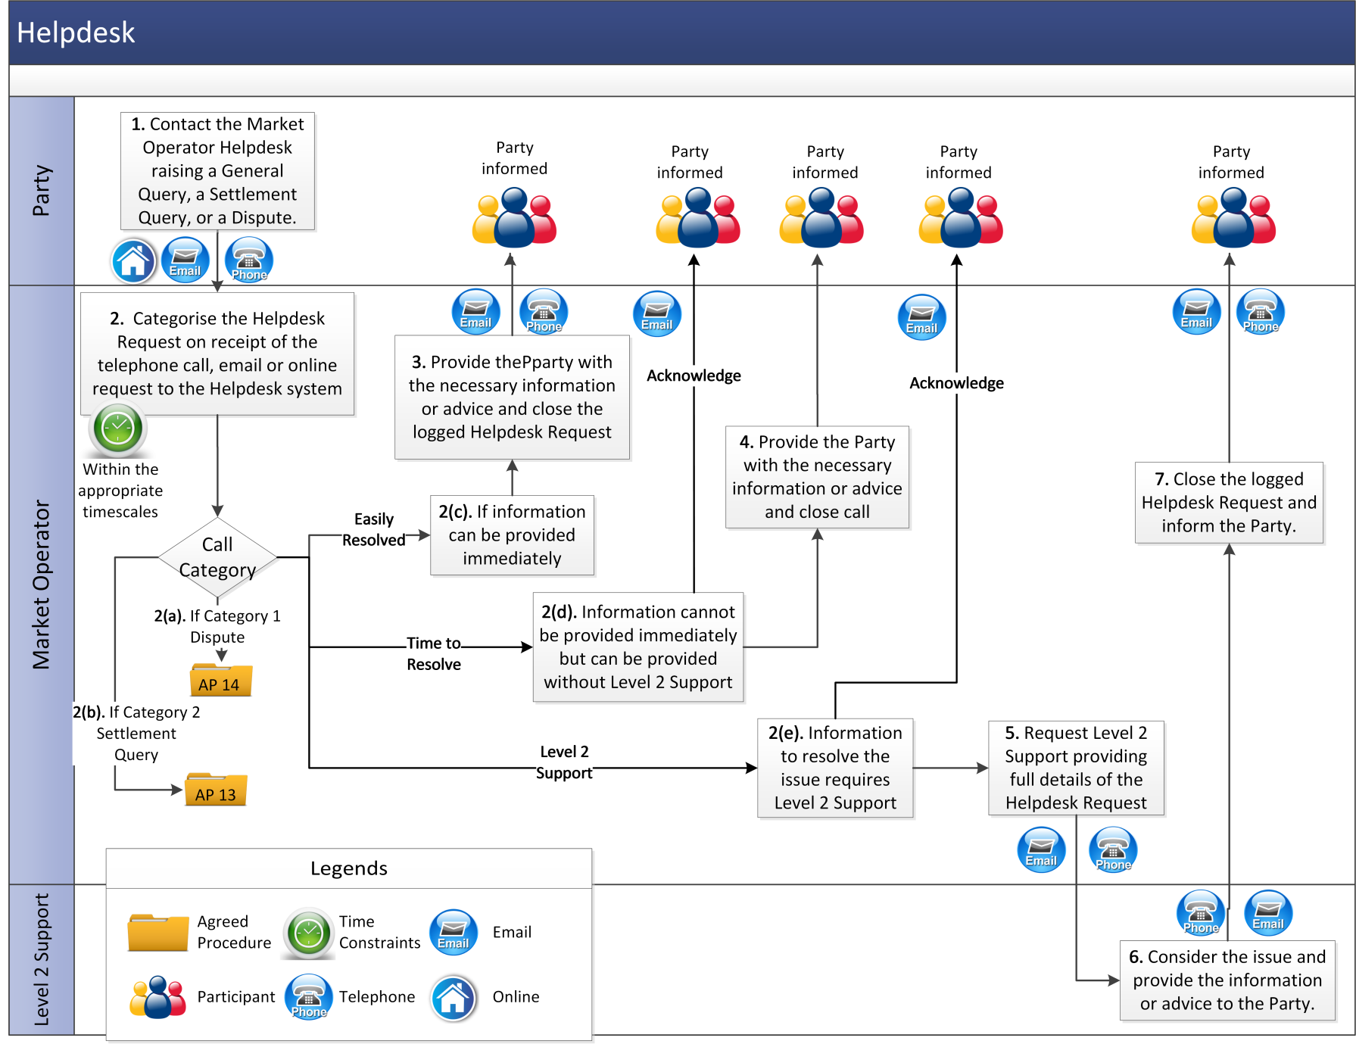

* 1. Implementation Procedures

### *Change Management for Scheduled Releases*

| **Step** | **Procedural Step Description** | **Timing** | **Method** | **By / From** | **To** |
| --- | --- | --- | --- | --- | --- |
| **1** | Issue Impact Assessment. | As required but at least 40 WD prior to proposed Release date | Email and Market Operator website | Market Operator | Participants, Meter Data Providers and System Operators |
| **2** | Provide comments on Impact Assessment documentation. | Within 5 WD of issue of Impact Assessment | Email | Participants, Meter Data Providers and System Operators | Market Operator |
| **3** | Hold technical workshop. | Within 10 WD of issue of Impact Assessment | Meeting and/or telephone | Market Operator | Participants, Meter Data Providers and System Operators |
| **4** | Consider comments and feedback. |  |  | Market Operator |  |
| **5** | Issue revised Impact Assessment (including revised Release plan if applicable). | Within 10 WD of the technical workshop | Email | Market Operator | Participants, Meter Data Providers and System Operators |
| **6** | If disagreement exists with Release detail then objecting Party can raise an Urgent Modification. | Prior to Release date | Email or if a Dispute, in accordance with Agreed Procedure 14 “Disputes” | Objecting Party | Modifications Committee |
| **7** | Issue notification of Release. | At least 1 week prior to Release date | Email, Market Operator website and BMI | Market Operator | Participants, Meter Data Providers and System Operators |

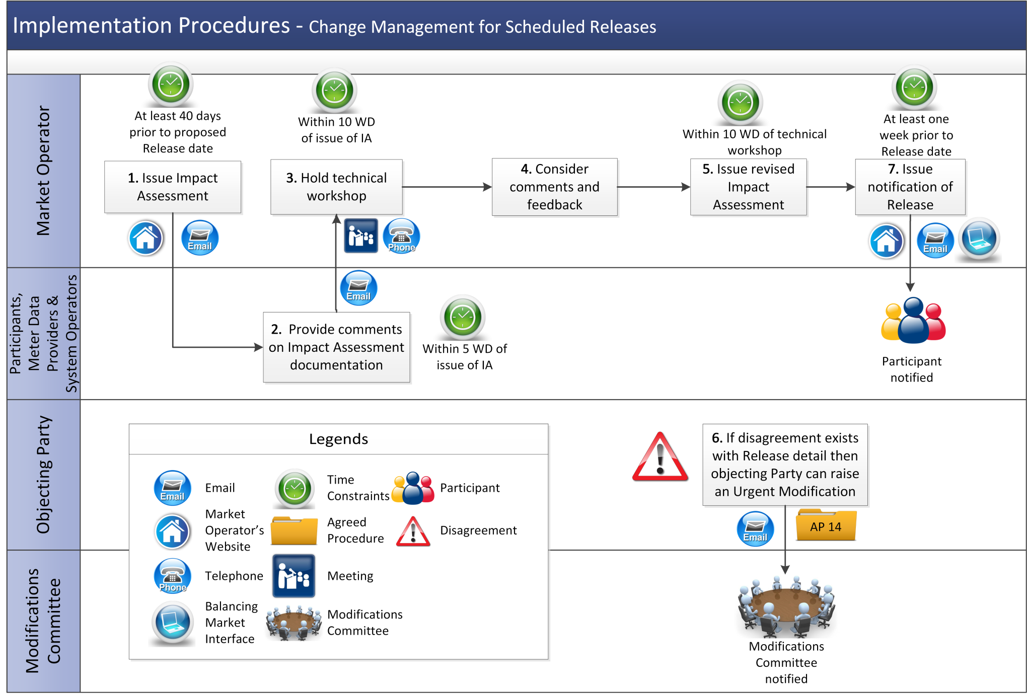

### *Implementation: Maintenance / Application Release and Emergency Release*

|  |  |  |  |  |  |
| --- | --- | --- | --- | --- | --- |
| **Step** | **Procedural Step Description** | **Timing** | **Method** | **By / From** | **To** |
| **1** | Perform Implementation:  a) Market Operator’s Isolated Market System returns within the published timelines, inform Participants, Meter Data Providers and System Operators;  or  b) Market Operator’s Isolated Market System cannot return within the published timelines then initiate procedures under AP 7 “Emergency Communications” for a General Communication Failure.  If the return to normal operation has completed successfully then go to step 3. | At published scheduled time, for Emergency Release when required | Email, Market Operator website and BMI | Market Operator | Participants, Meter Data Providers and System Operators |
| **2** | Initiate procedures under Agreed Procedure 7 “Emergency Communications” as a General Communication Failure. Inform Participants, Meter Data Providers and System Operators of the failure to complete the Implementation within published timescales. | As soon as is practicable | Email, Market Operator website and BMI | Market Operator | Participants, Meter Data Providers and System Operators |
| **3** | On return to normal operations inform Participants, Meter Data Providers and System Operators. | As soon as is practicable. | Email, Market Operator website and BMI | Market Operator | Participants, Meter Data Providers and System Operators |
| **4** | Participants, Meter Data Providers and System Operators invoke internal procedures to return to normal. | After Implementation. | - | Participants, Meter Data Providers and System Operators | - |

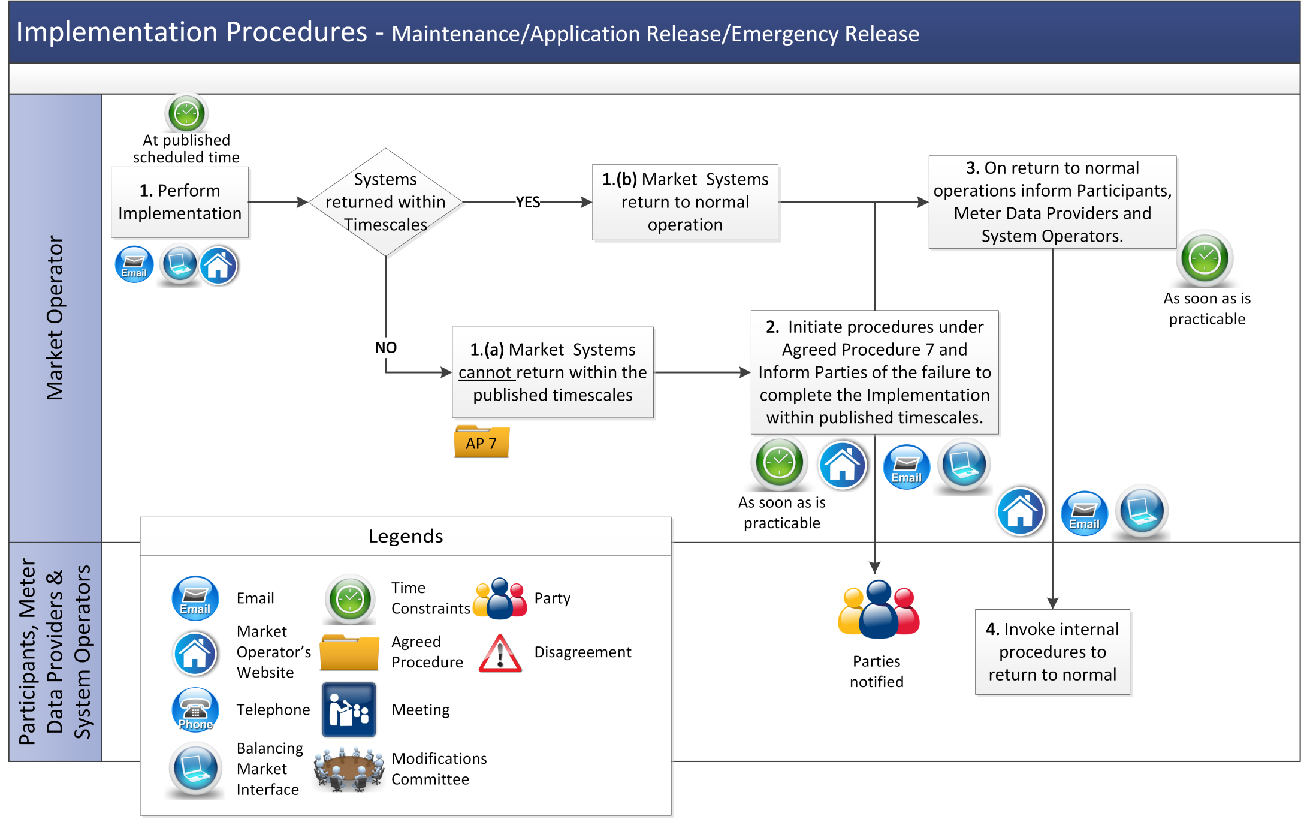

* 1. Problem Management

There are no procedural steps for Problem Management. Agreed Procedure 7 “Emergency Communications” details the process to be followed in the event of a General Communication Failure, a General System Failure and a Limited Communication Failure.

* 1. Post Event Reporting

| **Step** | **Procedural Step Description** | **Timing** | **Method** | **By / From** | **To** |
| --- | --- | --- | --- | --- | --- |
| **1** | If a General System Failure or General Communication Failure has been rectified go to step 2.  If a General System Failure or General Communication Failure has gone beyond 5 WD go to step 3  If the Regulatory Authorities direct the Market Operator to commission a report go to step 5. | - | - | - | - |
| **2** | Commission an external auditor to compile a Post Event Report in respect of the Failure. Go to step 6 | Within 2 WD following the restoration of the Market Operator’s Isolated Market System | Email and post | Market Operator | External auditor |
| **3** | Make an application to the Regulatory Authorities to determine the need for a Post Event Report at this stage. | If Post Event Report not yet commissioned then on the 6th WD of a Failure and every 5 WD thereafter during the Failure | Email | Market Operator | Regulatory Authorities |
| **4** | Notify Market Operator whether there is a need for a Post Event Report at this stage.  If there is a need for a Post Event Report make a formal request and go to Step 5.  If there is not a need for a Post Event Report, **end process**. The process stops at this stage until a further trigger for a request for a report is forthcoming or a report is automatically triggered. | Within 1WD of request | Email | Regulatory Authorities | Market Operator |
| **5** | Commission an external auditor to compile a Post Event Report in respect of the Failure or Material Incident | Within 2 WD of request from Regulatory Authorities | Email and post | Market Operator | External auditor |
| **6** | Complete the Post Event Report and submit the Post Event Report to the Market Operator. | Within 5 WD of agreement to carry out a Post Event Report | Email and post | External auditor | Market Operator |
| **7** | Receive the report from the external auditor and send to the Regulatory Authorities. | Within 2 WD of receipt of the Post Event Report from the external auditor | Email | Market Operator | Regulatory Authorities |

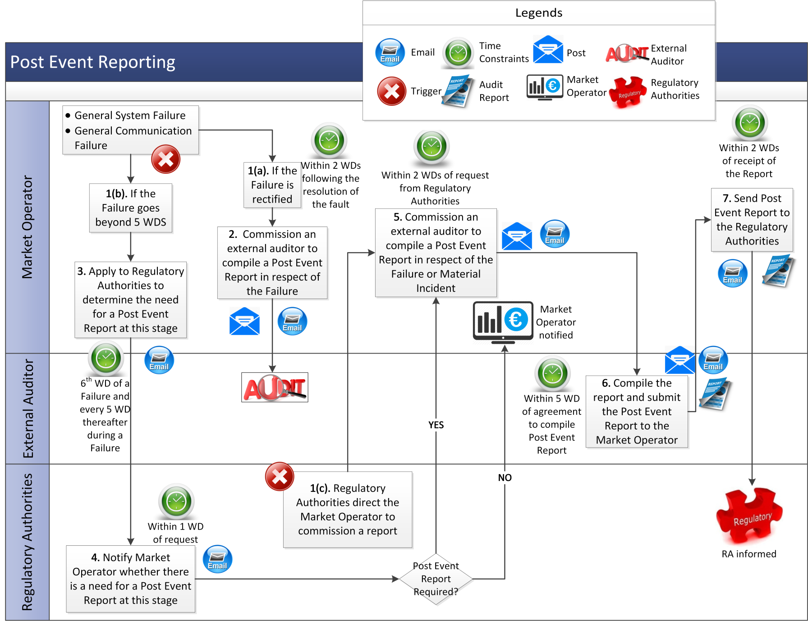

* 1. Authorised Person and Creation of a New Party Administrative User

This process should only be followed where the existing Party Administrative User access has expired, or is no longer in a position to act as Party Administrative User on behalf of the registered Party. In all other instances, existing Party Administrative Users have enabled privileges create additional Party Administrative User via the Balancing Market Interface.

| **Step** | **Procedural Step Description** | **Timing** | **Method** | **By / From** | **To** |
| --- | --- | --- | --- | --- | --- |
| **1** | Submit New Party Administrative User Form | As Required | Facsimile / Email | Party | Market Operator |
| **2** | Validate New Party Administrative User Form  a) If valid go to Step 3  b) If invalid advise Party of issue and request resubmission. | Within 5 WD of receipt | - | Market Operator | Party |
| **3** | Create Party Administrative User | Within 2 WD of Validation | BMI | Market Operator | - |
| **4** | Issue new Party Administrative User a Digital Certificate and any other additional authentication information for the Balancing Market Interface. | Within 1 WD of creation of new Party Administrative User | Email | Market Operator | New Party Administrative User |

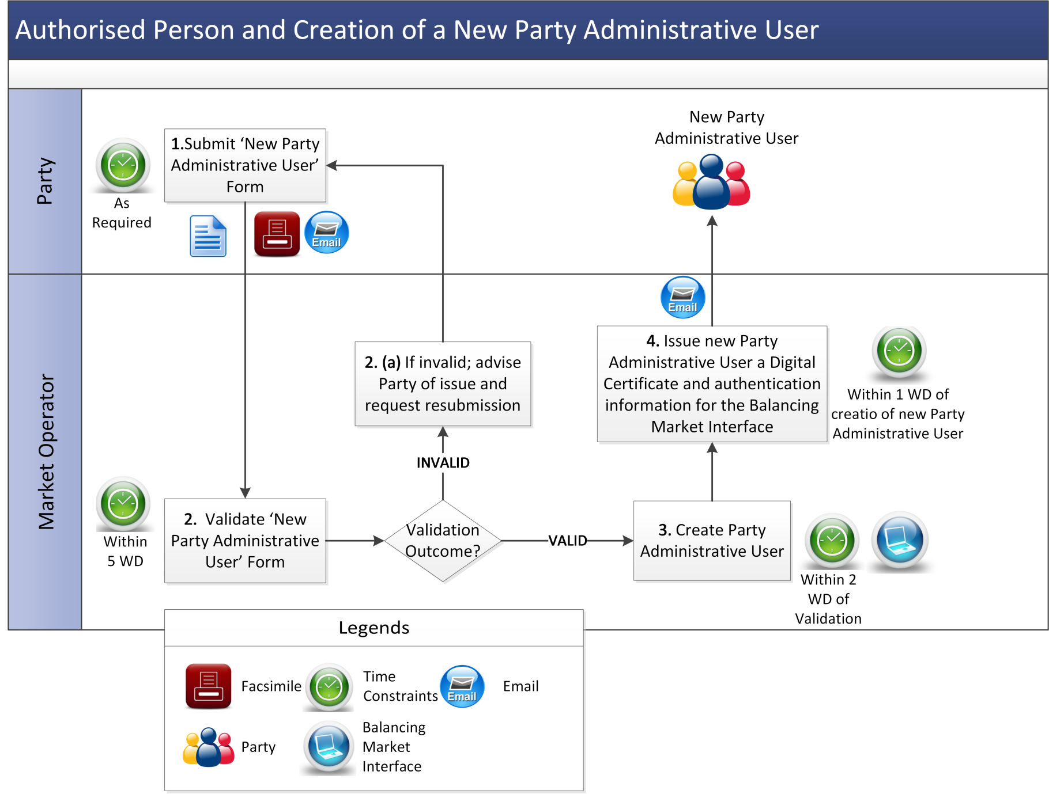

1. Definitions and Abbreviations

Definitions

|  |  |
| --- | --- |
| **Authorisation** | means the process by which a person from a Party becomes authorised to communicate with the Market Operator. |
| **Authorised Person** | means the representative of a Party who is authorised by that Party to communicate with the Market Operator. |
| **Billing Timescales** | means the timescales in which billing occurs. |
| **Emergency Implementation** | means Implementation of an Emergency Release. |
| **Emergency Release** | means an upgrade in system software, a bug-fix or an Implementation of an Urgent Modification, where the Market Operator considers that there is a risk to the operation of the Single Electricity Market. |
| **Failure** | means a General System Failure or MSP Failure or a failure of the MSP Software or a General Communication Failure or a Limited Communication Failure as the context implies. Agreed Procedure 7 “Emergency Communications” sets out the procedures to be followed in the event of a Failure. |
| **Finance System** | means the financial element of the Market Operator’s Isolated Market System |
| **General Important Query** | has the meaning set out in Table 1 (Helpdesk Categories) in section 2.1.1 above. |
| **General Standard Query** | has the meaning set out in Table 1 (Helpdesk Categories) in section 2.1.1 above. |
| **General Urgent Query** | has the meaning set out in Table 1 (Helpdesk Categories) in section 2.1.1 above. |
| **Helpdesk** | has the meaning given to it in paragraph G.3.1.1 of the Code. |
| **Helpdesk Category** | means a category between 1 and 8 applied to a Helpdesk Request. |
| **Helpdesk Request** | means a request handled by the Helpdesk. |
| **Impact Assessment** | means an analysis carried out to identify the implications of a change. |
| **Implementation** | means delivery of Releases on the production Market Operator’s Isolated Market System or Communication Channels. |
| **Isolated Market System** | has the meaning set out in the Code and, in the case of the Market Operator and each System Operator, it shall not include those elements of hardware, software and communications networks that are controlled by both the Market Operator and System Operator. |
| **Level 2 Support** | means Market Operator technical or business experts with the knowledge and expertise to assist / resolve issues and incidents with the Market Operator’s Isolated Market System or with the configuration of Communication Channels. |
| **Material Incident** | means an incident which, in the opinion of the Market Operator, has had a material impact on market prices/SMP/MSQs. |
| **Party Administrative User** | has the meaning given to it in Agreed Procedure 1 “Registration”. |
| **Post Event Report** | means an externally audited report produced in the event of a Failure |
| **Problem Management Function** | means a single senior officer or a group of officers from the Market Operator who will develop interim solutions and prioritise the restoration of Market Operator Isolated Market Systems in the event of a Failure. |
| **Release** | means an update to the Market Operator’s Isolated Market System. |
| **Technical Specification** | means a set of documentation prepared by the Market Operator which describes the Participant interfaces to the Central Market Systems. This documentation shall include detail of the required content of Type 2 Channel and Type 3 Channel Data Transactions submitted by Participants, validations undertaken and the content of response messages. |
| **Test Environment** | means a non-production version of a Market Operator‘s Isolated Market System used for test purposes prior to a Release. |

Abbreviations

|  |  |
| --- | --- |
| **BMI** | Balancing Market Interface |

1. Potential Failures and Typical Corrective Actions

| **Failure Group** | **Failure** | **Action** | **Maximum Duration** |
| --- | --- | --- | --- |
| Participant Data Receipt | Unable to receive Data Transactions from Participants | Implement process for General Communication Failure outlined in Agreed Procedure 7 “Emergency Communications” | 5 Working Days |
|  | Unable to validate the Data Transactions from Participants | Implement a manual procedure for validating received Data Transactions and issue Confirmation Notices via fax | 5 Working Days |
|  | Unable to issue Data Transactions or the Confirmation Notices / failure for the received validated Data Transactions | Send Confirmation Notices via fax and for all other Data Transactions will use any method agreed under Type 1 Channel | 5 Working Days |
| System Operators Communication Failure | Unable to extract Registration Data, Offer Data from the Market Operator’s Isolated Market System | Implement Administered Settlement | N/A |
|  | Unable to send Registration Data, Offer Data to the System Operators | Market Operator and each affected System Operator will agree an alternative secure method for transferring the data for each type of Data Transaction | 5 Working Days |
|  | Meter Data Providers/Interconnector Administrators are able to produce the meter data but unable to send it through a Communication Channel | Market Operator and each affected Meter Data Provider/Interconnector Administrator will agree an alternative secure method for transferring the data for each type of Data Transaction | 5 Working Days |
| Settlement Failure | Settlement cannot run  Or  Masterfile from Market Operator’s Isolated Market System to Settlements cannot be produced or transferred | None (After 3 Working Days implement Administered Settlement) | 3 Working Days |
| Finance System Failure | Finance System cannot run | Implement manual procedures to ensure payments are made to the relevant Participants | 5 Working Days |
|  | Data from Settlements System cannot be transferred to the Finance System | Use alternative data transfer methods or implement manual procedures to ensure payments are made to the relevant Participants | 5 Working Days |

1. Authorisation Categories

**Authorised Categories A**

|  |  |  |
| --- | --- | --- |
| **Category** | **Description** | **Agreed Procedure (“AP”)** |
| A | Submit Settlement Queries or Required Credit Cover Queries and Settlement Disputes | AP13 |
| B | Declare Limited Communication Failure  Request | AP7, AP11 |
| C | Request return of Collateral | AP9 |

**Authorised Categories B**

The following Authorised Categories list is not covered under the User Authorisations section of the Balancing Market Interface. However, these processes can be activated by Users that has sufficient access privileges to normally perform these tasks via the Balancing Market Interface, but due to a Limited Communications Failure are unable to do so.

|  |  |  |  |
| --- | --- | --- | --- |
| **Category** | **Description** | **Agreed Procedure (“AP”)** | **Authorised Person** |
| 1 | Submit/Modify Unit Registration and/or Interconnector Data | AP1 | Registration User |
| 2 | Request Commercial Offer Data & Technical Offer Data | AP4, AP7, AP10 | User with Trading Access |
| 3 | Ad hoc Report request (Includes Statements and Settlement Document) |  | As per requester System Access |
| 4 | Requesting Digital Certificates | AP3 | Party Administrative User |