|  |  |
| --- | --- |
| Agreed Procedure 15: Settlement and Billing | April 7  2017 |

Trading and Settlement Code

Version 1.0

Contents

1. Introduction 1

1.1 Background and Purpose 1

1.2 Scope of Agreed Procedure 1

1.3 Definitions 1

1.4 Compliance with Agreed Procedure 1

2. Overview 2

2.1 Categories of Settlement 2

2.2 Issuing of Settlement Statements and Settlement Reports 2

2.3 Issuing of Settlement Documents 2

2.4 Market Operator Charges 3

2.5 Timelines 4

2.6 Interest 4

2.6.1 Settlement Rerun 4

2.6.2 Shortfall and Unsecured Bad Debt 4

2.6.3 Other Overdue Payments under the Code including Market Operator Charges 4

2.6.4 Over and Under Payments 4

2.7 Settlement Statement Components 4

2.8 VAT 4

2.9 Participant Settlement Document Template 6

2.10 Timetable for Settlement Rerun 7

2.11 Payment Default 7

2.11.1 Financial and Non-Financial Default 7

2.11.2 De Minimis Level for Letter of Credit Draw Down 7

2.11.3 Unsecured Bad Debt Charge 8

2.11.4 Recovery of Unsecured Bad Debt Charge 8

2.11.5 Unpaid Market Operator Charge 9

3. Procedural Steps 10

3.1 Settlement Documents in respect of Billing Period Initial Settlement and Settlement Rerun 10

3.2 Settlement Documents in respect of Capacity Period Initial Settlement Statements and Settlement Rerun 14

3.3 Settlement Documents for Market Operator Charges (in respect of both Initial and Settlement Reruns) 18

APPENDIX 1: Interest Calculation Example 20

Document History

|  |  |  |  |
| --- | --- | --- | --- |
| Version | Date | Author | Comment |
| 1.0 | 07/04/2017 | I-SEM Project Team |  |

**RELATED DOCUMENTS**

|  |  |  |  |
| --- | --- | --- | --- |
| Document Title | Version | Date | By |
| Trading and Settlement Code |  |  |  |
| Agreed Procedure 1 "Registration" |  |  |  |
| Agreed Procedure 9 “Management of Credit Cover and Credit Default” |  |  |  |
| Agreed Procedure 10 “Settlement Reallocation” |  |  |  |
| Agreed Procedure 13, “Settlement Queries” |  |  |  |
| Agreed Procedure 14 “Disputes” |  |  |  |

1. Introduction
   1. Background and Purpose

This Agreed Procedure supplements the rules in relation to Settlement and billing as set out in the Trading and Settlement Code (hereinafter referred to as the “**Code**”). It sets out procedures with which Parties to the Code must comply.

* 1. Scope of Agreed Procedure

This Agreed Procedure describes the process for calculating and issuing Settlement Statements, Settlement Reports and Settlement Documents for Trading Payments, Trading Charges, Capacity Payments and Capacity Charges under the Code, and the issuing of Settlement Documents by the Market Operator. The general rules for Settlement and billing calculations are set out in the Code.

This Agreed Procedure forms an annex to, and is governed by, the Code. It sets out procedures to be followed subject to the rights and obligations of Parties under the Code. In the event of any conflict between a Party’s obligations set out in the Code and this Agreed Procedure, the Code shall take precedence.

It is not intended that there be any inconsistency or conflict between section 2 “Overview” and section 3 “Procedural Steps”. However, in the event of any inconsistency or conflict, section 3 “Procedural Steps” shall take precedence.

In section 3 “Procedural Steps” a corresponding process flow diagram is included for each procedural steps table.  Process flow diagrams are for illustrative purposes.  It is not intended that there be any inconsistency or conflict between any procedural steps table and process flow diagram however, in the event of any inconsistency or conflict, a procedural steps table shall take precedence.

* 1. Definitions

Words and expressions defined in the Code shall, unless the context otherwise requires or unless otherwise defined herein, have the same meanings when used in this Agreed Procedure.

References to particular paragraphs relate internally to this Agreed Procedure unless otherwise specified.

* 1. Compliance with Agreed Procedure

Compliance with this Agreed Procedure is required under the terms as set out in the Code.

1. Overview
   1. Categories of Settlement

Each Settlement Statement and Settlement Report contains details per Imbalance Settlement Period by Generator Unit or Supplier Unit of the inputs into the Settlement calculations and the amounts to be paid by or to Participants.

Settlement Statements and Settlement Reports are issued in line with the each type of Settlement run:

1. **Indicative Settlement run**: For Trading Payments / Trading Charges, the indicative Settlement Statement is issued in accordance with paragraph G 2.5.1 of the Code. For Capacity Payments / Capacity Charges, the indicative Settlement Statement for each Settlement Day in the Capacity Period is issued in accordance with paragraph G 2.5.2 of the Code. An indicative Settlement Statement is not used for payment purposes.
2. **Initial Settlement run**: For Trading Payments / Trading Charges, the Initial Settlement Statement is issued in accordance with paragraph G 2.5.1 of the Code. For Capacity Payments / Capacity Charges, the Initial Settlement Statement for each Settlement Day in the Capacity Period is issued in accordance with paragraph G 2.5.2 of the Code. The calculated Settlement amounts in the Initial Settlement Statements and Settlement Reports will be used in the Settlement Document in respect of the Initial Settlement Statements and Settlement Reports for the Settlement Period.
3. **Settlement Rerun**: Timetabled Settlement Reruns are completed in accordance with the Settlement Calendar. Settlement Statements and Settlement Reports from Settlement Rerun are issued to all Participants for all applicable charges and payments. The Timetabled Settlement Rerun shall be based on the data then available to the Market Operator at the time of its production.

An ad-hoc Settlement Rerun will occur if:

1. a Settlement Query is upheld and the value of change to Settlement items is considered to be of High Materiality, or
2. the decision for a Settlement Query to be upheld is made after the final Timetabled Settlement Rerun.
   1. Issuing of Settlement Statements and Settlement Reports

Individual Settlement Statements and Settlement Reports will be issued by the Market Operator. These reports shall include detail of the inputs into and results of all Settlement calculations on an Imbalance Settlement Period basis. Settlement Statements and Settlement Reports are issued with each Settlement run for a given Settlement Day.

When the republishing of Settlement Statements and Settlement Reports is required, all days in the relevant Settlement Period will be published to the same version number for the same Settlement Run. This alignment of version numbers will occur even if only a subset of the days in the Billing or Capacity Period has changed.

* 1. Issuing of Settlement Documents

The procedure in relation to Settlement Documents for Billing Period Initial Settlement and Settlement Rerun is set out at section 3.1 below and the procedure in relation to Settlement Documents for Capacity Period Initial Settlement and Settlement Rerun is set out at section 3.2 below.

Settlement Documents and Market Operator invoices are issued in the Participant’s designated currency and include the applicable VAT and Settlement Reallocation amounts.

Five Working Days after the completion of an Initial Settlement Billing Period, the Settlement Statement amounts are aggregated to calculate the Settlement Documents.

The timetable of publication of Settlement Documents will be set out in the Settlement Calendar in accordance with chapter G of the Code. Each Settlement Document will include all Trading Payments, Trading Charges, Capacity Payments and Capacity Charges that have not yet been included in a Settlement Document. These may relate to Trading Payments, Trading Charges, Capacity Payments and Capacity Charges arising from an Initial Settlement run, a Timetabled Settlement Rerun or an ad-hoc Settlement Rerun.

These Settlement Documents are issued to Participants for viewing and download via the Balancing Market Interface.

As noted above, each Settlement Document may contain charges and payments relating to different Billing Periods dependent on the type of charge / payment:

1. For Trading Payments and Trading Charges, the Billing Period will be one week commencing at 00:00 each Sunday.
2. For Capacity Payments and Capacity Charges, the Capacity Period will be a Month commencing at 00:00 on the first day of each Month.

The Market Operator will issue Settlement Documents to Participants covering all applicable charges and payments in respect of a Participants Units, as set out below. Details of charges and payments are outlined in section F.1.2 to section F.1.4 of the Code.

1. **Trading Payments and Trading Charges**: this includes Imbalance Component Payment Premium Component Payments and Discount Component Payments, Offer Price Only Accepted Offer Charge or Payment, Bid Price Only Accepted Bid Charge or Payment, Curtailment Charge or Payment, Uninstructed Imbalance Charge and Information Imbalance Charge, Fixed Cost Payments, Testing Charges, Imperfections Charges, Currency Adjustment Charges, Total Difference Charge, and Achievable Difference Payments.
2. **Capacity Payments and Capacity Charges**: this includes Capacity Payments and Capacity Charges, and Difference Payments Socialisation Charges.
3. **Debit Note**: this includes the charges for Unsecured Bad Energy Debt and the charge for Unsecured Bad Capacity Debt. Debit Notes will be issued on an ad-hoc basis.
4. **Settlement Document for Unsecured Bad Debt**: this includes payments arising as a consequence of recovery of any Unsecured Bad Energy Debt or Unsecured Bad Capacity Debt. This Settlement Document will be issued on an ad-hoc basis.
   1. Market Operator Charges

The procedure in relation to Settlement Documents for Market Operator Charges is set out at section 3.3 below.

Market Operator Charges include charges to recover Market Operator operating costs. The Variable Market Operator Charge and the Fixed Market Operator Charge shall be included on one invoice, as required. The Variable Market Operator Charges on the invoice will be calculated at a rate per MWh and will be invoiced to Participants in respect of their Supplier Units. The Fixed Market Operator Charge will be a monthly charge to all Participants based on the annual Charge set out for each Generator Unit and Supplier Unit.

In relation to each Market Operator invoice:

1. for Fixed Market Operator Charges, the period will be a calendar month.
2. for Variable Market Operator Charges, the period will be based on a Billing Period.
   1. Timelines

The Market Operator will publish a Settlement Calendar each year, four months before the beginning of the next year. This is an annual calendar which contains the timetable for the publication of Settlement Statements and Settlement Reports arising from Initial Settlement runs and Timetabled Settlement Reruns, and of Settlement Documents and Market Operator invoices including Payment Due Dates. A description of timelines are set out in section G.2 of the Code.

* 1. Interest
     1. Settlement Rerun

Interest is applicable whenever the Settlement Rerun increases or decreases the total amount payable for a Billing Period or Capacity Period. Interest in this case shall be charged at LIBOR plus 1%.

* + 1. Shortfall and Unsecured Bad Debt

Interest is applicable on any Shortfall or Unsecured Bad Debt amount from the time the payment is due at the Default Interest rate (as defined in the Code).

* + 1. Other Overdue Payments under the Code including Market Operator Charges

Interest is applicable as per the Code at the Default Interest rate.

* + 1. Over and Under Payments

Interest shall be paid in accordance with the Code.

An interest calculation example is set out at Appendix 1 “Interest Calculation Example”.

* 1. Settlement Statement Components

Settlement Statements and Settlement Reports contain both the input data and the calculated Settlement amounts for each relevant Imbalance Settlement Period in respect of each relevant Generator Unit or Supplier Unit. The data items included in each Settlement Statement and Settlement Report are detailed in Appendix G “Settlement Statements, Settlement Reports and Settlement Documents” of the Code.

* 1. VAT

VAT is applied to Participants in accordance with Applicable Laws. The Market Operator prepares Settlement Documents to enable Participants to account for VAT where appropriate.  The Settlement Document primarily comprises Trading Payments, Trading Charges, Capacity Payments and Capacity Charges generated:

1. within jurisdiction;
2. within EU; and
3. within Non EU.

using the proportion methodology based on cross border flows.

VAT will not be applied to Interest.

VAT will apply to Market Operator Charges at the local VAT rate.

* 1. Participant Settlement Document Template



In addition to the above template a Settlement Document backing file will include detail on billing runs and charges by Settlement type.

* 1. Timetable for Settlement Rerun

Statements Settlement and Settlement Reports arising from Timetabled Settlement Reruns are calculated and issued by the Market Operator to Participants in accordance with the Settlement Calendar.

Results of Settlement Reruns will be included on the next Settlement Document to be issued in accordance with the published Settlement Calendar.

Ad-hoc Settlement Reruns required following resolution of Settlement Queries or Disputes can be completed at any time.

Settlement Rerun amounts are calculated for each charge and payment type. The following amounts are set out on the Settlement Document, for each charge or payment type:

1. the Settlement Rerun amount;
2. the amount from the previous Settlement run amount; and,
3. the change in the Settlement amounts.
   1. Payment Default

This section sets out the billing process associated in the event that a Participant fails to fully pay a Settlement Document by the relevant Payment Due Date.

* + 1. Financial and Non-Financial Default

In the event that a Participant fails to fully pay a Settlement Document by the relevant Payment Due Date, the Market Operator will draw down on the Posted Credit Cover of the Participant to cover the Shortfall (see Agreed Procedure 9 “Management of Credit Cover and Credit Default” for further detail). The Shortfall is the amount that a Participant has failed to pay by the Settlement Document Payment Due Date. The Market Operator will apply interest to any amounts overdue from the relevant Payment Due Date.

Payment to an incorrect account, while not giving rise to a Shortfall, is a breach of obligation under the Code and Default. Administration fees may apply in this case.

* + 1. De Minimis Level for Letter of Credit Draw Down

Where:

1. a Participant has not paid a Settlement Document in accordance with the timelines set out in the Code; and
2. that Participant's Posted Credit Cover comprises of insufficient cash collateral to cover the unpaid amount (because that Participant’s Posted Credit Cover is only in the form of a Letter of Credit, or that Participants Posted Credit Cover comprises of insufficient cash collateral to cover the outstanding amount with that amount being covered by a Letter of Credit); and
3. the amount outstanding (or amount not covered by the cash collateral) is less than or equal to €1,000 (one thousand euros) or Pounds Sterling equivalent; and
4. there are funds due to the Market Operator in respect of the Balancing Cost sufficient to cover such amount,

then:

1. the outstanding amount will be temporarily funded by the sums due to the Market Operator in respect of the Balancing Cost; and
2. the Letter of Credit will not be drawn down,

provided that:

1. the amount will remain outstanding as a Default against the Participant until paid by the Participant;
2. the Participant will receive a Default Notice in respect of this Default despite the fact that the Letter of Credit may not have been drawn down; and
3. In the event the outstanding amount is not paid in full within 2 Working Days of the original Payment Due Date of the Settlement Document (or first due Settlement Document in the case of multiple Settlement Documents), then the Letter of Credit will be drawn down for the outstanding amount; If insufficient funds are due to the Market Operator in the Balancing Cost this provision shall not apply and the Letter of Credit will be drawn down as otherwise provided for in the Code.
   * 1. Unsecured Bad Debt Charge

The rules applicable to Unsecured Bad Debt are set out at paragraph G.2.7 of the Code.

Where the amount due under a Settlement Document is not fully paid and a drawdown of Posted Credit Cover does not cover the Shortfall by the Settlement Document Payment Due Date, the unpaid amount is referred to as Unsecured Bad Debt. In the event of Unsecured Bad Debt, the Market Operator shall reduce the amount that is paid out to other Participants in order to balance Settlement for that Settlement Period. The amount of the reduction will be the Unsecured Bad Debt Charge. Each Settlement Document affected by an Unsecured Bad Debt Charge shall be adjusted by a reduction in the amount payable to each affected Participant (as a SEM Creditor) in respect of their Generator Units. These Participants are known as the Reduced Participants (in accordance with paragraph G.2.7.3 of the Code) and the Participant who has incurred the Shortfall and subsequently the Unsecured Bad Debt is known as the Defaulting Participant. The Market Operator will issue a Debit Note to each Reduced Participant via Type 2 Channel or Type 3 Channel. The amount included on this Debit Note will represent the amount by which the original Settlement Document will be reduced.

Where the Unsecured Bad Debt is an Unsecured Bad Energy Debt or an Unsecured Bad Capacity Debt, the payments to Participants will be reduced in accordance with the methodology set out in chapter G of the Code.

* + 1. Recovery of Unsecured Bad Debt Charge

Where Unsecured Bad Debt is later partially or fully recovered from the Defaulting Participant, the Reduced Participants will be paid their share of the recovered Unsecured Bad Debt. The Market Operator shall calculate and issue a Settlement Document to the Reduced Participants in accordance with the methodology set out in section G of the Code. The Settlement Document can be downloaded from the Balancing Market Interface and it shall be paid together with the Settlement Document for the next Billing Period or Capacity Period, as appropriate.

* + 1. Unpaid Market Operator Charge

The Market Operator shall bear the cost of any unpaid Market Operator Charges and these costs shall be included in the calculation of the Market Operator Charge for subsequent years. For the avoidance of doubt, unpaid Market Operator Charges are not included in the calculation of Unsecured Bad Debt.

The unpaid Market Operator Charges are a debt of the relevant Participant that ranks pari passu with other Shortfall and Unsecured Bad Debt.

1. Procedural Steps
   1. Settlement Documents in respect of Billing Period Initial Settlement and Settlement Rerun

| Step | Step Description | Timing | | Method | From / By | To |
| --- | --- | --- | --- | --- | --- | --- |
|  | Produce and issue indicative Settlement Statements and Settlement Reports for each Settlement Day. | Before 17:00, 1 WD after the end of each Settlement Day | | Balancing Market Interface | Market Operator | Participant |
|  | Validate and if required raise Settlement Query. | In accordance with Agreed Procedure 13 “Settlement Queries” | | In accordance with Agreed Procedure 13 “Settlement Queries” | Participant | Market Operator |
|  | Produce and issue Initial Settlement Statements and Settlement Reports for each Settlement Day. For the last day of the Billing Period, this will include Make Whole Payments. | Before 12:00, 5 WD after the end of each Settlement Day. | | Balancing Market Interface | Market Operator | Participant |
|  | Validate and if required raise Settlement Query | In accordance with Agreed Procedure 13 “Settlement Queries ” | | In accordance with Agreed Procedure 13 “Settlement Queries” | Participant | Market Operator |
|  | Produce and issue Settlement Documents based on the relevant Settlement Statements, Settlement Reports and Settlement Reallocation Agreements. | | Before 12:00, 5 WD after the end of the Billing Period. | Balancing Market Interface | Market Operator | Participant |
|  | Payment of Settlement Documents. | Before 12:00, 3 WDs after the date of issue of the Settlement Document | | In accordance with Agreed Procedure 17 “Banking and Participant Payments” | Participants | Market Operator |
|  | Establish whether there is any Shortfall. If there is no Shortfall go to step 14.  Otherwise continue to step 8. | Before 17:00, 4 WD after the date of issue of the Settlement Document | | - | Market Operator | - |
|  | Draw down Credit Cover of a Participant with a Shortfall and follow Agreed Procedure 9 “Management of Credit Cover and Credit Default” as required.  If Credit Cover draw down covers the whole of the Shortfall prior to payment of the Settlement Document go to step 14, otherwise continue to step 9. | In sufficient time to meet payment deadline (before 17:00, 4 WD after the date of issue of the Settlement Document) | | - | Market Operator | - |
|  | Calculate and issue Debit Notes for the applicable Participants. | Before 17:00, 4 WD after the date of issue of the Settlement Document | | Email / Facsimile | Market Operator | Reduced Participant |
|  | Pay the net of the Settlement Document and the Debit Note to each Participant. | Before 17:00, 4 WDs after the date of issue of the Settlement Document | | In accordance with Agreed Procedure 17 “Banking and Participant Payments” | Market Operator | Participant |
|  | Issue a Default Notice to the Participant and if appropriate, initiate steps for Suspension in Agreed Procedure 18 "Suspension and Termination". | Before 17:00, 4 WDs after the date of issue of the Settlement Document | | In accordance with Agreed Procedure 18 ”Suspension and Termination” | Market Operator | Defaulting Participant |
|  | Attempt to recover Unsecured Bad Debt. If Unsecured Bad Debt is recovered the Market Operator issues a Settlement Document for Unsecured Bad Debt. | In timelines for the next Settlement Document for a Billing Period after recovery of monies. | | Email / Facsimile | Market Operator | Reduced Participant |
|  | Pay Settlement Document for Unsecured Bad Debt. If there is still Unsecured Bad Debt, return to step 12, otherwise, **end process**. | In timescales for the next Settlement Document for a Billing Period after recovery of monies. | | In accordance with Agreed Procedure 17 “Banking and Participant Payments” | Market Operator | Reduced Participant |
|  | Payments due to Participants are issued. | Before 17:00, 4 WDs after the date of issue of the Settlement Document | | In accordance with Agreed Procedure 17 “Banking and Participant Payments” | Market Operator | Participant |

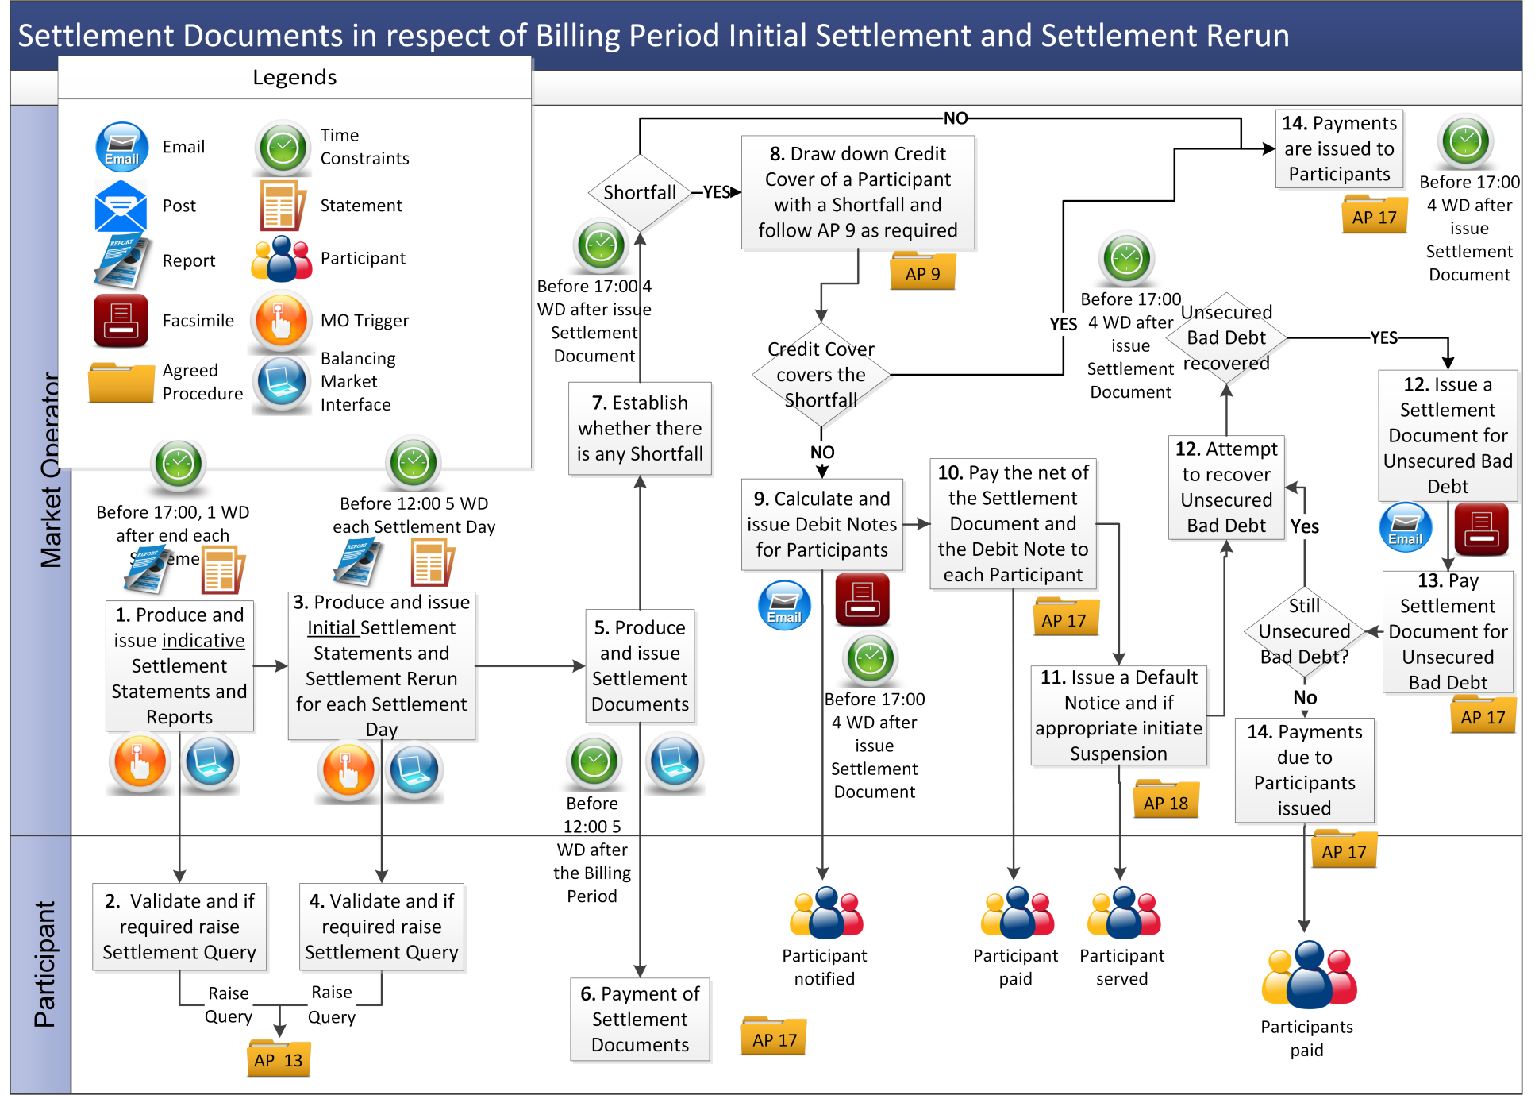

* 1. Settlement Documents in respect of Capacity Period Initial Settlement Statements and Settlement Rerun

| Step | Step Description | Timing | Method | From / By | To |
| --- | --- | --- | --- | --- | --- |
|  | Produce and issue indicative Settlement Statements and Settlement Reports for the Capacity Period. | Before 17:00, 3 WD after Capacity Period | Balancing Market Interface | Market Operator | Participant |
|  | Validate and if required raise Settlement Query. | In accordance with Agreed Procedure 13 “Settlement Queries | In accordance with Agreed Procedure 13 “Settlement Queries” | Participant | Market Operator |
|  | Produce and issue initial Settlement Statements and Settlement Rerun for the Capacity Period. | Before 12:00 5WD after Capacity Period | Balancing Market Interface | Market Operator | Participant |
|  | Validate and if required raise Settlement Query | In accordance with Agreed Procedure 13 “Settlement Queries” | In accordance with Agreed Procedure 13 “Settlement Queries | Participant | Market Operator |
|  | Produce and issue Settlement Documents based on the Initial Settlement Statements and Settlement Reports, Settlement Rerun and Settlement Reallocation Agreements. | In accordance with paragraph G.2.5.3 of the Code | Balancing Market Interface | Market Operator | Participant |
|  | Payment of Settlement Documents. | By 12:00 3 WD after the date of issue of the Settlement Document | In accordance with Agreed Procedure 17 “Banking and Participant Payments” | Participants | Market Operator |
|  | Establish whether there is a Shortfall. If there is no Shortfall go to step 14. Otherwise continue to step 8. | Before 17:00 4 WD after the date of issue of the Settlement Document | - | Market Operator | - |
|  | Draw down Credit Cover of any Participant with a Shortfall and follow Agreed Procedure 9 “Management of Credit Cover and Credit Default” as required.  If Credit Cover drawdown covers the whole amount of the Shortfall prior to payment of the Settlement Document, go to step 14. Otherwise, go to step 9. | In sufficient time to meet payment deadline (before 17:00 4 WD after the date of issue of the Settlement Document) | - | Market Operator | - |
|  | Calculate and issue Debit Notes for the applicable Participants. | Before 17:00, 4 WD after the date of issue of the Settlement Document | Email / Facsimile | Market Operator | Participant |
|  | Pay the net of the Debit Note and Settlement Document to each Participant. | Before 17:00, 4 WD after the date of issue of the Self Billing Invoice | In accordance with Agreed Procedure 17 “Banking and Participant Payments” | Market Operator | Participant |
|  | Issue a Default Notice to the Participant and initiate Suspension procedure in Agreed Procedure 18 "Suspension and Termination". | Before 17:00, 4 WD after the date or issue of the Settlement Document | In accordance with Agreed Procedure 18 “Suspension and Termination” | Market Operator | Defaulting Participant |
| 1. 12. | Attempt to recover Unsecured Bad Debt. If Unsecured Bad Debt is recovered Market Operator issues a Settlement Document for Unsecured Bad Debt. | In accordance with timelines for the next Settlement Document for a Capacity Period after recovery of monies. | Post, phone, fax | Market Operator | Reduced Participant |
|  | Market Operator pays Settlement Document for Unsecured Bad Debt.  If there is still Unsecured Bad Debt return to step 12, otherwise **end process**. | In timescales for the next Settlement Documents for a Capacity Period after recovery of monies. | In accordance with Agreed Procedure 17 “Banking and Participant Payments” | Market Operator | Reduced Participant |
|  | Payments due to Participants are issued. | Before 17:00, 4 WD after the date of issue of the Settlement Document | In accordance with Agreed Procedure 17 “Banking and Participant Payments” | Market Operator | Participant |

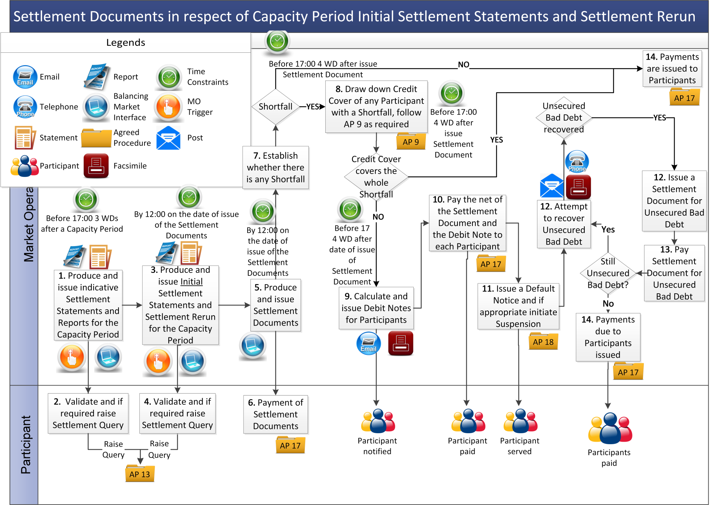

* 1. Settlement Documents for Market Operator Charges (in respect of both Initial and Settlement Reruns)

| Step | Step Description | Timing | Method | From / By | To |
| --- | --- | --- | --- | --- | --- |
|  | Produce and issue Settlement Statements and Settlement Reports for Market Operator Charges as applicable. | In accordance with the published Settlement Calendar. | Balancing Market Interface | Market Operator | Participant |
|  | Produce and issue Market Operator invoices for Market Operator Charges. | In accordance with the published Settlement Calendar. | Balancing Market Interface | Market Operator | Participant |
|  | Payment of Market Operator invoice. | In accordance with Agreed Procedure 17 “Banking and Participant Payments” | In accordance with Agreed Procedure 17 “Banking and Participant Payments” | Participants | Market Operator |
|  | Establish whether there is any Shortfall due to Variable Market Operator Charges. If there is no Shortfall due to Variable Market Operator Charges, **end process**, otherwise go to step 5. | Within 5 WD of the issue of the Market Operator invoice | - | Market Operator | - |
|  | Market Operator attempts to recover Unsecured Bad Debt. | As required | - | Market Operator | - |

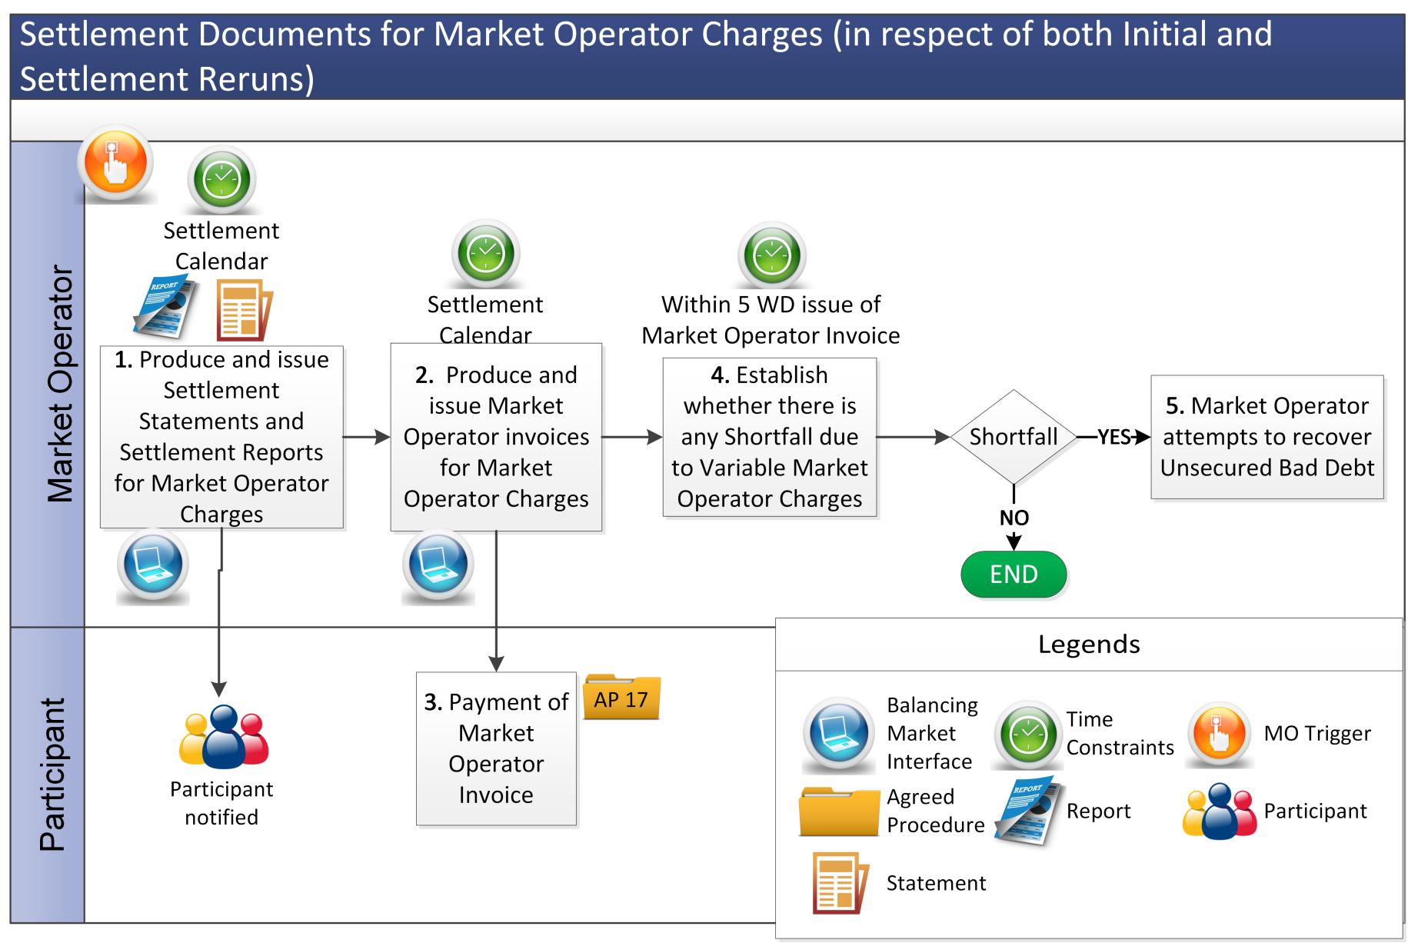

APPENDIX 1: Interest Calculation Example

Interest is applied when a Settlement Rerun increases or decreases the total amount payable for a Billing Period and/or a Capacity Period.

For Settlement Reruns, the net adjustment amounts are calculated and shown on the Settlement Document. Interest is calculated by applying a daily interest rate to the adjustment amount on the Settlement Document.

The revised interest calculation includes following steps:

1. **Adjustment Amounts for a Settlement Rerun** are calculated for each Settlement Document line item amount as the difference between the previous amount and the current amount for the relevant line item.
2. **Total Adjustment Amount for a Settlement Rerun** is calculated as sum of all adjustment amounts for each Settlement Document line item
3. **Total Adjustment Amount for a Settlement Rerun** for Interest calculation is determined as the sum of adjustment amounts for each Settlement Document line item excluding those flagged as “No Interest on revised amounts”. These line items are flagged as zero interest rate.
4. **Daily Interest Rate** is calculated as the interest rate, which is charged at LIBOR + 1%, divided by the number of days in the year configured in the system.
5. The number of days for interest calculation will be determined as the number of days in the period between the date of issue of the previous Settlement Document and the date of issue of the latest Settlement Document.
6. The interest amount for the Settlement Rerun will be calculated as the **Daily Interest Rate** (found in step 4) multiplied by the **Total Adjustment Amount for a Settlement Rerun for Interest** (found in step 3) multiplied by the number of days (found in step 5) for interest calculation

|  |
| --- |
| **Interest Amount**  = Total Adjustment Amount for a Settlement Rerun for Interest  * Daily Interest Rate  * # of interest |