|  |  |
| --- | --- |
| Agreed Procedure 16: Provision of Meter Data | April 7  2017 |

Trading and Settlement Code

Version 1.0

Contents

1. Introduction 1

1.1 Background and Purpose 1

1.2 Scope of Agreed Procedure 1

1.3 Definitions 1

1.4 Compliance with Agreed Procedure 1

2. Overview 2

2.1 Business requirements for Meter Data 2

2.2 Data required for business processes 2

2.3 Grouping individual Data Records into Data Transactions 5

3. Procedural Steps 6

3.1 Provision of Meter Data 6

Appendix 1: Definitions and Abreviations 9

Appendix 2: File Format Overview 10

General Description of the SEM-MDP message format 10

Document History

|  |  |  |  |
| --- | --- | --- | --- |
| Version | Date | Author | Comment |
| 1.0 | 07/04/2017 | I-SEM Project Team |  |

Related Documents

|  |  |  |  |
| --- | --- | --- | --- |
| Document Title | Version | Date | By |
| Trading and Settlement Code |  |  |  |
| Agreed Procedure 11 “Market System Operation, Testing, Upgrading and Support” |  |  |  |

1. Introduction
   1. Background and Purpose

This Agreed Procedure supplements the rules in relation to the delivery of Meter Data to the Market Operator set out in the Trading and Settlement Code (hereinafter referred to as the “**Code**”). It sets out procedures with which Parties to the Code must comply.

* 1. Scope of Agreed Procedure

This Agreed Procedure sets out the procedures in relation to the provision of:

1. Meter Data for all Supplier Units;
2. Meter Data for all Generator Units;
3. Interconnector Meter Data; and
4. Net-Inter-Jurisdictional Import.

This Agreed Procedure only relates to the requirements under the Code for Meter Data, therefore it does not deal with:

1. any Meter Data that does not describe Active Power; or
2. any agreement between the System Operators, Retail Market Operators, and any Meter Data Provider to provide data for other purposes not defined in the Code.

This Agreed Procedure forms an annex to, and is governed by, the Code. This document sets out procedures to be followed subject to the rights and obligations of Parties under the Code. In the event of any conflict between a Party’s obligations set out in the Code and this Agreed Procedure, the Code shall take precedence.

It is not intended that there be any inconsistency or conflict between section 2 “Overview” and section 3 “Procedural Steps”. However, in the event of any inconsistency or conflict, section 3 “Procedural Steps” shall take precedence.

In section 3 “Procedural Steps” a corresponding process flow diagram is included for each procedural steps table.  Process flow diagrams are for illustrative purposes.  It is not intended that there be any inconsistency or conflict between any procedural steps table and process flow diagram however, in the event of any inconsistency or conflict, a procedural steps table shall take precedence.

* 1. Definitions

Words and expressions defined in the Code shall, unless the context otherwise requires or unless otherwise defined herein at Appendix 1 “Definitions and Abbreviations”, have the same meanings when used in this Agreed Procedure.

References to particular paragraphs relate internally to this Agreed Procedure unless otherwise specified.

* 1. Compliance with Agreed Procedure

Compliance with this Agreed Procedure is required under the terms of the Code.

1. Overview
   1. Business requirements for Meter Data

Meter Data Providers are required to send Meter Data of all Generator Units, the Net-Inter-Jurisdictional Import, the Interconnector Meter Data, and Meter Data of all Supplier Units (always grouped by Settlement Day, midnight to midnight), as applicable, to facilitate the following time critical business processes:

1. Indicative Settlement;
2. Initial Settlement;
3. First Timetabled Settlement Rerun;
4. Second Timetabled Settlement Rerun;
5. Settlement Query process (as under Agreed Procedure 13 “Settlement Queries”);
6. Dispute process (as under Agreed Procedure 14 “Disputes”); and
7. Any Ad-hoc Settlement Rerun arising from the resolution of an upheld Settlement Query or Dispute.

All other requirements by the Market Operator for Meter Data, such as for the calculation of Capacity Payments and Charges, and calculations of Required Credit Cover, will be satisfied if timely delivery of Meter Data for the above business requirements is met.

* 1. Data required for business processes

The table below sets out the Meter Data that is required for each of the business processes listed at paragraph 2.1 above.

The Meter Data is grouped by Data Transaction. Data Transactions which contain the same Data Records but are sent under different timeframes (e.g. for indicative Settlement or for Initial Settlement) are given the same identifier, which populates the TRANSMISSION_ID field in the file sent to the Market Operator. The TRANSMISSION_ID field supports External Data Provider systems and validation rules for the submission of Meter Data Transactions.

Each Data Transaction from a Meter Data Provider must be complete. Each Data Record in a Data Transaction describes the Meter Data in respect of Generator Units, Meter Data in respect of Supplier Unit, Interconnector Meter Data or Net-Inter-Jurisdictional Import.

Each Data Record name in this Agreed Procedure aligns directly with the definitions of Units and Net-Inter-Jurisdictional Import in the Code.

| **Data Transaction** | **Identifier** | **SEM Business Process Supported** | **Frequency, including latest time of delivery** | **Data Records containing best available data** |
| --- | --- | --- | --- | --- |
| Generation Metering for indicative Settlement | NPEG/PEG  /ALL | Indicative Settlement | Each Week Day, by 14:00 on the next Week Day (D+1) | Generator Unit |
| Generation Metering for Initial Settlement | NPEG/PEG  /ALL | Initial Settlement | Each Week Day, by 17:00 on the fourth next Week Day (D+4) | Generator Unit |
| Generation Metering for ad-hoc Settlement Rerun | NPEG/PEG  /ALL | Settlement Query process and Dispute process | Ad-hoc, as material data changes are identified. Timelines under Agreed Procedure 13 “Settlement Queries” and Agreed Procedure 14 “Disputes” | Generator Unit |
| Generation Metering for first Timetabled Settlement Rerun | NPEG/PEG  /ALL | Settlement Rerun | On a Week Day, by 14:00, before the first Timetabled Settlement Rerun as defined in the Settlement Calendar and no earlier than one month before the relevant Timetabled Settlement Rerun | Generator Unit |
| Generation Metering for second Timetabled Settlement Rerun | NPEG/PEG  /ALL | Settlement Rerun | On a Week Day, by 14:00, before the second Timetabled Settlement Rerun as defined in the Settlement Calendar and no earlier than one month before the relevant Timetabled Settlement Rerun | Generator Unit |
| Aggregated Inter Jurisdiction Metering for indicative Settlement | CJF | Indicative Settlement | Each Week Day, before 14:00 on the next Week Day (D+1) | Net-Inter-Jurisdictional Flow |
| Aggregated Inter Jurisdiction Metering for initial Settlement | CJF | Initial Settlement | Each Week Day, before 17:00 on the fourth next Week Day (D+4) | Net-Inter-Jurisdictional Flow |
| Aggregated Inter Jurisdiction Metering for ad-hoc Settlement Rerun | CJF | Settlement Query process & Dispute process | Ad-hoc, as material data changes are identified. Timelines under Agreed Procedure 13 “Settlement Queries” and Agreed Procedure 14 “Disputes” | Net-Inter-Jurisdictional Flow |
| Aggregated Demand Metering for indicative Settlement | NPED/PED  /ALL | Indicative Settlement | Each Week Day, by 14:00 on the next Week Day (D+1) | Supplier Unit |
| Aggregated Demand Metering for initial Settlement | NPED/PED  /ALL | Initial Settlement | Each Week Day, by 17:00 on the fourth next Week Day (D+4) | Supplier Unit |
| Aggregated Demand Metering for first Timetabled Settlement Rerun | NPED/PED  /ALL | Settlement Rerun | On a Week Day, by 14:00 in time for the first Timetabled Settlement Rerun as defined in the Settlement Calendar and no earlier than one month before the relevant Timetabled Settlement Rerun | Supplier Unit |
| Aggregated Demand Metering for second Timetabled Settlement Rerun | NPED/PED  /ALL | Settlement Rerun | On a Week Day, by 14:00, before the second Timetabled Settlement Rerun as defined in the Settlement Calendar and no earlier than one month before the relevant Timetabled Settlement Rerun | Supplier Unit |
| Aggregated Demand Metering for ad-hoc Settlement Rerun | NPED/PED  /ALL | Settlement Query process & Dispute process | Ad-hoc, as material data changes are identified. Timelines under Agreed Procedure 13 “Settlement Queries” and Agreed Procedure 14 “Disputes”. | Supplier Unit |

* 1. Grouping individual Data Records into Data Transactions

Each Meter Data Provider shall be registered with the Market Operator under the procedure set out in Agreed Procedure 1 “Registration” and shall be assigned responsibility for the final delivery of specified Meter Data for Generator Units, Net-Inter-Jurisdictional Import, Interconnector Meter Data, and / or Meter Data for Supplier Units, to the Market Operator. Each Meter Data Provider is uniquely responsible for the final delivery of this Meter Data in accordance with the Code (in particular Appendix L “Meter Data Transactions” of the Code) and this Agreed Procedure.

An overview of the format of the file that shall be sent to the Market Operator by a Meter Data Provider is detailed at Appendix 2 “File Format Overview”.

A Meter Data Provider may choose to group Data Transactions into a single Data Transaction with prior agreement of the Market Operator, as long as the Data Transaction identifier of “ALL” is used in the TRANSMISSION_ID in the file, and it contains all Units for which the Meter Data Provider is responsible for providing to fulfil the relevant business process.

Subject to how they are grouped, Data Transactions will be required to be complete with regard to:

1. all Data Records for Units or for Net-Inter-Jurisdictional Import for which the Meter Data Provider is uniquely responsible; and
2. Data Records containing all fields as required in the file sent to the Market Operator.

There will be a unique relationship between a Meter Data Provider and a specific Unit or Net-Inter-Jurisdictional Import. For example, if a Meter Data Provider sends an Indicative Generation Data Transaction, and it contains a Generator Unit which is not registered as that specific Meter Data Provider’s responsibility, that entire Data Transaction will be rejected.

Once a Meter Data Provider submits Data Transactions with aggregated Meter Data in respect to a Settlement Day, the Units contained within those Data Transactions must be identical when submitting Data Transactions for that same Settlement Day for all other relevant procedural steps set out in section 3 below.

1. Procedural Steps
   1. Provision of Meter Data

| Step | | Step Description | Timing | | Mechanism | | By / From | | To | |
| --- | --- | --- | --- | --- | --- | --- | --- | --- | --- | --- |
|  | Determine what Data Records are due to be included in Data Transaction(s) to the MO for that Settlement Day in accordance with paragraph L.4 of Appendix L “Meter Data Transactions” of the Code. Any subsequent submissions to the MO should include all Data Records in the indicative file. | | Every Working Day | Balancing Market Interface | | Meter Data Provider | |  | |
|  | Determine the division of Data Records among the Data Transactions. | | Every Working Day | Balancing Market Interface | | Meter Data Provider | |  | |
|  | Create the appropriate Data Transactions for the Settlement Data containing Meter Data determined in step 1 and step 2. | | Before 14:00 the Week Day after the Settlement Day | Balancing Market Interface | | Meter Data Provider | |  | |
|  | Send any Data Transaction(s) created in step 3 to the Market Operator. | | Before 14:00 the Week Day after the Settlement Day | Balancing Market Interface | | Meter Data Provider | | Market Operator | |
|  | Update the appropriate Data Records for the Settlement Data determined in step 1. | | Before 17:00 four Week Days after the Settlement Day | Balancing Market Interface | | Meter Data Provider | |  | |
|  | If Data Records updated in step 5, send the collated Data Records in an updated Data Transaction(s) to the Market Operator. | | Before 17:00 four Week Days after the Settlement Day | Balancing Market Interface | | Meter Data Provider | | Market Operator | |
|  | If the Meter Data Provider has a responsibility to deliver a Data Transaction to support a Timetabled Settlement Rerun for the Settlement Day, update the appropriate Data Records for the Settlement Rerun. | | Before deadline for the first Data Transaction submission to MO for that Settlement Day in accordance with the Settlement Calendar | Balancing Market Interface | | Meter Data Provider | |  | |
|  | If Data Records updated in step 7, send these Data Records in an updated Data Transaction(s) to the Market Operator. | | Before 14:00 on the Day of the Settlement Rerun indicated in the Settlement Calendar | Balancing Market Interface | | Meter Data Provider | | Market Operator | |
|  | If the Meter Data Provider has a responsibility to deliver a Data Transaction to support the resolution of a Settlement Query or a Dispute for one or many Settlement Days, update the appropriate Data Records for the Settlement Query. | | As soon as possible, within the timelines for a Settlement Query or Dispute | Balancing Market Interface | | Meter Data Provider | |  | |
|  | If Data Records updated in step 9, send these Data Records in an updated Data Transaction(s) to the Market Operator. | | As soon as possible, within the timelines for a Settlement Query or Dispute | Balancing Market Interface | | Meter Data Provider | | Market Operator | |
|  | If an acknowledgement of receipt of Data Transaction is not received, contact the MO to resolve and if applicable utilise Agreed Procedure 7 “Emergency Communications”. | | As required | Balancing Market Interface | | Meter Data Provider | | Market Operator | |

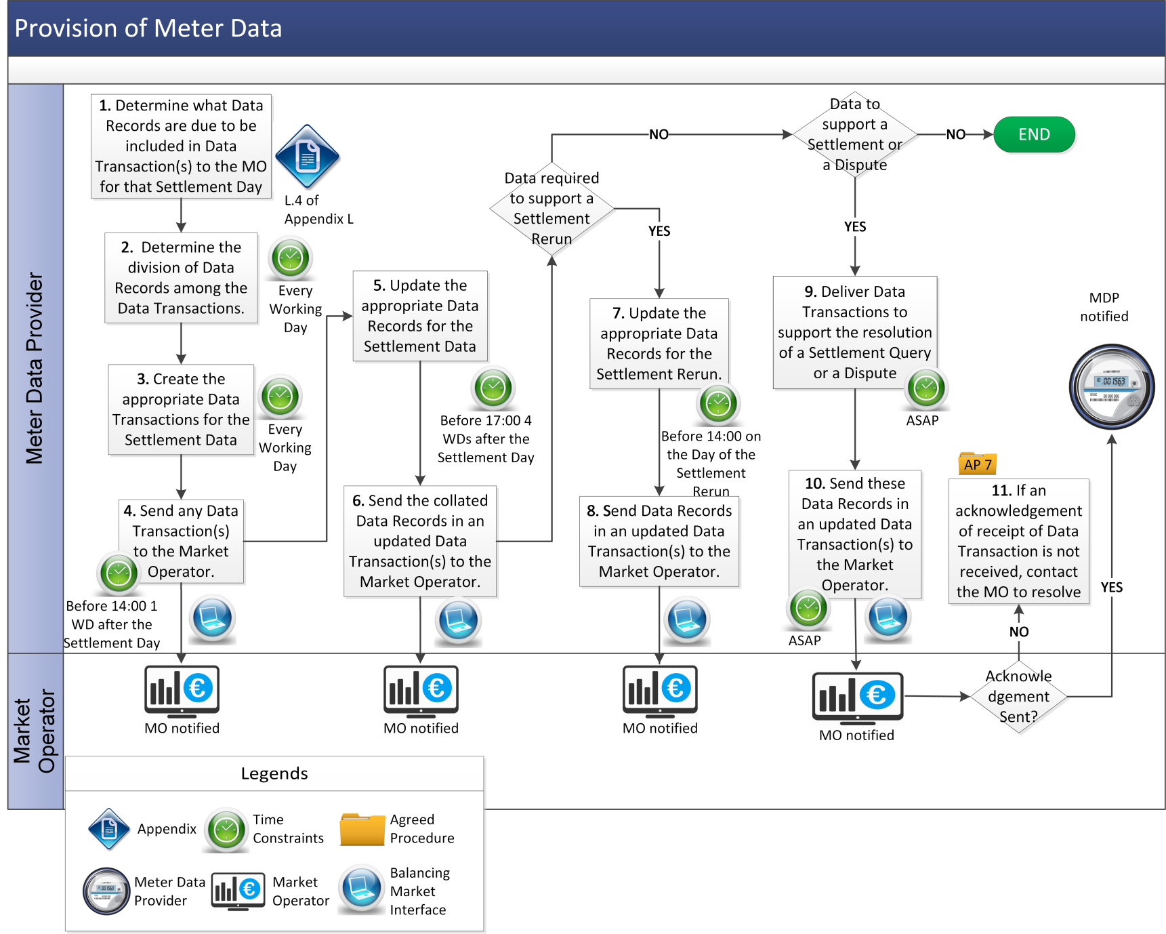

Appendix 1: Definitions and Abreviations

**Definitions**

|  |  |
| --- | --- |
| **Aggregated Demand Metering** | means a complete set of Supplier Unit Demand for which a Meter Data Provider is responsible, for all Trading Periods in the Settlement Day for which each Unit is registered, sent by that Meter Data Provider to the Market Operator |
| **Aggregated Inter Jurisdiction Metering** | means the complete set of Net-Inter-Jurisdictional Flow for which a Meter Data Provider is responsible, for all Trading Periods in the Settlement Day for which the Import is registered, sent by the Meter Data Provider to the Market Operator. |
| **Generation Metering** | means the complete set of Generator Units for which a Meter Data Provider is responsible, for all Trading Periods in the Settlement Day for which each Unit is registered, sent by the Meter Data Provider to the Market Operator. |
| **Net-Inter-Jurisdictional Flow** | means the Data Records describing the Net-Inter-Jurisdictional Import from Northern Ireland to Ireland. The Net-Inter-Jurisdictional Import from Ireland to Northern Ireland is the negatives of these Meter Data. |
| **Retail Market Operator** | means the business group within ESB Networks or NIE Networks responsible for managing the retail market data, registrations, and deregistration between final consumers and Supplier Units. |

## 

**Abbreviations**

|  |  |
| --- | --- |
| **CJF** | Cross Jurisdictional Flow. |
| **NPED** | Legacy Identifier indicating data that, pre-Cutover Time, would have been considered non-price effecting demand. |
| **NPEG** | Legacy Identifier indicating data that, pre-Cutover Time, would have been considered non-price effecting generation. |
| **PED** | Legacy Identifier indicating data that, pre-Cutover Time, would have been considered price effecting demand. |
| **PEG** | Legacy Identifier indicating data that, pre-Cutover Time, would have been considered price effecting generation. |

Appendix 2: File Format Overview

This Appendix provides an overview of some rules regarding the file format to be used in exchanging data between the Meter Data Providers and the SEM systems.

General Description of the SEM-MDP message format

The message format includes the following types of data:

1. Header details, containing the username and password and other security details from the digital certificate;
2. Unit level information, including the Unit name;
3. Time period Meter Data at a half-hourly resolution;
4. Non Interval Energy Proportion data at a half-hourly resolution; and
5. Trailer details, including a checksum to verify the integrity of the file.

The following principles apply to the file format:

1. The message is formatted via XML;
2. Full stop is used in fractional numbers, e.g. 12.34 or 0.34;
3. Negative numbers should be prefixed by a minus sign, e.g. -12.34 or -0.34;
4. Numbers (for Meter Data) should be expressed to a maximum of three decimal places; and
5. Meter Data for energy entering the Transmission System (i.e. generation) should be positive (there is no requirement for a “+” sign), and Meter Data for energy exiting the Transmission System (i.e. demand) should be signed negative (there is a requirement for “-” sign). Zero values are not signed positive or negative. Please note that this is a file-transfer convention only. Demand variables in the Code algebra, for example, Meter Demand MDvh are positive for the purposes of the Code algebra.