

Working Group 6 Report

Mod_18_10

Intra-Day Trading

02 November 2010

10.00am – 3.00pm

Europa Hotel
Belfast

Table of Contents

Attendees 3
Summary 4
Background 4
Presentation 5
SEMO IT – Summary of Systems Impacts 5
SEMO Market Development – Superpositioning vs. Protection 5
Data Transaction Contingencies 5
MSP Software Run Contingencies 5
Trading Windows & Optimisation Time Horizons 6
Credit Risk Management - (CRM) 6
Discussion Summary and Key Issues 7
Superposition vs. Protection 7
Data Transaction Contingencies 8
MSP Software Run Contingencies 9
Trading Windows and Optimisation Time Horizons 10
Credit Risk Management 12
Recap, Recommendations and Action Items 13
Appendix 1 – Working Group Presentation Slides 15
Appendix 2 – Conference Call 3 notes 15
Appendix 3 – Action Item Progression 17

Attendees

Name | Company
Aisling O'Donnell | SEMO
Alex Baird | SONI
Ann Ruddy | ESBCS
Aodhagan Downey | SEMO
Dana Kelleher | CER
David McMorrow | ESB
Dermot Barry | SEMO
Emeka Chukwureh | Airtricity
Emma Burns | CER
Ian Luney | AES Kilroot
Jean Pierre Miura | NIAUR
Jenny McGovern | ESB PG
Jill Murray | Bord Gáis
John Bennett | Design & Implement
Jonathan Jennings | SEMO
Juliet Corbett | NIAUR
Kate O’Connor | EirGrid
Killian Morgan | ESBCS
Kris Kennedy | SONI
Liam Ryan | SEMO
Mark Alexander | Energia
Niamh Delaney | SEMO
Niamh Quinn | ESBI
Nigel Thomson | SEMO
Paul McGuckin | Mutual Energy
Philip Newsome – Chair | CER
Rodney Doyle | EirGrid
Sean Mackin | SEMO
Shane O’Rourke | Endesa Ireland
Sherine King | SEMO
Stephen Powell | RA Consultant
Stephen Woodhouse | Poyry
Sinead O'Hare | NIE Energy
Tom McCartan | SONI
Wallace McKee | NIE Energy

Summary

The sixth Working Group meeting saw agreement by the group to progress a number of working assumptions presented by SEMO, including decisions on:

- Superpositioning versus protection
- MSP Software Run Contingencies
- WD1 Trading Window Options
- Credit Cover for Interconnector Units (with some additional work required)

A number of actions were placed on SEMO and Participants following the discussion and there was agreement to proceed with a number of working assumptions. A seventh Working Group meeting is expected to take place in advance of Modifications Committee Meeting 32 on November 25th. The aim of Working Group 7 is to close off any outstanding high level design questions prior to the submission of the High Level Design Summary to the Modifications Committee.

At Modifications Committee Meeting 32, a recommendation will be made to the SEMC regarding the High Level Design developed by the Modifications Committee and further detailed work on design and project planning.

Background

This Working Group is the sixth in a series of Working Groups set up to develop the Mod_18_10 Modification Proposal submitted by the RAs in March 2010. From the proposal:

This Modification Proposal, submitted by the RAs is proposed under the aegis of SEM Committee (SEMC) Decision SEM-10-011 on Regional Market Integration, in which the SEMC decided to bring a Modification to the TSC to engender rule changes to facilitate SEM Intra-Day Trading so as to maximise the use of existing and future Interconnectors’ within-day capacity and comply with the requirements of the Congestion Management Guidelines set out in ‘Regulation 714/2009 of the European Parliament and of the Council of 13 July 2009’.

Minutes of the previous five Working Groups and any other relevant materials can be found at www.sem-o.com.

Since the fifth Working Group, a third Intraday Trading conference call took place on October 28th to provide an opportunity for comment on the content to be presented at the sixth Working Group meeting. A number of actions were placed on the group for delivery at the meeting. See appendix 2 of this report for Conference Call 3 notes.

Presentation

Slides were presented by a number of SEMO representatives and are available in Appendix 1 of this report.

SEMO IT – Summary of Systems Impacts

- SEMO IT provided a high level update on the expected impacts the project will have on the market systems. Changes will impact on the following areas:
  - TSO/IA interfaces;
  - Metering interface;
  - Settlement interface;
  - Participant interface;
  - Reports impacts;
  - Finance interface;
  - MSP software;
  - Market database;
  - MI-Settlement interface
  - Settlement system; and
  - Credit management system.

SEMO Market Development – Superpositioning vs. Protection

- Compliance question raised at WG5 regarding whether protection is compliant.
- Design presented at WG5 requiring a single Interconnector per Participant that would not enable Interconnector Units to counter trade in future Gate Closures.
- Superpositioning is not consistent with allowing protection.
- Two options presented as follows:
  - Option 1 – Fixed and superposition
  - Option 2 – Protection and no superposition
- SEMO view is that Option 1 provides greatest trading flexibility to participants.

Data Transaction Contingencies

- Presenter outlined the following effects on data transactions
  - System Operator
  - Interconnector Administrator
  - EA1 MSP Software Run (proposed contingency data)
  - EA2 MSP Software Run (proposed contingency data)
  - WD1 MSP Software Run (proposed contingency data)

MSP Software Run Contingencies

- Outline of the key dependencies regarding EA1, EA2, WD1 and Day Ahead Operations Schedule was presented.
- Three options presented:
  - Option 1 – Fixed Sequencing.
  - Option 2 (A) and (B)– Cancellation of Runs
    - 2(A) Cancel EA1 run if the EA1 Software has not started by 30 minutes after the EA1 Gate Window Closure.
    - 2(B) Cancel EA2 run if the EA1 MSP Software Run has not started by 30 minutes after the EA1 Gate Window Closure (i.e. give priority to EA1).
  - Option 3 – Amend Initial conditions.

Trading Windows & Optimisation Time Horizons

- Two Optimisation Time Horizons presented:
- Option 1: WD1-18 hour Optimisation Time Horizon
- Option 2: WD1-30 hour Optimisation Time Horizon

Credit Risk Management - (CRM)

- Justification for Credit Cover for Interconnector Units presented by SEMO representative.
- Three options as presented at Conference Call 3:
  - Status Quo” CRM: Retain the current arrangements;
  - “Limit on submission” CRM: Accept Interconnector Unit’s Offer if and only if they have sufficient available Posted Credit Cover to cover export trades.
  - “Limit in MSP Software” CRM: Limit an Interconnector Unit’s MSQ in the MSP Software based on available Posted Credit Cover.
- Feedback from Participants on Options 1 and 2 taken to develop a Hybrid Option 1A.
Discussion Summary and Key Issues

The Secretariat provided an update on the progress of actions following the fifth Working Group meeting and third conference call. See Appendix 3 of this report for further details. Secretariat noted that a number of actions remain open and an update on all open actions will be given at the next Working Group meeting.

The Chair set out the key milestones of the group over the medium term with the aid of a timeline. The first milestone identified is to gain approval from the Modifications Committee on the high level design as agreed by the Working Group participants over the course of the Working Group meetings. It is expected that a progress report can then be submitted to the Nov 30th meeting of SEMC from the Modifications Committee with the aim of receiving approval in principle and followed by a decision to proceed with the Intra-Day Trading work stream in early 2011. From there, if there is agreement from the SEMC on the principles developed, the participants involved can work towards developing the design in tandem with detailed drafting of a Modification Proposal during 2011. SEMO IT noted that it requires SEMC direction to continue progressing the design for Intra-Day Trading.

A SEMO IT representative presented the high level impacts the project will have on the systems. It was noted that the impacts presented are based on the current understanding of the high level design. Other changes that cannot be identified at this stage may result from the detailed design phase. A SEMO IT timeline encompassing the intra-day project was presented, along with a timeline including other Modification Proposals with system impacts approved and scheduled for implementation. Attention was drawn to the absence of an October 2011 release, should Intra-Day Trading be implemented as per the required timescales. It was highlighted that timelines were based on initial assessments and are subject to change following more detailed assessment.

Superposition vs. Protection

SEMO representatives presented two options following discovery that the design presented at Working Group five poses difficulties facilitating superpositioning. The original design requiring a single Interconnector per Participant limits Interconnector Units counter trading in future Gate Closures. Two possible solutions put forward by SEMO include:

Option 1 – Fixed and Superposition
Fixed Allocations from each MSP Software Run and Superposition permitted within the MSP Software (i.e. Aggregate of IUNs within limits of Import and Export ATC).

Option 2 – Protection and no Superposition
Protection between MSP Software Runs but no superposition permitted (i.e. Aggregate of Import IUNs less than or equal to Import ATC and aggregate of Export IUNs greater than or equal to Export ATC).

Poyry questioned if Option 2 may result in capacity hoarding. SEMO agreed that there may be a possibility of capacity hoarding with Option 2. Confirmation provided by RA consultant that superpositioning is not explicitly defined as a requirement under the Congestion Management Guidelines (CMG), although other European regions facilitate superpositioning. EirGrid representative confirmed that Option 1 would align with the approach of other countries.

An RA representative queried whether Option 1 allows re-bidding at EA2 to facilitate counter trading. SEMO confirmed that Option 1 will accommodate counter trade on the Interconnector. ESBCS sought confirmation that Option 1 will require participants to act as three separate Interconnector Users to facilitate use of each gate. SEMO confirmed that there will be a requirement for three sets of firm volumes for Ex-Post utilisation.

The SEMO view is that Option 1 provides greatest trading flexibility to participants. There was further discussion around the definition of default data for the Interconnector. The group reached agreement that Option 1 is the preferred working assumption to progress.

Action: SEMO to progress Option 1 Fixed and Superposition as an agreed working assumption.

Data Transaction Contingencies

SEMO explained the necessity for contingency plans for System Operator and Interconnector Administrator Data Transactions for EA1, EA2 and WD1 MSP Software Runs.

The key intra-day timings are as follows:

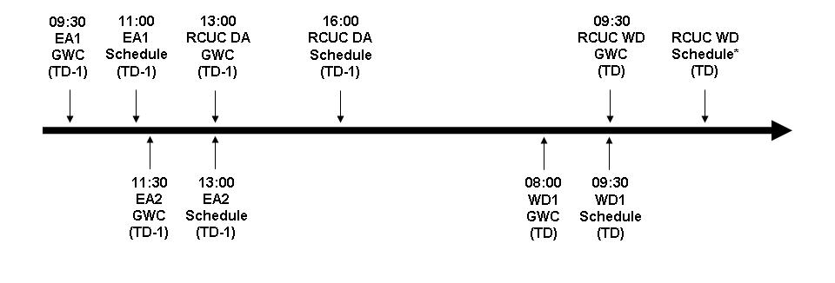
Airtricity questioned the contingency in place related to absence of information for the TSO. SEMO confirmed that, as with current practice, a communication is issued to the SO/IA when information is not available.

A discussion on contingency data for Active Capacity Holdings took place. SEMO emphasised that the as these are contingencies they are intended to be used rarely if ever. SEMO believed it best to set the value to zero in the case where SEMO does not receive any data from the IA. Participants believed this to be an unfair default value as participants will be at a monetary loss dependent on the amount paid for capacity. Airtricity suggested some logic should be applied to configuring a figure and suggested SEMO use an average. Concern raised by SEMO IT regarding the system changes and associated costs involved in such a change. SEMO pointed out that the contingency of using a zero value was only ever used once in the past with Moyle.

Action: SEMO to consider options for contingency data for capacity holdings rather than using zero.

A participant questioned the contingency for a change in Available Transfer Capacity (ATC). SEMO confirmed that MIUNs are recalculated if the ATC changes to reflect the change in capacity.

MSP Software Run Contingencies

Delivery of Intra-Day Trading will require SEMO and TSOs to reduce the time available to them to produce the existing Market and Operational Schedules respectively. SEMO believe it prudent to put in place contingencies to ensure that in all cases the Operations Schedule is delivered by 4pm.

The dependencies were outlined, stating that the EA1 MSP Software Run takes initial conditions are from the WD1 MSP Software Run. EA2 initial conditions are from the WD1 MSP Software Run, with the remaining Interconnector capacity being calculated from the ATC and the MIUNs set in the EA1 MSP Software Run. The WD1 Software Run initial conditions are taken from the EA2 MSP Software Run, with the remaining Interconnector Capacity calculated from the ATC and the MIUNs set in the EA1 and EA2 MSP Software Runs.

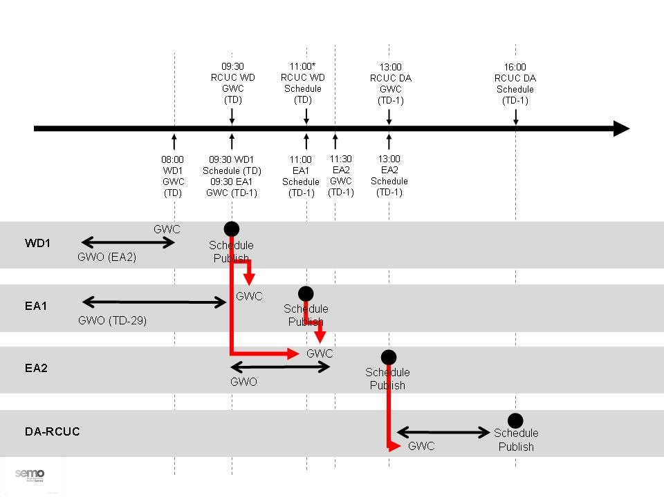

Three contingency options were presented for consideration:

Option 1 – Fixed Sequencing
SEMO would always wait for the relevant run to complete before starting the next run.

Option 2 (A) and (B)– Cancellation of Runs
A run is cancelled when the start of the MSP Software Run is delayed beyond 30 minutes after the relevant Gate Window Closure.
2(A) Cancel EA1 run if the EA1 Software has not started by 30 minutes after the EA1 Gate Window Closure
2(B) Cancel EA2 run if the EA1 MSP Software Run has not started by 30 minutes after the EA1 Gate Window Closure

Option 3 – Amend Initial conditions
Amend the initial condition inputs to specific of runs.

TSOs pointed out that Option 1 presents difficulties for running RCUC. PPB verified that changing the initial conditions for a RCUC run will have an impact on gas trading for generators. Clarification was sought by Endesa regarding the impact cancellation of a run will have on capacity holdings. SEMO advised that the impact will be dependent on which Ex-Ante run is cancelled. The contingency options presented will only be considered necessary when the critical timings cannot be achieved.

There was general agreement that Option 1 was not acceptable.

Option 3 posed difficulties for some participants as the Day Ahead Operational Schedule might not reflect the EA2 run due to delays but the EA2 would still go ahead.

Option 2(a) was unacceptable to some participants as it mean that explicitly paid for capacity holdings would be lost.

There was a general consensus that Option 2(B) was the preferred option.

Action: SEMO to progress with Option 2(B) as a working assumption.

- Cancel EA2 run if the EA1 MSP Software Run has not started by 30 minutes after the EA1 Gate Window Closure
  - No EA2 MSP Software Run, no publications

- Cancel EA2 run if the EA2 MSP Software Run has not started by 30 minutes after the EA2 Gate Window Closure
  - No EA2 MSP Software Run, no publications
  - Use EA1 schedule as input to DA-RCUC

- Cancel WD1 run if the WD1 MSP Software Run has not started by 30 minutes after the WD1 Gate Window Closure
  - No WD1 MSP Software Run, no publications
  - Use EA2 schedule as input to WD-RCUC

Trading Windows and Optimisation Time Horizons

SEMO gave a brief overview of the Optimisation Time Horizon for Ex-Ante and Ex-Post MSP Software Runs, and reiterated that the Trading Window for the EA1 and EA2 MSP Software Runs will be the entire Trading Day. SEMO also stated that under Intra-Day Trading, the Trading Window for WD1 begins after the start of the Trading Day. SEMO presented two options for the length of the WD1 Optimisation Time Horizon.

Option 1: WD1-18 hour Optimisation Time Horizon
Option 2: WD1- 30 hour Optimisation Time Horizon

A participant raised a query regarding the Optimisation Horizon for the within day RCUC run. It was stated that the Optimisation Time Horizon would begin at 06:00 and the Trading Window would begin at 18:00. Another query was raised by a participant regarding whether the Trading Window had been decided. It was stated by a SEMO member that it had not yet been decided but that it would be useful to do so.

Some Participants expressed concern about the data to be used in the overlap periods and this was addressed by SEMO, who stated that there would always be some data available and that it is highly unlikely that the Interconnector Unit (IU) flow would drop to zero. RA representative raised a question regarding how accommodating the 30 hour Time Horizon is in addressing TSO concerns. A SEMO member stated that it is necessary to have rules to reduce the risks of step changes (e.g. wind or load forecast between EA2 and WD1 Runs), hence Option 2 allows re-optimisation of Generator Units in the first part of the Trading Day (the Starting Overlap Optimisation Period, prior to the Trading Window).

There agreement that Option 2 represented the best option.

Action: SEMO to progress with Option 2 as a Working Assumption.

Discussion followed on the timing of Trading Window for WD1. Issues arose around whether the Trading Window should start before peak or after peak with varied opinions arising on the subject.

The SOs expressed serious concern about the prospect of the WD1 Trading Window starting before the peak. The introduction of changes to COD and MIUNs closer to real time posed a risk in their view to security of supply and the ability of the SOs to be able to cope with significant swings of potentially thousands of MW at the beginning of WD1 Trading Window.

The argument for having the Trading Window was argued by a Participant emphasising that a lot of the value of intraday trading is in the ability to adjust your position and this was especially true over the peak.

A compromise was reached where by the beginning of the WD1 Trading Window would be set to 18:00 initially on the basis of the SOs and othe concerns. This would allow for a period where the SOs and participants could gain experience with the new arrangements. SEMO would ensure that this time would be configurable and at some stage following the implementation of the Intraday Trading arrangements, a review would take place to decide whether it was feasible and desirable to change the beginning of the Trading Window.

Action: SEMO to progress with 18:00 as a Working Assumption for the beginning of the WD1 Trading Window.

Credit Risk Management

When the market was first established the principle of “full collateralisation” (insofar as reasonable) was implemented. Should a payment default occur, there are funds available to fulfil the Participant’s unresolved financial responsibilities in the market. At Conference Call 3, three options were presented, with Options 1 and 2 appearing to have elements aligning with various Participant views. As a result, hybrid Option 1A was presented at Working Group 6. This new option takes elements of Options 1 and 2, with the following features:

- Interconnector Units must have sufficient Credit Cover in place to cover their potential exposure in the market.
- As Undefined Exposure calculations for Interconnector Units are less useful than for other Units, exposure calculations for Interconnector Units will be based on:
  - Invoiced + Settled + Traded + Offered, rather than
  - Invoiced + Settled + Estimated
- SEMO would intend to make changes that will allow more timely provision of Credit Cover data (via reporting).

A participant raised a query regarding how the hybrid Option 1A affects importing Interconnector Users. A SEMO representative stated that there is zero effect on their credit position except for values that are either invoiced or settled both. These import values would reduce the Required Credit Cover. Another query was raised regarding how many hours of exposure there are. A SEMO member stated that it is the trading window in respect of the most recent gate closure that applies and that the exposure includes traded amounts between indicative settlement and initial settlement. An issue was raised by a participant regarding whether validation can be done when bids are submitted. A SEMO representative stated that the true position is not known until the trading day so the validation had to occur after Gate Closure.

RA representative raised the fact that Capacity exposure also needs to be considered. SEMO acknowledged this and took an action to produce a proposal by Working Group 7.

Action: SEMO to progress with Hybrid Option 1A as a Working Assumption.

Action: SEMO to propose arrangements that would include Capacity Period exposure for Interconnector Units.

Recap, Recommendations and Action Items

A recap of the discussions at the meeting and actions recorded was provided by the Chair, followed by an update on other related work streams including:

- Day ahead Market Coupling
  - Consultation to take place next year.
  - Consultation will be mindful of the developments of the Intra-Day Trading Modification project.
  - Considered as a separate workstream within the Regional Integration work.

- Framework Guidelines
  - Deadline for responses to consultation is November 10th.
  - ENTSO will then develop guidelines for Intra-Day Trading and Day ahead.

- FUI Stakeholder Group Meeting
  - Meeting to take place in January 2011 to address coordination of long term options.
  - Participants encouraged to provide feedback on how best to facilitate trade between IFA and BritNed in advance of the stakeholder meeting.

Chair requested that participants put forward their preference for UIOLI versus UIOSI at the next Working Group meeting.

There was unanimous agreement that the following options will be progressed as working assumptions going forward:

- Superpositioning versus Protection
  - Option 1 – Superpositioning and Protection

- MSP Software Run Contingencies
  - Option 2B – Cancellation of Runs (WD1 & EA2 before cancellation of EA1)

- WD1 Trading Window Options
  - 30 hour optimisation period
  - Trading Window begins at 18:00

- Credit Cover for Interconnector Units
  - CRM Hybrid Option 1A for Energy Market exposure (Capacity Market proposals to be provided at Working Group 7)

The next scheduled meeting of the Working Group is November 16th, where the agreed High Level Design Summary will be presented and any outstanding issues closed off. The document will then be submitted to the Modifications Committee on November 18th (one week in advance of Modifications Committee Meeting 32).

The following Action Items were identified for completion prior to Working Group seven.

- SEMO to:
  - Proceed with Option 1 Fixed and Superposition as an agreed working assumption;
  - Consider contingency options for Active Capacity Holdings rather than using zero;
  - Proceed with Option 2(B) Cancellation of all runs before EA1 as a Working Assumption;
  - Proceed with Option 2 as a Working Assumption for the WD1 Optimisation Time Horizon;
  - Proceed with 18:00 as the start time of the WD1 Trading Window and ensure that sufficient configurability is retained for possible future changes.
  - Progress with CRM Hybrid Option 1A as a Working Assumption;
  - Develop proposals for Capacity Market CRM exposure for Working Group 7; and,
  - Present high level design at Working Group 7.

- Participants to:
  - Provide an update at WG7 on preference for UIOLI or UIOSI.

- Secretariat to:
  - Draft and circulate Working Group report; and
  - Update Working Group timescales.

Appendix 1 – Working Group Presentation Slides

Presentation slides are available via the zip folder (Working Group 6 Report) on the SEMO Website.

Appendix 2 – Conference Call 3 notes

Intra-Day Trading Conference Call 3 Note

Introduction: A brief recap of Working Group 5 was outlined and the draft WG6 slides were presented. Please refer to slides for detail on the items presented.

1. Design Discussion:

Superposition vs. Protection

- Option 1: Fixed Allocations from each MSP Software Run and Superposition permitted within the MSP Software (i.e. Aggregate of IUNs within limits of Import and Export ATC)
- Option 2: Protection between MSP Software Runs but no superposition permitted (i.e. Aggregate of Import IUNs less than Import ATC and aggregate of Export IUNs less than Export ATC)

Action: Participants to provide feedback at or before WG6, on which option is preferred

Data Transaction Contingencies

Action: Participants to provide feedback at or before WG6, on the proposal presented.

MSP Software Run Contingencies

- Option 1: Fixed Sequencing- SEMO would always wait for the relevant run to complete before starting the next run
- Option 2: Cancellation of Runs- would occur when the start of the MSP Software Run is delayed beyond 30 minutes after the relevant Gate Window Closure
- Option 3: Amend Initial Runs- amendment of the initial conditions and inputs to specific of runs would occur when the start of the MSP Software Run is delayed beyond 30] minutes after the relevant Gate Window Closure

Action: Participants to provide feedback at or before WG6, on which option is preferred.

Trading Windows and Optimisation Time Horizons

- Option 1: WD1-18 hour Optimisation Time Horizon
- Option 2: WD1-30 hour Optimisation Time Horizon

Action: Participants to provide feedback at or before WG6, on which option is preferred.

Credit Management

Three Potential Options (Not yet impact assessed)
- Option 1: “Status Quo” CRM: Retain the current arrangements
- Option 2: “Limit on submission” (limiting bids post GC) CRM: Accept Interconnector Unit’s Offer if and only if they have sufficient available Posted Credit Cover to cover offered export trades
- Option 3: “Limit in MSP Software” CRM: Limit an Interconnector Unit’s MSQ in the MSP Software based on available Posted Credit Cover

Action: Participants to provide feedback at or before WG6, on which option is preferred.

2. SEMO Update on MSP Software Run process:

SEMO and SOs provided an update on the timelines associated with the production of the Market and Operational Schedules respectively.

Discussion and Actions:

A number of queries were raised on the slides presented and the following actions were recorded:

- Participants to provide feedback on their preferred Options for WG6 on Superposition vs. Protection, MSP Software Run Contingencies, Trading Windows and Optimisation Time Horizons and Credit Management.
- SEMO to provide more clarity on which WD1 is being referred to in the diagram on Slide 22 when discussing dependencies (including which runs they apply to) within the MSP Software Run Contingencies.
- SEMO to expand on CRM Options.
- SEMO to provide more clarity on Option 2 of Software Run Contingencies regarding treatment of capacity holdings in the event of a cancellation of EA1.
- SEMO to clarify for WG6 what happens exactly to the capacity holdings if EA1 is cancelled.

Next Steps:

- Working Group 6: Tuesday 2nd November (Belfast):
  - SEMO will provide an overview of the systems impact of current (provisional) design.
  - SEMO will provide an overview of the proposed timelines for the delivery of Intra-Day Trading based on current (provisional) design.
  - Objective of Working Group 6 is to come to a consensus on the various open issues (listed in the Actions section) which will enable definition of the overall design.
- Working Group 7: TBC - To deal with any outstanding issues.
Appendix 3 – Action Item Progression

The following Action Items were identified for completion at Working Group 6 and Conference Call 3. All open actions will be addressed at the next meeting.

Working Group 4: Mod_18_10
Action | Comment
RAs to:  Notify Secretariat when update on work streams becomes available | Open – no new updates received since WG4
TSOs to:  Further impact assess Option Group 1 | Open – in development
TSO to:  Advise Working Group participants of date of RCUC workshop | Open – Date & venue to be confirmed
SEMO to:  Further impact assess Option Group 1 | Open – in development
Conference Call 3: October 26th
Participants to:  Provide feedback on their preferred Options for WG6 on Superposition vs. Protection, MSP Software Run Contingencies, Trading Windows and Optimisation Time Horizons and Credit Management. | Open
SEMO to:  Provide more clarity on which WD1 is being referred to in the diagram on Slide 22 when discussing dependencies (including which runs they apply to) within the MSP Software Run Contingencies. | Complete – see WG6 slides
SEMO to:  Expand on CRM Options. | Complete – see WG6 slides
SEMO to:  Provide more clarity on Option 2 of Software Run Contingencies regarding treatment of capacity holdings in the event of a cancellation of EA1. | Complete – see WG6 slides
SEMO to:  Clarify for WG6 what happens exactly to the capacity holdings if EA1 is cancelled. | Complete – see WG6 slides

