

29th March 2018

Agreed Procedure Notification

Mod_01_18 Notification of Suspension to SEM NEMO’s

# Modifications Committee Meeting 65 Minutes

Proposer SEMO

Proposer delivered a [presentation](http://www.sem-o.com/MarketDevelopment/ModificationDocuments/Mod_01_18%20Notification%20of%20Suspension%20to%20SEM%20NEMOs.pptx) summarising the requirement for this proposal. Proposer advised of swim lane changes that would be captured in the legal drafting since they couldn’t be included in the proposal due to an administrative issue. Proposer advised that the proposal was raised at the request of the Modifications Committee to address an issue whereby SEMO are not currently obliged under the Code to notify SEM NEMOs that a Suspension Order has been issued (although it was accepted that this was part of SEMOs internal process).

Committee were in agreement to vote on this proposal subject to legal drafting changes.

# Notification

As per Section 2.223 of the T&SC, the Modifications Committee wish to notify the RAs of the effective date for Agreed Procedure Mod_01_18 Notification of Suspension to SEM NEMO’s to be **Thursday 5th April 2018**.

# Legal Drafting

As set out in Mod_01_18 Notification of Suspension to SEM NEMO’s with the inclusion of the following swim lanes as agreed –

Swim lane for Section 3.3.1

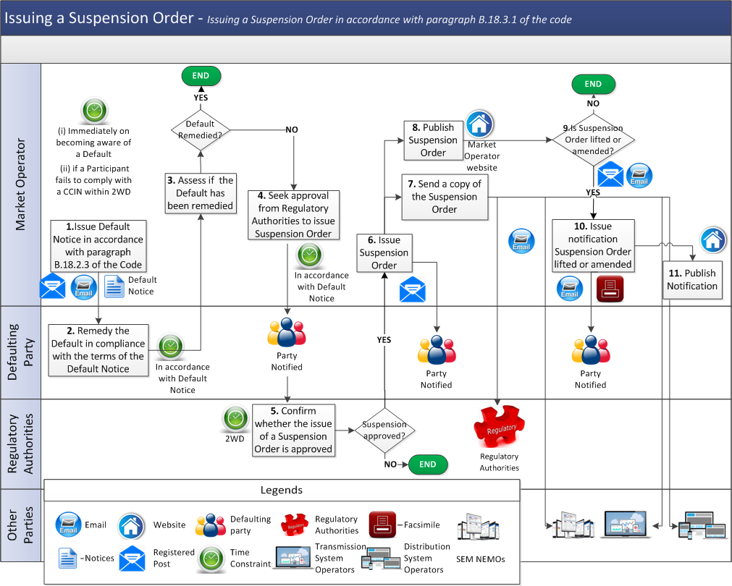

Swim lane for Section 3.3.2

