MODIFICATION PROPOSAL FORM

Proposer  (Company) | Date of receipt  (assigned by Secretariat) |  | Type of Proposal  (delete as appropriate) |  | Modification Proposal ID  (assigned by Secretariat)
Aughinish Alumina Ltd | 26 May 2017 |  | Urgent |  | Mod_03_17
Contact Details for Modification Proposal Originator
Name |  | Telephone number |  | Email address
Thomas O’Sullivan |  | +353 61 604473 |  | Thomas.osullivan@augh.com
Modification Proposal Title
Treatment of Transmission Losses for Trading Sites with Contiguous Autoproducers in I-SEM
Documents affected  (delete as appropriate) |  | Section(s) Affected |  | Version number of T&SC or AP used in Drafting
T&SC Part B |  | ISEM TSC F.4, |  | SEM-17-024 April 12th 2017
Explanation of Proposed Change
(mandatory by originator)
Existing Treatment of Losses in the SEM:
In the SEM a Netting Generator Unit (NGU) is used as part of the settlement calculation of the Aughinish Trading Site as a contiguous Autoproducer. The Aughinish transmission losses are applied to the net power exported from the site to give a comparable situation to a generator that is all located behind the one meter. Losses are not applied to the volume of power self-supplied on site. During our annual plant shutdown, the Trading Site is importing power. This power is assigned to the Trading Site Supplier Unit (TSSU) when consumption is greater than the MSQ of the on the site generation.
See examples for a typical 1hour settlement:

- Exporting (Normal operation)
Energy payment = (MSQ_{SK3} + MSQ_{SK4} – NGU_{Aughinish})*lossAdjustment*SMP
=(80+80-45)*0.973*SMP
= (115MWh)*0.973*SMP
= 111.895MWh*SMP
- Importing (Both gas turbines off)
Energy payment = (MSQ_{SK3} + MSQ_{SK4} – TSSU_{Aughinish})*lossAdjustment*SMP
=(0+0-45)*1*SMP
= (45MWh)*1*SMP
= -45MWh*SMP
In this situation other variable Supplier charges apply

Whilst the continuation of this fair treatment for autoproducers had been discussed and supported during the ISEM consultation process, it has come to our attention in the published TSC that the application of TLAFs in the settlement of the ISEM Balancing Market (BM) is not consistent with this methodology. Below are two examples of how the Aughinish manufacturing facility will be unfairly treated:

Treatment of Losses in the I-SEM
- Energy Settlement
The NGU no longer exists in the current version of the ISEM TSC, hence an Autoproducers in-house consumption will be allocated to its registered TSSU at all times whether importing or exporting power. Due to individual unit settlement in the ISEM Balancing Market, the generation units and the TSSU will be settled using different TLAFs, as currently drafted in the TSC. This results in transmission losses being over recovered by the market on power not entering the transmission system.

Below is an example for a typical 1hour settlement of the Aughinish Autoproducer site in the ISEM

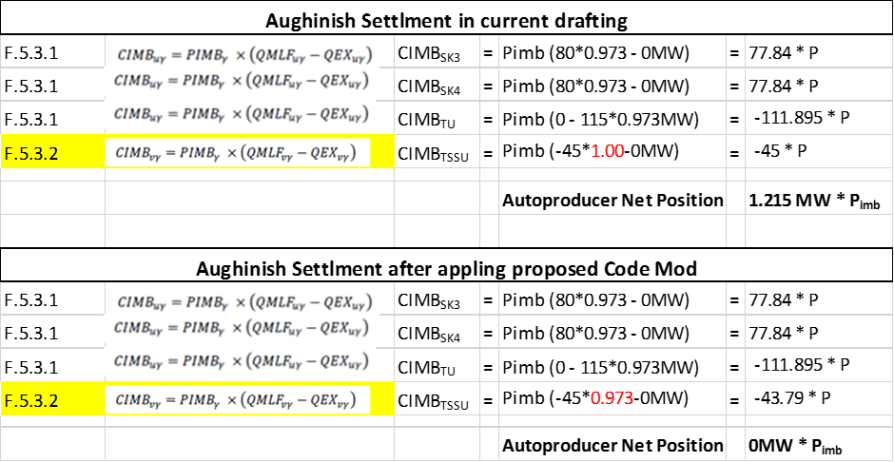

Aughinish believes that the annual cost of these Imbalance charges to our manufacturing facility, despite being fully balance responsible, would be significant and probably if not corrected would exceed €500,000/annum. This is clearly an anomaly in the rules and therefore should be corrected to reflect the current treatment for settlement of Trading Sites in the SEM

- Supplier charges
A separate issue with the application of losses is in the assessment of supplier charges for TSSUs. It would under certain conditions levy a penalty on power produced and consumed on site. For example, if the in-house consumption matched generation (zero power exported, zero power imported) the TSC as currently drafted, would apply supplier charges on a volume equal to (QM_{u}-QMLF_{u}) because the TSSU loss factor is different to the generator loss factor.

Below is an example of the settlement of the Aughinish Autoproducer site when no power is being exported to the market or the transmission system.

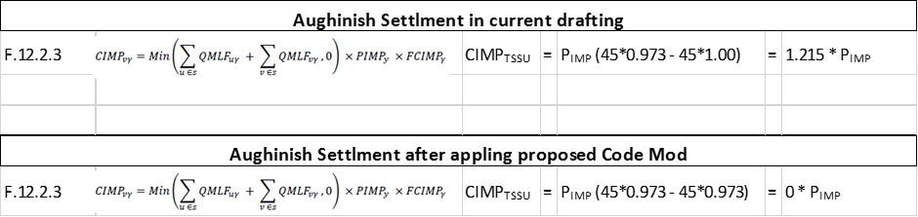

The materiality, based on Aughinishs historic metered generation is low but could be material in future markets.

Whilst it appears, the intention of F.4.2.13 is to address these two issues by applying a loss factor to the virtual Trading Unit. The effect is nullified because the Trading Unit has no volume in the Balancing Market. Instead, Aughinish proposes applying the appropriate published loss factors for the station node (or the weighted average if they differ for more than one generator) to the TSSU associated with the embedded generator(s) within an Autoproducer site. It is our expectation that this would correct both item 1 and item 2 above.

In making this modification proposal, Aughinish is aware that the Modification Committee needs to be cognisant of the potential for gaming the system. In the absents of being able to write the NGU back into the TSC part B Aughinish recommends that some restriction should apply. In the draft below, exclusions apply if the sites MEC is not greater than its MIC and in periods where the site is not generating any power.

Legal Drafting Change
(Clearly show proposed code change using tracked changes, if proposer fails to identify changes, please indicate best estimate of potential changes)
[See appendix 1 for editable redline version]

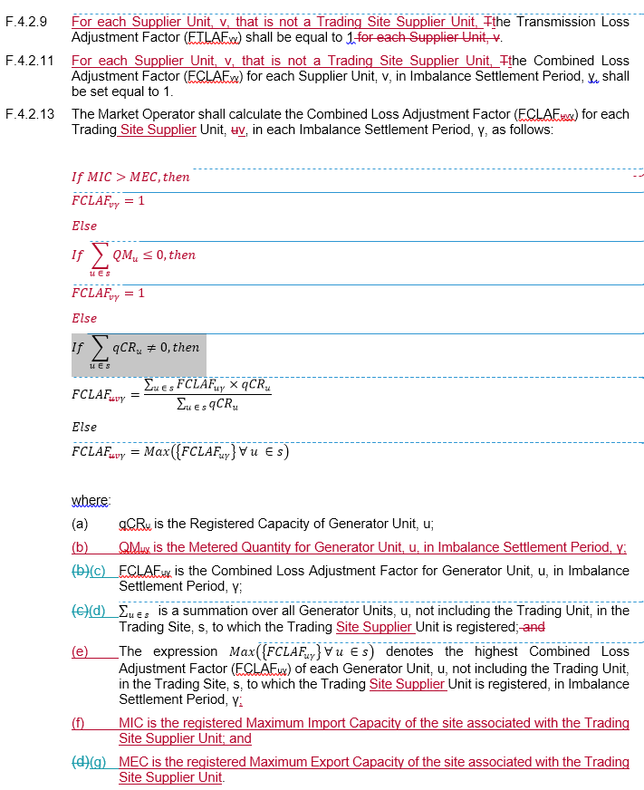

Modification Proposal Justification
(Clearly state the reason for the Modification)
- There are unforeseen consequences associated with the removal of Netting Generator Unit (NGU) as part of the ISEM TSC drafting.
- The additional cost of applying losses inside the Autoproducer site boundary is likely to exceed €500,000/annum for Aughinish Alumina manufacturing facility.
- The proposed changes only materially affect Trading Site with a contiguous Autoproducer
- Under the current SEM, losses are not applied to the volume of power self-supplied to the host site. This should remain true in the I-SEM under the principle not to change anything, which doesn’t need changing to comply with market coupling. This does not apply to other non-Trading sites importing and exporting in the I-SEM and is an anomaly, which has arisen due to the removal of the NGU.
- The current TSC drafting incorporates a penalty on co-generation operating within a Trading Site and its associated benefits for society, the environment and industry. It is in breach of national and European law.

This modification proposal is marked as “urgent” because this is a material inconsistency in the Code and is material under normal operation of an Autoproducer.

Code Objectives Furthered
(State the Code Objectives the Proposal furthers, see Section 1.3 of T&SC for Code Objectives)
- to facilitate the efficient discharge by the Market Operator of the obligations imposed upon it by its Market Operator Licences;
Correct application of losses on Autoproducers is critical to this objective

- to facilitate the efficient, economic and coordinated operation, administration and development of the Single Electricity Market in a financially secure manner;
Correct application of losses on Autoproducers is critical to this objective

- to facilitate the participation of electricity undertakings engaged in the generation, supply or sale of electricity in the trading arrangements under the Single Electricity Market;
Correct application of losses on Autoproducers is critical to this objective

- to promote competition in the single electricity wholesale market on the island of Ireland;
Correct application of losses on Autoproducers is critical to this objective

- to provide transparency in the operation of the Single Electricity Market;
Correct application of losses on Autoproducers is critical to this objective

- to ensure no undue discrimination between persons who are parties to the Code; and
Correct application of losses on Autoproducers is critical to this objective

- to promote the short-term and long-term interests of consumers of electricity on the island of Ireland with respect to price, quality, reliability, and security of supply of electricity.
Correct application of losses on Autoproducers is critical to this objective

Implication of not implementing the Modification Proposal
(State the possible outcomes should the Modification Proposal not be implemented)
- Aughinish will be penalised for losses associated with power, which never entered the Transmission system.
- Aughinish will be charged supplier charges when no power was taken from the market
- It is grossly unfair to charge losses for on-site consumption supplied by on-site generation. This only applies to Trading Sites and would be a penalty imposed on Trading Sites for the self-supply which would be inconsistent with the treatment of any other non-Trading Site which has on-site generation. The consequences of such could result in closure of the CHP plant
- The TSC would be in breach of national and European law.

Working Group  (State if Working Group considered necessary to develop proposal) |  |  | Impacts  (Indicate the impacts on systems, resources, processes and/or procedures; also indicate impacts on any other Market Code such as Capacity Marker Code, Grid Code, Exchange Rules etc.)
Please return this form to Secretariat by email to modifications@sem-o.com

