

Working Group 1 Report
Mod_03_18 Autoproducer credit cover
24 January 2019

Eirgrid conference centre, Dublin

COPYRIGHT NOTICE
All rights reserved. This entire publication is subject to the laws of copyright. This publication may not be reproduced or transmitted in any form or by any means, electronic or manual, including photocopying without the prior written permission of EirGrid plc and SONI Limited.

DOCUMENT DISCLAIMER
Every care and precaution is taken to ensure the accuracy of the information provided herein but such information is provided without warranties express, implied or otherwise howsoever arising and EirGrid plc and SONI Limited to the fullest extent permitted by law shall not be liable for any inaccuracies, errors, omissions or misleading information contained herein.

Table of Contents

1 Introduction 5
2 Background 6
3 Discussion 7
4 Next Steps & Actions 11
5 Appendix 1 DSU Feedback 12
6 Appendix 2 High Level Requirements 14
7 Appendix 3 Summary of Autoproducer Modeling Rev B 15

Document History

Version | Date | Author | Comment
1.0 | 15 February 2019 | Modifications Committee Secretariat | Issued to attendees at the meeting for review
2.0 | 5th April 2019 | Modifications Committee Secretariat | Issued to Modifications Committee

Distribution List

Name | Organisation
Modifications Committee Members | Modifications Committee
Working Group Attendees | Various

Reference Documents

Document Name | Document Reference
MOD_03_18 Autoproducer Credit Cover | Modification Proposal
MOD_03_18 slides | Presentation
MOD_09_18 Interim Credit Treatment for participants with Trading Site Supply Units v3 | Modification Proposal
MOD_09_18 Interim Credit Treatment for participants with Trading Site Supply Units v3 | Decision Letter
Working Group Slides for DSU | Presentation
Terms of Reference | Terms of Reference

In Attendance

Introduction
Name | Company
Thomas O’Sullivan | Aughinish
Christopher Goodman | SEMO
Robert McCarthy | Captured Carbon
Lisa McMullan | GridBeyond
Brendan O’Sullivan | SEMO
Jamie Mitchel | Energia
Katia Compagnoni | SEMO
Gina Kelly | CRU
Sandra Linnane | SEMO
Esther Touhey | SEMO

Secretariat welcomed all participants and thanks them for committing their time to the Working Group. A high level overview of the Working Group process was provided covering timescales, communication and the objective of submitting a Working Group Report with a Recommendation to the Modifications Committee.

Background

Mod_03_18 Autoproducer Credit Cover was received by the Secretariat on 11th January 2018. This modification was first raised at Meeting 79 on 25th January 2018.

At Meeting 79 the proposer delivered a presentation summarising the requirement for this proposal. The proposer addressed the collateral impacts that will be experienced and advised that this proposal was needed to correct the Trading & Settlement Code.
It was suggested that this issue will also affect Demand Side Unit (DSU) participants. MO Member advised that they were reviewing DSU impacts since this had only been raised the previous day. Members and observers were in broad agreement that this was something that needed to be addressed, however, it was also communicated that this proposal may address the Autoproducer issue for the proposer but may not work for all Autoproducer set ups or DSU participants. MO Member noted that the system change to deliver the proposal as drafted could not be done for I-SEM go live given the proximity of the cutover date.

MO Member advised that an interim modification to address the issue until an enduring solution can be included in the market systems should be possible. MO Member advised that this may involve provisions to treat affected Participants as Adjusted Participants along with bespoke rules on the volumes to apply to the Adjusted Participant calculations but that this needed to be further investigated to ensure a robust treatment.

It was agreed that a Working Group should be set up to explore this issue and develop this proposal for the enduring solution. It was also agreed that an additional proposal will be raised in the short term to mitigate this issue for go-live.
Mod_09_18 was received on 14th February and raised at Meeting 81 on 13 March and then approved at Meeting 82 on 23rd March. The proposal became effective on 27th August 2018.

Discussion

Overview & Background
The proposer gave a brief history of Aughinish Alumina claiming that they were arguably the most reliable generator, they are rarely a net consumer of power and, therefore, in settlement they are rarely exposed to demand tariffs. Since demand volumes are treated on a gross basis in the current credit calculations for the Undefined Exposure Period their entire demand, including that which is met by onsite generation, has these tariffs applied whereas in settlement they are only paid on the net consumption where the onsite generation is at reduced or zero availability which is extremely rare. This creates a situation where the unit is subjected to Credit Cover Requirements which appear excessive when considered in line with the net settlement across the Trading Site. Some data was presented to support this assertion.

Further, the proposer believed that the application of the standard deviation within the separate calculations for generation and supplier units would result in further increased credit requirements for the company.
Finally, the decision on Suspension Delay Periods at the time of raising the proposal was for Supplier and Generator Suspension Delay Periods to have differing durations in the ROI jurisdiction, resulting in differing Undefined Exposure Periods for Supplier Units and Generation Units. In the proposers view, this would have meant that the period for which required credit for Undefined Exposure for demand is calculated was greater than that applied for offsetting generation calculations resulting in a further overstatement of credit requirements for their Autoproducer site with a single Connection Point.
The proposer confirmed that their original proposal contained treatments to address these issues for Autoproducer Sites by treating the Undefined Exposure calculations based on Billing Period Cashflow as opposed to gross demand and imbalance settlement for generation volumes and also applying the standard deviation in the direction of the cashflow so that it was always additive to both payments and charges.
The proposer confirmed the interim solution to treat those affected as Adjusted Participants introduced via mod_09_18 was working well for their Autoproducer. DSU confirmed the interim solution was working for them also.
A question was raised as to whether the interim solution provides adequate protection to the market as intended by the credit mechanism if the interim approach endured for longer. SEMO raised a question around exposure and whether the original part B is currently covering this risk of exposure. It was agreed that clarity was needed for Autoproducers and DSU Participants on how the interim Modification has been applied in practice by SEMO. SEMO representative confirmed that the credit team provided an initial indication of the treatment of forecast data used for each adjusted Participant type; however, they will request and circulate further details on such process.
SEMO noted that the first Historical Assessment Period of 100 days since the start of I-SEM had recently become available; therefore, where all Participants were initially treated as ‘New’, most had recently been changed to ‘Standard’. SEMO also noted that they understood that the Autoproducer at Aughinish and most DSU Participants have been kept as ‘Adjusted’, other than those with portfolios whereby supply and generation are also under the same Participant as the DSU. SEMO suggested that any Participant who wished to confirm their treatment or request more detail may also wish follow up with the helpdesk.
It was confirmed that only Undefined Exposure is affected and that defined exposures are unaffected by the issue.

SEMO made a point that a statement on slide 20 of Aughinish’s presentation was not consistent with the SEMC policy of credit cover. The statement that “Any participant should only be exposed to their imbalance position” is not correct as to implement the SEMC policy of full collateralisation requires credit cover to be determined across a Participant’s gross exposure in relation to their consumption and not just their imbalances. SEMO agreed that there is a distinction between Supplier Units that represent retail companies, and thereby end consumers, and Supplier Units that “self-supply” and have no end consumers, noting that the rules of the calculation of Required Credit Cover implemented in Part B do not acknowledge this distinction. This also affects DSUs so a distinction needs to be made noting the difference between Supplier Unit that have end consumers and those that don’t (either through “self-supply” or where their Supplier Unit is used for algebraic purposes in settlement rules only).
It was noted that some changes for DSUs are anticipated, as part of the state aid directive, and that any enduring solution should be considered in that context. A DSU representative suggested that since the interim solution was working well they would be happy for it to continue if deemed necessary if it did not make sense to put in place the proposed enduring solution for DSUs due to the potential changes anticipated.

Impact on DSU Participants and Possible Solutions

DSU representative confirmed they have a similar issue to Autoproducers which is over collateralisation but noted some key differences. A Trading Site Supplier Unit (TSSU) for a DSU is not a unit with physically Metered Demand but rather has Metered Demand set to the negative of the Dispatch Quantity so that such a TSSU can never have a non zero Metered Quantity without DSU Dispatch Quantity in the market. However, as specified, its use in this manner is not noted in the Required Credit Cover calculations and incorrectly results in determining an Undefined Exposure for DSU sites.
DSU representative discussed DSU energy settlement calculation generally and for different scenarios of what is traded Ex Ante on the DSU a TSSU. They noted that it is not possible for the DSU to be unavailable and the TSSU to have a non zero demand so that there is no DSU analogue for an Autoproducer Site where the generation is unavailable to that demand and therefore credit exposure increases. This highlighted a key difference in the balancing market exposures for the unit types being discussed.
They went on to discuss a scenario for a DSU with a Balancing Market exposure whereby, if the TSSU would participate in any Ex Ante by selling a volume on the TSSU and not purchasing the same volume on the DSU which would cause an imbalance at the TSSU and this trading would be captured as defined exposure. SEMO suggested that, if such a defined exposure existed, then it may be appropriate to account for the potential for such an exposure in Undefined Exposure Calculations. It was suggested that in order for the Undefined Exposure calculations for DSUs to ensure that the wider market is not exposed to under collateralisation this may have to be the case and that this may mean that extending the current interim treatment for DSUs, as discussed previously in the context of potential changes to DSUs in future making it difficult to have a future proofed solution, is less desirable. SEMO suggested in that case that the preferred solution for DSUs would be one that captures current exposures and is future proofed for potential changes and extension of the interim treatment, whilst an option if this ideal is not possible, may be less desirable.
DSU representative stated that the solutions would be reflective on settlement and tariffs being included. It was agreed that more information was needed on the interim solution to be provided by SEMO’s Credit Team.
SEMO stated that timelines on implementation of any system changes have to be considered also in the context of changes arising from the state aid directive impacting on DSU. DSU are required to be treated the same as any generator so any enduring solution will need to be cognisant of other changes as the current position of no metering at the TSSU for a DSU site may not permanently be the case.
DSU representative stated they would be comfortable with this and maintain the interim Mod_09_18 in the meantime. MOD_03_18 should ideally include provisions for DSUs. A long term solution that will work should include Autoproducer Site and DSU algebra and be mindful of the potential impact of the state aid directive for DSUs. A discussion took place around the fact that the initial drafting of the interim solution defined its end dated as being required to be no later than the implementation date of Mod_03_18 but SEMO noted that this was removed in the final drafting as detailed in the decision letter so that it shouldn’t be an issue. It was, however, noted that a review of the interim provisions would be required if they were to endure for DSUs and that the proposal may need to cover amended legal drafting to account for this and a review of sub-section G.12.4 on Adjusted Participants.

It was agreed that MOD_03_18 as currently drafted is specific to Autoproducers. DSU representative is realistic about dates and timelines for System changes and is happy that the interim solution is there and could be extended if necessary. SEMO’s preference is for something that will work with all anticipated long term changes.
It was suggested that a good output of this first working group would be a high level principle scope of ‘solution requirements’ that are future proofed insofar as is possible.

Materiality

It was noted that if there is a difference in Undefined Exposure Period as a result of differing Supplier and Generator Suspension Delay Periods and this has the potential to cause a significant impact on the credit requirements for Autoproducers and DSUs. The envisaged SEM Committee decision to have these set to 14 days for ROI Suppliers and 7 days for ROI Generators would result in a larger credit requirement for Autoproducers and DSUs. Currently the market systems do not support different undefined exposure periods for different unit types. This is consistent with Part B of the T&SC which is written on single undefined exposure period that covers everything. To implement the RAs parameter decision, which included separate values for Supplier Unit and Generator Unit, will require a further modification to the T&SC to define the changes to the algebra and further work the vendor to implement the changes. The difference is to allow the customer to switch from their previous Supplier to the Supplier of Last Resort. The MO is planning to raise such a Modification in the near future. As a result of this limitation, these have been set equal at 7 days as an interim provision so that this effect is currently not at issue, however, an action was taken for the Regulatory Authorities (RAs) representative to confirm the intentions going forward as to whether they would still require different values to be introduced in future and if an exemption could be made for Autoproducers and DSUs, so that this can be taken into account in the Working Groups recommendation and potential Modification Proposal.
SEMO reviewed the equations on approved Mod_22_18, in the context of concerns around the direction of standard deviation being applied causing an exposure, which is effective on the baseline of version 20. In the legal drafting introduced by this proposal, standard deviation will apply in one direction only. This is in contrast with the proposer’s initial understanding that the effect would be disproportionately onerous for participants with demand and generation due to it applying conservatively in both directions.

The materiality presented by the proposer for their Autoproducer contains a figure of approximately €486,000 due to the difference between the undefined exposure period for the Supplier and Generator Units and approximately €170,000 due to the issue of standard deviation in the undefined exposure calculation. The MO argued and the proposer confirmed that the €170,000 is not an issue since MOD_22_18 has resolved this and the €486,000 is also currently not an issue because the Suspension Delay Period duration of 7 days currently applies to both Generator and Supplier Units in both Jurisdictions.
This will potentially become a problem if these were to differ in future, unless an exception is made for Autoproducers and DSUs on the ground that the 14 days for Supplier Units are required to allow Suppliers of Last Resort to complete switching over of retail customers does not apply to Trading Site Supplier Units. The RAs agreed that this could be taken as an action for them to consider and advise.
It was confirmed that the issue with Supplier Tariffs (Imperfections, Capacity Charges etc.) with an approximated impact of overstating collateral for the proposer of around €143,000 due to the effect of the application of tariffs on Aughinish applies in the absence of the interim solution and this item would also otherwise affect Demand Side Units (although a figure for DSU materiality is not available). SEMO commented that this figure justifies the need for a Modification as it was inappropriate for the MO to hold collateral for such amount since it does not represent an exposure in settlement. It was also noted that further assessment of this materiality is with actual data from I-SEM would be unlikely result in any reduction that would change this view.

The proposer gave a summary – SEMO passed 100 days, therefore it would be appropriate to look at what would have been the exposure of Autoproducers and DSU as a result of the “as is” design, versus what their actual exposures would have been over that same historical period. The proposer stated that it was not a simple ask to run this. It was agreed to take an action that Autoproducers and DSU would both look individually at their own comparison of the interim, proposed and existing provisions for credit assessment and that SEMO would assist by providing data, templates or guidance if required.
The proposer noted some differences between the set-up of his Autoproducer Site and that of other Demand Sites in the context of their discussions with industry and the principle of these differences was acknowledged. In particular, they highlighted the single Connection Point for import and export and noted that despite the gross metering set up for system operation that it was important that the principle of netting at the Connection Point was appropriately acknowledged by and reflected in the Market.

Market Risk
The question was raised about what would be the Market exposure should the Autoproducer site become a net importer. It was also noted that the enduring solution should work for any Autoproducer including one which was a net importer in order to ensure that the solution is universal.
The proposer stated that CHP on the Autoproducer site could be turned off if a cheaper alternative would be going back to being a net consumer. But it would be costly as it would not be able to start alumina plant without CHP – it’s not just a power generator, it also gives steam to alumina process. Historically, they have run the alumina plant very rarely without CHP before and that this was very costly. They could consume power up to 45MW but they are arguing that this exposure to the Undefined Exposure period should be removed by the enduring solution. They agreed that this future exposure should be calculated as normal if their site reverted to a power consumer. This is catered for in their original proposal.
It was noted that if a Participants Generator Imbalance or Supplier Demand changed by more than the Credit Cover Adjustment Trigger due to becoming a net importer or otherwise they would be required to notify the Market Operator and would then be treated as an Adjusted Participant until such times as this was captured under Standard Participant calculations and that a revised forecast would need to be provided. Once Adjusted Participant rules are correctly followed there is no risk to the Market.
The DSU representative also stated that the risks for the Market occur only when the TSSU trades differently from the DSU in the Ex-Ante Market, but the defined exposure for this is also covered by the current rules as it is picked up in trading exposure. However they will include all scenarios in their analysis in support of the Modification.
It was noted that it would be prudent to review the Code provisions contained in G.12.4 around the normal requirements to become an Adjusted Participant where volumes change and an action was taken in this regard by the Market Operator representatives. It was also noted that one of the solution requirements should be that the wider market remains appropriately and adequately protected by the collateral provisions.
Timelines for progression were further discussed as detailed in the next steps section below.

next steps & Actions

next steps

- A review of key points was discussed as were the agreed actions and next steps and the timeline for progression.
- Secretariat to issue timeline for progressing the Working Group – Working Group 2 will be required, details of which will be issued shortly. It is anticipated that that Working Group will take place in March with a view to submitting a revised or new modification on this topic by Meeting 91 on 27th June.
- The proposer noted that they had identified some typographical errors in their original proposal on review and it was agreed that an action should be taken to circulate the detail on these so that they could be addressed in the final drafting.
- When discussing an action related to Autoproducer and DSU attendees sending in their solution requirements it was noted that it would be useful for these to refer to the existing proposal and to suggest alternative drafting is the existing proposal did not address the requirement to facilitate the process of discussing legal drafting at subsequent working groups.
- A further action was discussed for the Secretariat to circulate any questions from Modifications Committee Meeting 89 to the group for discussion at the next session.
- A discussion around whether the enduring treatment should specify Autoproducers and DSUs as distinct from all Participants with Trading Site Supplier Units and it was suggested that it may be best to trigger this for any Participant with a Trading Site Supplier Unit since the netting issue with which it is concerned likely applies to all such Participants but this can be considered further.

Action
- Secretariat to draft Working Group 1 Report – this will then be sent for Attendee Review and subsequently provided to the Modifications Committee;
- Secretariat to provide Working Group timeline for a second meeting;
- SEMO to provide detail from the Settlement team detailing how interim credit cover is calculated;
- RAs to follow up internally on any potential issues in the exemption on differing Suspension Delay Periods of 14 & 7 days for Autoproducers and DSUs and to advise on the policy intentions regarding these parameters more generally;
- Proposer to email minor typographical errors in the current proposal and this will be potentially highlighted as housekeeping items in the final recommendation report or incorporated in any future V2 of the Mod;
- DSU attendees and Proposer to draft Solution Requirements – including possible legal drafting requirements focusing on what they want out of solution and whether or not the initial proposal would work for each. To be submitted by 6th February 2019 and the Secretariat will draft a single report for distribution to the Modifications Committee including broader requirement to retain protection against Market Risk for the wider market;
- Autoproducer and DSUs to review the period post 100 days since go live and compare outcomes between proposed solution, interim solution and current Standard Participant implementation. SEMO will provide analytical support if needed - Secretariat to schedule conference calls if needed.
- SEMO representatives to review text in section G.12.4 (Adjusted Participants) and confirm if it needs amendment.
- Secretariat to report to the Panel and circulate any relevant questions to the Working Group on foot of Modifications Committee Meeting 89 if required.

Appendix 1 DSU Feedback

High level requirements

Following on from the discussions at the working group meeting, Electricity Exchange has identified the following high-level requirements for DSUs in relation to collateral:

- Arrives at an appropriate level of collateral (i.e. no under or over collateralisation); and
- Reflects the net trading position of DSUs and their TSSUs in collateral.

Electricity Exchange decided to limit the criteria to a small number to not over-complicate the assessment of the options. As outlined in our slides and discussion at working group meeting 1, Electricity Exchange feel that criterion 1 needs to be read as not under collateralising DSUs/TSSUs and creating unnecessary risk to the market as well as not creating an undue collateral burden for DSU/TSSUs.

Assessment against high level requirements

Following review, Electricity Exchange are happy that the original proposal if appropriately amended to include DSUs would allow for a solution to the high-level criteria above.
Firstly, a cash flow based approach will look at the actual cash outflows and inflows of the units and would do so on a net basis. Therefore, this would not lead to over-collateralisation as the amount of collateral would directly relate to outturn (or forecasted in the case of new or adjusted participants) financial exposure to the market. Electricity Exchange feel that this is more appropriate than the treatment of the TSSU as a normal supplier unit for the purposes of undefined exposure as it is not possible for the TSSU to have demand without a netting generation quantity of the DSU. As the netting function is a market construct, Electricity Exchange do not feel it is appropriate to calculate undefined exposure based on metered demand.
As regards under-collateralisation, Electricity Exchange feel this criterion is also met. A DSU/TSSU pair can only be in a net negative cash position due to ex-ante trading. As outlined in our slides, Electricity Exchange feel there is potential for ex-ante trading to take place through TSSUs without being accounted for in undefined exposure calculations (e.g. ex-ante sales through a TSSU with a meter of zero would not feed into collateral). This creates a potential exposure to the market similar to assetless trading. Electricity Exchange feel that a cash flow based approach will capture this in a way similar to how such exposures are captured for assetless units (i.e. undefined exposure will project forward based on historical actual financial exposure).

Implication of State Aid related modifications

While it was discussed at the meeting that the implementation of this modification may come after the point of the changes required for DSUs in relation to state aid approval of the CRM, Electricity Exchange do not feel this is an appropriate criterion for assessing the solution.
It is not yet possible to know the implication of changes in relation to DSUs or TSSUs coming from this future modification. The working group have agreed that it is necessary to expand the originally proposed modification to extend to DSUs due to known issues in the code drafting.
Electricity Exchange feel it is appropriate to address these issues now as the baseline enduring solution and assess if any future changes also need to be considered in relation to collateral calculations. It would not be possible at this juncture to create a futureproof solution and Electricity Exchange do not feel it is appropriate for the interim solution to endure when known issues have been raised in relation to the code drafting. Specifically, the interim solution does not account the potential for TSSU based ex-ante trading.

Conclusion

Electricity Exchange feel that at a high level the original proposal would allow for DSU concerns if extended to include DSU/TSSU trading sites as well as those in relation to autoproducers. Electricity Exchange are happy for the working group to progress a solution based on the original proposal with appropriate amendments. However, Electricity Exchange note that some drafting amendments were mentioned at the working group meeting and that these should be addressed before arriving at final wording of the revised proposal. These included:

- Review of code references to align with most up to date code drafting; and
- Review of the original proposals elements which related to standard deviation and signage to ensure this aligns with the intended treatment and recent modification relating to signage.

Electricity Exchange are available to discuss these points prior to a second working group meeting as well as to complete further actions as may be required in relation to the working group.

Appendix 2 High Level Requirements

High-level Requirements Mod_03_18

High-level requirement from the perspective of an Autoproducer (the proposer):

- The TSC collateral calculation must recognise that the Autoproducer structure is a market design to facilitate enhanced TSO control over assets within a single site. Similar to the energy trading code and to the capacity trading code, the collateral code should access autoproducers as a single site generator whenever it is delivering power.
- Modify the TSC to align collateral requirement of an Autoproducer, delivering power to the market, to those of a generator delivering power to the market.
- For an Autoproducer, delivering power to the market,
  - Supplier charges should not apply to Undefined Exposure
  - A single suspension delay period must apply to the net position of the single site in Undefined Exposure to be consistent with a treatment of a generator.
  - A single TLAFs must apply to the net position of the single site to be consistent with treatment of a generator, where relevant.
- TSC Part C should protect the market from default risk no different to the protections in Part A unless otherwise directed by appropriate market modification.

Assessment on high-level requirement against the original proposal Mod_03_18

- Yes. achieved in original proposal
  - By specifically excluding ‘supplier Units which is registered as part of an Autoproducer” in calculating Supplier Unit Undefined Exposure in section G.14.7.1, the proposed code is recognising that the market autoproducer structure contains a SU which is part of a site delivering power to the market.
  - Similar to above, the proposed exclusion from G.14.8.1, Capacity Charges reinforces this recognition
- Yes. achieved in original proposal
  - The new proposed sections G.14.16 and G14.17 are duplicates of the Undefined Exposure for generators, but have been modified to catch the entire cash flow of a site registered as part of an autoproducer.
- Yes. achieved in original proposal
  - By combining Autoproducer generation and supplier units into a single calculation for Undefined Exposure, the Combined Credit Assessment Price (CCAPg) for the Undefined Exposure Period G.14.2.6 does not apply and removes supplier charges from the self-supplied power within an autoproducer site for the purpose of Undefined Exposure assessment.
  - By combining Autoproducer generation and supplier units into a single calculation for Undefined Exposure any present or future deviation between the Supplier Suspension Delay Period and the Generator Suspension Delay Period are irrelevant for an autoproducer who is delivering power to the market, for the purpose of Undefined Exposure assessment.
  - TLAFs are netted within in the energy calculation for autoproducers, using historic cash settlement as a prediction of future exposure solves this concern.
- Yes. achieved in original proposal
  - Part A of the TSC used a Netting Generator Unit to net off self-supplied demand within an autoproducer. In the opinion of Aughinish the proposed code modification to part C of the TSC gives the same result. The market is no more or less collateralised.

Appendix 3 Summary of Autoproducer Modeling Rev B

Note on Excel model used
In this document, Aughinish used the Excel model issued by SEMO 20 Dec 2018 to assess materiality of proposed code Mod. This model was issued with best intensions to aid participants and the published explanatory note clearly highlights assumptions, simplifications and approximations that were needed in creating the model. The application of the model was carried to best endeavours, if there are any modelling errors in the application of the excel model they are sole the responsibility of Thomas O’Sullivan.

This model proves to be very accurate when comparing Aughinishs real life Required Collateral and that modelled of a Virtual Single Generator Unit of identical net volumes. The average deviation is €49,289. Most of the larger deviations, visible in the graph below, can be explained by known issues observed with publication of indicative statements in the real market.

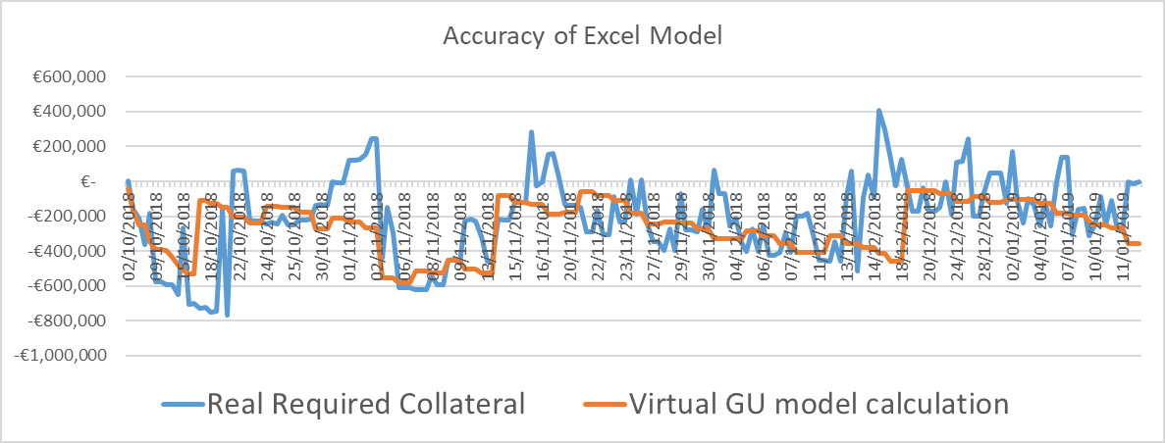

Aughinish have used this model to create a baseline and then to demonstrate the materiality of the TSC as currently drafted compared with the proposed modification.

Modelling of materiality for Autoproducers

Standard Estimate Autoproducer as per TSC:
To replicate the TSC as written Aughinish modelled
  - Two thermal generators (SK3 & SK4) delivering up to 80MW each, never trading ExAnte.
  - One Virtual generator (TU) selling up to 115Mw in the Exante markets
  - One supplier (TSSU) consuming ~45MW, never trading ExAnte.
The required collateral for these 4 units was added to reflect the Participant position
Note the STD estimate and the NEW Estimate are almost identical

SK3 80MW - Trade in BM

SK4 80MW – Trade in BM

TU1 115MW – Trade in ExAnte

TSSU (45MW) – Trade in BM
Participant
115MW

Standard Estimate Virtual GU:
Aughinish used exact metered volumes and ExAnte traded volumes to represent a single generator unit trading identical volumes.
- ONE GU trading up to 115MW ExAnte and delivering real QM of Aughinish site

GU 115MW – Trade in ExAnte and deliver in BM

Participant
115MW

Result of comparison:

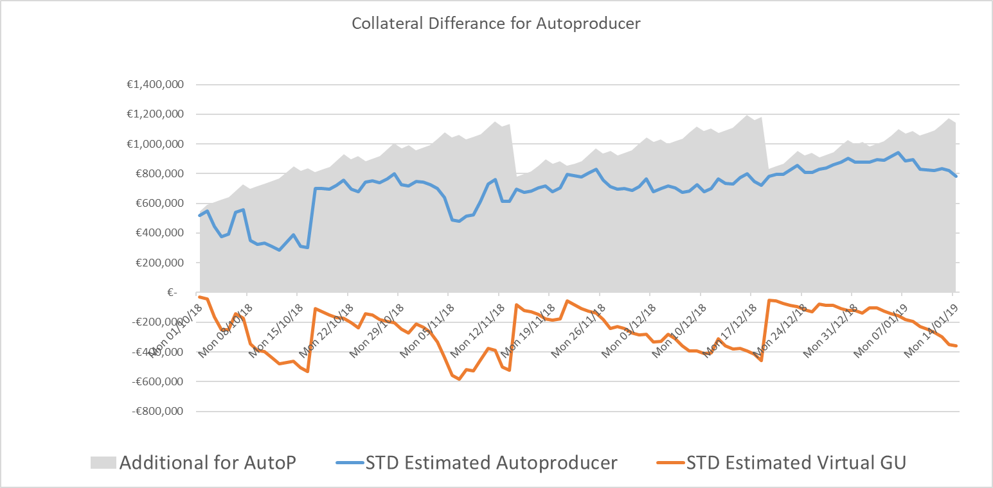

On average across the first 106 days of ISEM an Autoproducer requires €949,271 more collateral than a Generator Unit trading the same volumes and delivering the same volumes.

Maximum deviation was €1,192,993 on the 16 Dec 2018

Materiality component breakdown

The average difference is €949,271

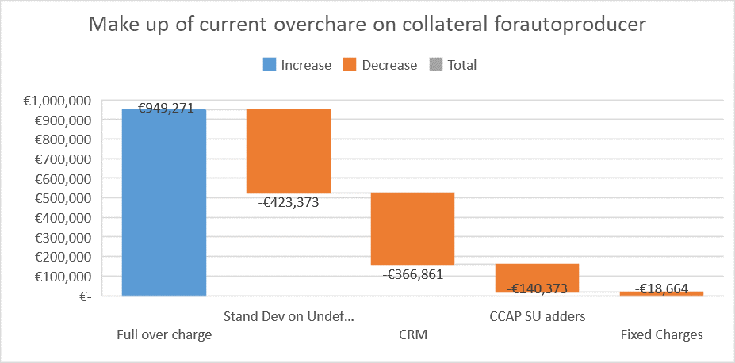

Current over charge | -€ 949,271
Stand Deviation on Undefined Exposure | -€ 423,373
Capacity (remove SU exposure) | -€ 366,861
Remove €6.49/MWh SU add-on to CCAP | -€ 140,373
Fixed Charges | -€ 18,664

New learning is that the treatment of capacity is a new item to be considered under materiality, this was not known when the code Mod was proposed. Above through a process of model manipulation Aughinish was able to breakdown the €949,271 into the main TSC aspects.

Materiality of 14day Supplier suspension day period

Additionally Aughinish added 7days to the models calculated ‘Billing Period Undefined Potential Exposure (EUPESpg)’ for Supplier units only to consider the effect if the RA is successfully passes a code mod to give effect to their requirements.

Using this crude assessment in the excel model we estimate this would require €718,166 additional collateral.

This is more than the simple calculation of 45MW * 24hr * 7days * €57.86/MWh = € 437,421

Either one is material.

Conclusion

The Interim credit calculation for Aughinish under Code Mod_09_18 as an Adjusted Participant is performing well. It closely correlated to simple generator with identical volumes traded and delivered.

The average additional collateral required by Aughinish as an Autoproducer is €949,271 in the current wording of the Trading and Settlement code. Without an enduring solution, €949,271 is the financial materiality of the proposed Code Mod_03_18.

The RA hope to implement a Code Mod to have additional 7-days of supplier suspension periods. Aughinish’s exposure would be an additional €700,000 of posted collateral if this code mod were applied with no relief for Autoproducers.

https://www.sem-o.com/documents/general-publications/Explanatory-Note-for-New-vs-Standard-Credit-Calculations.pdf https://www.sem-o.com/documents/general-publications/TEMPLATE_New_vs_Standard_Forecast_Credit_Cover.xlsx

