|  |  |
| --- | --- |
| Part B Agreed Procedure 9: Management of Credit Cover and Credit Default | May 17  2022 |

Trading and Settlement Code

Version 26.0

Version 26.0

Version 26.0

Contents

1. Introduction 1

1.1 Background and Purpose 1

1.2 Scope of Agreed Procedure 1

1.3 Definitions 1

1.4 Compliance with Agreed Procedure 1

2. Overview 2

2.1 Credit Risk 2

2.2 Elements of SEM Credit Risk 2

2.3 Inputs to the Calculation of Required Credit Cover 3

2.4 Provision of Credit Cover 3

2.5 Management of Credit Cover Requirements 4

2.5.1 Warning Notices and Credit Cover Increase Notices 4

2.5.2 Non-acceptance of Contracted Quantities 4

2.6 Settlement Reallocation Agreements 4

2.7 Payment Default 4

2.8 Eligibility of Credit Cover Providers 5

2.9 Monitoring Credit Cover Providers 5

2.9.1 Eligibility of Credit Cover Providers 5

2.9.2 Ongoing Monitoring of Credit Cover Providers 6

2.10 Changing Posted Credit Cover 6

2.10.1 Registering a new Letter of Credit or Demand Guarantee 6

2.10.2 Cancelling a Letter of Credit or Demand Guarantee 7

2.10.3 Amending an existing Letter of Credit or Demand Guarantee 7

2.10.4 Depositing Cash in a SEM Collateral Account 7

2.10.5 Withdrawing Cash from a SEM Collateral Account 7

2.11 New Participants and Adjusted Participants 8

2.11.1 New Participants 8

2.11.2 Adjusted Participant 8

2.12 Transfer from a SEM Collateral Reserve Account to make a payment due under a Settlement Document 8

2.12.1 Transfer from a SEM Collateral Reserve Account to make a payment due under a specified Settlement Document 9

2.12.2 Standing Request to transfer from a SEM Collateral Reserve Account to make a payments due under Settlement Documents 9

3. Procedural Steps 11

3.1 Management of Credit Cover Requirements 11

3.2 Submitting a Letter of Credit or Demand Guarantee (Eligibility of Credit Cover Provider) 16

3.3 Ongoing Monitoring of Credit Cover Providers 19

3.4 Changes to Posted Credit Cover 23

3.5 New Participant and Adjusted Participant Credit Cover 27

3.6 Transfer from SEM Collateral Reserve Account to make a payment due under a Settlement Document 29

3.7 SEM Collateral Reserve Account Standing Request 32

APPENDIX 1: Definitions and Abbreviations 35

APPENDIX 2: Calculation of VAT for Required Credit Cover (if applicable) 36

**DOCUMENT HISTORY**

|  |  |  |  |
| --- | --- | --- | --- |
| **Version** | **Date** | **Author** | **Comment** |
| 21.0 | 12/04/2019 | SEMO | Baseline Documentation at V21.0 |
| 21.0 | 12/04/2019 | SEMO | Mod_13_17 Deferral of SEM NEMO Credit Reports and Non-Acceptance of Contracted Quantities |
| 21.0 | 12/04/2019 | SEMO | Mod_15_17 Credit Treatment for Adjusted Participants |
| 22.0 | 29/04/2020 | SEMO | Baseline Documentation at V22.0 |
| 22.0 | 29/04/2020 | SEMO | Mod_04_19 Running indicative settlement on all days |
| 23.0 | 03/11/2020 | SEMO | Baseline Documentation at V23.0 |
| 23.0 | 03/11/2020 | SEMO | Mod_02_20 Housekeeping Feb 2020 |
| 24.0 | 01/07/2021 | SEMO | Baseline Documentation at V24.0 |
| 24.0 | 01/07/2021 | SEMO | Mod_10_20 Rescind CCIN via email when indicative settlement is delayed and settlement team can verify meter volumes |
| 24.0 | 01/07/2021 | SEMO | Mod_05_21 Collateral exposure of Autoproducer and DSU |
| 25.0 | 09/11/2021 | SEMO | Baseline Documentation at V25.0 |
| 26.0 | 17/05/2022 | SEMO | Baseline Documentation at V26.0 |
| 26.0 | 17/05/2022 | SEMO | Mod_01_22 Balance Surety_Demand Guarantee |

**RELATED DOCUMENTS**

|  |  |  |  |
| --- | --- | --- | --- |
| **Document Title** | **Version** | **Date** | **By** |
| Trading and Settlement Code | 26.0 | 17/05/2022 | SEMO |
| Agreed Procedure 1 "Registration" |  |  |  |
| Agreed Procedure 10 “Settlement Reallocation” |  |  |  |
| Agreed Procedure 15 “Settlement and Billing” |  |  |  |
| Agreed Procedure 17 " Banking and Participant Payments” |  |  |  |

1. Introduction
   1. Background and Purpose

This Agreed Procedure supplements the rules in relation to the management of Credit Risk to be administered by the Market Operator, as set out in the Trading and Settlement Code (hereinafter referred as the “**Code**”). It sets out procedures with which Parties to the Code must comply.

* 1. Scope of Agreed Procedure

This Agreed Procedure sets out procedural steps in relation to:

1. management of Credit Cover requirements;
2. Credit Cover Provider changes;
3. monitoring of Credit Cover Providers;
4. changing Credit Cover;
5. New Participant and Adjusted Participant Credit Cover;
6. SEM Collateral Reserve Account drawdown requests for specific Settlement Documents; and
7. SEM Collateral Reserve Account Standing Requests.

This Agreed Procedure forms an annex to, and is governed by, the Code. This document sets out procedures to be followed subject to the rights and obligations of Parties under the Code. In the event of any conflict between a Party’s obligations set out in the Code and this Agreed Procedure, the Code shall take precedence.

It is not intended that there be any inconsistency or conflict between section 2 “Overview” and section 3 “Procedural Steps”. However, in the event of any inconsistency or conflict, section 3 “Procedural Steps” shall take precedence.

In section 3 “Procedural Steps” a corresponding process flow diagram is included for each procedural steps table.  Process flow diagrams are for illustrative purposes.  It is not intended that there be any inconsistency or conflict between any procedural steps table and process flow diagram however, in the event of any inconsistency or conflict, a procedural steps table shall take precedence.

* 1. Definitions

Words and expressions defined in the Code shall, unless the context otherwise requires or unless otherwise defined herein at Appendix 1 “Definitions and Abbreviations”, have the same meanings when used in this Agreed Procedure.

References to particular paragraphs relate internally to this Agreed Procedure unless otherwise specified.

* 1. Compliance with Agreed Procedure

Compliance with this Agreed Procedure is required under the terms of the Code.

1. Overview
   1. Credit Risk

Credit Risk is the risk of a Default by a Participant in respect of their financial obligations in the SEM. Effective management of this risk is essential to ensuring the financial integrity of the SEM.

* 1. Elements of SEM Credit Risk

Credit Risk in the SEM consists of five major elements:

TABLE 1 : SEM CREDIT RISK ELEMENTS

|  |  |
| --- | --- |
| **SEM Credit Risk Element** | **Description** |
| **Actual Exposures (amounts billed but not paid)** | Amounts of Settlement Documents which are currently owed for which the payment date has not passed. |
| **Actual Exposures (amounts calculated but not billed)** | Settlement amounts which have been calculated, but not yet included on a Settlement Document. These may include Indicative Settlement Statement and Initial Settlement Statement amounts (depending upon the latest information available). |
| **Exposure in respect of Volumes Traded Not Delivered** | The risk or benefit that exists as a result of a sale or purchase by a Participant in the ex-ante markets. For ex-ante sales, this risk is specifically on non-delivery in real time, whereas for ex-ante purchases, this may represent a benefit, as the default risk has been transferred from the Market Operator under the Code to the relevant SEM NEMO |
| **Undefined Potential Exposure** | This is the risk that arises as a result of future Settlement that will be incurred during the period of time in which the Market Operator seeks to remedy a payment Default by a Participant. This arises because in the event that a payment Default leads to suspension of a Supplier Unit, retail market processes must be carried out before the Supplier Unit can be deregistered and cease to incur further risk. |
| **Fixed Credit Requirement** | The Fixed Credit Requirement is the minimum Credit Cover requirement for any Participant. It is a value determined for each Generator Unit and Supplier Unit separately on an annual basis. |

A Participant’s Credit Risk is the aggregate Credit Risk for all potential payments in the SEM. It includes:

1. Trading Charges;
2. Trading Payments;
3. Capacity Charges;
4. Capacity Payments;
5. VAT (as applicable); and
6. Settlement Reallocation Agreements.

* 1. Inputs to the Calculation of Required Credit Cover

The sets of data required to calculate Required Credit Cover are set out below.

* Metered Demand / Generation: used to determine forecast exposures for Participants based on analysis of gross historical metered volumes.
* Imbalance Settlement revenues: used to determine forecast values for a Participant in respect of their Generator Units based on analysis of net historical settlement volumes.
* Historical Assessment Period for Billing Period: a parameter set by the Regulatory Authorities from time to time under paragraph G.10.1.1 of the Code, and is the number of historical days over which the analysis of metered volumes / settlement values is carried out.
* Analysis Percentile Parameter: sets the percentile confidence value in the statistical analysis. It is the “z” score taken from the standard normal distribution that corresponds to the Analysis Percentile, which is set by the Regulatory Authorities from time to time under paragraph G.10.1.1 of the Code.
* Credit Cover Adjustment Trigger: a parameter set by the Regulatory Authorities from time to time under paragraph G.10.1.1 of the Code. A Participant is classed as an Adjusted Participant under the Code if the Participant’s trade volumes increase by a percentage greater than this value
* Fixed Credit Requirement: a parameter set by the Regulatory Authorities from time to time under paragraph G.10.1.1 of the Code, and sets the value of Required Credit Cover that must be in place for each registered Supplier Unit or Generator Unit in the SEM. Credit Assessment Price: the price to be used for determining Required Credit Cover and is calculated based on statistical analysis of historical imbalance prices.
* Capacity Auction results: used in the determination of the exposures of Participants.
  1. Provision of Credit Cover

Posted Credit Cover is collateral required to be posted as a guarantee against a Participant’s Credit Risk in the SEM. In the event of a payment default, this Posted Credit Cover can be utilised by the Market Operator to satisfy a Participant’s outstanding financial obligations in the SEM. Given the requirement for Settlement Reruns, a Participant withdrawing or being suspended from the SEM will not have its Posted Credit Cover reimbursed until the last Timetabled Settlement Rerun has been completed.

Posted Credit Cover for use in the SEM must be posted in accordance with section G.9 of the Code.

In the event of a Shortfall, Posted Credit Cover will need to be accessible in a timely manner such that the Market Operator may meet all relevant payment obligations in respect of the SEM.

* 1. Management of Credit Cover Requirements
     1. Warning Notices and Credit Cover Increase Notices

The procedural steps in relation to management of Credit Cover requirements are set out at section 3.1 below.

The Market Operator will carry out one Credit Assessment on the first Working Day following a Non-Working Day which will be carried out at 15:30 and three Credit Assessments on all other Working Days. These will be carried out at 09:00, 12:00 and 15:30. As part of the Credit Cover assessment, the Credit Cover Ratio is compared against the following defined values to determine whether the Market Operator shall issue a Warning Notice or Credit Cover Increase Notice to the Participant:

1. Warning Limit: If the Credit Cover Ratio equals to or exceeds the Warning Limit but does not exceed the Breach Limit, a Warning Notice shall be sent to the Participant by the Market Operator.
2. Breach Limit: If the Credit Cover Ratio exceeds the Breach Limit, a Credit Cover Increase Notice shall be sent to the Participant by the Market Operator.

The Warning Limit and Breach Limit are parameters set by the Regulatory Authorities from time to time under paragraph G.10.1.1 of the Code.

* + 1. Non-acceptance of Contracted Quantities

Each Scheduling Agent for a Participant shall submit to the Market Operator details of the Contracted Quantities in accordance with paragraph F.2.2.1 of the Code. As part of the process for managing Credit Cover requirements set out at section 3.1 below, the Market Operator shall consider such Contracted Quantities and shall accept or not accept Contracted Quantities in accordance with paragraph.G.12.3.2 of the Code.

* 1. Settlement Reallocation Agreements

The Code permits Participants to lodge Settlement Reallocation Agreements, which enable the transfer of Settlement obligations in the SEM from one Participant known as the Secondary Participant to another Participant known as the Principal Participant. This serves to reduce the Credit Cover requirements of Secondary Participant, with a consequential increase in the Credit Risk of the Principal Participant. The Required Credit Cover calculations consider the impact of Settlement Reallocation Agreements on the two affected Participants.

The procedures in relation to Settlement Reallocation Agreements are set out in the Code and Agreed Procedure 10 “Settlement Reallocation”.

* 1. Payment Default

The procedure for when a Participant fails to pay any amount due is set out in Agreed Procedure 15 “Settlement and Billing”. Where this draws down on a Participant’s Posted Credit Cover, then the procedures in this Agreed Procedure shall be followed.

* 1. Eligibility of Credit Cover Providers

It is the responsibility of each Participant to ensure that in obtaining a Letter of Credit or Demand Guarantee, its Credit Cover Provider meets the Bank and Insurance Undertaking Eligibility Requirements as set out in the Code and continues to meet them throughout the entire period for which it is the Participant’s Credit Cover Provider.

In order to assist Participants in obtaining appropriate Credit Cover, the Market Operator shall maintain a List of Eligible Banks and Insurance Undertakings setting out those Banks and Insurance Undertakings which meet the Bank and Insurance Undertaking Eligibility Requirements.

When presenting a Letter Of Credit or Demand Guarantee as a part of or in respect of its entire Credit Cover, each Participant must comply with the requirements set out in Appendix A "Standard Letter of Credit and Standard Demand Guarantee" of the Code.

* 1. Monitoring Credit Cover Providers

The Market Operator shall not accept a Letter of Credit or Demand Guarantee unless a Participant supplies adequate proof that the associated Credit Cover Provider meets the Bank and Insurance Undertaking Eligibility Requirements.

The processes below shall be used to facilitate the provision and maintenance of the Market Operator List of Eligible Banks and Insurance Undertakings. Nevertheless, a Participant is obliged to ensure that its Credit Cover Provider meets the Bank and Insurance Undertaking Eligibility Requirements throughout the entire period within which its Credit Cover Provider is in place.

The procedural steps in relation to the ongoing monitoring of Credit Cover Providers are set out at section 3.3 below.

* + 1. Eligibility of Credit Cover Providers

Where a Participant intends to use a Credit Cover Provider which is not contained in the List of Eligible Banks and Insurance Undertakings, the Participant shall provide proof to the Market Operator that the potential Credit Cover Provider meets the Bank and Insurance Undertaking Eligibility Requirements. Such proof shall be provided by the Participant before instructing its Credit Cover Provider to register a Letter of Credit or Demand Guarantee with the SEM Bank. On receipt of such proof, the Market Operator shall add the potential Credit Cover Provider to the List of Eligible Banks and Insurance Undertakings.

If a Participant uses a Credit Cover Provider that is on the List of Eligible Banks and Insurance Undertakings, it shall nevertheless request proof from the relevant Bank or Insurance Undertaking that it continues to meet the Bank and Insurance Undertaking Eligibility Requirements. In the event that the Participant fails to receive satisfactory proof from such Bank and Insurance Undertaking, the Participant shall inform the Market Operator that such Bank or Insurance Undertaking has not provided confirmation as required and the Market Operator shall remove the Bank from the List of Eligible Banks and Insurance Undertakings.

* + 1. Ongoing Monitoring of Credit Cover Providers

As the Market Operator requires, the Market Operator shall periodically conduct a review of the List of Eligible Banks and Insurance Undertakings to assess whether the Banks or Insurance Undertakings continue to meet the Bank and Insurance Undertaking Eligibility Requirements. Where the Market Operator assessment indicates that a particular Bank or Insurance Undertaking no longer meets the Bank and Insurance Undertaking Eligibility requirements, then the Market Operator shall remove the Bank or Insurance Undertaking from the List of Eligible Banks and Insurance Undertakings.

Where the Market Operator obtains information that a Bank or Insurance Undertakings on the List of Eligible Banks or Insurance Undertakings may no longer meet the Bank and Insurance Undertaking Eligibility Requirements, the Market Operator shall conduct a review to assess whether the Bank or Insurance Undertaking still meets the Bank and Insurance Undertaking Eligibility Requirements. If the Bank or Insurance Undertaking no longer meets the Bank and Insurance Undertaking Eligibility requirements, the Market Operator shall remove the Bank or Insurance Undertaking from List of Eligible Banks and Insurance Undertakings.

Where a Bank or Insurance Undertaking is removed from the List of Eligible Banks and Insurance Undertakings, the Market Operator shall review whether the Market Operator holds any Letters of Credit or Demand Guarantee issued from that Bank or Insurance Undertaking and inform the affected Participants who shall post any additional Required Credit Cover with another Credit Cover Provider within 10 Working Days.

* 1. Changing Posted Credit Cover

The procedural steps in relation to changing Posted Credit Cover are set out at section 3.4 below.

Where a Participant requires or is required to change its Posted Credit Cover, this can be achieved by:

1. Registering a new Letter of Credit or Demand Guarantee;
2. Amending an existing Letter of Credit or Demand Guarantee;
3. Cancelling a Letter of Credit or Demand Guarantee;
4. Depositing cash in its SEM Collateral Account and providing the Market Operator with a Deed of Charge and Account Security; or
5. Withdrawing cash from its SEM Collateral Account.
   * 1. Registering a new Letter of Credit or Demand Guarantee

The procedural steps in relation to submitting a Letter of Credit or Demand Guarantee are set out at section 3.2 below.

Where a Participant is seeking to register a new Letter of Credit or Demand Guarantee, the Participant shall ensure that the Credit Cover Provider meets the Bank and Insurance Undertaking Eligibility Requirements and either:

1. the Bank or Insurance Undertaking is on the Market Operator’s List of Eligible Banks and Insurance Undertakings prior to submission via SWIFT in the case of a Bank or either SWIFT or Email in the case of an Insurance Undertaking; or
2. provide proof that the Bank or Insurance Undertaking meets the Bank and Insurance Undertaking Eligibility Requirements to the Market Operator.

If the Market Operator determines that the relevant Bank or Insurance Undertaking meets the Letter of Credit or Demand Guarantee requirements and the Bank and Insurance Undertaking Eligibility Requirements, the Market Operator shall accept the Letter of Credit via SWIFT or Demand Guarantee via either SWIFT or Email.

* + 1. Cancelling a Letter of Credit or Demand Guarantee

Where a Participant wishes to cancel a Letter of Credit or Demand Guarantee, it shall issue a request via SWIFT in the case of a Bank, or via SWIFT or Email in the case of an Insurance Undertaking to the Market Operator. The Market Operator shall assess whether after cancellation the Participant’s Posted Credit Cover would continue to exceed its Required Credit Cover.

Where the assessment by the Market Operator determines that Posted Credit Cover after the cancellation continues to meet the Required Credit Cover, the Market Operator shall within two Working Days of receipt of the request, accept the cancellation of the Letter of Credit via SWIFT or Demand Guarantee via SWIFT or Email and remove details of the Letter of Credit or Demand Guarantee from the Market Operator’s systems. Otherwise, the Market Operator shall reject the cancellation of a Letter of Credit via SWIFT and a Demand Guarantee via SWIFT or Email and shall notify the Participant via email.

* + 1. Amending an existing Letter of Credit or Demand Guarantee

Where a Participant is seeking to amend an existing Letter of Credit or Demand Guarantee, it shall submit the replacement Letter of Credit via SWIFT or Demand Guarantee via SWIFT or Email. Once received, the Market Operator shall determine whether the relevant Bank or Insurance Undertaking meets the Letter of Credit or Demand Guarantee requirements. If such status checks are passed successfully, the Market Operator shall replace the Letter of Credit or Demand Guarantee and shall cancel the previously lodged Letter of Credit or Demand Guarantee. Otherwise, the Market Operator shall reject the cancellation / withdrawal and shall notify the Participant (via email) and, where appropriate, the affected Bank via SWIFT or Insurance Undertaking via SWIFT or Email .

* + 1. Depositing Cash in a SEM Collateral Account

Any Participant may deposit cash to their SEM Collateral Account without giving any prior notice to the Market Operator. Once recorded by the Market Operator as being deposited and cleared, the Market Operator shall take the updated balance into account when calculating the Posted Credit Cover for the next Working Day.

* + 1. Withdrawing Cash from a SEM Collateral Account

Any Participant may apply to withdraw cash from their SEM Collateral Account, via the Helpdesk. Once the Market Operator has verified the request with the Participant and the proposed withdrawal amount the Market Operator shall assess the resulting Posted Credit Cover (taking account of the proposed withdrawal amount) against the latest calculated Required Credit Cover, then:

1. if accepting the request will result in a Credit Cover Increase Notice, the Market Operator shall reject the request to withdraw cash from the SEM Collateral Account and shall notify the affected Participant; or
2. if accepting the request will not result in a Credit Cover Increase Notice, the Market Operator shall accept the request and shall initiate the withdrawal (in accordance with the provisions of Agreed Procedure 17 “Banking and Participant Payments”).
   1. New Participants and Adjusted Participants
      1. New Participants

New Participants do not have any historical Settlement data which can be used as the basis for a statistical analysis of historical exposures in order to calculate Undefined Potential Exposure. Each New Participant shall provide forecast quantity data (i.e. Generation and/or Demand) to the Market Operator as part of the registration process set out in the Code and Agreed Procedure 1 “Registration”. This forecast data will be used in conjunction with the Credit Assessment Price to determine the Undefined Potential Exposure, as part of the Required Credit Cover.

The forecast quantities provided by New Participants will be evaluated against the Meter Data received from the relevant Meter Data Provider. If there is a significant difference between the Meter Data and the forecast quantities provided (i.e. the difference exceeding the Credit Cover Adjustment Trigger), the Market Operator shall calculate the Undefined Potential Exposure based on the Analysis Percentile Parameter of the known Meter Data against the Credit Assessment Price extrapolated across the future risk period. This assessment methodology will be used until there is sufficient historical data for the statistical analysis.

The procedural steps in relation to Required Credit Cover for a New Participant are set out at section 3.5 below.

* + 1. Adjusted Participant

An Adjusted Participant is a Participant whose Generation or Demand configuration has changed (i.e. increased or decreased) significantly from historical patterns (defined as the time-weighted average of Metered Demand quantities or Total Daily Amounts for Suppliers and Generators respectively across all of the four most recent Billing Periods). This could be due to, for example, acquisition of new assets, winning significant new customers in the retail market or a significant Generator planned outage. In such cases, statistical analysis of historical exposures may not be a valid indicator of future performance and the process for New Participants described at paragraph 2.11.1 above will be applied.

The Adjusted Participant procedure also applies to any Participant who has registered an Autoproducer Unit or a Demand Side Unit as per G.12.4.4 and G.12.4.5.

Participants who are expecting the time-weighted average with respect to its Supplier and/or Generator Units of Metered Demand quantities and/or Total Daily Amounts across all of the four most recent Billing Periods compared with forecasted averaged Metered Demand quantities and/or Total Daily Amounts with respect to its Supplier and/or Generator Units, in any of the next four Billing Periods, to increase or decrease by more in absolute terms than the Credit Cover Adjustment Trigger, are required to notify the Market Operator. In these cases the Market Operator shall use a Participant’s forecast Credit Assessment Volume to calculate the Participant’s Undefined Potential Exposure.

The procedural steps in relation to Required Credit Cover for an Adjusted Participant are set out at section 3.5 below.

* 1. Transfer from a SEM Collateral Reserve Account to make a payment due under a Settlement Document

In accordance with paragraph G.1.6.6 of the Code, a Participant may authorise that the Market Operator shall transfer from the relevant SEM Collateral Reserve Account an amount specified by that Participant, in order to make any payment for that Participant due under a Settlement Document providing that that the Participant’s Posted Credit Cover is equal to or greater than the Participant’s Required Credit Cover.

This payment mechanism may not be used for a payment in respect of a Market Operator Charge and it should not be considered a replacement for the normal payment processes outlined in Agreed Procedure 17 “Banking and Participant Payments”.

* + 1. Transfer from a SEM Collateral Reserve Account to make a payment due under a specified Settlement Document

The procedural steps in relation to a transfer from a SEM Collateral Reserve Account to make a payment due under a specified Settlement Document are set out at section 3.6 below.

In order to request the Market Operator to transfer funds from a SEM Collateral Reserve Account to make a payment due under a specific Settlement Document, a Participant must provide written instruction to the Market Operator by sending an email to the Market Helpdesk mailbox: [MarketHelpdesk@sem-o.com](mailto:MarketHelpdesk@sem-o.com). This email must be received before 15:00 one Working Day after a Settlement Document to which the payment relates has been published.

The email subject should be “REQUEST: PT_X000YY - Payment using SEM Collateral Reserve Account” and the email must specify:

1. Participant’s SEM Collateral Reserve Account number;
2. Participant's Account ID (e.g. PT_X000YY);
3. Settlement Document number to be paid; and
4. Amount to be transferred to make the payment.

On receipt of such email, the Market Operator shall review the credit status of the Participant based on the most recent Required Credit Cover Report, as at the date and time of receipt of the email request.If the Participant’s Posted Credit Cover is equal to or greater than its Required Credit Cover, the Market Operator shall make a transfer from the Participant SEM Collateral Reserve Account to make payment due under the specified Settlement Document. Otherwise the request shall be denied.

The Market Operator shall reply to the email request by 12:00 one Working Day before the relevant Payment Due Date to confirm whether the payment can be made by way of a transfer from the relevant SEM Collateral Reserve Account.

In the event that a transfer request is denied, the Participant shall continue to have the obligation to make payment of Settlement Documents by the Payment Due Date and time, in accordance with the Code.

* + 1. Standing Request to transfer from a SEM Collateral Reserve Account to make a payments due under Settlement Documents

A Participant may submit a Standing Request to instruct the Market Operator to transfer funds from a SEM Collateral Reserve Account to pay all qualifying amounts due under Settlement Documents until such time as the Participant withdraws the instruction. The procedural steps in relation to submitting a Standing Request are set out at section 3.7 below.

A Standing Request should be in the form of a written instruction sent to the Market Operator by letter or fax and signed by an authorised signatory.

The letter/fax subject should be “REQUEST: PT_X000YY – Standing request for payments from SEM Collateral Reserve Account” and it must specify:

1. Participant’s SEM Collateral Reserve Account number;
2. Participant's Account ID (e.g. PT_X000YY); and
3. Maximum amount to be transferred from SEM Collateral Reserve Account.

The Standing Request shall be considered by the Market Operator taking into account the following conditions:

1. The Participant fully understands their obligations under the Code, in particular their responsibility and maintenance of Required Credit Cover in the SEM Collateral Reserve Account.
2. The Participant agrees that any duplicate payments should be refunded to their SEM Collateral Reserve Account.
3. If a request is made for a refund from the relevant SEM Collateral Reserve Account during the term of the Standing Request, the request will be reviewed and may be revoked.
4. If the Participant’s Posted Credit Cover is less than its Required Credit Cover then the transfer shall not take place and Participant shall be notified by the Market Operator by 12:00 one Working Day before the relevant Payment Due Date. The Participant is required make alternative arrangements to make the relevant payment.

The arrangement shall be effective for Settlement Documents with a Payment Due Date at least two Working Days following the approval of the Standing Request. In the event that the Standing Request is denied, the Participant is still under obligation to make payments, by the relevant Payment Due Date and time, as required under the Code.

1. Procedural Steps
   1. Management of Credit Cover Requirements

| Step | Procedural Step | Timing | Method | By/From | To |
| --- | --- | --- | --- | --- | --- |
|  | Carry out a Credit Assessment for each Participant. | In accordance with the timelines set out at section 2.5 above | - | Market Operator | - |
|  | In respect of any Participant, if the circumstances set out at section G.12.3.2 of the Code apply, the Market Operator shall not accept Contracted Quantities submitted by the relevant Scheduling Agent under paragraph F.2.2.1 of the Code in respect of the Participant after the expiration of the applicable Response Period, in accordance with paragraph G.12.3.3 of the Code.  In respect of any other Participant the Market Operator shall accept Contracted Quantities for any Units submitted by the relevant Scheduling Agent under paragraph F.2.2.1 of the Code and update the Credit Assessment for that Participant as appropriate. | - | Balancing Market Interface / Email / Facsimile | Market Operator | Scheduling Agent |
|  | Produce and issue a Required Credit Cover Report to each Participant, which shall contain any Warning Notices and Credit Cover Increase Notices, as follows:   1. If its Credit Cover Ratio is equal to or exceeds the Warning Limit and is less than the Breach Limit, a Warning Notice shall apply; or 2. If its Credit Cover Ratio is equal to or exceeds the Breach Limit, a Credit Cover Increase Notice shall apply. 3. If the Market Operator determines that a Credit Cover Increase Notice be rescinded in accordance with G.12.1.7, a Notice of Rescinded CCIN shall apply. | In accordance with the timelines set out at section 2.5 above | Balancing Market Interface / Email | Market Operator | Participant |
|  | Provide each SEM NEMO with a SEM NEMO Credit Report which shall include in relation to Participants which are participating in the SEM NEMO’s day-ahead or intraday market:   1. details of any Participant whose Credit Cover Ratio is equal to or exceeds the Breach Limit; and 2. details of any Participant whose Credit Cover Ratio was equal to or exceeded the Breach Limit in the previous SEM NEMO Credit Report but is now less than the Breach Limit. | On completion of each Credit Assessment | Balancing Market Interface / Email / Facsimile | Market Operator | Each SEM NEMO |
|  | Confirm issuance of any Credit Cover Increase Notice, rescinding of Credit Cover Increase Notice or Warning Notice to each Participant. If a Credit Cover Increase Notice has been issued and has not been rescinded in accordance with paragraph G.12.1.7 of the code continue to step 6, otherwise **end process**. | Each WD by 17:00 | For a Credit Cover Increase Notice or Notice of Rescinded CCIN by Email and/or Telephone  For a Warning Notice by Email | Market Operator | Participant |
|  | Provide a valid response to Credit Cover Increase Notice, with completed actions, in accordance with the Code. | Within 2 WD of Credit Cover Increase Notice (or as otherwise agreed by the Regulatory Authorities in accordance with paragraph G.12.1.5 of the Code) | In accordance with the Code | Participant | Market Operator |
|  | Monitor receipt of Credit Cover Increase Notice responses. If a valid response with completed actions is received within defined timescales **end process**, otherwise continue to step 9. | Within 2 WD of receipt of Credit Cover Increase Notice (or as otherwise agreed by the Regulatory Authorities in accordance with paragraph G.12.1.5 of the Code) | - | Market Operator | - |
|  | Issue a Default Notice to the Participant and initiate steps for Suspension, as set out in Agreed Procedure 18 “Suspension and Termination". | After 17:00, 2 WD after the issue of the Credit Cover Increase Notice (or as otherwise agreed by the Regulatory Authorities in accordance with paragraph G.12.1.5 of the Code) | Facsimile / Email and Registered Post | Market Operator | Participant |
|  | Perform actions to remedy Default, as outlined in the Default Notice. | Within the timeframes as set out in the Default Notice | - | Participant / Market Operator | - |

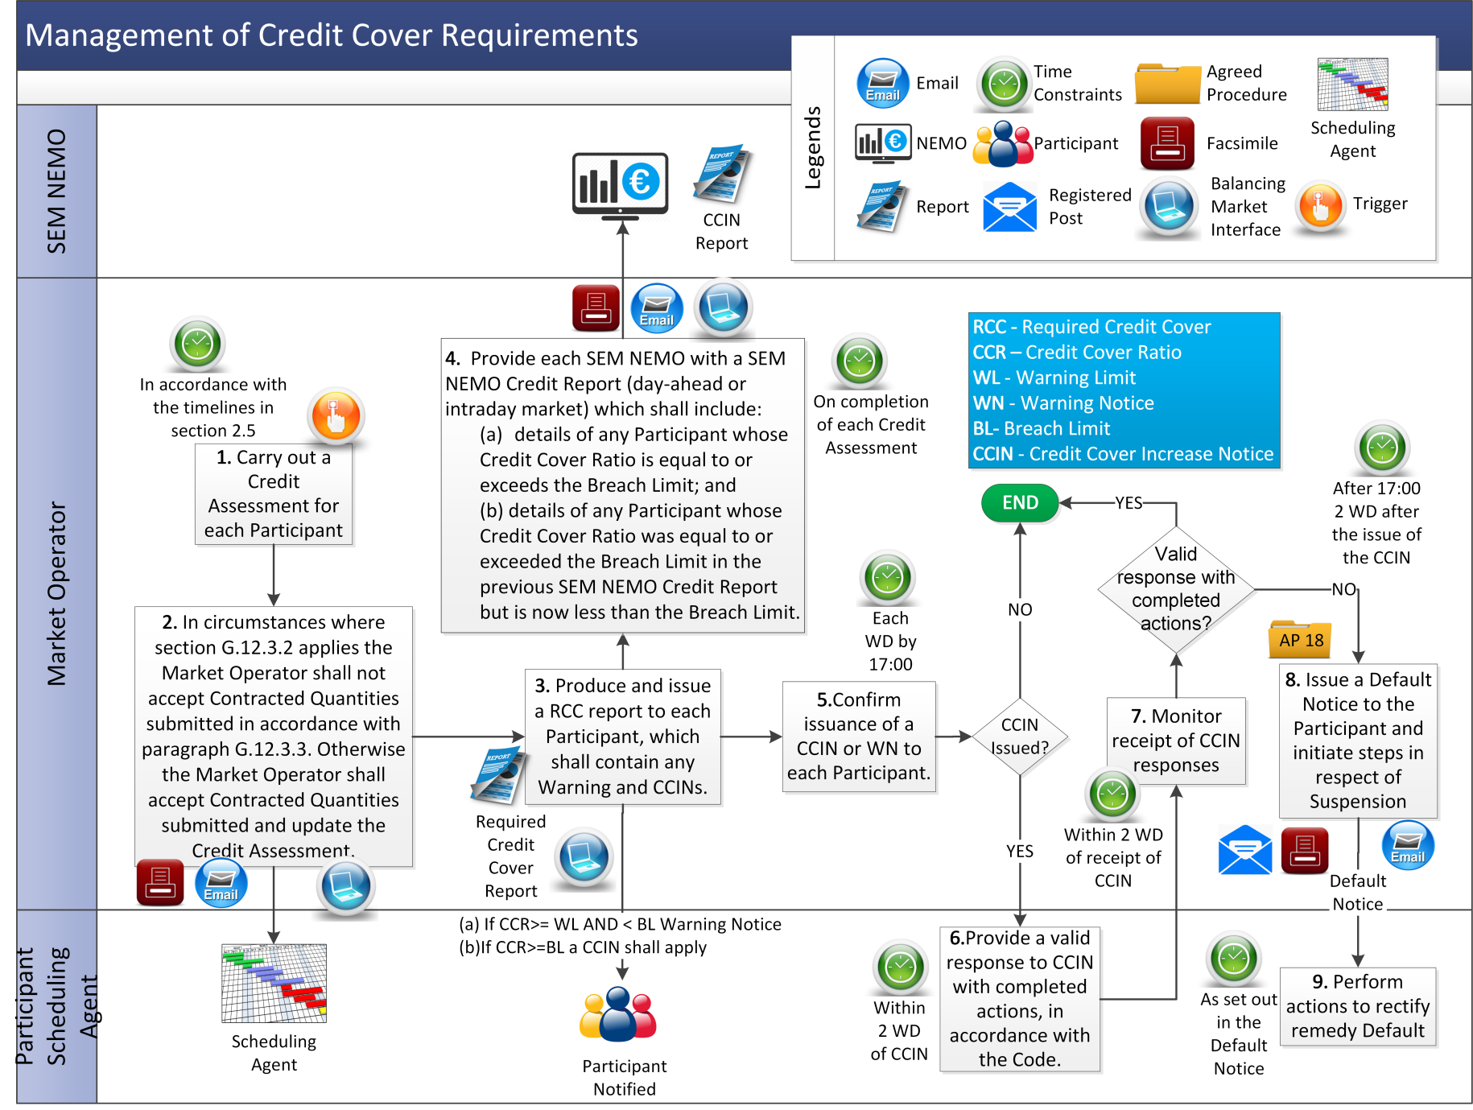

* 1. Submitting a Letter of Credit or Demand Guarantee (Eligibility of Credit Cover Provider)

| Step | Procedural Step | Timing | Method | By/From | To |
| --- | --- | --- | --- | --- | --- |
| **1** | Submit a Letter of Credit or Demand Guarantee from a new or existing Credit Cover Provider. | At least 4 WD prior to the date from which the Letter of Credit or Demand Guarantee needs to be accepted | SWIFT for Letter of Credit / SWIFT or Email for Demand Guarantee | Participant | Market Operator |
| **2** | Submit proof that the new Credit Cover Provider meets the Bank and Insurance Undertaking Eligibility Requirements. | At least 4 WD prior to the date from which the Letter of Credit or Demand Guarantee needs to be accepted | Email / Facsimile | Participant | Market Operator |
| **3** | Review the Letter of Credit or Demand Guarantee and proof provided by the Participant to confirm that:   1. the Letter of Credit or Demand Guarantee meets the requirements as set out in the Code (particularly Appendix A “Standard Letter of Credit and Standard Demand Guarantee” of the Code); and 2. the new Credit Cover Provider meets the Bank and Insurance Undertaking Eligibility Requirements. | Within 2 WD of receipt of Letter of Credit or Demand Guarantee and proof | - | Market Operator | - |
| **4** | Inform the Participant of the results of status checks and compliance with the Letter of Credit or Demand Guarantee requirements.   1. If a new Credit Cover Provider and Letter of Credit or Demand Guarantee and proof have passed the checks, accept the Letter of Credit or Demand Guarantee and continue from step 5; or 2. If an existing Credit Cover Provider and Letter of Credit or Demand Guarantee and proof have passed the checks, accept the Letter of Credit or Demand Guarantee, **end process**; or 3. Reject the Letter of Credit or Demand Guarantee and **end process**. | Within 2 WD of receipt of Letter of Credit and proof | Email | Market Operator | Participant |
| **5** | Add the Credit Cover Provider to the List of Eligible Banks and Insurance Undertakings and publish to Market Operator website. | Within 1 WD of completion of status and compliance checks | Market Operator website | Market Operator | Participant |

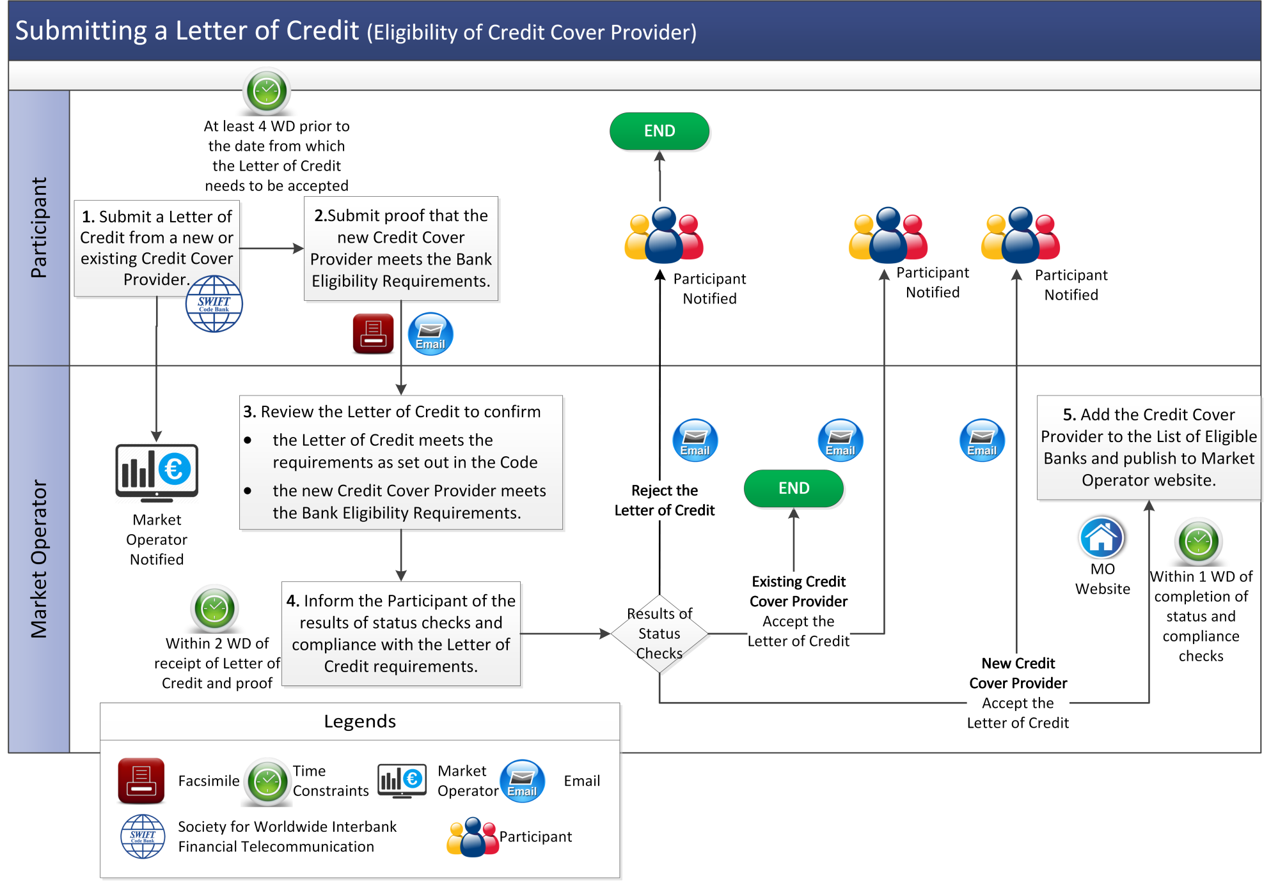

* 1. Ongoing Monitoring of Credit Cover Providers

| Step | Procedural Step | Timing | Method | By/From | To |
| --- | --- | --- | --- | --- | --- |
| **1** | If required by the Market Operator, go to step 3;  or  On receipt of relevant information relating to the potential status of a Credit Cover Provider published on the Market Operator website, continue to step 2. | - | - | Market Operator | - |
| **2** | Consider whether the identified Credit Cover Provider continues to meet the Bank and Insurance Undertaking Eligibility Requirements. If it is determined that the Credit Cover Provider still meets the Bank Eligibility Requirements, **end process**. Otherwise go to step 4. | Within 2 WD of receipt of information | - | Market Operator | - |
| **3** | Review the eligibility of each Credit Cover Provider on the List of Eligible Banks and Insurance Undertakings against the Bank and Insurance Undertakings Eligibility Requirements.  If the Market Operator determines that all Credit Cover Providers still meet the Bank and Insurance Undertaking Eligibility Requirements, **end process**.  Otherwise continue to step 4. | As scheduled | - | Market Operator | - |
| **4** | Update List of Eligible Banks and Insurance Undertakings. | Within 1 WD of completion of the review | Market Operator website | Market Operator | - |
| **5** | Identify any Participants which have invalid Letters of Credit or Demand Guarantees as determined from the updated List of Eligible Banks and Insurance Undertakings. For each such Participant, compare its Required Credit Cover with its revised Posted Credit Cover (i.e. ignoring any Credit Cover provided from Banks not on the List of Eligible Banks and Insurance Undertakings) then,   1. if the Participant’s Required Credit Cover is greater than its revised Posted Credit Cover, continue to step 7; or 2. if the Participant’s Required Credit Cover is less than or equal to its revised Posted Credit Cover, continue to step 6. | Within 1 WD of completion of the review | - | Market Operator | - |
| **6** | Inform each Participant of its revised Posted Credit Cover and return any Letters of Credit or Demand Guarantees issued by a Bank or Insurance Undertaking that is not on the List of Eligible Banks and Insurance Undertakings, **end process**. | Within 1 WD of completion of the review | SWIFT / Email | Market Operator | Participant |
| **7** | 1. Inform each Participant of its revised Posted Credit Cover. 2. Inform the Participant of its Letters of Credit or Demand Guarantees for which the associated Banks or Insurance Undertakings have been determined by the Market Operator to no longer meet the Bank or Insurance Undertaking Eligibility Requirements. 3. Request the posting of additional Credit Cover to meet the Participant’s Required Credit Cover. | Within 1 WD of completion of the review | Facsimile | Market Operator | Participant |
| **8** | Commence the procedure set out in section 3.4 below to change Posted Credit Cover as required. | Within 10 WD of notification at step 7 | - | Participant | - |
| **9** | Cancel any Letters of Credit or Demand Guarantees where the associated Bank or Insurance Undertaking is not on the List of Eligible Banks and Insurance Undertakings. | Once PCC>RCC for the period to which affected Letters of Credit or Demand Guarantee relate | - | Market Operator | - |

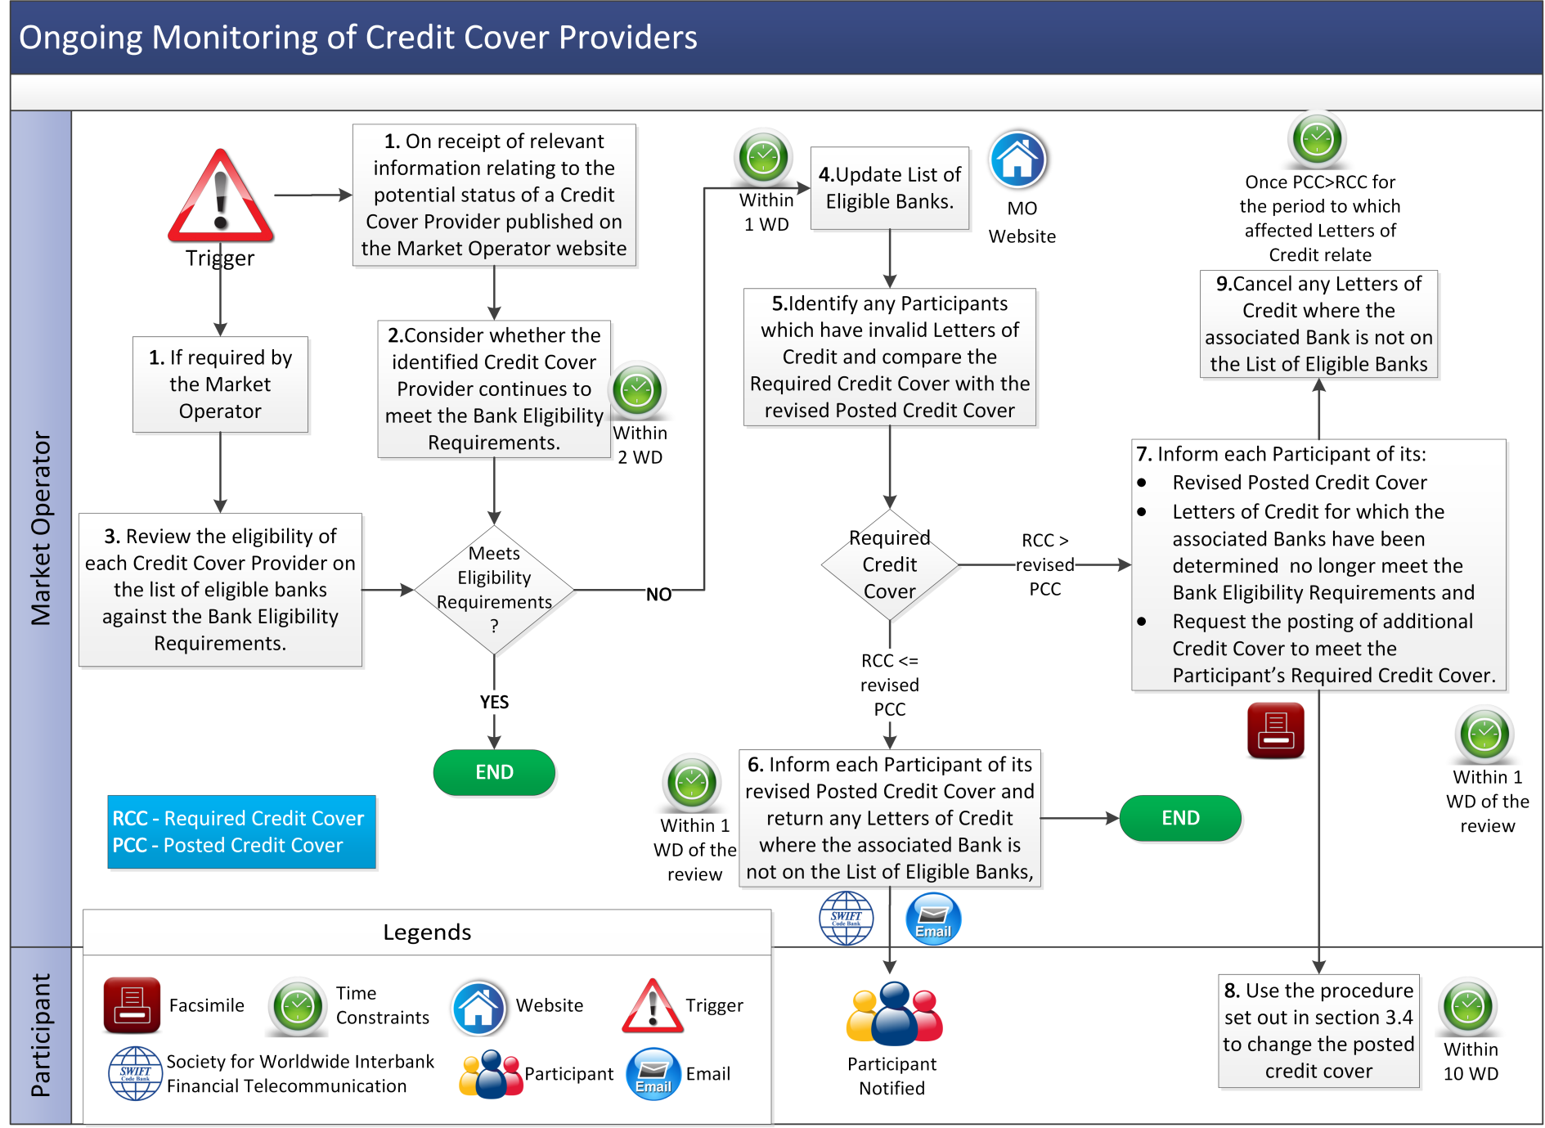

* 1. Changes to Posted Credit Cover

| Step | Procedural Step | Timing | Method | By/From | To |
| --- | --- | --- | --- | --- | --- |
| **1** | If the proposed change to Posted Credit Cover:   1. is a new Letter of Credit or Demand Guarantee, continue to step 2. 2. is an amendment to an existing Letter of Credit or Demand Guarantee, go to step 3. 3. relates to the cancellation of a Letter of Credit or Demand Guarantee, go to step 6. 4. is a deposit of cash to a SEM Collateral Account, go to step 5. 5. is a request for withdrawal of cash from a SEM Collateral Account, go to step 13. | As required (by 12:00 on any WD in order for this procedure to commence on that WD) | - | Participant | - |
| **2** | Follow the procedure set out in section 3.2 to assess the eligibility of the proposed Credit Cover Provider, **end process**. | - | - | Market Operator | - |
| **3** | Retrieve and validate the Letter of Credit or Demand Guarantee details from the SEM Bank. Confirm that the Credit Cover Provider is on the List of Eligible Banks and Insurance Undertakings and the Letter of Credit or Demand Guarantee requirements have been met.   1. If validation is successful and the existing Letter of Credit or Demand Guarantee is for a higher value than the new Letter of Credit or Demand Guarantee, go to step 10. 2. If validation is successful and the existing Letter of Credit or Demand Guarantee is for an equal or lower value than the new Letter of Credit or Demand Guarantee, go to step 11. 3. Otherwise go to step 4. | - | SWIFT in the case of Letter of Credit / SWIFT or E-mail in case of Demand Guarantee | Market Operator | SEM Bank |
| **4** | Reject the amended Letter of Credit or Demand Guarantee and inform the Participant of the validation failures, **end process**. | Within 2 WD of validation | SWIFT / Email | Market Operator | Participant |
| **5** | Deposit Cash in the SEM Collateral Account and notify Market Operator of completion, **end process**. | As required | EFT / Email | Participant | Market Operator |
| **6** | Request cancellation of existing Letter of Credit or Demand Guarantee. | As required | SWIFT/ Email | Participant | Market Operator |
| **7** | Check if the Credit Cover Ratio (calculated excluding the Letter of Credit and Demand Guarantee requested to be cancelled) for the Participant is less than the Breach Limit. If so, continue to step 8. Otherwise, go to step 9. | - | - | Market Operator | - |
| **8** | Accept the cancellation of the affected Letter of Credit and Demand Guarantee and notify the Participant, **end process**. | Within 2 WD of request | SWIFT / Email | Market Operator | Participant |
| **9** | Notify the Participant of rejection of the replacement/ cancellation of the relevant Letter of Credit or Demand Guarantee, **end process**. | Within 2 WD of request | SWIFT / Email | Market Operator | Participant |
| **10** | If accepting the amended Letter of Credit or Demand Guarantee will not result in the issuing of a Credit Cover Increase Notice, continue to step 11. Otherwise, go to step 12. | - | - | Market Operator | - |
| **11** | Accept the amended Letter of Credit or Demand Guarantee and notify the Participant, **end process**. | Within 2 WD of request | SWIFT / Email | Market Operator | Participant |
| **12** | Notify the Participant of the rejection of the amendment to the Letter of Credit, **end process**. | Within 2 WD of request | SWIFT / Email | Market Operator | Participant |
| **13** | Check if the Credit Cover Ratio (calculated excluding the cash requested to be withdrawn) is less than the Breach Limit. If so, continue to step 14. Otherwise, go to step 15. | Within 5 WD of request | - | Market Operator | - |
| **14** | Transfer the cash to the Participant’s Bank account and notify Participant that this has been completed, **end process**. | Within 5 WD of request | EFT / Email | Market Operator | Participant |
| **15** | Notify the Participant of the rejection of the cash withdrawal. | Within 5 WD of request | Email | Market Operator | Participant |

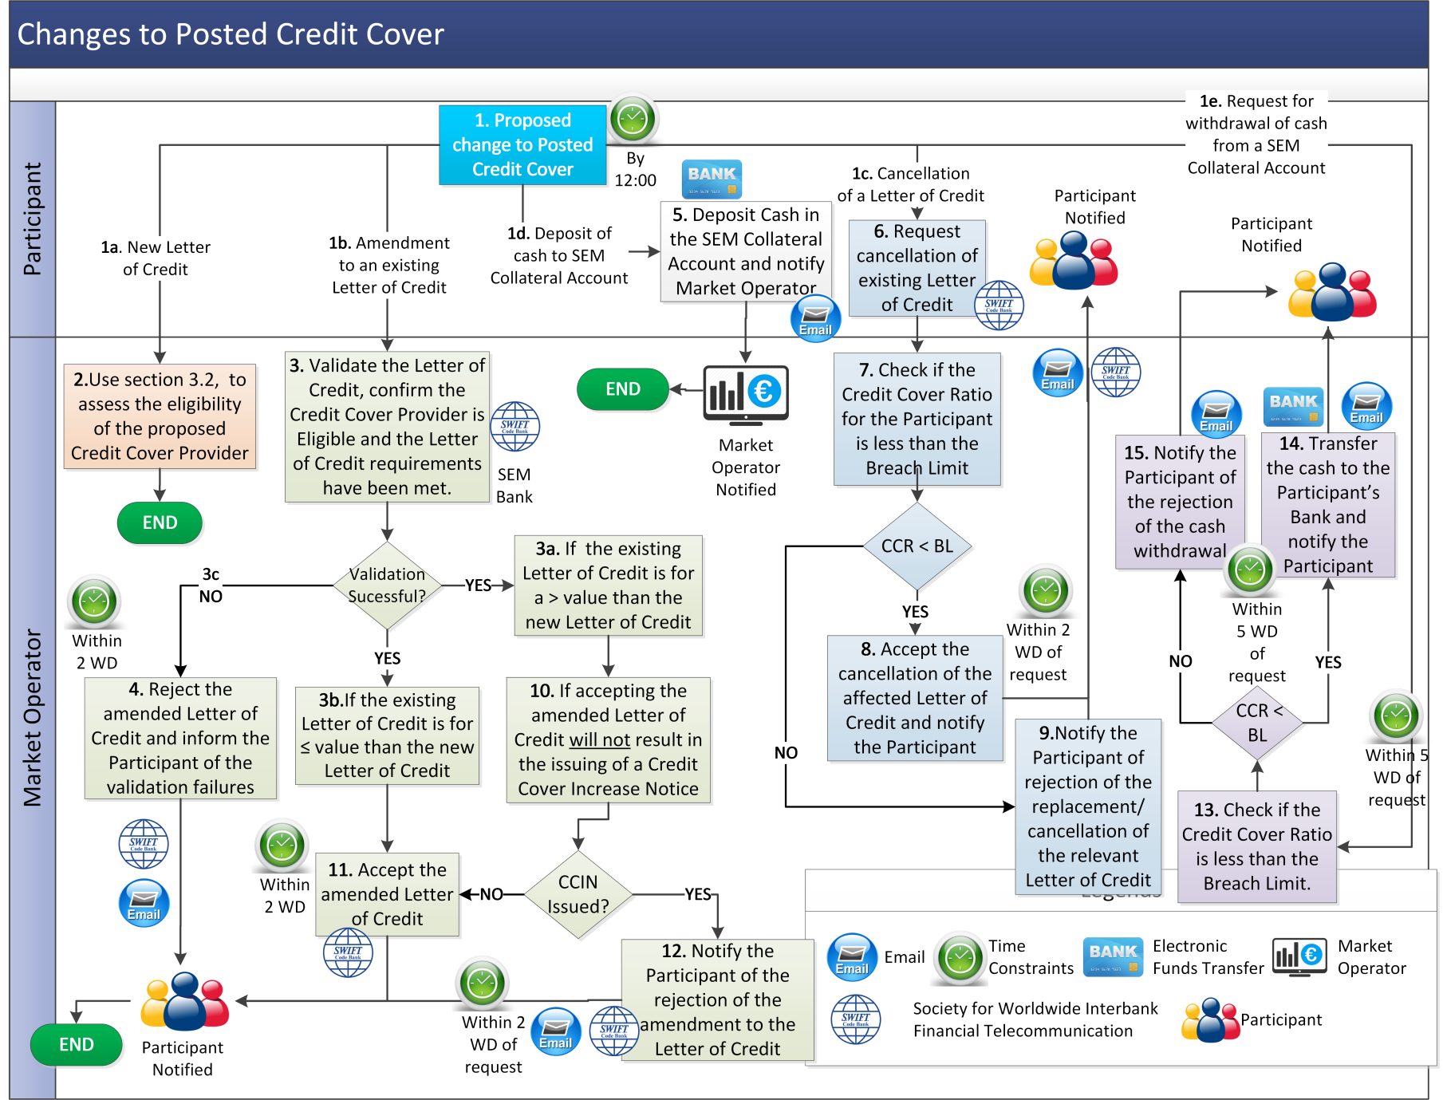

* 1. New Participant and Adjusted Participant Credit Cover

|  |  |  |  |  |  |
| --- | --- | --- | --- | --- | --- |
| Step | Procedural Step | Timing | Method | By/From | To |
| **1** | Either:   1. on receipt of Application form for Unit Participation (in respect of Unit that is not an Interconnector Unit), in accordance with Agreed Procedure 1 "Registration";   or   1. in the event that a Participant becomes an Adjusted Participant. | As required | - | New Participant / Adjusted Participant / Market Operator | - |
| **2** | Submit forecast data with respect to the Units registered to the Participant in accordance with the requirements of the Registration Pack for New Participants or in accordance with paragraph G.12.4.3 and G.12.4.4 of Code for Adjusted Participants. | Within 1 WD of becoming a New Participant or Adjusted Participant as applicable | Email / Facsimile | New Participant / Adjusted Participant | Market Operator |
| **3** | Calculate and notify the Required Credit Cover, utilising the forecast data supplied. If an Adjusted Participant, continue to step 4, otherwise **end process**. | Within 1 WD of receipt of forecast data | Email / Facsimile | Market Operator | New Participant / Adjusted Participant |
| **4** | Calculate and notify the current Posted Credit Cover, as part of the Required Credit Cover Report. | Within 1 WD of receipt of forecast data | Balancing Market Interface | Market Operator | New Participant / Adjusted Participant |

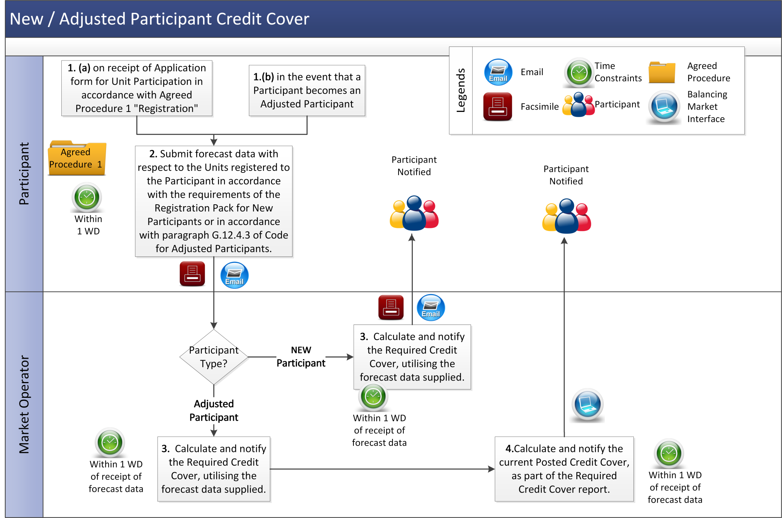

* 1. Transfer from SEM Collateral Reserve Account to make a payment due under a Settlement Document

| Step | Procedural Step | Timing | Method | By/From | To |
| --- | --- | --- | --- | --- | --- |
| **1** | Request a transfer from a SEM Collateral Reserve Account to make a payment due under a specified Settlement Document in accordance with section 2.12.1 above. | Before 15:00 1 Working Day after Settlement Documents to which the payment relates have been published | Email | Participant | Market Operator |
| **2** | Based on the most recent Credit Assessment in relation to the Participant, if the Participant’s Posted Credit Cover is greater than or equal to its Required Credit Cover, go to step 4. Otherwise continue to step 3 | Before 12:00 the day before Payment Due Date of relevant Settlement Document(s) | - | Market Operator | - |
| **3** | Issue a confirmation stating that the request for payment of the relevant Settlement Document by way of transfer from the SEM Collateral Reserve Account has been declined and that alternative method of payment must be arranged by the Participant, **end process** | Before 12.00 one Working Day before Payment Due Date | Email | Market Operator | Participant |
| **4** | Issue a confirmation stating that the request for payment of the relevant Settlement Document by way of transfer from the SEM Collateral Reserve Account has been approved | Before 12.00 one Working Day before Payment Due Date | Email | Market Operator | Participant |
| **5** | Perform transfer of funds from Participant's SEM Collateral Reserve Account to SEM Clearing Account | Before Settlement Document Payment Due Date | - | Market Operator | - |
| **6** | Reconcile payment to outstanding Settlement Document | Before Settlement Document Payment Due Date | - | Market Operator | - |
| **7** | Inform Participant that the transfer has taken place | Before 17:00 on the Settlement Document Payment Due Date | Email | Market Operator | Participant |

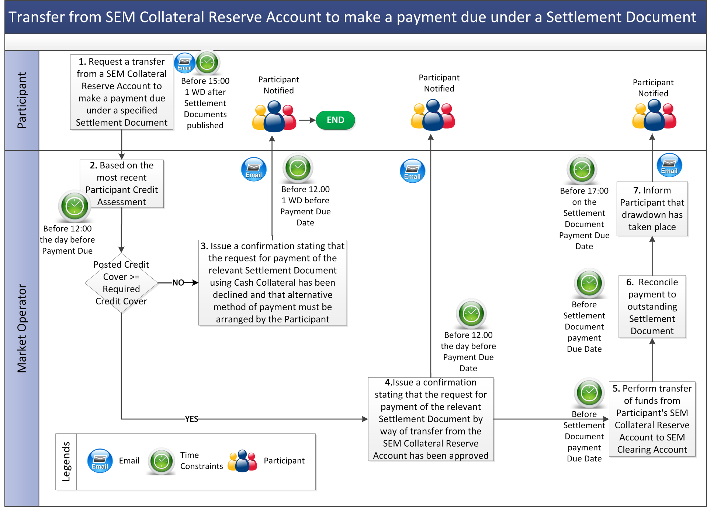

* 1. SEM Collateral Reserve Account Standing Request

| Step | Procedural Step | Timing | Method | By/From | To |
| --- | --- | --- | --- | --- | --- |
| **1** | Participant submits a Standing Request to instruct the Market Operator to transfer funds from SEM Collateral Reserve Account to pay all qualifying amounts due under Settlement Documents in accordance with section 2.12.2 above. | As required | Post / Facsimile | Participant | Market Operator |
| **2** | Assess if the Participant meets the conditions set out in section 2.12.2 above. If yes, go to step 4, otherwise, continue to step 3. | On receipt of request at step 1 | - | Market Operator | - |
| **3** | Inform Participant that the Standing Request has been declined and that an alternative form of payment must be made. | 2 WD after the Standing Request is submitted | Email | Market Operator | Participant |
| **4** | Inform Participant that the Standing Request has been approved. Continue to step 5 after each publication of each relevant Settlement Document. | 2 WD after the Standing Request is submitted | Email | Market Operator | Participant |
| **5** | On publication of each relevant Settlement Document assess if, based on the most recent Credit Assessment in respect of the Participant, the Participant’s Posted Credit Cover is equal to or greater than its Required Credit Cover. If yes go to step 7, otherwise continue to step 6. | By 12:00 1 WD before Settlement Document Payment Due Date | - | Market Operator | - |
| **6** | Inform Participant that the Standing Request has been declined and that an alternative method of payment must be made, **end process.** | Before 12:00 1 WD before Settlement Document Payment Due Date | Email | Market Operator | Participant |
| **7** | Transfer funds from Participant's SEM Collateral Reserve Account to SEM Clearing Account. | Before Settlement Document Payment Due Date | - | Market Operator | - |
| **8** | Reconcile payment to outstanding Settlement Document. | Before Settlement Document Payment Due Date | - | Market Operator | - |

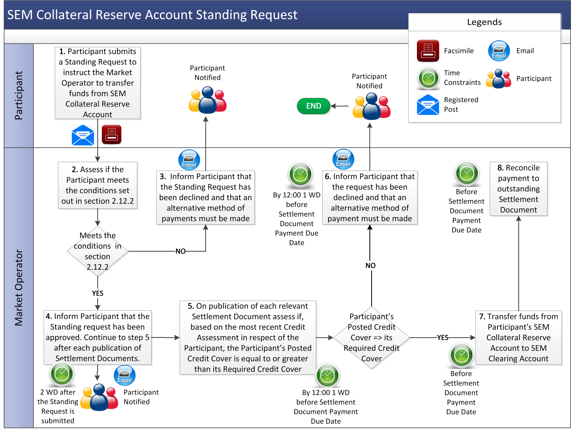

1. Definitions and Abbreviations

**Definitions**

|  |  |
| --- | --- |
| **Credit Risk** | means the potential amount of payment default by a Participant on their financial obligations in the SEM |
| **List of Eligible Banks and Insurance Undertakings** | means the list of Banks or Insurance Undertakings that meet the Bank and Insurance Undertaking Eligibility Requirements as published on the website of the Market Operator and which may be updated from time to time. |
| **Standing Request** | means an instruction from a Participant to the Market Operator to drawdown from a SEM Collateral Reserve Account to pay all qualifying Settlement Document amounts until such time as the Participant withdraws the instruction. |

**Abbreviations**

|  |  |
| --- | --- |
| **SWIFT** | Society for Worldwide Interbank Financial Telecommunication |

1. Calculation of VAT for Required Credit Cover (if applicable)

In accordance with Section G (Financial and Settlement) of the Code, the Required Credit Cover for each Participant shall include an amount in respect of VAT. This amount shall be calculated as follows:

1. For published Settlement Documents that are included in the Actual Supplier Exposure and Actual Generator Exposure, the amount of VAT as calculated on the Invoice will be included in the VAT amount of the Required Credit Cover as applicable.
2. For published Settlement Statements that have not been included in any Settlement Documents, an amount in respect of VAT will be calculated for all the payments and charges as applicable in accordance with the rules as set out in Agreed Procedure 15. This amount will be included in the VAT amount of the Required Credit Cover. This applies to Settlement Statements issued in respect of Trading Charges and Trading Payments and Capacity Charges and Capacity Payments.
3. For the amounts calculated in respect of Undefined Potential Exposure amounts, an amount in respect of VAT will be calculated as applicable.